1. **Organisms referred to as amphibians of plant kingdom are**

(a) Pteriphytes (b) Bryophytes

(c) Angiosperms (d) Gymnosperms

1. **Bryophytes are found in**

(a) Rocky places (b) Hilly areas

(c) Moist and shady places (d) Aquatic areas

1. **Organisms that play an important role in plant succession on base rocks are**

(a) Mosses (b) Pteridophytes

(c) Protist (d) None of these

1. **Which of the following statement is incorrect with respect to bryophytes?**

(a) The plant body is thallus like, more differentiated than algae and attached to substratum by the help of rhizoids.

(b) The antherozoids are released in water for fertilization.

(c) Zygote formed undergoes meiotic cell division immediately.

(d) They have leaf like, stem like and root like structures.

1. **The sporophyte of bryophytes develops after**

(a) Reduction division of zygote

(b) Multiplication in zygote

(c) Before the formation of zygote

(d) None of these

1. **_______ forms gametophyte of bryophytes.**

(a) Zygote (b) Sporophyte

(c) Gametes (d) Spores

1. **The male sex organ of bryophyte is called**

(a) Antherozoids (b) Testes

(c) Globule (d) None of these

1. **The sex organ in bryophytes are**

(a) Reduced to single celled stage

(b) Multicellular

(c) Net cell developed

(d) Formed in sporophyte

1. **The main plant body of bryophyte is**

(a) Diploid (b) Haploid

(c) Polyploid (d) All of these

1. **Female sex organ of bryophytes is**

(a) Oval in shape (b) Irregular

(c) Flask shaped (d) Depends on the organism

1. **Female sex organ of bryophyte is called**

(a) Nucleus (b) Ovary

(c) Oogonia (d) Archegonium

1. **Archegonium contains _______ egg cells in bryophytes**

(a) More than one (b) Two

(c) Four (d) One

1. **Division in zygote results in the formation of _______ in bryophytes**

(a) Gametophyte (b) Sporophyte

(c) Antherozoids (d) Archegonium

1. **Gametophyte of bryophyte is**

(a) Free living and sporophyte

(b) Free living and autotrophic

(c) May be free living or autotropic

(d) Always pressure

1. **Peat used in transshipment is a product obtained by**

(a) Liverworts (b) Phaeophyceae

(c) Mosses (d) None of these

1. **Organisms which first colonizes the base rocks is**

(a) Mosses (b) Mycorrhiza

(c) Lichens (d) Both (a) and (c)

1. **Mosses are ecologically important because**

**I. The first organism to colonize base rocks.**

**II. It decompose rocks making suitable for the growth of higher plant.**

**III. It forms dense mats on soil.**

**IV. It reduces the impact of falling rain and soil erosion.**

(a) Only I (b) Only II

(c) III and IV (d) All of these

1. **Organisms participating as pioneers in ecological succession belongs to**

(a) Lichens (b) Mosses

(c) Liverworts (d) Both (a) and (b)

1. **The thallus of liverworts are**

(a) Sexual multiplication of the formation of sex organs called gemmae.

(b) Dorsiventral and appressed to substrate.

(c) Found in xeric habitats.

(d) Diploid

1. **Asexual reproduction in liverworts means**

(a) Fragmentation of thalli

(b) Formation of specialized structure called gemmae

(c) Both (a) and (b)

(d) None of these

1. **Sexual reproduction in liverworts takes place by**

(a) Formation of sex organs always on the same thallus.

(b) Formation of male and female sex organs on different thallus.

(c) Sexual reproduction is absent.

(d) Male and female sex organs may be present on same or different thallus

1. **Spore in bryophytes are formed**

(a) On the gametophyte

(b) On the sporophyte

(c) In the seta of sporophyte

(d) In the capsule of sporophyte

1. **The gametophyte of bryophyte develops from**

(a) A haploid spore (b) A diploid spore

(c) Zygote (d) None of these

1. **Zygote of bryophyte**

(a) Multiply and forms gametophyte

(b) Multiply and forms sporophyte

(c) Undergoes reduction division just after formation

(d) All are correct

1. **The dominant stage of gametophyte of mosses consists of**

(a) Protonema which develops from the lateral bud

(b) A leafy stage developing from a spore

(c) Both (a) and (b)

(d) A leafy stage developing from the secondary protonema

1. **Protonema is found in**

(a) Liverworts (b) Selaginella

(c) Funaria (d) None

1. **Which one is correct about protonema?**

(a) It is a dominant stage mosses

(b) Develops from spore

(c) It is creeping, green, branched and frequently filamentous

(d) All are correct

1. **Leafy stage in bryophytes**

(a) Develops from secondary protonema.

(b) Consist of upright, slender axis and bears consist of alternately arranged leaves.

(c) Attached to the soil through unicellular and branched rhizoids.

(d) All of these

1. **Sex organs in mosses develops on**

(a) Secondary protonema (b) Leafy stage

(c) On capsule of sporophyte (d) None of these

1. **Sporophyte of mosses is more elaborated from**

(a) Ferns (b) Pinus

(c) Polytrichum (d) Marchantia

1. **Spores in bryophytes are formed by**

(a) Mitosis

(b) Meiosis in gametophyte

(c) Mitosis in zygote

(d) Meiosis in zygote

1. **Elaborate mechanism of spore dispersal is found in**

(a) Ferns (b) Mosses

(c) Liverworts (d) None of these

1. **The plants frequently grown as ornamentals and are used for medicinal purpose belong to**

(a) Angiosperms (b) Pteridophytes

(c) Algae (d) Some protest

1. **The first terrestrial plants to posses vascular tissues are**

(a) Gymnosperms (b) Bryophyte

(c) Pteridophytes (d) All of these

1. **The main plant body of pteridophytes is**

(a) Gametophytes as well as sporophyte

(b) Sporophyte

(c) None of these

(d) Both (a) and (b)

1. **The plant body of pteridophyte is**

(a) Not well-developed

(b) Lacks vascular tissue

(c) Is thalloid

(d) Posses true root, leaves and stem

1. **Pteridophytes have only**

(a) Small microphyllous leaves

(b) Large macrophyllous leaves

(c) Both microphyllous as well as macrophyllous in some of the ferns

(d) All of the above

1. **Prothallus is the gametophyte of**

(a) Bryophytes (b) Algae

(c) Gymnosperm (d) Pteridophyte

1. **The gametophyte of pteridophyte grows in damp, moist and shady places because**

(a) They are limited and restricted to a narrow geographical region.

(b) They need water for fertilization of gametes formed on the gametophyte.

(c) Water is required for gametogenesis.

(d) Egg cell swims in water to reach to the antheridia.

1. **Gametophyte of pteridophyte**

(a) Parasite on sporophyte

(b) Not a free living stage

(c) Photosynthetical and free living

(d) Is unicellular

1. **Vascular plants which do not bear seeds is**

(a) Angiosperms (b) Pteridophytes

(c) Gymnosperms (d) None of these

1. **Macrophylls leaves are characteristics of**

(a) Mosses (b) Ferns

(c) Funaria (d) None of these

1. **Pteridophyte having microphylls is**

(a) Ferns (b) Psilotum

(c) Selaginella (d) All of these

1. **The production of spores by the spore mother cells is the result of**

(a) Mitosis

(b) Meiosis

(c) Mitosis and meiosis both

(d) Amitosis

1. **The leaves bearing sporangia are called**

(a) Sporophylls (b) Fronds

(c) Tropophylls (d) Scaly leaves

1. **Cones in pteridophytes are formed in**

(a) Salvinia

(b) Selaginella and lycopodium

(c) Dryopteris

(d) Selaginella and Equisetum

1. **Sex organs in pteridophytes are formed on the**

(a) Multicellular well-developed sporophyte.

(b) Multicellular main gametophyte phase of the plant.

(c) Photosynthetic, free living gametophyte.

(d) Parasite, gametophyte dependent on sporophyte

1. **The male and female sex organs of pteridophyte are called**

(a) Globule and nucule respectively

(b) Spermatangia and oogonia respectively

(c) Antheridia and archegonia respectively

(d) Tests and ovary respectively

1. **Zygote of pteridophyte**

(a) Undergoes reduction division just often formation

(b) Produces multicellular gametophyte

(c) Produces multicellular sporophyte

(d) Remains dormant

1. **Majority of the pteridophytes are**

**I. Homosporous and produce only one kind of spores.**

**II. Aquatic in nature.**

**III. Heterosporus and produce small and large spores.**

**IV. Restricted to narrow geographical zone because of specific requirement of water**.

(a) I and II (b) II and III

(c) III and IV (d) IV and I

1. **Heterosporous plants are**

(a) Plants producing one kind of spores.

(b) Plants producing large and small spores.

(c) Plants producing two type of spores which are similar in size.

(d) None of these

1. **Megaspore germinate into**

(a) Female gametophyte

(b) Gametophyte having both male and female sex organs

(c) Male gametophyte

(d) Male sporophyte

1. **The female gametophytes are retained on the parent sporophyte in**

(a) Homosporous species of pteridophytes

(b) Heterosporous species of pteridophytes

(c) Both are correct

(d) Both are incorrect

1. **Process similar to seed habit considerably is observed in**

(a) Homosporous species of pteridophytes

(b) Heterosporous species of pteridophyte

(c) All the members of pteridophytes

(d) Not seen in pteridophyte

1. **Vascular plants, with seeds but no fruits are**

(a) Bryophyte (b) Angiosperms

(c) Gymnosperms (d) Pteridophytes

1. **In heterosporous pteridophyte**

(a) Zygote develops into young embryo in the female gametophyte.

(b) Zygote multiples and develop into sporophyte in the soil.

(c) All spores are similar

(d) None of these

1. **Naked seed plants are**

(a) Algae (b) Bryophyte

(c) Angiosperms (d) Gymnosperms

1. **The tallest gymnosperms is**

(a) Sequoia (red wood tree)

(b) Pinus

(c) Cycas

(d) Ginkgo

1. **Coralloid roots having association with N2 fixing bacteria are found in**

(a) Pinus (b) Cedrus

(c) Sequoia (d) Cycas

1. **In gymnosperms, the mycorrhizal association are found in**

(a) Pinus (b) Cycas

(c) Cedrus (d) All of these

1. **Gymnosperms**

(a) Are naked seeds plants

(b) Have tap roots

(c) Are heterosporous

(d) All of these

1. **Which of the following are correct for gymnosperms?**

**I. Have adventitious root system.**

**II. The leaves in gymnosperms can withstand extreme temperature, humidity and wind.**

**III. Microspores are produced in microsporangia.**

**IV. They include medium or tall sized trees and shrubs.**

(a) I and III (b) I, II and II

(c) II, III and IV (d) I and IV

1. **In cycas**

(a) The stems are unbranched.

(b) The pinnately compound leaves persist for years.

(c) Have symbiotic association with n2 fixing cynobacteria.

(d) All are correct

1. **Which of the following statements are correct for conifers?**

**I. Needle like leaves to reduce surface area.**

**II. Thick cuticle on leaves.**

**III. Sunken stomata to reduce water loss.**

**IV. The main plant body is gametophyte.**

(a) II and III (b) IV only

(c) I only (d) II, I and III

1. **Which of the following sequence is correct?**

(a) Strobili–Sporophylls→Sporangia→Spores

(b) Strobili–Sporangia→Sporophylls→Spores

(c) Sporophylls–Strobili→Sporangia→Spores

(d) Spores–Sporangia→Strobili→Cones

1. **Male gametophyte which is highly reduced and confined to only limited numbers of cells is**

**called**

(a) Antherozoid (b) Spermatozoid

(c) Pollen grain (d) All of these

1. **Male and female cones are formed on the same tree of**

(a) Cycas (b) Pinus

(c) Both (a) and (b) (d) None of these

1. **In gymnosperms, the male and female gametophyte**

**I. Do not have independent free living existence.**

**II. Remain within the sporangia retained on parent sporophyte.**

**III. May be born on same or different tree.**

**IV. Perform meiosis to produce gametes.**

(a) I and II (b) II and III

(c) III and IV (d) All

1. **Angiosperms include**

(a) Vascular plants with naked seeds

(b) Vascular plants with covered seeds

(c) Few vascular plants with naked seeds

(d) Few vascular plants with covered seeds

1. **Microscopic angiosperm is**

(a) Sequoia (b) Eucalyptus

(c) Wolffia (d) Never microscopic

1. **The height of eucalyptus tree is approximately**

(a) 100 m (b) 1000 m

(c) 10 m (d) 10‒20 m

1. **Male sex organ in angiosperm is located in**

(a) Male cone (b) Sporophyll

(c) Flower (d) Carpel

1. **Male sex organ in flower is**

(a) Antheridia (b) Stamens

(c) Spermatangia (d) Nucule

1. **Embryo sacs in angiosperms is**

(a) Male gametophyte

(b) Well-developed female gametophyte

(c) Highly reduced female gametophyte

(d) Well-developed female sporophyte

1. **Embryo sac of angiosperms posses**

(a) Egg apparatus (b) Synergids

(c) Antipodal (d) All of these

1. **Egg apparatus of angiosperms contain**

(a) One egg cell (b) Two synergids

(c) Both (a) and (b) (d) Two antipodals

1. **The cells of embryo sac are**

(a) Diploid

(b) Haploid

(c) May be haploid or diploid

(d) None of these

1. **Diploid secondary nucleus in embryo sac of angiosperm is the product of**

(a) Fusion of two synergid cells

(b) Fusion of two antipodal cells

(c) Fusion of two polar nuclei (d) Fusion of egg cell and antipodal cell

1. **The pistil in angiosperm is made up of**

(a) Ovary (b) Stigma

(c) Style (d) All of these

1. **Ovary is the characteristic feature of**

(a) Gymnosperms (b) Angiosperm

(c) Pteridophyte (d) All of these

1. **In double fertilization**

(a) one male gamete fuses with the antipodal, while the other fuses with the diploid nucleus

(b) one male gamete fuses with the egg and the other fuses with the secondary nucleus

(c) Both (a) and (b)

(d) Fertilization takes place in two plants simultaneously

1. **Synergids and antipodals**

(a) Develop into new plants

(b) Are diploid

(c) Degenerate after fertilization

(d) Are produced in male gametophyte

1. **Double fertilization is the unique characterisitic feature of**

(a) Angiosperm (b) Gymnosperm

(c) Pteridophyte (d) Dicotyledons only

1. **Zygote after multiplication in angiosperm develop in**

(a) Endosperm (n) (b) Embryo (n)

(c) Endosperm (d) Embryo (2n)

1. **Endosperm in angiosperm is formed**

(a) Before fertilization

(b) After fertilization

(c) Vary from species to species

(d) All of these

1. **In haplontic life cycle, the sporophytic generation is seen by**

(a) Well-developed multicellular sporophyte

(b) Zygote

(b) Embryo

(d) None of these

1. **In haplontic life cycle, the zygote divides by**

(a) Mitosis (b) Meiosis

(c) Any of these (d) Amitosis

1. **Volvox, spirogyra chlamydomonas come under**

(a) Haplodiplontic life cycle organism

(b) Diplohaplontic organism

(c) Haplontic life cycle

(d) Diplontic life cycle

1. **Sporophyte, dominant, photosynthetic and independent phase of plant represents**

(a) Haplontic

(b) Diplontic

(c) Diplohaplontic life cycle

(d) Both (b) and ©

1. **Diplontic life cycle is seen in**

(a) Angiosperms and gymnosperms

(b) Spermatophytes

(c) Both (a) and (b)

(d) Pteridophyte

1. **When both the phases of life cycle are multicellular, i.e., haploid and diploid phases are more than one celled**

(a) Life cycles are called haplodiplontic

(b) They differ in the dominant phase

(c) They are in pteridophytes and bryophytes

(d) All of these

1. **Most of the alga show**

(a) Haplontic life cycle

(b) Diplontic life cycle

(c) Haplodiplontic life cycle

(d) None of these

1. **Algae showing haplodiplontic life cycle are**

(a) Spirulina and spirogyra

(b) Ectocarpus and polysiphonia

(c) Kelps

(d) Both (b) and (c)

1. **Which alga shows diplontic life cycle?**

(a) Chara (b) Fucus

(c) Ectocarpus (d) Polysiphonia

1. **How many organisms show haplodiplontic life cycle?**

**Sphagnum, Volvox, Ulothrix, Marchantia, Polytrichum, Selaginella, Pinus, Cedrus, Ectocarpus, Polysiphonia**

(a) 8 (b) 6

(c) 7 (d) 9

1. **How many organisms show diplontic life cycle?**

**Selaginella, Equisetum, Cycas, Cedrus, Ectocarpus, Fucus, Sequoia**

(a) 7 (b) 5

(c) 4 (d) 6

1. **Gametogenesis in organism showing haplontic life cycle takes place in**

(a) Mitosis (b) Meiosis

(c) Both (a) and (b) (d) Amitosis

1. **Bryophytes are also called ‘amphibians of the plant kingdom’ because**

(a) water is essential for reproduction

(b) they occur only in water

(c) these plants can live in soil, but are dependent on water for sexual reproduction

(d) water is essential for spore formation

1. **The main plant body of bryophytes is ...*A*... .It produces ...*B*..., hence is called a ...*C*... .Fill in the blanks by choosing the correct option for *A, B* and *C*.**

(a) A–diploid, B–spores, C–sporophyte

(b) A–haploid, B–gametes, C–gametophyte

(c) A–diploid, B–endospores, C–sporophyte

(d) A–haploid, B–conidia, C–gametophyte

1. **Peat moss is**

(a) Funaria (b) Sphagnum

(c) algae (d)fern

1. **In given figure *A*, *B*, *C* and *D* represent**

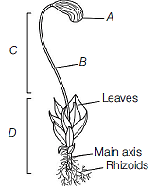

(a) A–Apophysis, B–Capsule, C–Sporophyte, D–Gametophyte

(b) A–Capsule, B–Seta, C–Sporophyte, D–Gametophyte

(c) A–Apophysis, B–Seta, C–Gametophyte, D–Sporophyte

(d) A–Apophysis, B–Capsule, C–Gametophyte, D–Sporophyte

1. **Which of the following liverworts has thalloid plant body?**

(a) Marchantia (b) Funaria

(c) Sphagnum (d) Pogonatum

1. **Gemmae are asexual buds, which originate from small receptacles called gemma cups. These are found in**

(a) Funaria (b) Marchantia

(c) Fern (d) None of these

1. **If the leaf of *Funaria* has 5 chromosomes, the primary protonema will have**

(a) 10 chromosomes (b) 5 chromosomes

(c) 15 chromosomes (d) 20 chromosomes

1. **In mosses, vegetative reproduction takes place by**

(a) fragmentation and budding in the secondary protonema

(b) gemmae formation and endospore formation

(c) gemmae and tubers formation

(d) protonema

1. **In moss, the sporophyte is differentiated into**

(a) seta and capsule

(b) foot and seta

(c) foot, seta and capsule

(d) protonema, foot and capsule

1. **Funaria, Polytrichum and Sphagnum are the examples of**

(a) liverworts (b) ferns

(c) mosses (d) pteridophytes

1. **In a moss, the sporophyte**

(a) produces gametes that give rise to the gametophyte

(b) is partially parasitic on the gametophyte

(c) arises from a spore produced from the gametophyte

(d) manufactures food for itself, as well as for the gametophyte

1. **Porphyra and Polysiphonia belong to -**

(a)Chlorophyceae (b) Rhodophyceae

(c) Xanthophyceae (d) Phaeophyceae

**I. Green algae occur in fresh water, brackish water salt water.**

**II. Habitat of Brown algae-fresh water (rare), brackish water, salt water**

**Ill. Some red algae are found in fresh water, mostly occur in salt water, some are in brackish water**

**IV. Most of the red algae are multicellular.**

**V. Red algae may occur in both well lighted regions close to water-surface and also at great depths in oceans where**

**light penetration is little.**

**VI. Cell wall of red algae consists of cellulose + polysulphate easters.**

**VII. 2 - 8, equal and apical flagella in green algae**

(a) All are correct (b) All are false

(c) I and VI are correct (d) II, Ill and V are correct

1. **Examine the figures A, B, C, D. In which one of the four options all the items, A, B, C and D are correct**

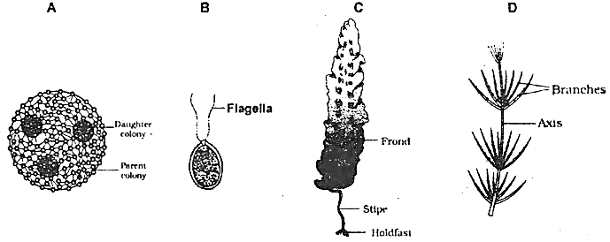

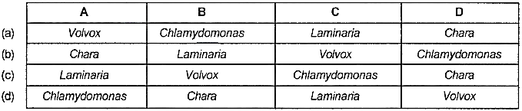

1. **Bryophytes include -**

(a) Mosses (b) Lycopods

(c) Horse tail (d) Liverworts+ mosses

1. **Bryophytes mostly grow -**

(a) in dry area

(b) In snow

(c) In moist shaded areas in hills, damp+ humid +shaded localities

(d) In water

1. **Bryophytes are called "Amphibians of the plant kingdom" because -**

(a) They are found in only water

(b) Plants live in soil but are dependent on water for sexual reproduction

(c) It needs water for spores formation

(d) Water is essential for its survival

1. **Plant body of bryophyte is** -

(a) Less differentiated than that of algae

(b) Equally differentiated to that of Algae

(c) More differentiated to that of algae

(d) Is not differentiated at all

1. **The plant body of bryophytes is thallus-like and prostate or erect, and attached to substratum by -**

(a) Unicellular roots

(b) Multicellular roots

(c) Unicellular or multicellular rhizoids

(d)Adhesive

1. **The plant body of all bryophytes are gametophyte, haploid and thallus like having -**

(a) Root+ Stem + Leaf

(b) No root+ no stem+ no leaf

(c) Xylem and phloem

(d)Wood

1. **The gametophytes in bryophytes produces biflagellate gametes (antherozoids) in ___ and produces ovum (female gamete) in ____ _**

(a) Antheridium, carpogonium

(b) Anther, ovary

(c)Archegonium, antheridium

(d)Antheridium, archegonium

1. **Choose the correct option** -

(a) In bryophytes sexual reproduction is oogamous type

(b) Sex organs are unicellular in algae and fungi but multicellular in bryophytes to angiosperms

(c) Archegonium is flask shaped

(d)All

1. **Which is the prominent phase in the life cycle of bryophytes** -

(a) Gametophyte (b) Sporophyte

(c) Seta (d) Sporogonium

1. **Gametophytic generation is dominant In -**

(a) Gymnosperms (b) Bryophyte

(c) Pteridophytes (d) Angiosperms

1. **Choose the incorrect statement for bryophyte -**

(a) Zygote does not undergo meiosis immediately

(b) Zygote produces embryo which changes into sporophyte

(c) Bryophytes are of little economic importance

(d) Bryophytes are of great economic importance

1. **Which is the correct statement about bryophytes?**

(a) Sporophyte is multicellular, not free living but attached with plant body (gametophyte) for nourishment from it

(b) Some cells of the sporophyte undergo meiosis to produce haploid homospores

(c) Spores germinate to produce gametophyte

(d)All

1. **Sphagnum is used as a packing material for transportion of living materials because of its -**

(a) Acidic nature as it does not undergo decay

(b) Creeping capacity

(c) Water holding capacity

(d) Both a and c

1. **Sphagnum is also called** -

(a) Bog or peat moss (b) Club moss

(c) Spike moss (d) Reindeer moss

1. **Sphagnum (a moss) provides-**

(a) oil (b)Peat(fuel)

(c)Agar (d)Antibiotics

1. **Mosses are of great ecological importance because of-** ,

(a) Its contribution to prevent soil erosion

(b) Its contribution in ecological succession

(c) Both a and b

(d) Its capability to remove CO from the atmosphere

1. **The mosses which form dense extensive mats on the soil prevents -**

(a) Uprooting of trees (b) Soil erosion

(c) Falling of leaves (d) Evaporation of water from the soil

1. **Identify a, b, c in diagram:**

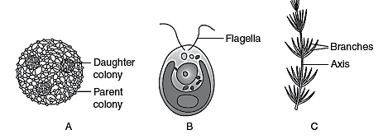

(a) A– Volvox, B–Chlamydomonas, C–Chara

(b) A–Chara, B–Volvox, C–Chlamydomonas

(c) A–Chlamydomonas, B–Chara, C–Volvox

(d) A–Chara, B–Chlamydomonas, C–Volvox

1. **Identify a, b, c in diagram:**

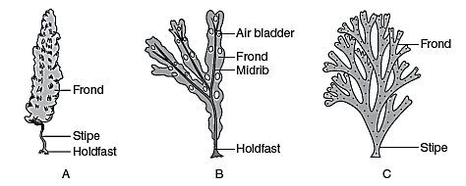

(a) A–Fucus, B–Laminaria, C–Dictyota

(b) A–Laminaria, B–Dictyota, C–Fucus

(c) A–Laminaria, B–Fucus, C–Dictyota

(d) A–Dictyota, B–Fucus, C–Laminaria

1. **Identify the A, B, C and D shown in this figure?**

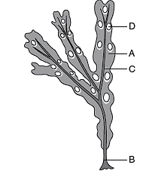

(a) A–Holdfast, B–Air bladder, C–Midrib, D–Frond

(b) A–Frond, B–Midrib, C–Air bladder, D–Holdfast

(c) A–Air bladder, B–Midrib, C–Holdfast, D–Frond

(d) A–Frond, B–Holdfast, C–Midrib, D–Air bladder

1. **What indicates A to E in the below figure?**

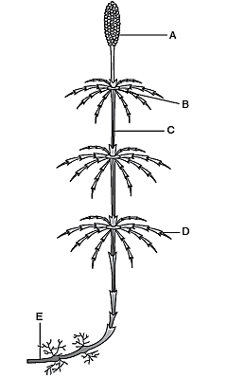

(a) A–Node, B–Rhizome, C–Internode, D–Strobilus, E–Branch

(b) A–Strobilus, B–Node, C–Internode, D–Branch, E–Rhizome

(c) A–Branch, B–Internode, C–Strobilus, D–Node, E–Rhizome

(d) A–Strobilus, B–Node, C–Branch, D–Internode, E–Rhizome

1. **Identify the A, B and C shown in this figure?**

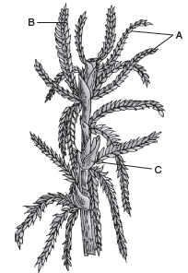

(a) A–Branches, B–Antheridial branch, C–Archaegonial branch

(b) A–Antheridial branch, B–Branches, C–Archaegonial branch

(c) A–Branches, B–Archaegonial branch, C–Antheridial branch

(d) A–Archaegonial branch, B–Archaegonial branch, C–Branches

1. Identify the A, B and C shown in this figure?

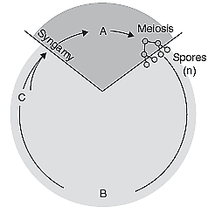

(a) A–Gametophyte (n), B–Zygote (2n), C–Gametogenesis

(b) A–Zygote (2n), B–Gametophyte (n), C–Gametogenesis

(c) A–Zygote (2n), B–Gametogenesis, C–Gametophyte (n) (d) A–Gametogenesis, B–Zygote (2n), C–Gametophyte (n)

1. **What indicates A, B and C in this figure**.

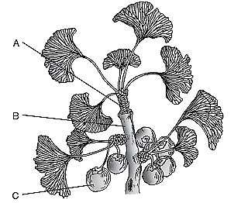

(a) A–Dwarf shoot, B–Long shoot, C–Seeds

(b) A–Long shoot, B–Seeds, C–Dwarf shoot

(c) A–Long shoot, B–Dwarf shoot, C–Seeds

(d) A–Seeds, B–Long Shoot, C–Dwarf Shoot

1. **Bryophytes are not characterised by -**

(a) vascular tissue

(b) Rhizoids

(c) Alternation of generation

(d) Presence of chlorophyll

1. **Bryophytes show -**

(a) Asexual reproduction and zygotic meiosis immediately

(b)Asexual reproduction and sporic meiosis

(c) No asexual reproduction but sporic meiosis

(d) Gametophytic dominance and sporic meiosis

1. **Gemmae are·multicellular green structures for vegetative propagation. These are found in gemma cups in -**

(a) Riccia thallus (b) Marchantia thallus

(c) Funaria protonema (d) Fern prothallus

1. **A true moss is that -**

(a) Which has leafy, radially symmetrical body and grows in tufts. Plant body has an axis with spirally arranger leaves

(b) Which has a protonema stage and multicellular rhizoids with oblique septa

(c) Both a and b

(d) Which has vascular tissues

1. **Funaria requires water because -**

(a) fertilisation occurs in water only

(c) plants dry up and die without water

(b) Funaria is a hydrophyte

(d) no branching and sex organs cannot develop without water

1. **Sphagnum is also called peat moss because -**

(a) It grows in acidic marshes (bog) and helps in peat formation

(b) It is found in peat

(b) it decays to form peat

(d) it fossilized quickly

1. **Which one is correct about Marchantia (Liverwort)?**

(a) Plant body is monoecious or dioecious

(b) Sporophyte is differentiated into foot, seta and capsule

(c) Spore germinates to produce thallus

(d)All

1. **Which one is not a true moss -**

(a) Nest moss (b) Funaria

(c) Sphagnum (d) Polytrichum

1. **Asexual reproduction in liverworts takes place by**-

(a) Fragmentation of thalli + gemmae formation

(b) Gemmae formation+ Diploid spores formation

(c) Spores formation+ isogamy

(d) Fragmentation+ zoospores formation

1. **In mosses gametophyte has 2 stages. What are these stages?**

(a) 1st stage is protonema and the second stage is leafy stage

(b) 1st stage is sporogonium phase and 2nd protonema stage

(c) 1st stage is gemmae formation and 2nd one is meiosis (d) 1st stage is zygote and 2nd one is Spore mother cell

1. **Protonema-**

(a) Is a stage of gametophytic generation

(b) Is a creeping, green, branched stages and developes indirectly from a spore

(c) Produces lateral bud which forms leafy plant body

(d)All

1. **In mosses asexual reproduction occurs by-**

(a) fragmentation and budding in the secondary protonema

(b) Gemmae and adventious bud formation

(c) Gemmae and tubers formation

(d) By multiflagellate spores formation

1. **The sporophyte in mosses is -**

(a) Less elaborated than that in liverworts

(b) More elaborated than that in liverworts

(c) Equally elaborated than that in liverworts

(d) Independent of gametophyte

1. **Spores dispersal in mosses occurs by –**

(a) simple mechanism (b) elaters

(c) elaterophores (d) elaborate mechanism

1. **In bryophytes meiosis occurs in -**

(a) Spores

(b) Gametes mother cells

(c) Gametes

(d) Spore mother cells in capsule */* sporophyte */* sporogonium

1. **Multicellular sporophytic phase is expected in the life cycle of -**

(a)Euglenoids (b) Green algae

(c) Diatoms (d) Bryophyta

1. **You are given an unknown plants to study in the laboratory. You find that it has chlorophyll, no xylem. Its multicellular sex organs are enclosed in a layer of jacket cells. Its gametophyte stage is free living. The plant probably belongs to**

(a)Chlorophyceae (b) Bryophyte

(c) Pteridophyte (d) Gymnosperm

1. **Place the following groups of plants in order, beginning with those that first appeared on the earth and progressing toward those that appeared most recently in time -**

(a) Gymnosperms, angiosperms, ferns, moss, algae

(b)Algae, moss, ferns, gymnosperms, angiosperms

(c) Moss, algae, ferns, angiosperms, gymnosperms

(d) Algae ferns, angiosperms, gymnosperms, Moss

1. **A moss sperm moves by means of**

(a) Cilia. (b) 3 flagella

(c) flagella (d) Many flagella

1. **The embryonic development in bryophyte takes place in the**

(a) Protonema (b) Sporangium

(c)Antheridium (d) Archegonium

1. **Natural system of classification was based upon**

(a) structural embryology (b) phytochemistry

(c) anatomy (d) All of these

1. **Phylogenetic system of classification is based upon**

(a) evolutionary relationship of organisms

(b) cytological information

(c) structural embryology

(d) All of the above

1. **Which one is correct about heterosporous pteridophytes?**

(a) microspore and megaspores develop into the male and the female gametophytes respectively

(b) The female gametophyte are retained on the parent sporophyte for variable period

(c) The development of the zygote into the embryo takes place within female gametophyte

(d) All

1. **Which of the following group does not have free living gametophyte -**

(a) Bryophytes only

(b) Pteridophytes only

(c) Gymnosperms only · (d) Gymnosperms+ Angiosperms

1. **Seed plants are all -**

(a) Heterosporous (b) Dioecious

(c) Monoecious (d) Homosporous

1. **Why are gymnosperms referred to as "naked seed plants"?**

(a) They lack ovule

(b) They lack ovaries

(c) They have no seed coat

(d) The embryo is unprotected

1. **The product(s) of fertilization in gymnosperms is *I* are arid in angiosperms is *I* are ____ _**

(a) Endosperm, embryo and endosperm

(b) Embryo, endosperm and embryo

(c) Embryo, embryo

(d) Embryo, endosperm

1. **In gymnosperms ovule -**

(a) Is not enclosed before fertilization but enclosed after fertilization

(b) Remains enclosed before fertilization only

(c) Is not enclosed by any ovary wall and remains exposed, both before and after fertilization

(d) Is never formed

1. **Gymnosperms include -**

(a) Medium sized trees (b) Tall tree

(c) Shrubs (d)All

1. **Which is the tallest gymnospermy plant?**

(a) Sequoia (b) Pinus

(c) Ginkgo (d) Cycas

1. **In gymnosperms roots are generally -**

(a) Fibrous root (b)Adventitious root

(c) Tap root (d) Prop root

1. **In which of the following gymnosperms corolloid root having N-fixing cyanobacteria (Nostoc) is found-**

(a) Pinus (b) Ginkgo

(c) Cycas (d) Cedrus

1. **Mycorrhizal root (having symbiotic fungi) is found -**

(a) Pinus (b) Ginkgo

(c) Cycas (d) None

1. **Which one is not the characteristic of Cycas?**

(a) Unbranched stem

(b) Compound leaves (pinnate)

(c) Dioecious (male and female cone on separate plants)

(d) Archegonia is absent

1. **Branched stem is found in -**

(a) Cycas + Pinus (b) Cycas + Cedrus

(c) Pinus (d) Cycas only

1. **The leaves of gymnosperms are well-adapted to withstand extremes of temperature, humidity and wind . In conifers what are the xerophytic characters? ·**

(a) Needle like leaves (b) Thick cuticle

(c) Sunken stomata (d)All

1. **All are archegoniate except -**

(a) Angiosperms (b) Bryophytes

(c) Pteridophytes (d) Gymnosperms

1. **Which one is conifer?**

(a) Gnetum (b) Cyca

(c) Pinus (d)All

1. **Which one is correct about Pinus?**

(a) Monoecious- Male (microsporangiate) and female (megasporangiate) cones are produced on same plant

(b) Monoecious- Male and female sporophylls born on same strobilus

(c) Dioecious - Male and female cones are produced on different plants

(d) Monoecious - Micro and megasporocarp develop on same plant

1. **Megasporangium (Nucellus) is-**

(a)Anther (b) Ovary

(c) Ovule (d) Megaspore mother cell

1. **Mosses and ferns are found in moist and shady places because both**

(a) require the presence of water for fertilization

(b) do not need sunlight for photosynthesis

(c) depend for their nutrition on microorganisms, which can survive only at low temperature

(d) cannot compete with sun-loving plants

1. **Prothallus of the fern produces**

(a) spores (b) gametes

(c) Both (a) and (b) (d) cones

1. **Which of the following are homosporous?**

(a) Salvinia, Equisetum (b) Salvinia, Lycopodium

(c) Selaginella, Salvinia (d) Lycopodium, Equisetum

1. **Go through the following figures and identify these plants (A, B and C).**

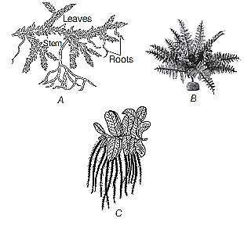

(a) A–Equisetum, B–Selaginella, C–Fern

(b) A–Selaginella, B–Fern, C–Salvinia

(c) A–Fern, B–Salvinia, C–Equisetum

(d) A–Salvinia, B–Equisetum, C–Fern

1. **Two very distinct generations are found in the life cycle of**

(a) bacteria (b) Spirogyra

(c) Volvox (d) ferns

1. **The nucellus is protected by envelopes (integument) and this composite structure is called -**

(a)Antheridium (b) Ovule

(c) Ovary (d) Megaspore mother cell

1. **Megaspore mother cell undergoes ____ division to form megaspore-**

(a) Mitotic (b) Meiosis

(c) Amitotic (d) Dinomitotic

1. **Megaspore develops into multicellular structure called -**

(a) Male gametophyte (b) Female gamete

(c) Female gametophyte (d) Megaspore mother cell

1. **In gymnosperms, the female gametophyte is retained within -**

(a) Ovary (b) Microsporangiate cone

(c) Archegonia (d) Megasporangium or ovule

1. **Pollen grain is** -

(a) Female gamete (b) Microspore

(c) Megaspore (d) Male cone

1. **The development of pollen grains occurs within -**

(a) Ovary (b) Ovule

(c) Megasporangium (d) Microsporangium

1. **Which one is correct about male and female gametophyte?**

(a) In bryophytes and pteridophytes they have independent free-living existence

(b) Both a and b

(c) In gymnosperms and angiosperms they have no independent free-living existence

(d) In bryophytes, pteridophytes and angiosperms they have free-living life. They remain in sporangia which are

retained on sporophytes

1. **Where are the female sex organs */* archegonia (2 or more in number) found in -**

(a) Microgametophyte (b) Megagametophyte

(c) Microsporangium (d)Antheridia

1. **In gymnosperms male gametophyte -**

(a) Is highly developed

(b) Has an independent life

(c) Is highly reduced and confined to only a limited number of cells

(d) Is produced in macrosporangiate cone

1. **In gymnosperms pollination takes place by-**

(a) Wind (b) Water

(c) insects (d)Animals

1. **In gymnospermic plants, during pollination pollen grains are transferred to-**

(a) Stigma (b) On archegonia

(c) On ovary (d) Micropyle end of ovule

1. **Resin and turpentine are obtained from -**

(a) Teak (b) Eucalyptus

(c) Oak (d) Pine

1. **Chilgoza used as fruit is obtained from -**

(a) Pinus gerarcdiana (b) Cycas

(c) Gnetum (d)Angiosperm

1. **Sago is obtained from -**

(a) Cycas (b) Pinus

(c) Cedrus (d) Gnetum

1. **Red wood of china is obtained from -**

(a) Cycas revoluta (b) Pinus longifolia

(c) Gnetum (d) Cedrus

1. **Source of Canada balsam (a mounting agent to make permanent slide) is obtained from -**

(a) Abies (b) Pinus

(c) Cedrus (d)Angiosperm

1. **Ephedrine obtained from the stem of Ephedra is given to cure -**

(a) Asthma (b) Respiratory disorder

(c) Cold and cough (d) All of the above

1. **Cedar wood oil is obtained from** -

(a) Pinus (b) Ginkgo

(c) Juniperus (d) Cycas

1. **Which one is the source of wood -**

(a) Pinus roxburghii (P. longifolia / chirpine)

(b) Cedrus

(c) Abies, Sequoia

(d)All

1. **Which one forms coal?**

(a) Fern+ Cycas

(b) Fern+ Cycadofilicales or pteridospermales

(c) Ginkgo+ Cedrus

(d) Cycas + Pinus

1. **In gymnosperms, the pollen chamber represents**

(a) a cell in the pollen grain in which the sperms are formed

(b) a cavity in the ovule in which pollen grains are stored after pollination

(c) an opening in the megagametophyte through which the pollen tube approaches the egg

(d) the microsporangium in which pollen grains develop

1. **In *Pinus*, male cone bears a large number of**

(a) ligules (b) anthers

(c) microsporophylls (d) megasporophylls

1. **In gymnosperms, the multicellular female gametophyte is retained within**

(a) microsporangium (b) megasporangium

(c) male gametophyte (d) archegonia

1. **Choose the correct pattern of arrangement of reproductive structures of gymnosperms**.

(a) Spores→ Sporophylls→ Sporangia→ Strobili

(b) Spores→ Sporangia→ Sporophylls→ Strobili

(c) Sporangia→ Sporophylls→ Spores→ Strobili

(d) Spores→ Sporangia→ Strobili→ Sporophylls

1. **The correct sequence of the ploidy in moss protonemal cell, primary endosperm nucleus in dicots, leaf cell of a moss, prothallus cell of a fern, gemma cell in Marchantia, meristematic cell of monocot, ovum of liverwort, and zygote of fern-**

(a) N, 3N, N, N, N, 2N, N, 2N

(b) 3N, 2N, N, N, N, 2N, N, N

(c) 2N, 3N, 2N, N, N, N, N, N

(d)N, 3N, N, N, N,N, 2N, 2N

1. **Examine the figures A, B, C and D. In which one of the four options all the items, A, B, C and Dare correct?**

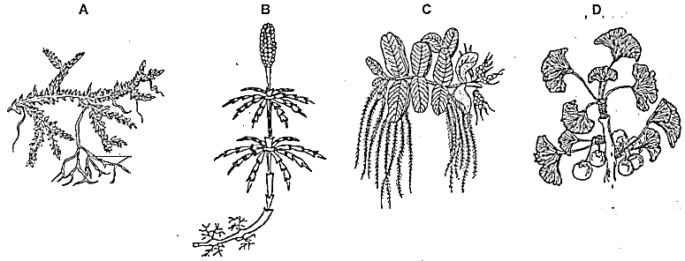

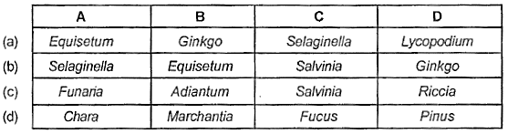

1. **Phylogeny and inter-relationship found between taxa on the basis of number, type and arrangement of chromosomes is-**

(a) Cytotaxonomy (b) Chromotaxonomy

(c) Karyotaxonomy (d) Chemotaxonomy

1. **Cytotaxonomy is connected with -**

(a) Chemical composition of cytoplasm

(b) Cell organelles

(c) Cytochromes

(d) Shape and size of cells

1. **Natural system of classification is based on -**

(a) Ontogeny (b) Phylogeny

(c) Morphology (d) Morphology and affinities

1. **A system of classification in which a large number of traits are considered is -**

(a) Artificial system (b) Phylogenetic system

(c) Synthetic system (d) Natural system.

1. **In artificial system, the organisms are classified on the basis of -**

(a) All the possible characters

(b) Phylogenetic trends

(c)A few characters

(d) Anatomical, cytological and biochemical traits along with morphological traits

1. **Natural system of classification differs from artificial system in**

(a) Employing only one floral trait

(b) Taking only one vegetative trait

(c) Bringing out similarities and dissimilarities

(d) Developing evolutionary trends

1. **Plant classification proposed by Carolus Linnaeus was artificial because it was based on -**

(a) Only a few morphological characters

(b) Evolutionary tendencies which are diverse

(c)Anatomical characters which are adaptive in nature

(d) Physiological traits along with morphological characters

1. **Phylogenetic system brings out -**

(a) Reproductive similarities

(b) Grouping according to morphological characters

(c) Grouping on the basis of increasing complexities

(d) Grouping according to evolutionary trends and genetic relationships

1. **System of classification used by Linnaeus was -**

(a) Natural system (b) Artificial system

(c) Phylogenetic system (d}Asexual system

1. **Phylogenetic system of classification was proposed by -**

(a) Hutchinson */* Engler and Prantl

(b) Bentham and Hooker

(c) Linnaeus

(d) Santapau

1. **Kary taxonomy is based on** -

(a) Trinomial nomenclature

(b) Organic evolution

(c) Bands formed on chromosomes

(d) Number of chromosomes

1. **Chemotaxonomy is connected with** -

(a) Classification of chemicals found in plants

(b) Use of phytochemical data in systematic botany.

(c) Application of chemicals on herbarium sheets

(d) Use of statistical methods in chemical yielding plants

1. **Phenetic classification is based on -**

(a) Ancestral lineage of existing organisms

(b) Observable characteristics of existing organisms

(c) Dendrograms based on DNA characteristics

(d) Sexual characteristics

1. **Natural system of classification was proposed by -**

(a) Bentham and Hooker (b) Hutchinson

(c) Whittaker (d) Engler and Prantl

1. **Phylogenetic system of classification is based on -**

(a) Morphological features

(b) Chemical constituents

(c) Evolutionary relationships

(d) Floral characters

1. **System of classification that employs numerical data to evaluate similarities and differences is known as -**

(a) Cytotaxonomy (b) Biosystematics

(c) Phenetics (d) Chemotaxonomy

1. **Classification based on a few morphological characters is -**

(a) Artificial (b) Natural

(c) Phylogenetic (d) Both band c

1. **Which of the following correctly represents the type of life cycle patterns from the options given?**

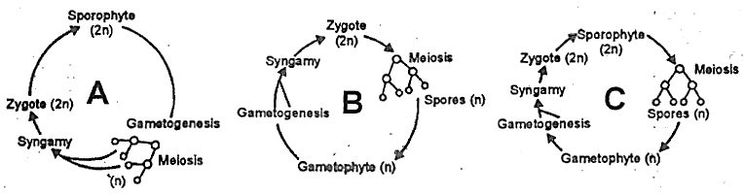

(a) A- Diplontic, B - Haplodiplontic, C - Haplontic

(b) A- Haplodiplontic, B - Haplontic, C - Diplontic

(c)A- Haplontic, B - Diplontic, C- Haplodiplontic

(d)A- Diplontic, B - Haplontic, C- Haplodiplontic

1. **Angiosperms are also called**

(a) seedless plants (b) fruitless plants

(c) flowering plants (d) All of these

1. **Stamen consists of**

(a) filament and anther (b) style and stigma

(c) filament and pistil (d) anther and pistil

1. **Transfer of pollen grain from anther to the stigma of ovary is called**

(a) autogamy (b) pollination

(c) syngamy (d) allogamy

1. **In the angiosperm ovule, central cell of the embryo sac prior to the triple fusion, contains**

(a) a single haploid nucleus

(b) one diploid nucleus

(c) two haploid polar nuclei

(d) one diploid and one haploid nuclei

1. **Male gametophyte with least number of cells is present in**

(a) Pteris (b) Funaria

(c) Lilium (d) Pinus

1. **Match the following -**

**Column I Column II**

**A. Haplontic life cycle I. Bryophytes, Pteridophytes, Ectocarpus, Polysiphonia, kelps.**

**B. Diplontic life cycle II. Seed bearing plants (Gymnosperm and Angiosperm), Fucus.**

**C. Haplo-diplontic life cycle Ill: Many algae (Volvox, Spirogyra, and some species of Chlamydomonas).**

(a)A-lll,B-11,C-I (b)A-l, B-ll,C-111

(c)A-ll, B-l,C-111 (d)A-111,B-l, C-ll

1. **The major difference between the mosses and ferns is:**

(a) Ferns lack alternation· of generation while mosses show the same.

(b) Mosses are facultative aerobes while ferns are obligate aerobes.

(c) Vascular bundles of ferns show xylem vessels while those of mosses lack it.

(d) Sporophytes of ferns live much longer as compared to the sporophytes of mosses

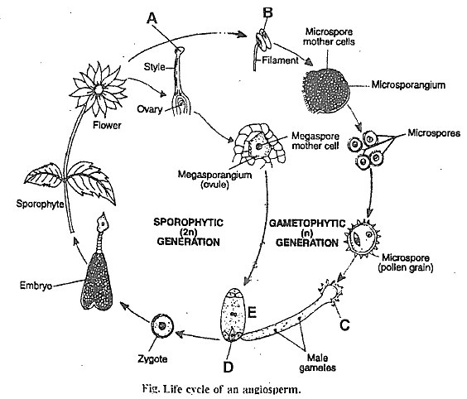

A, B, C, D and E are respectively-

(a) Stigma, Anther, Male gametophyte, Egg and Female gametophyte .

(b) Stigma, Anther, Female gametophyte, Egg and Male gametophyte

(c) Stigma, Anther, Male gametophyte, Fertilized egg and Female gametophyte

(d) Stigma, Anther, Embryo sac, Egg and Female gametophyte

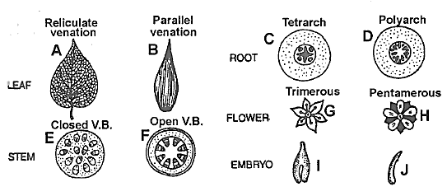

**Dicot and Monocot characters are respectively -**

(a) A, *c* F, H, I; and B, D, E, G, J

(b) A, D, F, H, I; and B, C, E, G, J

(c) A, C, E, G, I; and B, D, F, H, J

(d) B, C, F, H, I; and A, D, E, G, J

1. **Archegoniophore is present in**

(a) Funaria (b) Marchantia

(c) Chara (d) Adiantum

1. **Compared with the gametophytes of the bryophytes the gametophytes of vascular plants tend to be**

(a) Smaller and to have smaller sex organs

(b) Larger but to have smaller sex organs

(b) Smaller but to have larger sex organs

(d) Larger and to haver larger sex organs

1. **The gametophyte is not an independent, free-living generation in**

(a) Pinus (b) Polytrichum

(c) Adiantum (d) Marchantia

1. **Which one of the following is wrongly matched?**

(a) Cassia- lmbricate aestivation

(b) Root pressure - Guttation

(c) Puccinia - Smut

(d) Root- Exarch protoxylem

1. **Selaginella and Salvinia are considered to represent a significant step toward evolution of seed habit because**

(a) Megaspores possess endosperm and embryo surrounded by seed coat

(b) Embryo develops in female gametophyte which is retained on parent sporophyte

(c) Female gametophyte is free and gets dispersed like seeds

(d) Female gametophyte lacks archegonia

1. **Among the following, which structure is not functionally similar to others ?**

(a) antheridium (b) archegonium

(c) oogonium (d) ovum

1. **Consider the following four statements whether they are correct or wrong :**

**(A) The sporophyte in liverworts is more elaborate than that in mosses**

**(B) Salvinia is heterosporous**

**(C) The life-cycle in all seed-bearing plants is diplontic**

**(D) In Pinus male and female cones are born on different trees**

**The two wrong statements together are**

(a) Statements (A) and (C)

(b) Statements (A) and (D)

(c) Statements (B) and (C)

(d) Statements (A) and (B)

1. **In angiosperms, functional megaspore develops into:**

(a) Embryo sac (b) Ovule

(c) Endosperm (d) Pollen sac

1. **The presence of multicellular sex organs, embryonic development, the dominating gametophytic phase, the need for water during sexual reproduction, and the lack of genuine roots, stems, and leaves are some notable characteristics of this plant.**

(a) Bryophytes (b) Pteridophytes

(c)Angiosperms (d) Gymnosperms

1. **Identify odd one w. r. t ploidy level**

(a) Leaf cell of a dicot

(b) Ovum of a liverwort

(c) Zygote of a fern

(d) Meristem cell of monocot

1. **Heterospory is found in some members of ___ and all members of ___ _**

(a) Bryophyta, Pteridophyta

(b) Pteridophyta, Bryophyta

(c) Bryophyta, Gymnospermae

(d) Pteridophyta, Spermatophyta

1. **In gymnosperms, microspore develops into a male gametophytic generation which is highly reduced and is confined to only a limited number of cells. This reduced gametophyte is known as**

(a) Pollen grain (b) Endosperm

(c) Prothallus (d) Embryo sac

1. **Gemmae are the specialised structures produced in liverworts. These are**

(a) Non-green, multicellular, asexual buds develop in gemma cups

(b) Green, multicellular; asexual buds develop in gemma cups

(c) Non-green, multicellular, diploid, sexual spores

(d) Green, unicellular, diploid, sexual spores

1. **Horsetails and ferns**

(a) Lack archegonia

(b) Possess vascular tissues in main plant body

(c) Show diplontic type of life cycle

(d) Do not produce motile male gametes

1. **Haplo-diplontic life cycle is followed by**

(a) bryophytes and pteridophytes

(b) algae and bryophytes

(c) angiosperms and gymnosperms

(d) None of these

1. **Life cycle of Ectocarpus and Fucus, respectively are**

(a) haplontic, diplontic

(b) diplontic, haplo-diplontic

(c) haplo-diplontic, diplontic

(d) haplo-diplontic, haplontic

1. **Which of the following statement for conifers is correct?**

(a) Presence of sunken stomata

(b)Absence of needle shaped leaves

(b) Presence of thick cuticle

(d) More than one option is correct

1. **In which of the following pair of plants the male and female gametophytes do not have an independent free living existence?**

(a) Cycas, Pinus (b) Marchantia, Cycas

(c) Salvinia, Funaria (d) Sphagnum, Dryopteris

1. **A. Gymnosperms are heterosporous.**

**B. Bryophytes have well developed vessels and sieve tubes.**

**C. Strobilus is found in the main plant body of Equisetum.**

**D. Antheridia are absent but archegonia are present in bryophytes.**

(a) All are correct (b) A and C are correct

(c) Only A is correct (d) B and C are correct

1. **In the life cycle of *Funaria* first stage of the gametophyte**

(a) Bears sex organs

(b) Is branched and frequently filamentous

(c) Possesses spirally arranged leaves

(d) Develops directly from zygote

1. **Consider the following statements -**

**A. Sea Weeds include phaeophyceae and rhodophyceae.**

**B. Red algae differs from green and brown algae in not having any flagellate stage.**

**C. Bryophytes absorb most of their water through above-ground structures.**

**D. Bryophytes seldom reach a height of more than 20 cm because they lacks vascular system, roots and mechanical**

**tissues.**

**E. The gametophyte in the life cycle of a fern is independent and autotrophic.**

**the above statements**

(a) A and B are correct (b) B and C are correct

(c) C and D are correct (d)All are correct.

1. **Each character is given equal importance and at the same time hundred of characters can be considered in**

(a) Cytotaxonomy (b) Morphotaxonomy

(c) Chemotaxonomy (d) Numerical taxonomy

1. **Which one of the following pairs is wrongly matched?**

(a) Ginkgo -Archegonia (b) Salvinia - Prothallus

(c) Viroids – RNA (d) Mustard - Synergids

1. **Cycas and Adiantum resemble each other in having:**

(a) Seeds (b) Motile Sperms

(c) Cambium (d) Vessels

1. **Which one of the following is common to multicellular fungi, filamentous algae and protonema of mosses**

(a) Diplontic life cycle

(b) Members of kingdom plantae

(c) Mode of Nutrition

(d) Multiplication by fragmentation

1. **Gymnosperms are characterized by the**

(a) absence of seeds

(b) presence of flowers

(c) presence of seeds in cones

(d) absence of vascular tissues

1. **Which one of the follwing is a correct statement**

(a) In Pteridophyte gametophyte has a protonemal and leafy stage

(b) In gymnosperms female gametophyte is free-living

(c) Antheridiophores and archegoniophores are present in pteridophytes.

(d) Origin of seed habit can be traced in pteridophytes

1. **Go through the statements-**

**A. Oogamous sexual reproduction involves fusion of motile and non motile gametes.**

**B. A bryophyte of considerable economic importance is Sphagnum.**

**C. In Selaginella sporophyte is dominant.**

**D. The term prothallus is used for reduced gametophyte**

**E. Iodine can be obtained from Porphyra.**

**Which of the above statement is correct?**

(a) A, B, E only (b) B, C, E only

(c) A, D, E only (d) A, B, C, D only

1. **Which one of the following is a correct statement?**

(a) Fronds are found in Bryophytes.

(b) Heterocysts are found in Nostoc

(c) Diatoms produce basidiospores.

(d) Multiciliaated sperms are found in Angiosperms

1. **In the prothallus of a vascular cryptogam , the antherozoids and eggs mature at different times. As a result:**

(a) There is high degree of sterility

(b) There is no change in success rate of fertilization

(c) Self fertilization is prevented

(d) One can conclude that the plant is apomictic

1. **Winged pollen grains are present in**

(a) Mango (b) Cycas

(c) Mustard (d) Pinus

1. **In which of the following, all listed genera belong to the same class of algae**

(a) Porphyra, Ectocarpus, Ulothrix

(b) Volvox, Spirogyra, Chlamydomonas

(c) Chara, Fucus, Polysiphonia

(d) Sargassum, Laminaria, Gracillaria

1. **In a moss the sporophyte**

(a) Arises from a spore produced from the gametophyte

(b) is partially parasitic on the gametophyte

(c) produces gametes that give rise to the gametophyte

(d) Manufactures food for itself, as well as for the gametophyte