Laquon Hamilton

ITS-462

Midterm Exam

Screenshots

XML and XSD

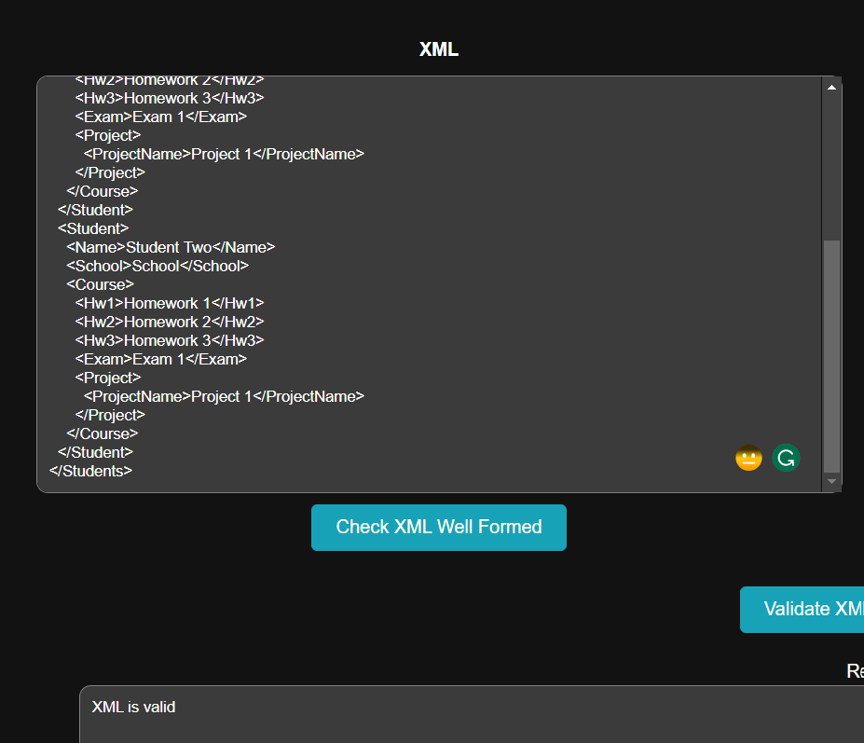

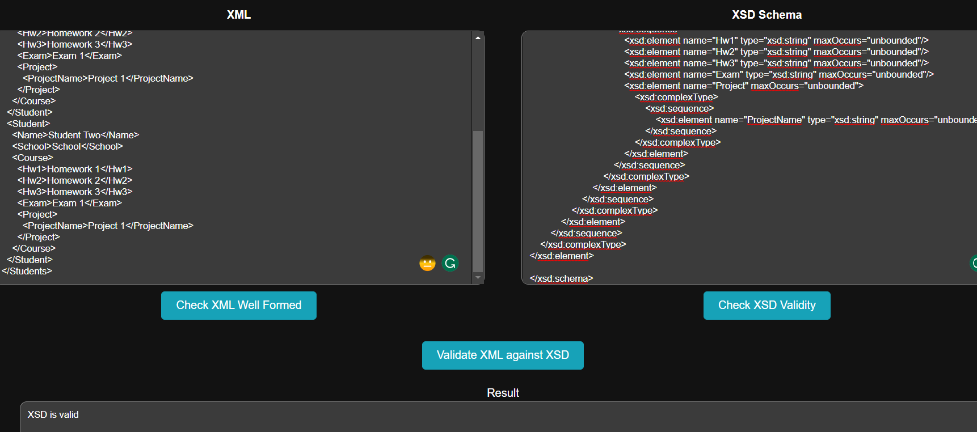

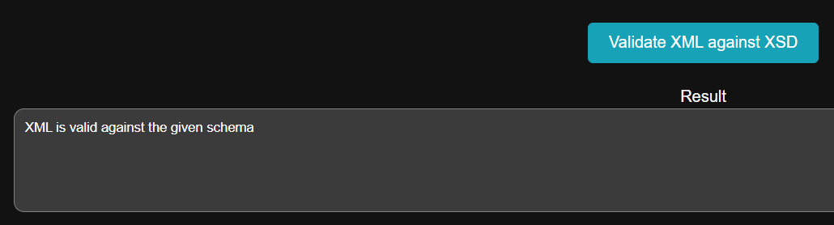

XSLT

