Laquon Hamilton

ITS-462

Lab 6

1. Create an app that contains a ListView that you want to add and delete rows. Setup the

structure of the app using an MVVM approach where the data model, view, ad binding code is

in separate classes.

2. Create another app as above except where you can edit the ListView items.

3. Modify the application from the test to use tabbed trip information where flight expenses, car

rental, hotel expenses, meal expenses, and other expenses are on separate tabs. Put all the

views (controls) for each category on different tabs.

4. Propose your idea for an app for the final project and, if possible, your team member

* A Bank Account Details app. I will most likely work by myself

Screenshots

1.

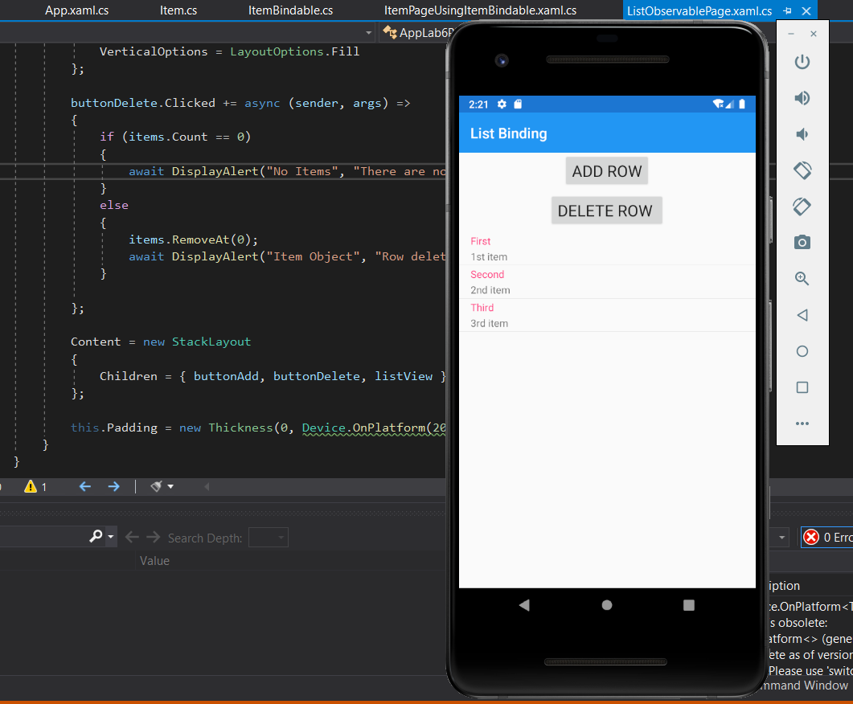

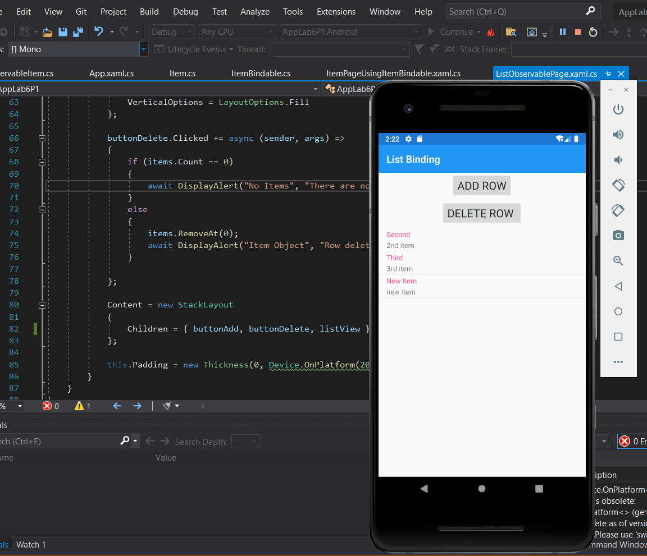

2.

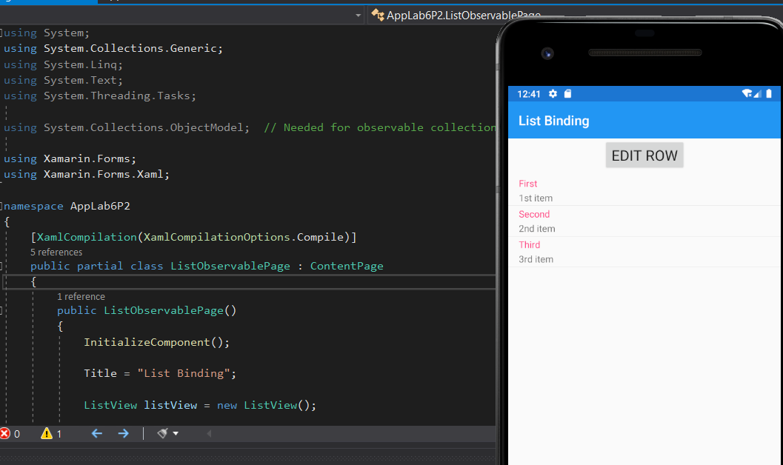

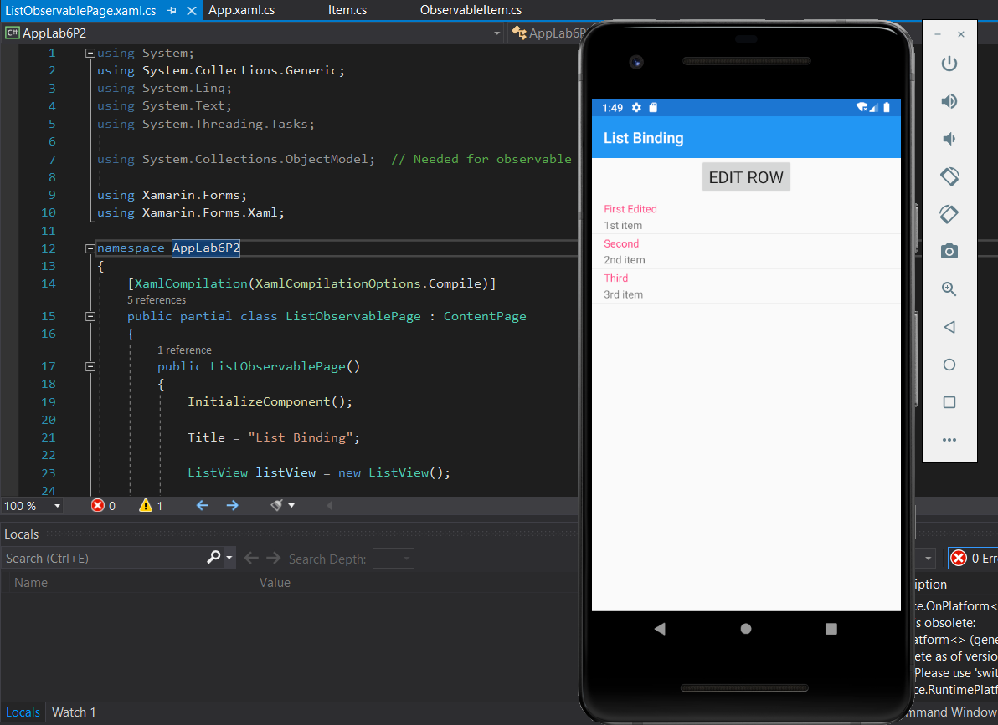

3.

