Laquon Hamilton

ITS-440

Lab 1 / HW 1

1. Install Visual Studio 2017 with Xamarin. Test to make sure it runs and that an emulator starts and is able to display a label.

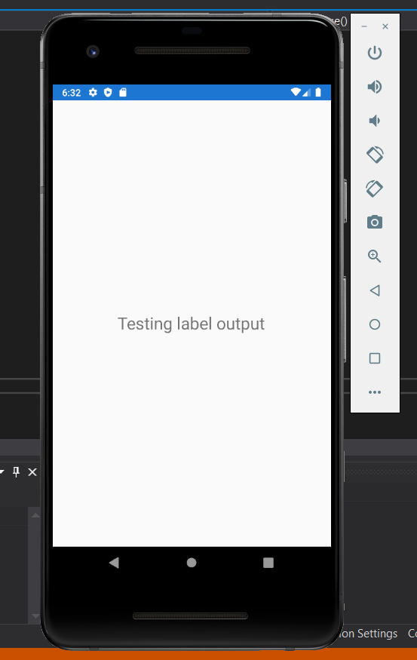

2. Create an app which recreates the app on pages 42 and 43 of the book. Display it on the emulator. Take a pic of your computer screen with the IDE in the background and the emulator showing the app.

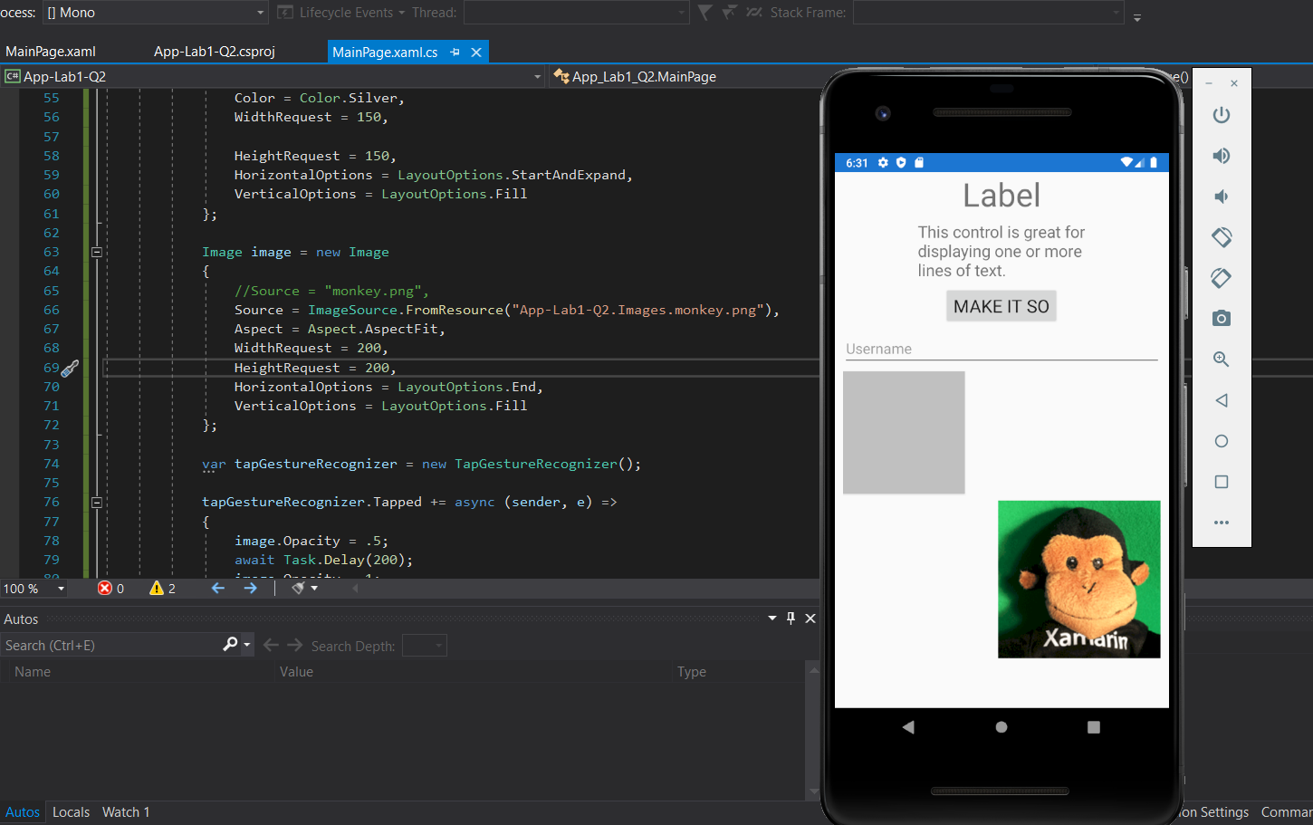

3. Build an app to enter a user’s contact information that contains entry fields for firstname, lastname, phone number, email, and address. Pick a background color (other than the default) or an image displayed in the app background. Display an image (pick any free image) to display as a banner across the top of the app. Create a button named “Save” that when clicked displays a message “Data has been saved” and clears out the text boxes.

