Laquon Hamilton

ITS-462

Lab 3

1) Define an XML Schema for the XML document you created in Lab 01.

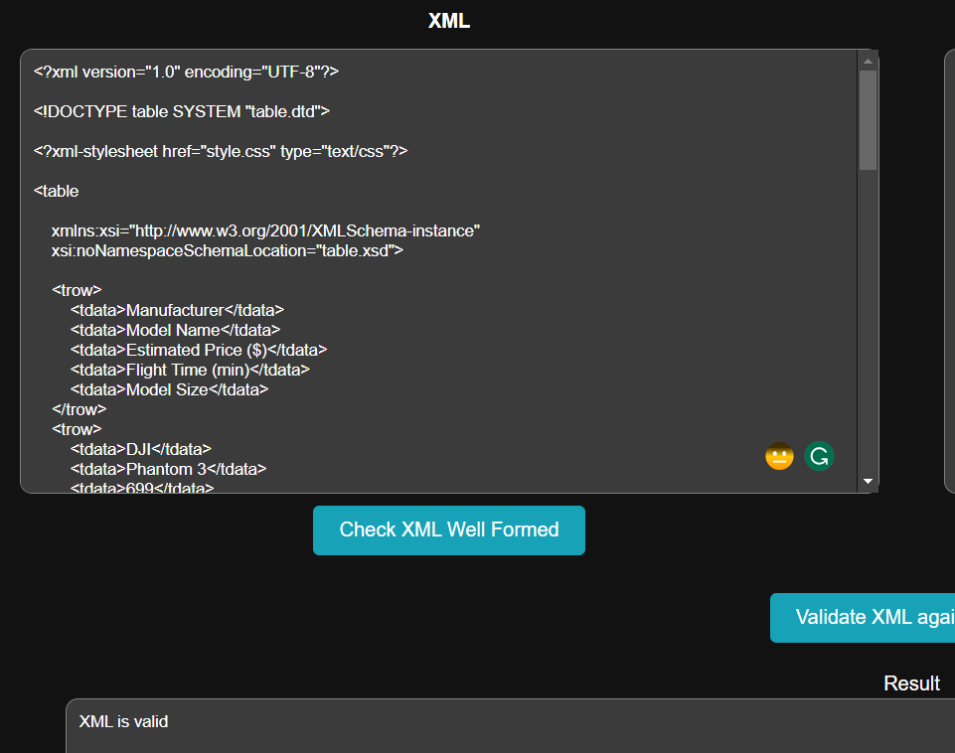

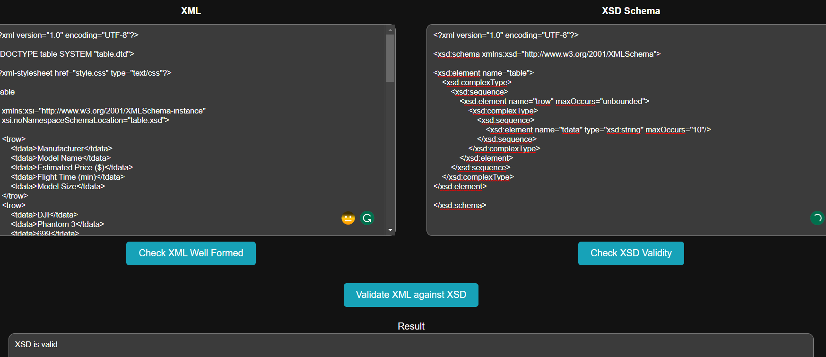

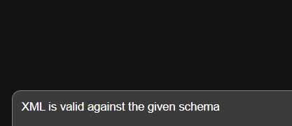

2) Create a C# application that validates the programming language document using XML Schema created in the previous step.

