Laquon Hamilton

ITS-440

Lab 2

1) Build an app that scales properly to different screen sizes (use the appropriate layout to

accomplish this). Take the app designed in HW1 and adapt it for auto scaling. Test it on an

Android emulator (or Android hardware connected to your computer) and Universal Windows

Platform.

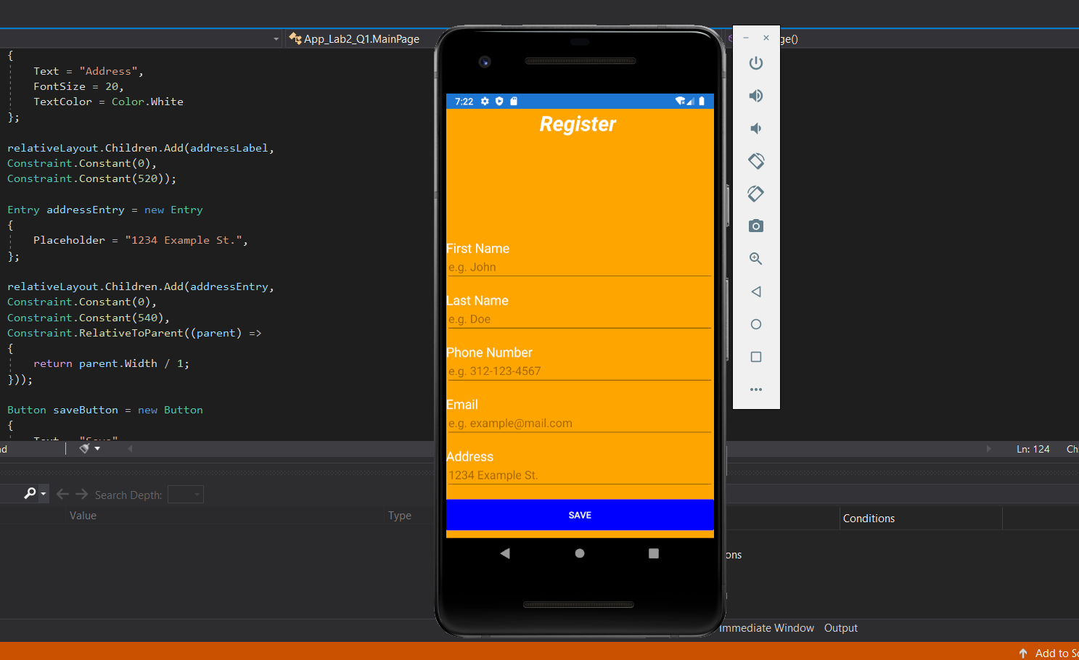

2) Build an app that uses a Grid Layout. Take the app designed in HW1 and implement the views into a grid layout. It is up to your design discretion to decide which controls to place into which grid cells. Provide padding between rows and columns in the grid (you choose how much

padding). Test it on one target platform.

