Laquon Hamilton

ITS-462

Lab 9

1. Create a drone Restful Web service which supports retrieval of drone data using different criteria. You can modify the previous lab 8 implementation to comply with using a Restful implementation of the server and client. The service will have a Restful client which consumes WCF services.

You should use the drone database created in the previous lab as the backend data store. Please use implement the back-end database in MySQL. The Web service should support the following methods:

getManufacturerList()

getModelSizeList()

getDrones()

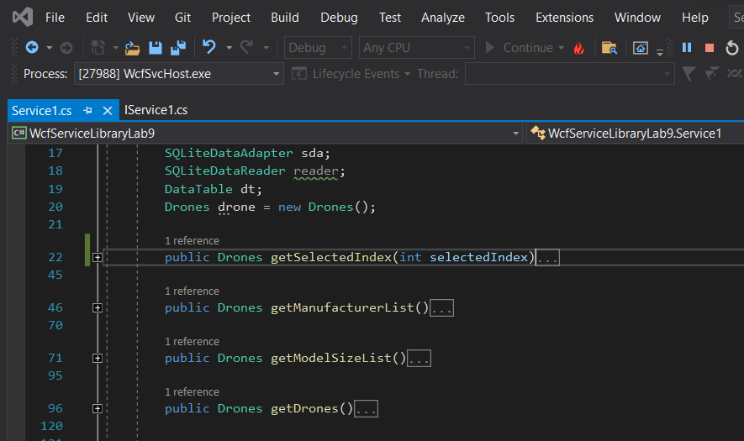

2. Create a client application (a Windows Form application or web client) that consumes the Restful drone Web service created in step 1. The UI of the application may look like the following.

