webstore = Entire framework
Project Specific Files: Files specified in lab/project homework (Controllers, Views, Model)

To run the webserver: put the webstore folder in htdocs and travel to the folder directory in command prompt
C:\xampp\htdocs\webstore> php spark serve
php spark serve starts the webserver

In a browser, go to:
localhost:8080/login for the site to display

For user views:
testuser@mail.com
testpass

For admin views:
admin@mail.com
adminpass

***If it gives an error, go to xampp and add this “extension=intl” into the Apache config file php.ini for the webserver to start.

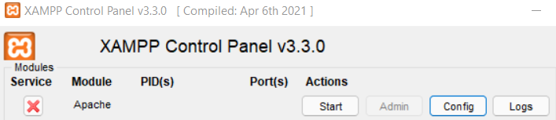
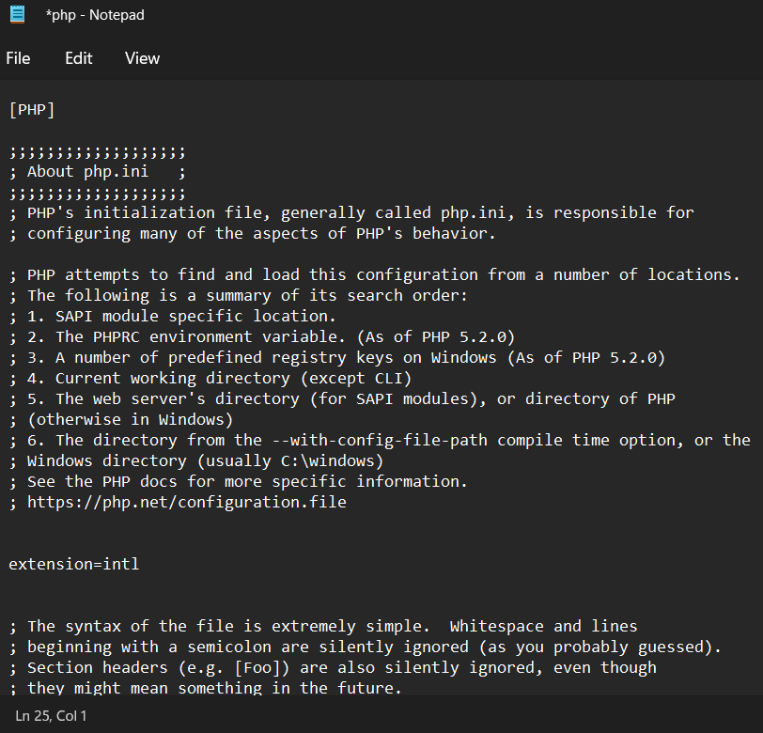

Then run the php spark serve command again. Your antivirus may give a warning about a “rewrite.php” that is part of the framework, it is harmless but if you want to look at it, it is in webstore > System > Commands > Server > rewrite.php

In a browser, go to:
localhost:8080/login for the site to display

I also provided the database for phpMyAdmin so you don’t have to configure database settings, but if you want to the file is located in webstore > app > Config > Database.php

Also the session may expire after awhile (1 hour?) and trying to access the pages afterwards will lead to something like localhost/webstore/index.php/login.php giving a page not found error. Simply log in again by going to localhost:8080/login

