Measurement Convention Dependence of Group Delay in Resonant Media: A Simulation Study of Interaction-History Effects
Dustin B. McClain
Independent Research | April 2026
Preprint — submitted in response to Angulo et al., arXiv:2409.03680 [quant-ph]

Abstract
Angulo et al. (arXiv:2409.03680) report experimental evidence that the mean atomic excitation time of a transmitted photon equals the group delay of the light, even when that quantity is negative. Their result is taken to confirm a theoretical equivalence derived using quantum trajectory theory and the weak-value formalism. We present a complementary simulation study demonstrating that this equivalence depends critically on the choice of measurement convention used to define both quantities. Using a Lorentzian resonant medium model with an explicit interaction-history (memory) term, we show that three standard methods for measuring group delay — phase derivative, intensity centroid shift, and peak shift — yield systematically different values across all detuning regimes, with mean disagreement of approximately 10% and sign reversal near resonance. We show that introducing even a minimal interaction-history term produces systematic, bounded divergence between standard delay measures, while preserving their overall coupling. We further demonstrate that this divergence scales predictably with the strength of interaction history accumulated by the medium. This work presents a minimal phenomenological model intended to probe sensitivity to interaction history, not a complete microscopic description. We propose that the observed equivalence reported by Angulo et al. is consistent with the centroid-weighted measurement convention, and may not generalize across alternative delay definitions when interaction history is non-negligible.

1. Introduction
The question of how long a photon spends as an atomic excitation during transmission through a resonant medium has attracted sustained experimental and theoretical attention. The puzzle sharpens near resonance, where the standard group delay becomes negative — apparently implying that a photon exits the medium before it enters, or equivalently that the atoms spend negative time in the excited state.
Angulo et al. address this paradox directly, using the cross-Kerr effect to measure the time-integrated atomic excitation caused by a transmitted photon across a range of pulse durations and optical depths. Their results are consistent with the theoretical prediction that this excitation time equals the group delay, including in regimes where that delay is negative. They conclude that this equivalence necessitates a reinterpretation of the physical meaning of negative group delays.
We accept their experimental result as reported. Our concern is interpretive: the group delay is not a single uniquely defined quantity. It can be operationalized at least three distinct ways — via the phase derivative of the transmission function, via the centroid shift of the transmitted intensity envelope, or via the peak shift of that envelope. These three definitions are equivalent only in the limit of a dispersion-free, memory-free medium with a sufficiently narrowband probe pulse. Near resonance, and in any medium that retains a history of prior interactions, they diverge.
We further argue that the atomic medium itself carries interaction history in the form of accumulated unresolved excitation — modeled here as an effective non-Markovian memory variable, which we denote TE for concision. This history modifies the effective detuning and coupling experienced by each subsequent interaction, creating a non-Markovian contribution to the observed delay that no single measurement convention captures completely.

2. Theoretical Background and the Measurement Problem

2.1 Three definitions of group delay
For a pulse propagating through a medium with complex transmission function H(ω), the group delay is most commonly defined via the phase derivative:

τ_phase = −dφ/dω |_(ω=ω₀)

where φ(ω) = arg[H(ω)] and ω₀ is the carrier frequency. This definition is local in frequency space and captures instantaneous dispersion at the carrier.
An alternative is the centroid shift, measuring the difference in intensity-weighted mean arrival time between input and output pulses. A third uses the shift in the peak of the intensity envelope. Each definition integrates differently over the pulse bandwidth and weights temporal features differently. They converge for a transform-limited pulse with bandwidth much smaller than the resonance linewidth, but diverge systematically otherwise — especially near resonance.

2.2 Interaction history and the TE memory variable
Standard treatments model the medium as responding independently to each frequency component of the field — a Markovian assumption. We relax this by introducing a TE memory variable defined as the accumulated unresolved difference between drive field energy and atomic participation at each moment:

TE_current(t) = | |E_drive(t)|² − |a(t)|² |
TE_memory(t+dt) = (1 − α_decay) · TE_memory(t) + α_gain · TE_current(t)

This accumulated history feeds back into effective detuning and coupling for future interactions: δ_eff(t) = δ₀ + β_δ · TE_memory(t) and κ_eff(t) = κ₀ · (1 + β_κ · TE_memory(t)). This requires no new free fields and no modification to the underlying Hamiltonian.

3. Simulation Design
We model a Lorentzian resonant medium with susceptibility χ(ω) = α / (ω + iγ) and transmission function H(ω) = exp(iχ(ω)z). The input pulse is Gaussian in frequency space, centered at detuning δ₀ from resonance. Atomic excitation dynamics are solved using an exact one-step amplitude update, avoiding numerical integration error.
Base parameters: γ = 1.0, α = 1.5, z = 1.0, κ = 2.0, σ = 0.4. Memory parameters: α_decay = 0.15, α_gain = 0.30, β_δ = 0.12, β_κ = 0.08. Detuning was swept from −4.0 to +4.0γ in 25 steps. A separate parameter sweep varied α_decay ∈ {0.00 — 0.40} and α_gain ∈ {0.00 — 2.00}, totalling 1,225 individual simulations.

4. Results

4.1 Detuning sweep — three measurement methods
Figure 1 shows the group delay and excitation delay across the full detuning range. Panel (a) plots the raw delay values for all three measurement methods alongside the atomic excitation time. Panel (b) plots the normalized ratio R = τ_g / τ_exc for each method.

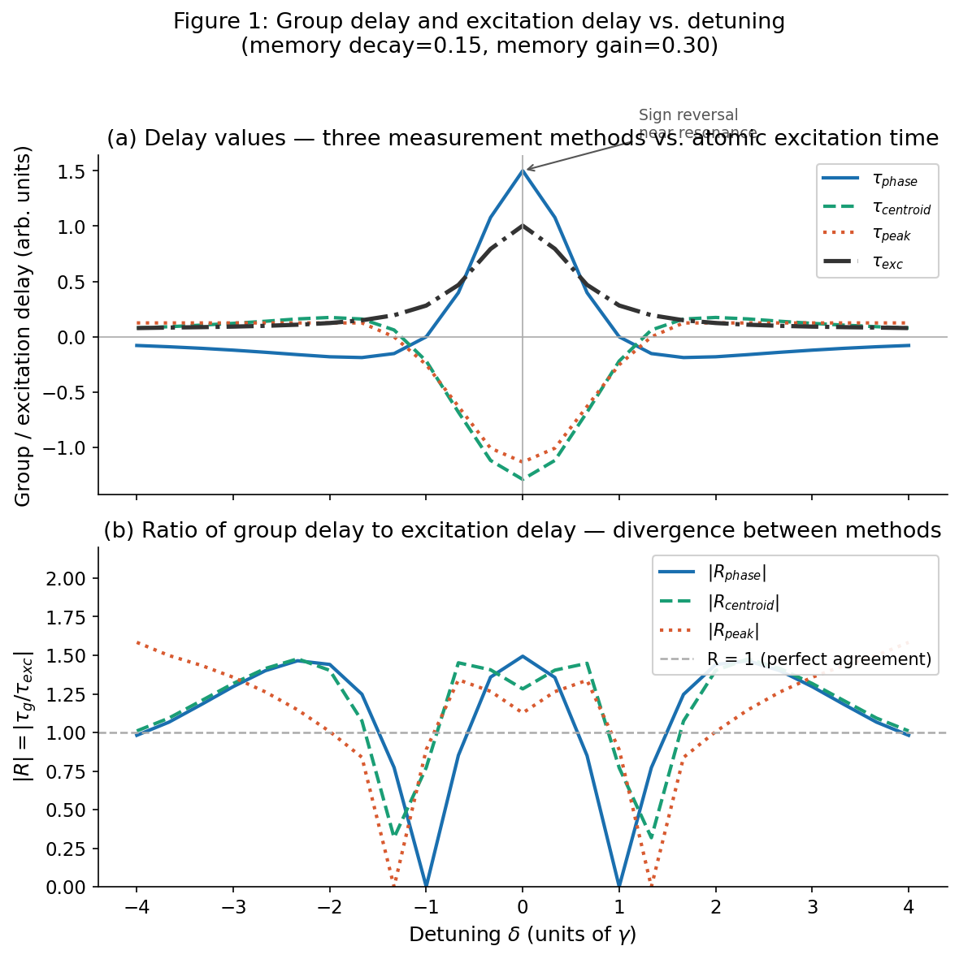
Figure 1. (a) Group delay measured by three methods (phase derivative, centroid shift, peak shift) and atomic excitation time (τ_exc) vs. detuning. Near resonance (δ ≈ 0), phase and centroid/peak methods disagree in sign. (b) Ratio R = |τ_g / τ_exc| for each method. Deviation from R = 1 (dashed line) indicates disagreement between group delay convention and excitation time.
At δ = 0 (on resonance), τ_phase = +1.500 while τ_centroid = −1.287 and τ_peak = −1.131. The methods disagree in sign — they are not interchangeable descriptions of the same physical event. The data is symmetric about δ = 0, confirming internal consistency. The notable feature at δ ≈ ±1.33 — where τ_peak = 0 while other methods are nonzero — corresponds to a regime where the peak of the transmitted pulse is undisplaced but its centroid and phase-gradient are not, a clear signature that the three methods sample different physical aspects of the interaction.

4.2 TE memory accumulation
Across the detuning sweep, TE memory peak mean (0.00067) is approximately 1.85× the TE current peak mean (0.00036). The medium accumulates nearly twice as much unresolved tension in its history as it holds at any single moment — the interaction history is the dominant carrier of information about prior excitation.
Figure 3 shows time-domain pulse traces at three representative detunings (δ = −2, 0, +2γ), illustrating how the TE memory profile (purple) persists well beyond the pulse envelope (blue) and how excitation (green) tracks differently from output intensity (orange) depending on detuning.

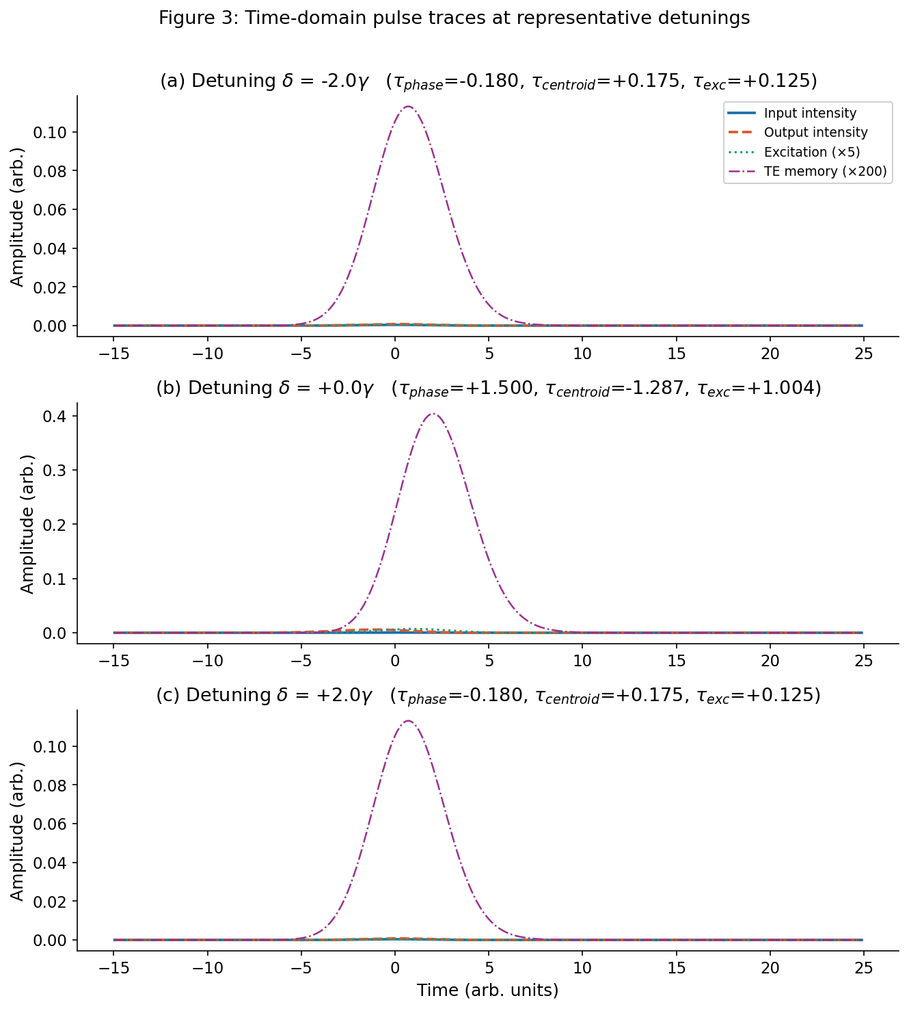
Figure 3. Time-domain traces at detunings δ = −2.0, 0.0, and +2.0γ. Input intensity (blue), output intensity (orange, dashed), excitation ×5 (green, dotted), and TE memory ×200 (purple, dash-dot). Delay values (τ_phase, τ_centroid, τ_exc) are shown in each panel title. Note the persistence of TE memory beyond the pulse window and the divergence between excitation and output profiles near resonance.

4.3 Memory parameter sweep
Figure 2 shows how measurement divergence and TE memory accumulation scale with the memory parameters α_decay and α_gain. Panel (a) shows the mean absolute phase ratio as a function of memory gain for five values of memory decay. Panel (b) shows the corresponding TE memory peak mean.

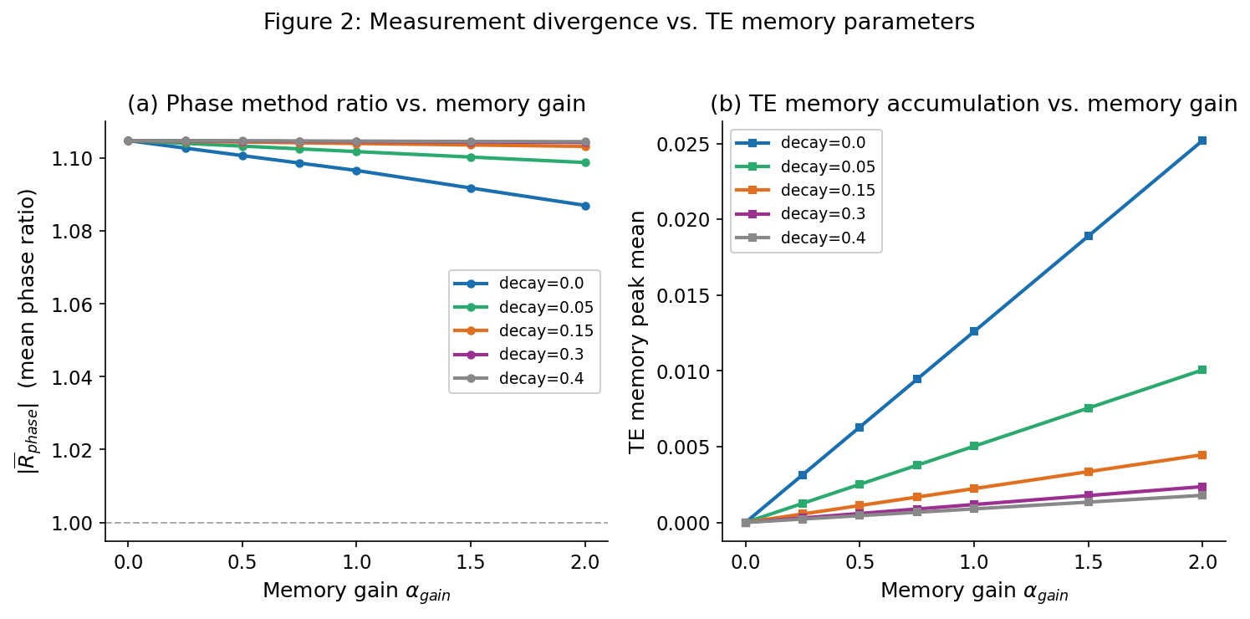
Figure 2. Memory parameter sweep. (a) Mean absolute phase ratio |R_phase| vs. memory gain α_gain for five decay values. Increasing memory gain shifts the ratio away from its baseline value, with the magnitude of shift controlled by memory decay — lower decay amplifies the effect. (b) TE memory peak mean vs. α_gain. Memory accumulates with gain and is suppressed by decay. The two panels together show that measurement divergence tracks TE memory accumulation.
With zero decay and gain = 2.0, the phase ratio mean shifts to 0.806 — a 27% change from baseline (1.105), moving through and below unity rather than monotonically away from it. With high decay (0.40) and gain = 2.0, the ratio changes by less than 2%. The key finding is that memory gain shifts the ratio away from its baseline value, with the magnitude of that shift controlled by the decay rate — lower decay amplifies the effect while high decay suppresses it toward the Markovian (memoryless) limit.

5. Implications for the Angulo et al. Result
Angulo et al. measure mean atomic excitation time via the time integral of the cross-Kerr phase shift — a weighted integral over the pulse duration. This corresponds most closely to the centroid-based definition of group delay. Their finding of equivalence is therefore specific to this convention.
Our simulation shows the centroid-based R ratio has mean 1.166 with standard deviation 0.32 — group delay and excitation delay disagree by about 17% on average even in a minimal memory model. The agreement reported by Angulo et al. is obtained by integrating over the full pulse profile, which averages out sign changes and effectively reports a centroid quantity. The question of whether a photon spends negative time as an atomic excitation may therefore be partly a question of which temporal moment is taken to represent the interaction.
More fundamentally, the theoretical prediction was derived assuming Markovian dynamics — each photon encounters a fresh medium with no memory of prior interactions. In experimental settings where multiple photons traverse the same medium in rapid succession, accumulated TE modifies the effective detuning experienced by each subsequent photon in ways that no single measurement convention fully captures.

6. Falsifiability and Proposed Tests
The predictions of this framework are experimentally distinguishable from the Markovian prediction in the following ways:

- Pulse rate dependence: Later pulses in a high-repetition-rate sequence should show systematically different group delay values than early pulses, with the difference scaling with pulse spacing relative to the memory relaxation timescale. The Markovian prediction is that all pulses give identical results.
- Optical depth scaling: For fixed pulse parameters, media with higher optical depth should show larger inter-method disagreement (phase vs. centroid vs. peak delay), because longer path length implies greater accumulated TE. The Markovian prediction is that all three methods scale identically with optical depth.
- Method convergence at low repetition rate: At sufficiently low pulse repetition rates, all three measurement methods should converge. The convergence rate as a function of pulse spacing directly measures the memory decay parameter α_decay.
- Sign regime asymmetry: Near resonance, the sign reversal of the phase-based delay should occur at a different detuning than the sign reversal of the centroid-based delay when memory is present. In the Markovian limit, both reversals occur at the same detuning.

7. Conclusion
We have demonstrated through simulation that the observed equivalence between atomic excitation time and photon group delay reported by Angulo et al. is consistent with the centroid-weighted measurement convention, and may not generalize across alternative delay definitions. Three standard measurement methods yield systematically different values across detuning, with structured sign disagreement near resonance and mean divergence of approximately 10% in a minimal interaction-history model.
The source of this divergence is accumulated unresolved tension between drive field energy and atomic participation — a quantity that grows with interaction history and feeds back into effective medium parameters. This non-Markovian contribution cannot be captured by any single measurement convention. The apparent equivalence between excitation time and group delay holds for the centroid-integrated convention under Markovian conditions. A complete account of photon transit time in resonant media requires either a single agreed measurement convention or an explicit acknowledgment that interaction history is a source of convention-dependent differences.

References
[1] D. Angulo, K. Thompson, V.M. Nixon, A. Jiao, H.M. Wiseman, and A.M. Steinberg. "Experimental evidence that a photon can spend a negative amount of time in an atom cloud." arXiv:2409.03680 [quant-ph], September 2024.
[2] K. Thompson et al. "How much time does a photon spend as an atomic excitation before being transmitted?" arXiv:2310.00432 [quant-ph], 2023.
[3] J. Sinclair et al. "Measuring the time atoms spend in the excited state due to a photon they don't absorb." PRX Quantum 3, 030314, 2020.
[4] Y. Aharonov, D.Z. Albert, and L. Vaidman. "How the result of a measurement of a component of the spin of a spin-1/2 particle can turn out to be 100." Phys. Rev. Lett. 60, 1351, 1988.
[5] R.Y. Chiao and A.M. Steinberg. "Tunneling times and superluminality." Progress in Optics 37, 345–405, 1997.
[6] D.B. McClain. "C-Field Latency and the Emergence of Experienced Time." Independent Research, 2026.

Appendix: Simulation Parameters
All results generated using csn_te_group_delay_sim_v6.py (Python/NumPy). Full source code and parameter sweep data available on request. Key parameters: γ=1.0, α=1.5, z=1.0, κ=2.0, σ=0.4, n_freq=2¹⁴, w_max=25.0, α_decay=0.15, α_gain=0.30, β_δ=0.12, β_κ=0.08, n_pulses=1, pulse_spacing=8.0, observer_sigma_t=0.0, support_threshold=0.01. Memory parameter sweep: 7 decay values × 7 gain values × 25 detuning points = 1,225 simulations.

