5. Asynchronous gRPC: Synchronous vs. Asynchronous Execution
In the Section 4, the synchronous server gives every running request its own worker thread and when a handler needs to wait for disk, database or another service, its thread is blocked and cannot do anything. However, the asynchronous version uses Python’s asyncio and grpc.aio. All requests run as co-routines on one event loop and the control is handed back to the loop whenever a co-routine has to wait by the keyword await. This way other requests can run in the meantime. The contract rental.proto and OOP classes are not changed since both servers implement the same RentalService.

What changed from the synchronous server
Aspect | Synchronous (Section 4) | Asynchronous (this section)
Server object | grpc.server(ThreadPoolExecutor(10)) | grpc.aio.server()
Handlers | def RentBook(self, request, context) | async def RentBook(self, request, context)
Artificial delay | time.sleep(delay) blocks one thread | await asyncio.sleep(delay) yields to the loop
Concurrency | one thread per running request, at most 10 at once | one thread, one event loop, any number of waiting requests
Client | grpc.insecure_channel, blocking stub calls | grpc.aio.insecure_channel, await stub.Method(...)
Port | localhost:50051 | localhost:50052
OOP code | RentalManager, BookCatalog (unchanged) | the same classes (unchanged)

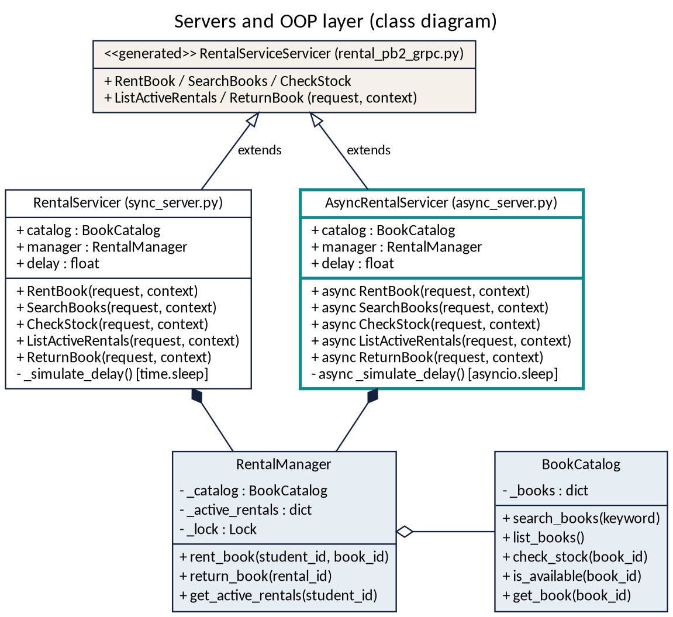
Figure 1. UML class diagram. Both servicers extend the generated base class and own one RentalManager; only the handlers differ.

The asynchronous server
async_server.py defines AsyncRentalServicer. It creates the catalog and the manager once, so stock and rentals are persistent between calls. Just like in the synchronous server. The conversion helpers like book_to_pb, rental_to_pb and result_to_pb are imported from sync_server.py. They are not copied. In this case, the handler still only reads the request, calls the OOP layer and prints the result into a message:
async def _simulate_delay(self):
if self.delay > 0:
await asyncio.sleep(self.delay) # yields to the event loop

async def SearchBooks(self, request, context):
await self._simulate_delay()
if request.keyword:
books = self.catalog.search_books(request.keyword)
else:
books = self.catalog.list_books()
return rental_pb2.SearchResponse(books=[book_to_pb(b) for b in books])
- No await on the OOP calls. To make the handlers call them directly search_books, rent_book and the others are plain, fast functions with no I/O. On the other hand, the lock inside RentalManager is held for a few microseconds and never across an await. This way, it cannot cause a deadlock.
- Never time.sleep. --delay option uses ayncio.sleep only to prevent the freezing of whole event loop by time.sleep inside the async def. If this was not implemented, when time.sleep freeze the event loop, every other request would wait with it and there would be no concurrency.
- Server start-up. grpc.aio.server(), add_insecure_port("localhost:50052"), await server.start() and await server.wait_for_termination(), run by asyncio.run. The helper create_server(port=0) lets the tests use a free port.

The asynchronous client
There are 2 demos of async_client.py. While Demo 1 makes simple awaited calls like rent, out of stock, unknown book, Demo 2 does the important part: ten students search at the same time. In this case, asyncio.gather starts all the ten co-routines and each one sends its request immediately and is suspended at its await, after that it resumes when its reply arrives:
results = await asyncio.gather(
*(one_search(stub, i + 1, kw, timeout, t0)
for i, kw in enumerate(SEARCH_KEYWORDS))
)
While the searches are still ongoing, there is a small background task which prints “still working” in every 0.1 s to show the client is not frozen. Every call has a timeout=, and errors are caught as grpc.aio.AioRpcError. A stopped server gives an error message like UNAVAILABLE, and the slow server gives the message DEADLINE_EXCEEDED. Same with the messages in sync_client.py.
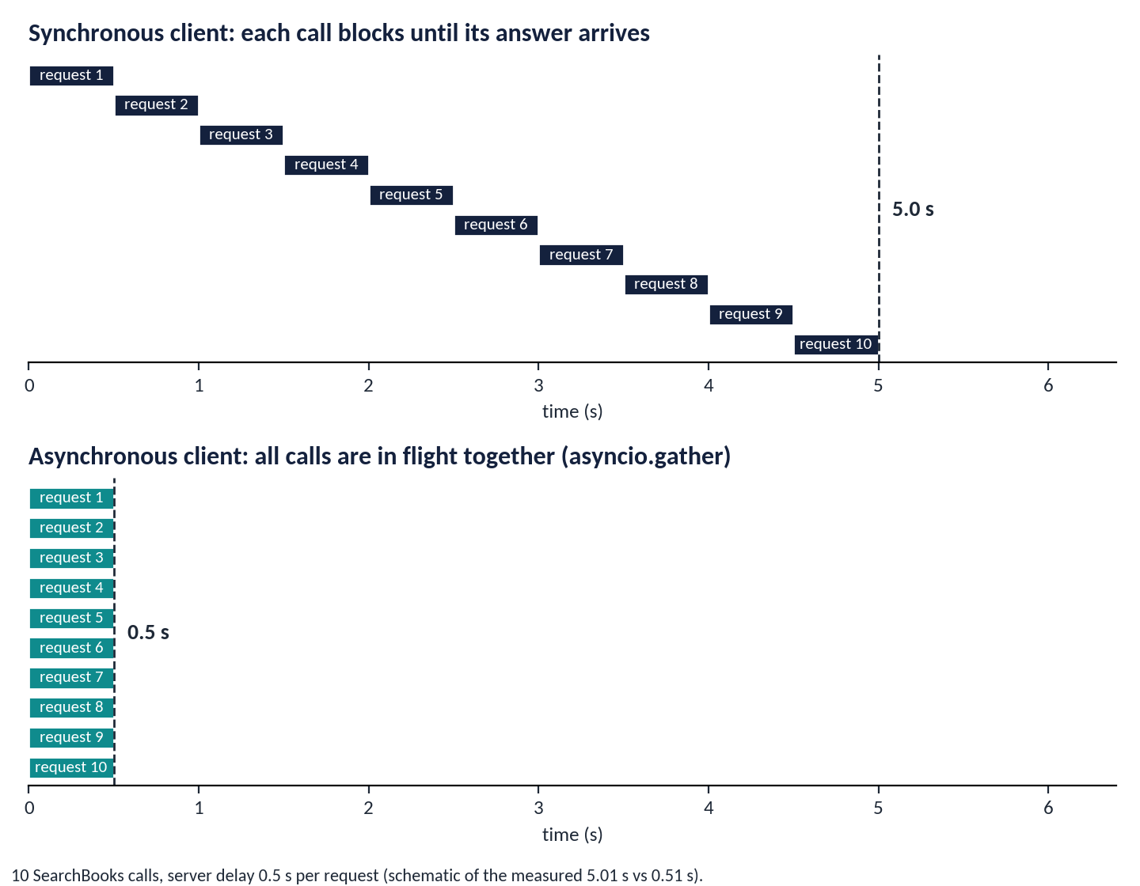
Figure 2. Ten searches with a 0.5 s server delay: one after another (top) and with asyncio.gather (bottom).

Measured results
compare_sync_async.py starts both servers in one process with the same delay of 0.5 s per request and times the same SearchBooks calls. Rows (a) and (b) are the main comparison. Rows (c) and (d) show that a thread-pool server can also run requests in parallel, within the limits of its pool.
Scenario | Requests | Time
(a) sync client, one call after another | 10 | 5.01 s
(b) async client, asyncio.gather | 10 | 0.51 s
(c) sync server (10 workers), threaded clients | 50 | 2.52 s
(d) async server, asyncio.gather (one thread) | 50 | 0.51 s

Row (a) is about N times the delay (10 x 0.5 s) and row (b) is about one delay, a speed-up of 9.9 times. In row (c), 50 requests on 10 workers need five rounds of 0.5 s, which gives 2.5 s. The async server in row (d) is not limited by a pool, so 50 requests take as long as 10. Each number is one run on one machine over localhost, and the times vary by a few hundredths of a second between runs.

When async helps, and when it does not
Asynchronous handling helps when requests spend their time waiting. The delay in our experiment is simulated; the real OOP methods finish in microseconds, so with --delay 0 the two servers feel the same on this project. When a handler waits for a database, a file or another network call, the gain appears. Async is not used to speed up CPU-heavy work: a long computation inside an async def handler blocks the event loop and delays every other request. As row (c) shows, a thread pool also serves parallel clients, however it need a thread per running request and is limited by its size.
The OOP layer is shared by both servers and is protected by the existing threading.Lock in RentalManager. compare_sync_async.py also sends 10 concurrent RentBook calls for B003, which has a single copy, to each server: exactly 1 of 10 succeeds on both, and the other 9 receive success = False. A test with 20 concurrent calls gives the same result.

Testing and how to run
test_async_grpc.py has 18 tests built on unittest.IsolatedAsyncioTestCase. Each test starts a real grpc.aio server on a free port and calls it over the network. They cover rentals, out of stock, unknown book, empty student ID, case-insensitive search, stock check, active rentals, return, 10 concurrent searches, and the timing test (ten gathered searches with a 0.3 s delay finish in under 1.5 s instead of 3 s). They also cover the 20 concurrent rentals and DEADLINE_EXCEEDED. All 50 tests of the project pass: 13 for the OOP layer, 19 for the synchronous server and 18 for the asynchronous one.
pip install -r requirements.txt
python async_server.py --delay 0.5 # terminal 1
python async_client.py # terminal 2
python compare_sync_async.py --delay 0.5 # starts both servers itself
python -m unittest -v # all 50 tests

