Starting the server with npm run dev runs a local instance of the server with no errors

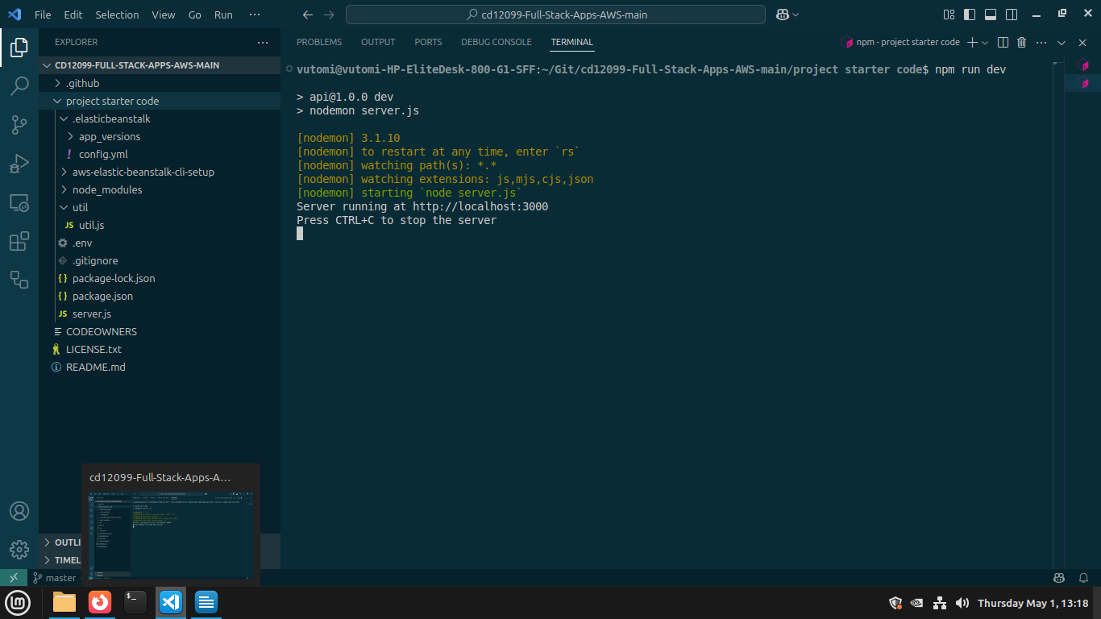
The project demonstrates RESTFUL design principles using local link
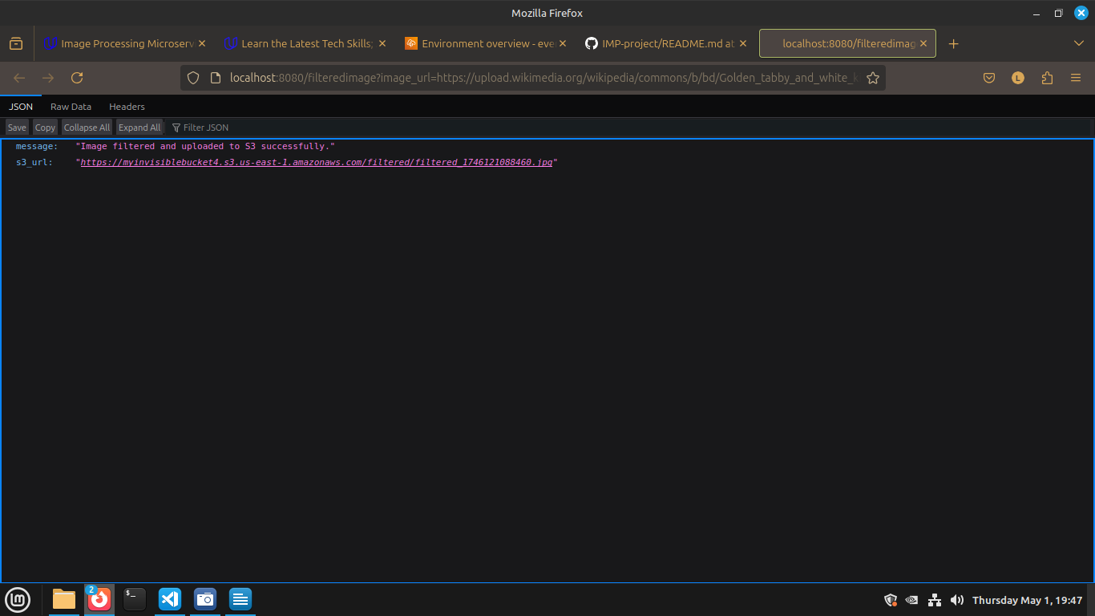

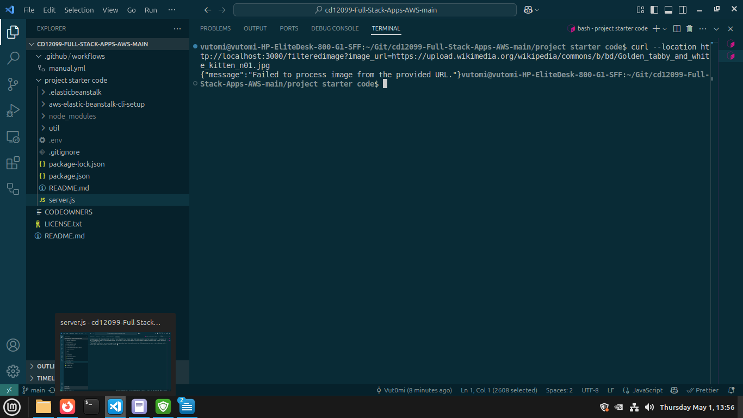

The project uses AWS Elastic Beanstalk’s CLI and Console Dashboard

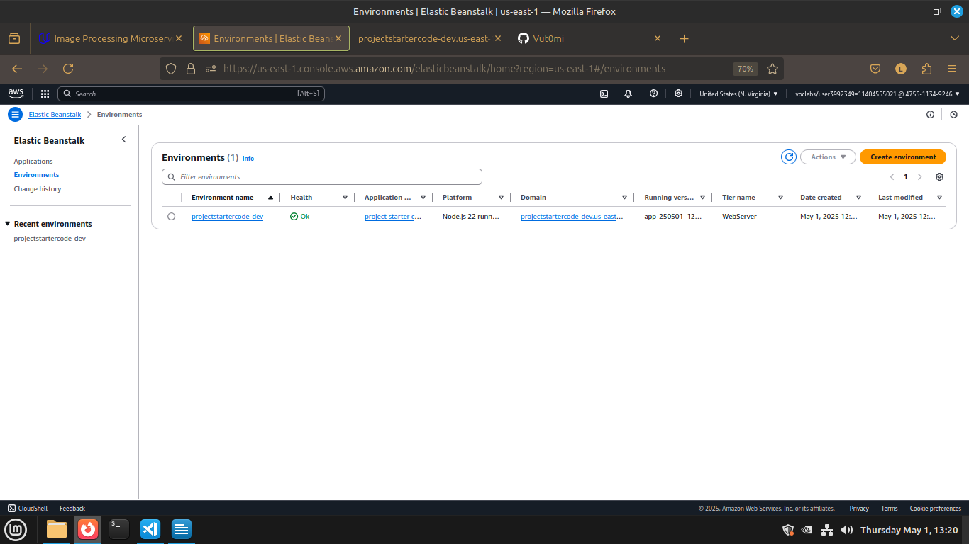

using the EBS url :

