Starting the server with npm run dev runs a local instance of the server with no errors

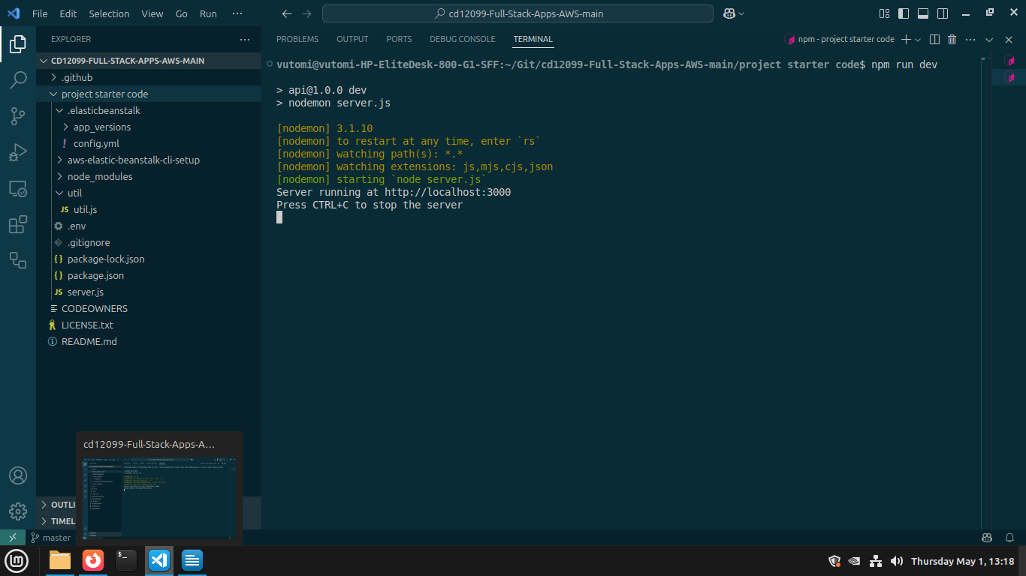
The project demonstrates RESTFUL design principles

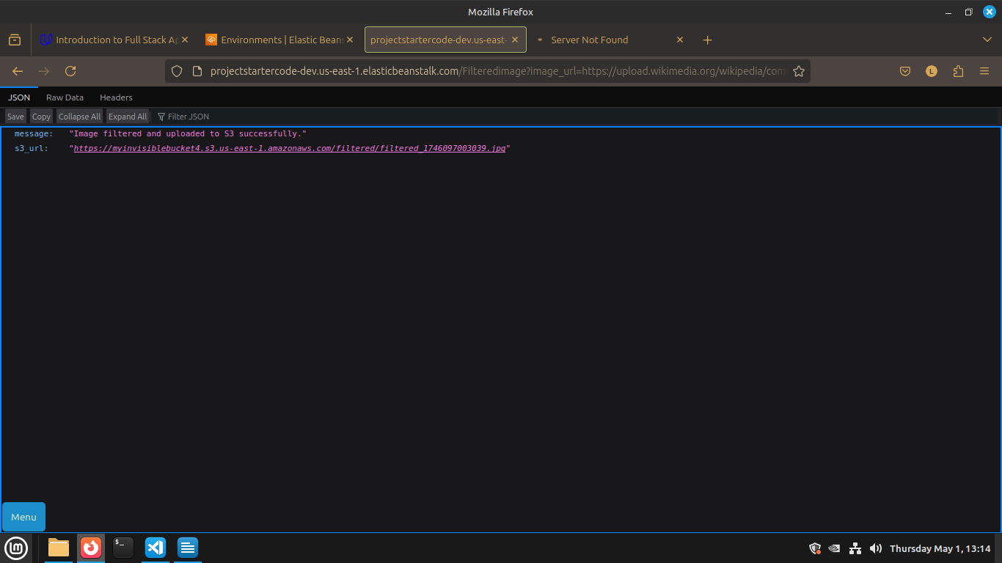

The project uses AWS Elastic Beanstalk’s CLI and Console Dashboard

