What is Emmet?

Emmet is a popular plugin used for time saving.

Writing shortcuts expand full piece of code for CSS and HTML.

Difference between Library and framework?

The main difference is inversion of control.

Library: collection of classes and functions. Library is called when ever your code required particular functionality. Ex: with out washing machine clothes can wash. But using washing machine clothes can wash quick where as here washing machine is the library (tool) helps us to reduce work

Framework: It’s a structure and contain rules. Should be used in specific format Ex: If we want make a washing machine There are many brands which provide structures. It would be easy because of blueprint of washing machine is already present. Here structure of washing machine is framework. In framework it provides structure and gaps where user need to fill code.

In Library, developer calls functions present in library when ever necessary, where as in framework It calls the code whenever required.

What is CDN? Why it’s used?

CDN - Content delivery network. It’s mainly used to store static data like webpage, photos, videos etc.

Ex if you are requesting to facebook.com from different location and from different devices at a time stress on server might be high and due to heavy traffic, our website may load bit late. To avoid such situations, we maintain CDN’s this CDNS maintain nodes which share data among all cheche’s (datacentres)

Its used basically to speed up website.

Why is react is known as React?

Basically, react is library build by Facebook having changes in view (MVC) there will changes in UI which reacts for user triggering events.

What is cross origin in script tag?

Cross Origin attribute mainly used to handle CORS request. That will handle whether data is safe or not. Mainly it’s used to allow access the request to server which is deployed in another domain.

What is difference between React and React Dom?

React is the entry level or point to react library which can be accessed through script tag. And can be used globally. Can be used for mobile apps and web

React Dom package contains Dom related functionality and can be used in script tag. Used for web APPs

What is difference between react development.js and react production.js?

The main difference between react development.js and production.js is build time. In development it takes time to load where as in production it’s bit fast compare to development time. No warnings propagate in production time. In dev time it’s in out local whereas production time it’s on client. In production it’s minified and optimised version is used to takes less amount of time

What is difference between async and defer?

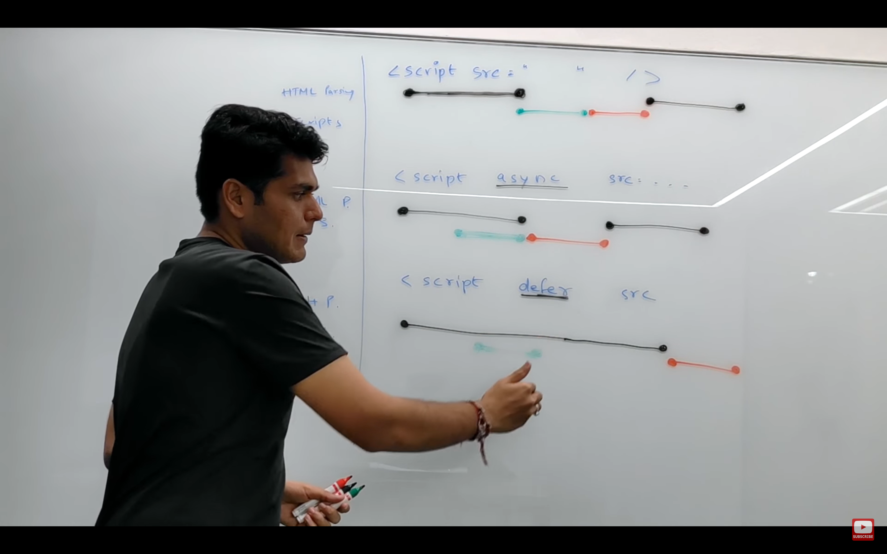

If we are not using any attribute html parsing will execute until it encounters script tag. Once encounter html parsing will be pause. scripts it will fetch and execute there and then itself and again starts html parsing until scripts got executed.

In async, html parsing executed parallelly to fetching scripts once fetching got done. Html parsing gets pause and executes script tags. Once execution gets completed html parsing continues. This async attribute is mostly used when scripts are independent of each other scripts and scripts will not execute in order

In defer, html parsing and script fetching will execute parallelly. Once html parsing and script fetching done. Scripts execution starts. It executed scripts in order fashion.