*Vutukuru, Ram Anand (rxv162130)*

*Kassap, Christopher (cxk112830)*

*Decision Trees Part I*

**CS 6375.501 – Machine Learning – Assignment 2**

1. Representing Boolean Functions

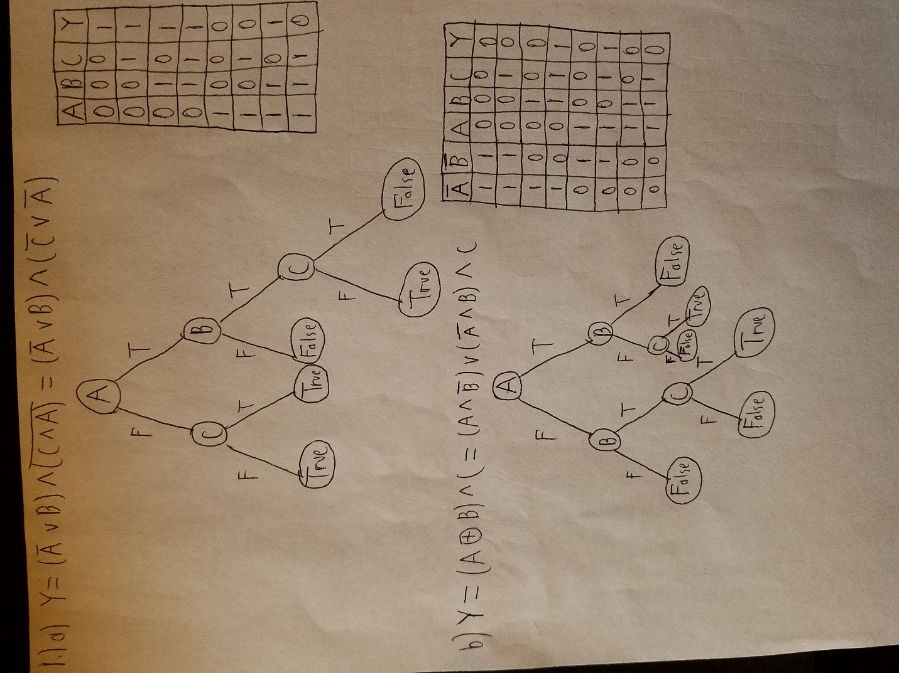

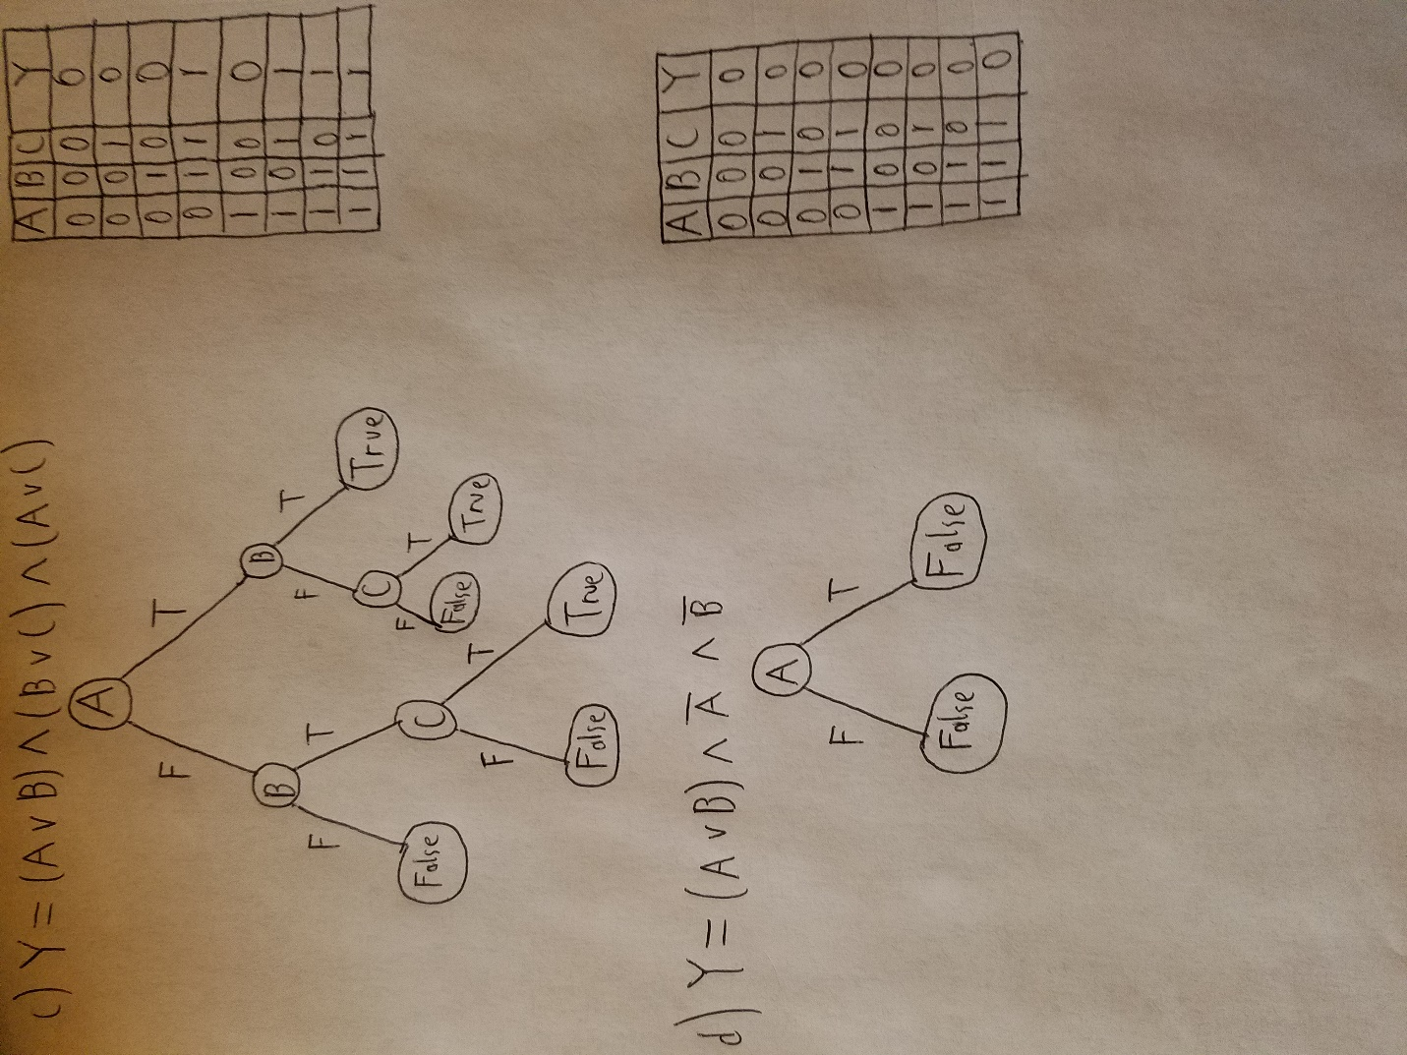

1. Decision Tree (ID3)

