|  |  |
| --- | --- |
| K Value | SSE Value |
| 3 | 1.91069170607 |
| 5 | 1.62794492813 |
| 7 | 1.1504263782 |
| 9 | 1.07910462821 |
| 11 | 0.795501535281 |

K = 3

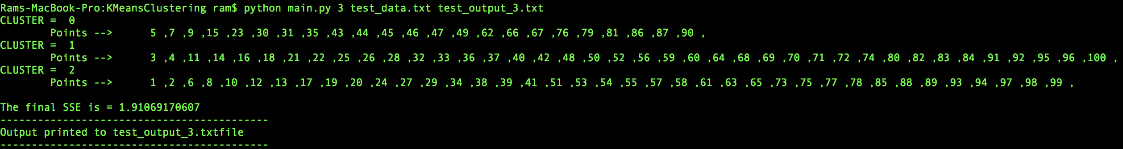

k = 5

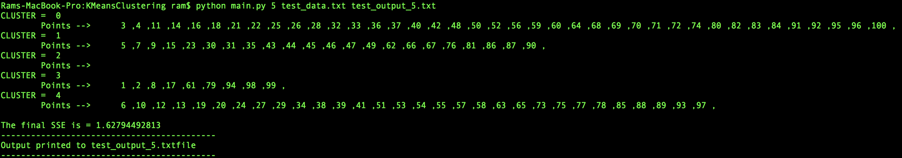

K = 7

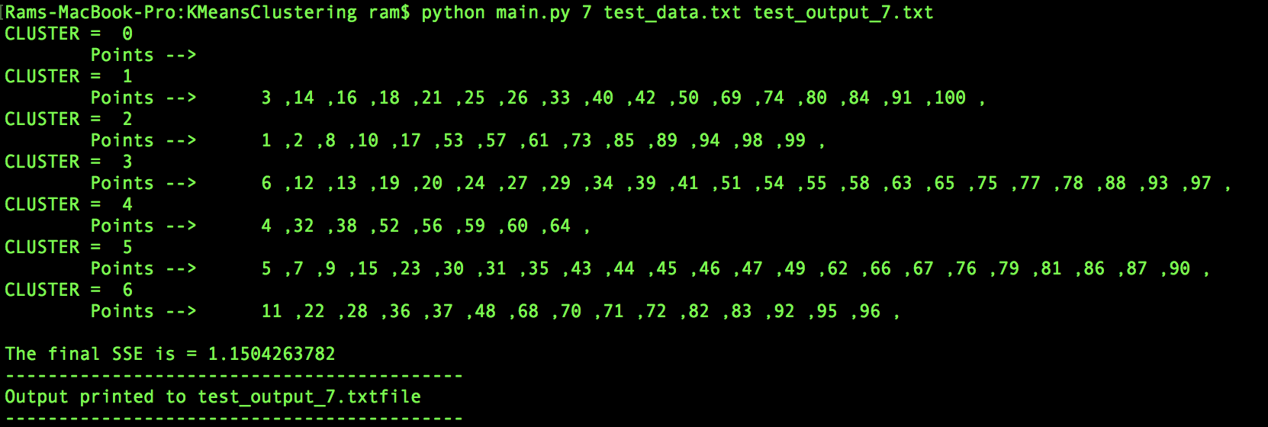

K = 9

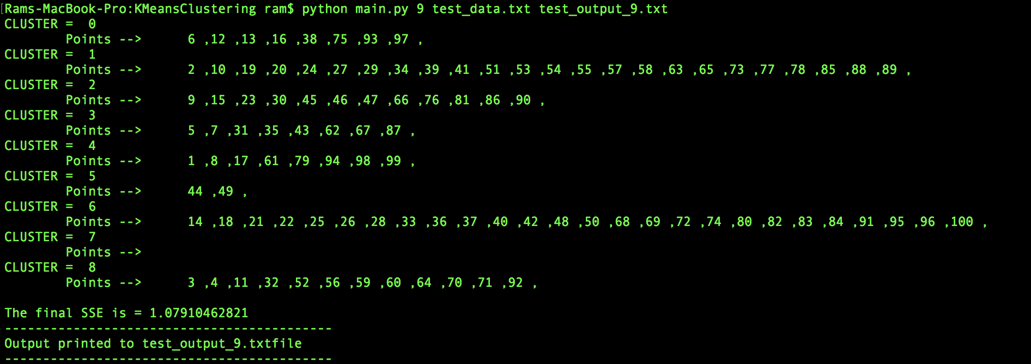

K = 11

