**BACKGROUND**

Phinduvuke Bus Ticket Booking System is a modern, user-friendly digital platform designed to streamline the process of booking bus tickets for travel within Eswatini. The system aims to improve the efficiency, convenience, and accessibility of transportation services, addressing challenges that have traditionally been associated with bus travel in the country, such as long waiting times, limited availability of tickets, and the need for physical presence at ticketing counters.

Eswatini, a small landlocked country in Southern Africa, has a vibrant bus transportation network that is essential for both domestic travel and commuting. However, with growing demand and urbanization, there has been a need for a more organized and convenient way to access bus services. Phinduvuke was developed to meet this need, offering an online platform where passengers can easily view schedules, select routes, and secure tickets for their trips.

Launched as a response to the increasing reliance on technology for day-to-day activities, Phinduvuke is designed to be accessible through mobile phones, tablets, and computers, making it possible for users to book tickets anytime and anywhere. The platform is intended to enhance customer experience by reducing the hassle of waiting in line at bus stations and minimizing the risk of missing a bus due to lack of information about availability.

The system integrates real-time updates, which ensures that passengers have up-to-date information on bus schedules and seat availability. Additionally, it supports multiple payment options, including mobile money, bank transfers, and credit card payments, catering to the diverse preferences of Eswatini’s population. This convenience aligns with the government’s ongoing efforts to promote digital solutions and modernize the transport sector.

By providing a more structured and reliable service, Phinduvuke also aims to address key transportation issues such as overcrowding, ticket fraud, and inefficiency. It is hoped that the system will contribute to the economic development of Eswatini by facilitating smoother travel for business, tourism, and everyday commuting, while also improving safety and reducing the environmental impact of transportation through optimized routes and schedules.

In the long run, Phinduvuke’s implementation has the potential to expand beyond the current scope, offering further enhancements such as integration with other forms of transport, loyalty programs, and more personalized travel services.

**PROBLEMS**

The Phinduvuke Bus Ticket Booking System faces several specific challenges related to the ticket booking process itself. These issues can affect the user experience, operational efficiency, and overall effectiveness of the system. Some of the key problems related to ticket booking in the organization include;

• **Payment Failures**: Users may face difficulties during the payment process, including failed transactions, incorrect deductions, or issues with payment gateways. This can result in a situation where users believe they have booked a ticket, but the payment does not go through, leaving them without a confirmed reservation. The lack of immediate feedback or confirmation in such cases adds to the frustration.

• **Inaccurate or Outdated Information**: The system might sometimes show inaccurate bus schedules or route information due to ³delays in updating schedules from bus operators or changes in transport availability. Inaccurate information regarding departure times or routes can lead to confusion, missed buses, or passengers arriving at the wrong terminal.

• **Technical Glitches and System Errors**: Users might encounter technical glitches, such as website crashes, slow loading times, or errors in ticket selection, which can disrupt the booking process. These technical issues can prevent users from completing their bookings, resulting in lost sales or delayed travel plans.

• **Limited Support for Group Bookings**: If the system does not offer sufficient options for group bookings (for example, booking multiple tickets at once), this could limit its appeal for families, groups of travelers, or business-related bookings. Group booking options are important for making the platform more versatile and accommodating a wider range of travel needs.

• **Security Concerns and Data Privacy**: Ensuring the security of users’ personal and payment information is crucial. If users feel that their data is not protected, they may hesitate to book tickets through the platform. Issues such as weak encryption or security breaches could result in a loss of customer trust, which would negatively impact ticket sales.

**SOLUTIONS**

To address the challenges faced by the Phinduvuke Bus Ticket Booking System, here are potential solutions to the specific problems:

**1. Payment Failures**

**Solutions:**

* **Improved Payment Gateway Integration:** Ensure the platform integrates with reliable and robust payment gateways that offer fail-safes for transactions, like retry mechanisms for failed payments. This would help reduce transaction errors.
* **Instant Payment Confirmation:** Implement a system that provides immediate feedback to users after a transaction is processed, including a confirmation number and a clear indication of successful payment. This would prevent users from mistakenly thinking their booking is complete when it is not.
* **Multiple Payment Options:** Offer a range of payment methods (mobile money, credit/debit cards, bank transfers, etc.) and ensure they are thoroughly tested and optimized to prevent errors. Mobile money options, such as those commonly used in Eswatini, should be prioritized.
* **Payment Retry Functionality:** In cases where a payment fails, allow users to retry the transaction without losing their booking information, so they don’t have to start the process over again.

**2. Inaccurate or Outdated Information**

**Solutions:**

* **Real-Time Updates from Bus Operators:** Implement an automated integration system with bus operators to provide real-time updates on bus schedules, route changes, and seat availability. This would ensure that the system is always displaying the most current information.
* **Manual Update Alerts:** Create a feature for operators to update schedules manually in case of changes, with notifications sent to users about any modifications. A system of alerts can be set up for operators to notify customers about schedule changes or cancellations.
* **User Notifications:** Send automatic notifications to users regarding any changes to their travel plans, such as time delays or changes in departure points. This would reduce confusion and help users adjust their plans.
* **Advanced Scheduling Algorithms:** Implement more sophisticated algorithms to calculate and predict potential delays, offering users proactive notifications on likely disruptions.

**3. Technical Glitches and System Errors**

**Solutions:**

* **Regular System Maintenance:** Perform regular testing and maintenance of the platform to identify and resolve potential vulnerabilities or bugs. Regular updates and server optimizations will help maintain a smooth user experience.
* **Scalable Infrastructure:** Invest in scalable server infrastructure to handle heavy traffic during peak booking periods. Cloud-based hosting solutions, like AWS or Google Cloud, can provide elasticity in scaling resources according to demand.
* **Load Balancing:** Implement load balancing to ensure that the system can handle high traffic loads without crashing. This would distribute incoming traffic across multiple servers, reducing the risk of system overload.
* **Backup Systems:** Establish backup systems and failover mechanisms in case of downtime, ensuring that users can still complete their bookings even if the primary system encounters issues.

**4. Limited Support for Group Bookings**

**Solutions:**

* **Group Booking Functionality:** Add a dedicated feature for group bookings that allows users to easily select and book multiple seats at once. This could include bulk discounts, which would make the service more appealing to families, businesses, or organizations.
* **Group Discount Packages:** Offer group booking discounts or special packages to encourage larger groups to use the system. This will make it easier for families and organizations to book together, thus increasing overall sales.
* **Customizable Booking Options:** Implement a customizable booking tool that allows users to specify the number of seats, traveler preferences, and even special requests (e.g., seat selection, meal preferences). This would enhance the group booking experience.

**5. Security Concerns and Data Privacy**

**Solutions:**

* **Encryption and Secure Payment Systems:** Implement robust encryption (e.g., SSL/TLS) for all sensitive user data, including personal details and payment information. Ensure that payment gateways are PCI-DSS compliant for secure handling of card payments.
* **Two-Factor Authentication (2FA):** Introduce two-factor authentication (2FA) for users to log in to their accounts, adding an extra layer of security to prevent unauthorized access.
* **Regular Security Audits:** Conduct frequent security audits and penetration testing to identify vulnerabilities in the system. This helps in proactively addressing potential security weaknesses.
* **Clear Privacy Policy and User Consent:** Ensure that users are fully aware of how their data is being handled by providing clear privacy policies and obtaining user consent. Transparent practices help build trust with customers.
* **Data Tokenization:** Use data tokenization for sensitive information, such as credit card details, so that no actual data is stored on the system, reducing the risk in case of a breach

**PLANNING**

### Scope Definition

1. **Core Requirements**:
   * **Facial Recognition**: Implement a facial recognition system for user authentication and security.
   * **Java Console Application**: Develop a Java-based console application for managing the booking system.
   * **MySQL Database**: Design and implement a MySQL database to store user data, booking information, and bus schedules.
   * **Data Analysis and Visualization**: Create tools for analyzing booking data and visualizing trends and patterns.

**Scope Definition**

1. **Core Requirements**:
   * **Facial Recognition**: Implement a facial recognition system for user authentication and security.
   * **Java Console Application**: Develop a Java-based console application for managing the booking system.
   * **MySQL Database**: Design and implement a MySQL database to store user data, booking information, and bus schedules.
   * **Data Analysis and Visualization**: Create tools for analyzing booking data and visualizing trends and patterns.

**Task Breakdown**

1. **Facial Recognition**:
   * Research and select a suitable facial recognition library or API (e.g., OpenCV, Amazon Rekognition).
   * Develop a module for capturing and processing facial images.
   * Integrate the facial recognition module with the user authentication system.
   * Test the facial recognition system for accuracy and reliability.
2. **Java Console Application**:
   * Design the architecture of the console application.
   * Implement core functionalities such as user registration, login, ticket booking, and payment processing.
   * Develop a user-friendly interface for the console application.
   * Test the application for usability and performance.
3. **MySQL Database**:
   * Design the database schema to store user information, bus schedules, booking details, and payment records.
   * Implement the database using MySQL.
   * Develop APIs for interacting with the database (e.g., CRUD operations).
   * Ensure data integrity and security through proper indexing, constraints, and encryption.
4. **Data Analysis and Visualization**:
   * Identify key metrics and data points to analyze (e.g., booking trends, peak travel times, payment success rates).
   * Develop scripts or tools for extracting and processing data from the database.
   * Create visualizations (e.g., charts, graphs) to represent the analyzed data.
   * Implement a dashboard for displaying the visualizations and insights

### Team Assignment

1. **Facial Recognition**:
   * Assign team members with expertise in computer vision and machine learning to work on the facial recognition module.
2. **Java Console Application**:
   * Assign experienced Java developers to design and implement the console application.
3. **MySQL Database**:
   * Assign database administrators and developers to design and implement the MySQL database.
4. **Data Analysis and Visualization**:
   * Assign data analysts and visualization experts to work on data analysis and visualization tools.

**Team Roles:**

* **Project Manager:** Oversees the overall project and ensures deadlines are met.
* **Facial Recognition Developer (Python):** Works on implementing facial recognition for login validation.
* **Java Application Developer:** Develops the Java console application for database interactions.
* **Database Developer:** Designs and manages the database (ERD, tables, SQL queries).
* **Data Analyst (Python):** Focuses on data analysis and visualization using Python.
* **Documenter:** Responsible for preparing project reports, UML diagrams, and presentations

**Analysis**

**GATHERING AND ANALYSIS REQUIREMENTS FOR EACH COMPONENET.**

The requirements for each component of the **Phinduvuke Bus Ticket Booking System** into detailed requirements for development, focusing on the functionalities, user interactions, and technical aspects for each module:

**. Facial Recognition System**

* **Functional Requirements:**
  + Capture facial images for user authentication.
  + Compare the captured images with stored user images to validate identity.
  + Integrate with user registration to store facial data securely.
  + Provide feedback on the success or failure of recognition attempts.
* **Non-Functional Requirements:**
  + Ensure accuracy with minimal false positives/negatives.
  + Maintain a high speed of recognition for a seamless user experience.
  + Use secure storage for facial data (e.g., encrypted storage).
* **Technical Requirements:**
  + Use a facial recognition library.
  + Develop in Python for better integration with machine learning libraries.
  + Test and validate the model on a dataset relevant to the user base.

**2. Java Console Application**

* **Functional Requirements:**
  + User registration, login, and profile management.
  + Browse bus schedules and routes.
  + Book and manage tickets.
  + Process payments through integrated payment gateways.
  + Provide real-time updates on booking status.
* **Non-Functional Requirements:**
  + User-friendly command-line interface.
  + Robust error handling and input validation.
  + Ensure application scalability to handle increasing user base.
* **Technical Requirements:**
  + Use Java for developing the console application.
  + Modular design for easy maintenance and updates.
  + Implement APIs to interact with the MySQL database.

**3. MySQL Database**

* **Functional Requirements:**
  + Store and manage data for users, buses, routes, schedules, bookings, payments, and feedback.
  + Support CRUD operations for all entities.
  + Ensure data integrity and relational consistency.
* **Non-Functional Requirements:**
  + High availability and reliability.
  + Optimize for read and write operations.
  + Secure data storage with encryption and access controls.
* **Technical Requirements:**
  + Design an ERD (Entity-Relationship Diagram) to model data relationships.
  + Use indexing for faster query execution.
  + Implement backup and recovery solutions.

**4. Data Analysis and Visualization**

* **Functional Requirements:**
  + Extract key metrics such as booking trends, peak travel times, and payment success rates.
  + Generate visual representations of data (charts, graphs).
  + Provide insights on system performance and user behavior.
* **Non-Functional Requirements:**
  + Ensure data accuracy and timeliness.
  + Design visualizations that are intuitive and easy to interpret.
  + Support for real-time and historical data analysis.

The **technical stack** suitable for the **Phinduvuke Bus Ticket Booking System**, leveraging **Java**, **MySQL**, and **Python**:

### ****1. Frontend (User Interface)****

* **Technology**: Java (Console Application)
* **Purpose**:
  + Provide a command-line interface for users to interact with the system.
  + Manage user inputs for registration, login, booking, and payment processing.
* **Reason**: Java is a robust, platform-independent language suitable for creating scalable console applications.

### ****3. Database****

* **Technology**: MySQL
* **Purpose**:
  + Store and manage all system data, including user information, bus schedules, routes, bookings, payments, and feedback.
  + Ensure data integrity and support relational operations.
* **Reason**: MySQL is a widely used, reliable relational database management system that integrates well with Java applications.

### ****4. Facial Recognition****

* **Technology**: Python
* **Purpose**:
  + Implement the facial recognition module for user authentication.
  + Process and compare facial images for login validation.
* **Reason**: Python offers powerful libraries for image processing and machine learning, making it the preferred choice for implementing facial recognition.

### ****5. Data Analysis and Visualization****

* **Technology**: Python (with pandas, matplotlib, seaborn)
* **Purpose**:
  + Extract, process, and analyze booking data to identify trends and patterns.
  + Create visualizations like charts and graphs to represent the data insights.
  + Develop a dashboard for displaying key metrics and analytics.
* **Reason**: Python's rich ecosystem for data analysis and visualization makes it a perfect fit for this component.

To model the system architecture of the **Phinduvuke Bus Ticket Booking System**, we can create a UML diagram that represents the major components of the system and their interactions namely;

1. **User Interface (Java Console Application)**
   * Handles user input and output.
   * Communicates with the backend logic.
2. **Database (MySQL)**
   * Stores user data, bus schedules, bookings, and payment details.
   * Provides data persistence and retrieval.
3. **Facial Recognition Module (Python)**
   * Handles facial recognition for user authentication.
   * Integrated with the backend for validating user identity.
4. **Data Analysis and Visualization Module (Python)**
   * Extracts and processes data from the database.
   * Generates visual reports and dashboards.
5. **Payment Gateway Integration (Java)**
   * Handles transactions through various payment methods.
   * Securely processes payments and communicates with the backend.

**Design**

**UML DIAGRAMS**

**USE CASE DIAGRAM** **Book a bus Ticket**

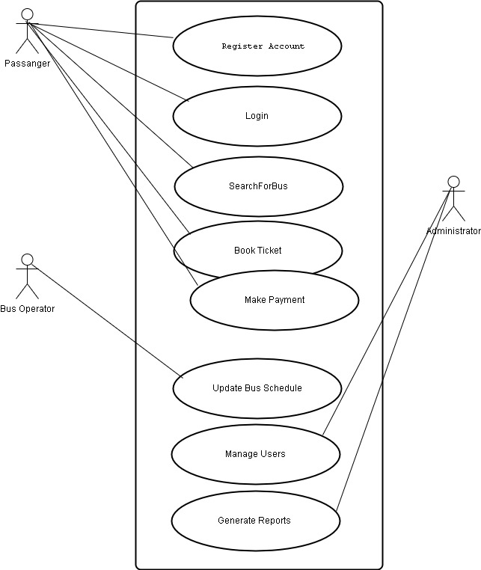

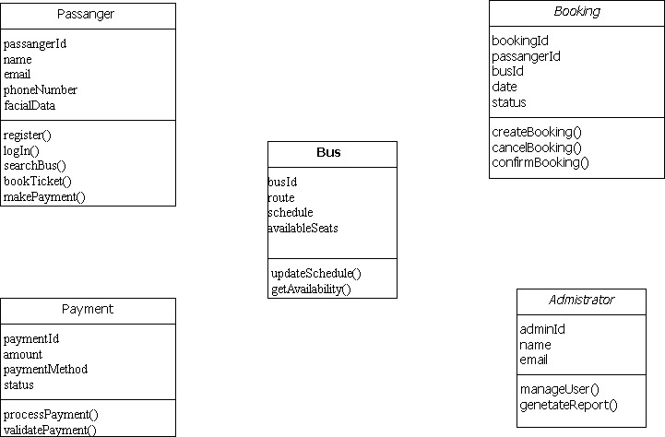

## **CRC Diagram (Class-Responsibility-Collaboration)**

|  |  |
| --- | --- |
| **Passenger** | |
| **RESPONSIBILITY** | **COLLABORATION** |
| Register  Login  SearchBuses  bookTickets  makePayments | Booking  Payments  bus |

|  |  |
| --- | --- |
| **Bus** | |
| **RESPONSIBILITY** | **COLLABORATION** |
| maintainSchedule  updateRoute  manageSeats | booking |

|  |  |
| --- | --- |
| **Booking** | |
| **RESPONSIBILITY** | **COLLABORATION** |
| CreateBooking  cancelBooking  confirmBooking | Passenger  Bus  Payment |

|  |  |
| --- | --- |
| **Payment** | |
| **RESPONSIBILITY** | **COLLABORATION** |
| processPayments  validatePayments | Booking  Payments |

## **Sequence Diagram: Ticket Booking Process**

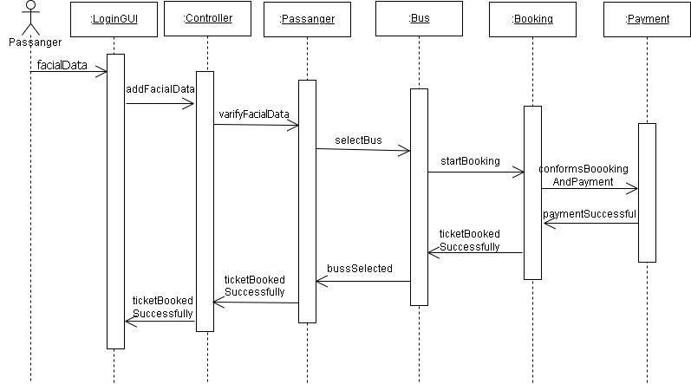

## **Collaboration Diagram: Ticket Booking Process**

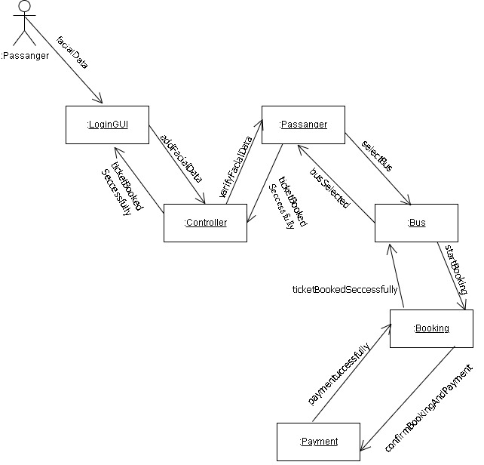

## **Activity Diagram: Ticket Booking and Payment**

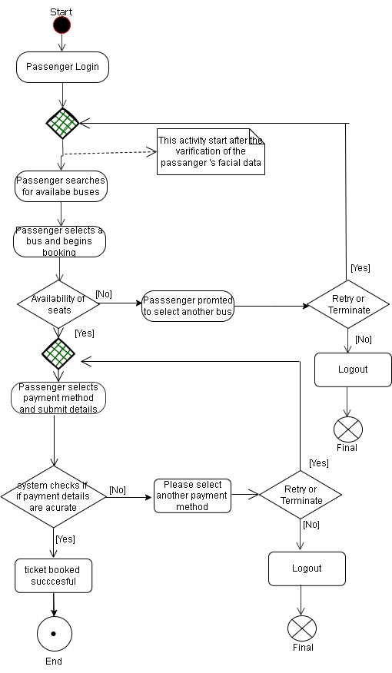

Challenges of the Phinduvuke Bus Ticket Booking System

Despite its innovative approach, the Phinduvuke Bus Ticket Booking System faces several challenges in implementation and operation:

* + 1. Technical Challenges

Integration with Payment Gateways: Ensuring seamless transactions with multiple payment methods (mobile money, credit/debit cards, bank transfers) while minimizing failures.

System Reliability: Preventing website crashes, slow response times, and technical glitches during peak usage hours.

Facial Recognition Accuracy: Ensuring a high level of accuracy in facial recognition for user authentication while preventing false positives/negatives.

* + 1. Operational Challenges

Real-Time Updates: Ensuring that bus schedules, seat availability, and route changes are updated in real time.

Bus Operator Cooperation: Getting transport operators to consistently update their schedules and provide timely information.

Customer Support: Handling user complaints related to failed payments, booking errors, and system downtime efficiently.

* + 1. User Experience Challenges

Adoption & Digital Literacy: Encouraging users in Eswatini to transition from traditional ticket purchasing to an online system.

Mobile Accessibility: Ensuring the system is optimized for mobile users, given that many users primarily access the internet via mobile phones.

Group Booking Limitations: Enhancing the booking experience for families, businesses, and large groups.

Achievements of the Phinduvuke Bus Ticket Booking System

Despite these challenges, the system has achieved several milestones:

* + 1. Enhanced Convenience & Efficiency

Users can book tickets from anywhere at any time, reducing long queues at ticket counters.

Multiple payment options make transactions more flexible and accessible.

* + 1. Improved Transport Management

The system provides real-time updates on schedules and seat availability, reducing uncertainty for travelers.

Optimized routes help manage traffic congestion and ensure better resource allocation.

* + 1. Strengthened Security & Data Protection

Implementation of facial recognition enhances security and prevents fraudulent bookings.

Encrypted payment processing ensures secure transactions, reducing risks of financial fraud.

* + 1. Data-Driven Decision Making

The system collects valuable data on travel trends, peak hours, and user preferences, helping bus operators optimize their services.

Advanced analytics improve decision-making for transport authorities and private operators.

* + 1. Contribution to Eswatini’s Digital Transformation

Supports the government’s push for digital innovation in the transport sector.

Encourages cashless transactions, aligning with global digital economy trends