WEBSITE PROJECT PROPOSAL
Web Development (Introduction) (WEDE5020)
Student: Vuyelwa Sewela
Student number: ST10502203
Selected organisation: Ous Ma'mikis WhatsApp Café
Portfolio of Evidence - 2026

Table of Contents
1. Proposal 1: Ous Ma'mikis WhatsApp Café
2. Proposal 2: NSPCA / SPCA Network
3. Selected Project Plan
4. Sitemap
5. Low-fidelity Wireframes
6. Timeline and Milestones
7. Budget
8. Technical Requirements
9. References

1. Proposal 1: Ous Ma'mikis WhatsApp Café

1.1 Organisation overview
Ous Ma'mikis WhatsApp Café is a small food business that prepares and sells convenient meals to customers in the surrounding area. The business currently relies mainly on WhatsApp to communicate with customers, share menu information and receive food orders. A large part of the target audience includes staff members working at nearby companies that do not have their own canteens, as well as office workers, regular local customers and people looking for convenient prepared meals. The proposed mission is to prepare satisfying home-style meals and make ordering simple for local customers. The proposed vision is to become a trusted local lunch option known for approachable service, easy ordering and dependable prepared meals.

1.2 Website goals, objectives and KPIs
The website will give customers a quicker way to view meals, sample prices and photographs without having to request the menu first. It will also strengthen the business's online presence and support enquiries through both forms and WhatsApp. Success can be measured through monthly website visits, menu-page views, enquiry-form submissions, WhatsApp button clicks and the percentage of visitors using a mobile device. Initial prototype targets are 100 monthly visits, at least 20 enquiry or WhatsApp actions per month and a mobile usability test with no horizontal scrolling at the defined breakpoints.

1.3 Current process analysis
The current WhatsApp-only process is familiar and personal, but customers may need to ask for the menu before they can decide what to buy. This creates repeated work for the owner and makes it harder for a new customer to discover the business through a normal web search. The proposed site keeps WhatsApp available while moving frequently requested information into a structured website.

1.4 Features, design and user experience
The proposed site will include Home, Menu, About, Order, Gallery, Contact and References pages. Later phases will add menu search/filtering, a gallery lightbox, validated enquiry and contact forms, a WhatsApp order summary and an interactive map. The visual direction uses warm cream, orange and green tones to suggest homemade food, with strong contrast, readable typography, clear calls to action and a responsive layout. The site will be designed mobile-first because customers are likely to browse during a workday on their phones.

1.5 Technical requirements, timeline and budget
The site will use semantic HTML5, an external CSS stylesheet and vanilla JavaScript, with Git/GitHub for version control. Netlify is suitable for student deployment because its Free plan supports static deployment, custom domains and a limited monthly credit allowance (Netlify, 2026). A .co.za domain is currently listed by Afrihost at R197 for registration and R99 annual renewal (Afrihost, 2026). South African published-price research reports a median online-store price of R7 250, which provides a useful benchmark for a small interactive business site even though this student prototype does not process live card payments (Orcanically, 2026). The academic implementation is divided across Part 1 HTML/planning, Part 2 CSS/responsiveness and Part 3 JavaScript/SEO/testing/deployment.

2. Proposal 2: NSPCA / SPCA Network

2.1 Organisation overview
The National Council of SPCAs (NSPCA) is a South African non-profit animal-welfare organisation. The NSPCA states that it has protected animals since 1955, that its mission is to prevent cruelty and promote the welfare of all animals, and that its vision is to end animal cruelty in South Africa and engender compassion for all animals (NSPCA, 2026). The wider SPCA network serves people who need to report cruelty, contact a local SPCA, seek animal-care advice, adopt animals, volunteer or donate.

2.2 Website goals, objectives and KPIs
The project concept would create a more consolidated experience for locating participating SPCAs and viewing their key public information. Important goals would be to reduce the time required to find the correct local SPCA, make emergency and normal contact information clear, make adoption information easier to browse and provide a consistent page structure for participating societies. Possible KPIs would include successful locator searches, adoption-profile views, completed contact actions, donation clicks and task-completion rates in usability testing.

2.3 Current website analysis
The NSPCA already has a functioning national website and a 'Find Your Local SPCA' tool. The NSPCA explains that local SPCAs are separate autonomous societies responsible for their own areas, and its locator allows users to search by postal code or location (NSPCA, 2026). This means the original ICE concept of creating a locator is partly already addressed by the live site. A revised project would therefore focus less on replacing the existing national platform and more on improving consistency, adoption discovery and information architecture across participating local societies.

2.4 Proposed features and design
The proposed site would include a clear local-SPCA finder, uniform society profile pages, adoption profiles with filtering, lost-and-found information, donation and volunteer calls to action, emergency-contact guidance and social-media links. The design would prioritise trust, clarity, accessibility and strong contrast. Because users may arrive during stressful situations, emergency information would be visually separated from ordinary enquiries, while adoption browsing would use friendly imagery and concise filters.

2.5 Technical requirements, timeline and budget
A prototype could use HTML, CSS and JavaScript with a small static dataset, but a real national implementation would eventually need a database, content-management workflow, location services and strong governance over local-society information. This makes it significantly more complex than the café project. For an introductory web-development PoE, Ous Ma'mikis is therefore the more achievable choice because the project can still demonstrate responsive design, search/filtering, forms, a map, SEO and JavaScript without pretending to solve a national data-management problem.

3. Selected Project Plan
Ous Ma'mikis WhatsApp Café is selected for implementation. It matches the small-business option in the brief, has a clearly defined target audience and provides enough natural functionality for all three parts of the PoE. The project will not invent private business details. Any unconfirmed WhatsApp number, street address, exact trading hours or production menu will remain marked as prototype content until confirmed by the organisation.

4. Sitemap
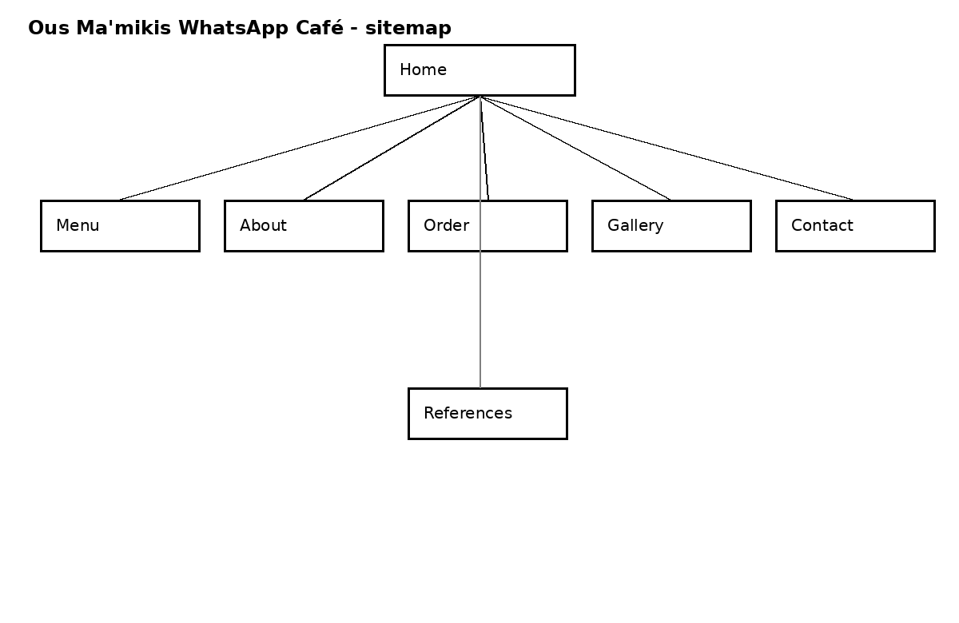

5. Low-fidelity Wireframes
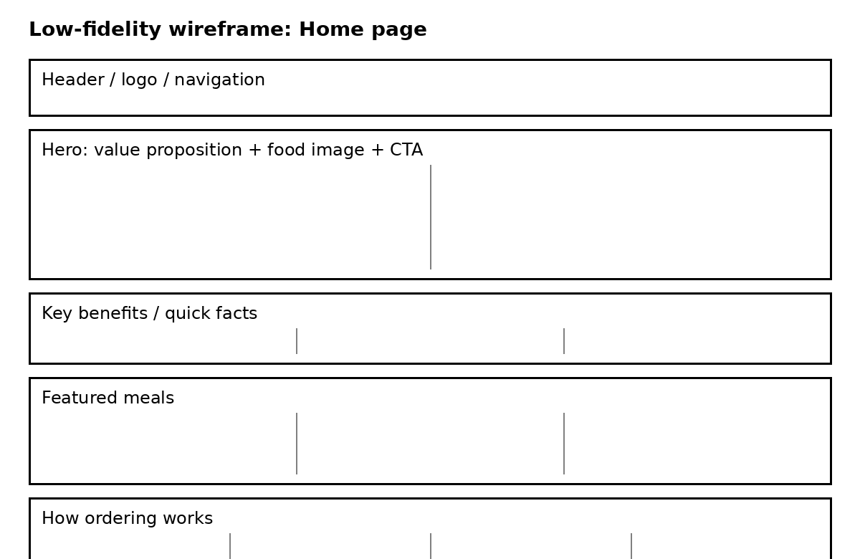
Home page wireframe
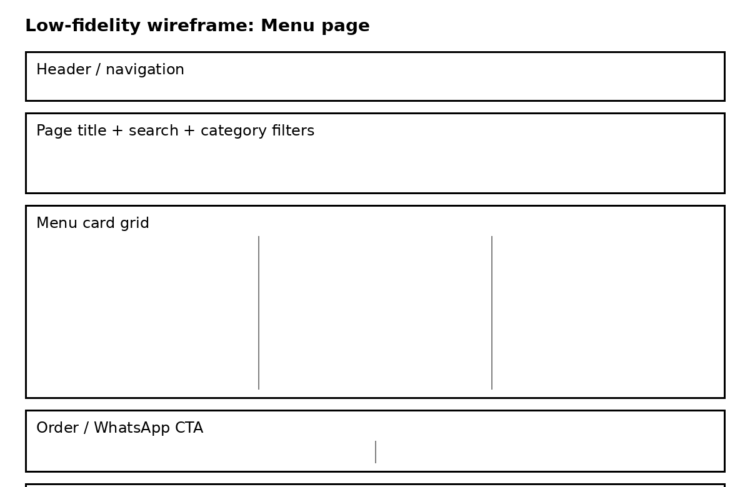
Menu page wireframe
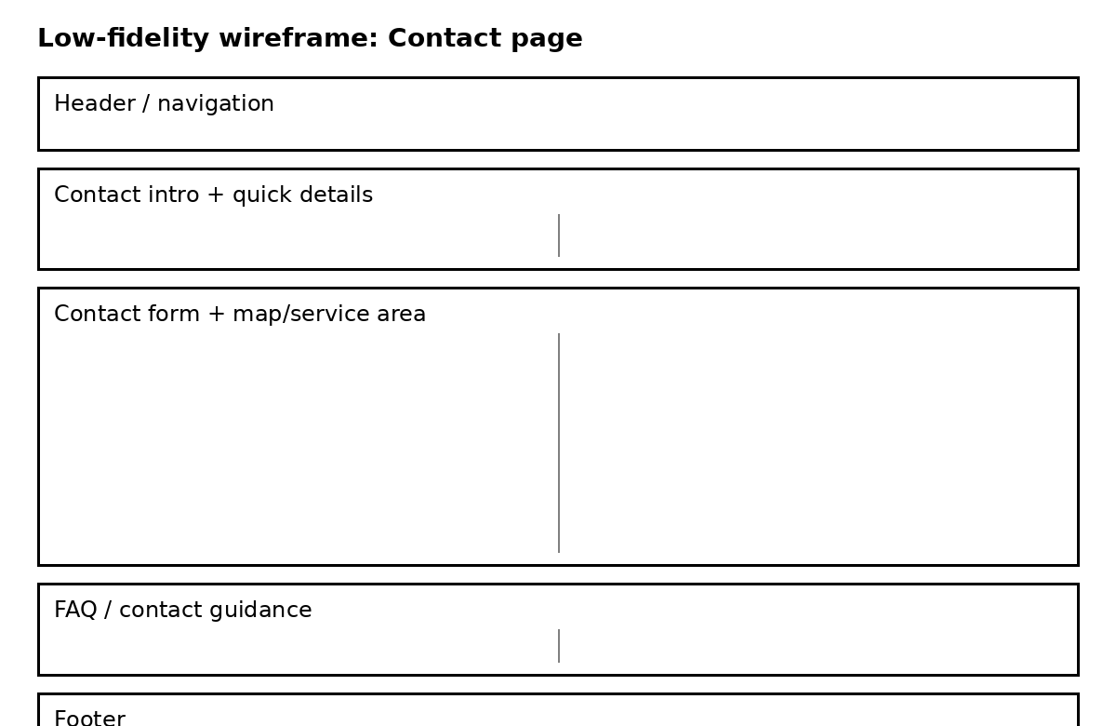
Contact page wireframe

6. Timeline and Milestones
Milestone | Main work | Estimated hours | Submission alignment
Planning and proposal | Research, proposals, sitemap, wireframes, file structure | 18 | Before Part 1 due date
Part 1 HTML foundation | Semantic pages, content, navigation, references, README | 24 | Part 1
Part 2 visual design | External CSS, Grid/Flexbox, responsive breakpoints, states, screenshots | 22 | Part 2
Part 3 functionality | JavaScript, search/filter, gallery, forms, WhatsApp, SEO, sitemap.xml | 20 | Part 3
Testing and deployment | Browser/device checks, fixes, README/changelog, Netlify deployment | 6 | Before final submission
Total planned effort: approximately 90 hours, matching the minimum suggested time in the assessment brief.

7. Budget
Item | Basis | Estimated cost | Notes
Website development | 2026 SA median online-store benchmark | R7 250 once-off | Benchmark only; student development is completed as coursework.
.co.za domain | Afrihost published price | R197 registration; R99 renewal | Domain optional for the student prototype.
Hosting | Netlify Free plan | R0 within free-plan limits | Appropriate for learning/prototype traffic.
Alternative shared hosting | Afrihost Linux Silver | R84/month | Optional if business later wants traditional hosting/email.
Maintenance allowance | Project estimate | R700/month | Example allowance for small monthly content updates; not a quoted market tariff.
The budget separates published external prices from project estimates so that assumptions are not presented as supplier quotations.

8. Technical Requirements
- HTML5 for semantic page structure and accessible forms.
- CSS3 in an external stylesheet using Flexbox, Grid, relative units, pseudo-classes and responsive media queries.
- Vanilla JavaScript for mobile navigation, menu search/filtering, cart behaviour, lightbox, form validation and WhatsApp message generation.
- Git and a private GitHub repository for version control with descriptive commits.
- Netlify for deployment and static form handling; form detection must be enabled in Netlify.
- A .co.za domain can be connected later if the business chooses to register one.
- OpenStreetMap embed for the map without inventing an unconfirmed private address.
- Search-engine optimisation through unique titles, meta descriptions, heading hierarchy, descriptive links, alt text, robots.txt and sitemap.xml.

9. References
Afrihost (2026) Domain search and registration. Available at: https://www.afrihost.com/domains (Accessed: 2 November 2026).
Afrihost (2026) Shared Hosting. Available at: https://www.afrihost.com/shared-hosting (Accessed: 2 November 2026).
Google Search Central (2026) Influencing title links in Google Search. Available at: https://developers.google.com/search/docs/appearance/title-link (Accessed: 2 November 2026).
MDN Web Docs (2026) Responsive web design. Available at: https://developer.mozilla.org/en-US/docs/Learn_web_development/Core/CSS_layout/Responsive_Design (Accessed: 2 November 2026).
MDN Web Docs (2026) Semantic HTML. Available at: https://developer.mozilla.org/en-US/curriculum/core/semantic-html/ (Accessed: 2 November 2026).
Netlify (2026) Pricing and Plans. Available at: https://www.netlify.com/pricing/ (Accessed: 2 November 2026).
Netlify Docs (2026) Forms setup. Available at: https://docs.netlify.com/manage/forms/setup/ (Accessed: 2 November 2026).
NSPCA (2026) About the NSPCA. Available at: https://nspca.co.za/about-us/ (Accessed: 2 November 2026).
NSPCA (2026) Find Your Local SPCA. Available at: https://nspca.co.za/find-an-spca/ (Accessed: 2 November 2026).
OpenAI (2026) ChatGPT (GPT-5.6 Sol) [Large language model]. Available at: https://chatgpt.com/ (Accessed: 2 November 2026).
Orcanically (2026) What a Website Costs in South Africa: 2026 Price Survey. Available at: https://orcanically.co.za/resources/website-cost-survey/ (Accessed: 2 November 2026).
Sewela, V. (2026) WEDE5020 ICE Task 1 [Unpublished student work]. The Independent Institute of Education.
Image credits used in the website are listed on the website References page and in README.md. All Creative Commons image links and licences should be rechecked before final submission if images are changed.

