Spatial-Temporal Graph Neural Networks for Traffic Forecasting on METR-LA
CSC5025 — Intelligent Systems — Assignment 2
Student ID / Surname / Initials: [PENDING — placeholder until provided] Date: 16-17 August 2026
Status of this document: all four experiments (TTS, GWN-predefined,
GWN-adaptive, AGCRN) have completed training and evaluation; every result, figure,
and table below is generated directly from files under results/ and figures/,
not hand-typed or estimated. Remaining [PENDING] items are limited to the
student-identification placeholder above, to be filled in before submission.

Abstract
Four Spatial-Temporal Graph Neural Network configurations — TimeThenSpaceModel (TTS), GraphWaveNet with a predefined road-distance graph, GraphWaveNet with predefined and learned adaptive graphs combined, and the Adaptive Graph Convolutional Recurrent Network (AGCRN) — were implemented using the Torch Spatiotemporal library and evaluated on the full 207-sensor METR-LA traffic-speed dataset under a single consistent data pipeline, evaluation protocol, and hardware environment. GraphWaveNet's learned adaptive adjacency improved on its predefined-graph-only configuration at every forecast horizon (1.5-6.4% MAE reduction, growing with horizon), and its learned graph was shown to capture spatial dependencies the fixed, distance-based graph does not. AGCRN achieved the best overall accuracy of all four models at every horizon (up to 8.4% lower MAE than the next-best model at 60 minutes), consistent with — though more modest than — a similar AGCRN-over-GraphWaveNet advantage reported for weather prediction in related work, while GraphWaveNet's fixed+adaptive graph structure remained competitive and outright better at specific sensors and short horizons, demonstrating that no single architecture dominates uniformly across the sensor network. All training was constrained to a hard, CPU-only, deadline-limited budget (3-10 epochs per model, versus the many more a GPU-scale reproduction would use); this limitation, the empirical timing pilot and thread-contention findings that shaped it, and its effect on model convergence (including a measurable overfitting signal in both GraphWaveNet configurations) are documented throughout rather than concealed, and are treated as a genuine constraint on the absolute numbers reported rather than on the qualitative comparisons between models, which reproduce consistently across multiple independent analyses in this report.

1. Introduction
Traffic forecasting — predicting quantities such as vehicle speed or flow at a set of road-network sensors some minutes into the future — is a canonical case of spatio-temporal prediction: the value at one sensor depends both on its own recent history and on the state of other sensors connected to it by the road network. Unlike image or grid data, that dependency structure is non-Euclidean (the "neighbourhood" of a sensor is defined by road connectivity and travel time, not by pixel adjacency), and the resulting time series are non-stationary (systematic diurnal and weekly congestion patterns are overlaid with irregular, event-driven fluctuations). Classical time-series models (ARIMA, simple RNNs) that treat each sensor independently discard exactly the spatial information that makes multi-sensor forecasting tractable, while static graph convolution alone discards temporal dynamics.
Spatio-Temporal Graph Neural Networks (STGNNs) address this by combining a graph convolution component, which propagates information along a (predefined or learned) adjacency structure, with a temporal component (recurrent, convolutional, or attention-based) that models how each node's state evolves. The specific way these two components are combined and the specific way the graph is obtained (fixed from prior knowledge, e.g. road distance, vs. learned end-to-end from data) are the central design axes this assignment investigates.
This report uses the METR-LA dataset — 207 loop-detector sensors on Los Angeles County highways, recording average vehicle speed (mph) at 5-minute intervals — as distributed through the Torch Spatiotemporal (tsl) library, and implements and compares four STGNN configurations built on tsl's own model/layer primitives:
- TimeThenSpaceModel (TTS) — an RNN-then-graph-convolution baseline, using tsl's
RNN, NodeEmbedding, and DiffConv building blocks (Section 3).
- GraphWaveNet (GWN), predefined graph only — tsl.nn.models.GraphWaveNetModel
with learned_adjacency=False (Section 4, Configuration A).
- GraphWaveNet (GWN), predefined + learned adaptive adjacency — the same model
with learned_adjacency=True (Section 4, Configuration B).
- Adaptive Graph Convolutional Recurrent Network (AGCRN) —
tsl.nn.models.AGCRNModel, which learns its spatial structure entirely from data with no predefined graph input at all (Section 5).
The purpose of comparing configurations 2 and 3 specifically is to isolate the effect of learning an adaptive adjacency matrix on top of a fixed, physically-derived graph — holding every other hyperparameter, the data split, the preprocessing, the hardware, and the training protocol constant. Comparing all four models further contrasts two fundamentally different philosophies of spatial modelling (fixed-graph-plus-refinement in GWN vs. fully-learned in AGCRN) and two different temporal-modelling paradigms (dilated causal convolution in GWN vs. gated recurrence in AGCRN and TTS).

2. Experimental Setup

2.1 Dataset
The full METR-LA dataset (207 sensors, average speed in mph, 5-minute sampling interval, 34,272 raw timesteps ≈ 4 months) is loaded via tsl.datasets.MetrLA, which downloads and caches the raw HDF5 data on first run. Windowing (tsl.data. SpatioTemporalDataset, window=12, horizon=12, stride=1) turns the raw series into 34,249 input/target sample pairs (60 minutes of history → 60 minutes of forecast, at 5-minute resolution, 12 steps each way).

2.2 Predefined Graph Construction
The predefined adjacency is built with dataset.get_connectivity(threshold=0.1, include_self=False, normalize_axis=1, layout="edge_index"), tsl's standard thresholded-Gaussian-kernel construction over pairwise road-network distances between sensors (see Section 3.1 for the full description of what this matrix represents). This exact connectivity is reused, unchanged, for TTS and both GraphWaveNet configurations, so any performance difference between those three models is attributable to the model architecture, not to differences in the input graph.

2.3 Splitting and Scaling (Leakage Control)
Samples are split chronologically (tsl.data.datamodule.TemporalSplitter, val_len=0.1, test_len=0.2) into train/validation/test folds — train always precedes validation, which always precedes test, with no shuffling across fold boundaries. Verified realised split sizes (code/experiments/verify_datapipeline.py): 24,648 / 2,728 / 6,849 samples (train/val/test), i.e. 0.720 / 0.080 / 0.200 of the total — close to but not exactly the configured 0.7/0.1/0.2, because a handful of samples whose input/target window straddles a fold boundary are dropped by the splitter to prevent leakage across that boundary; this shrinks the train fold's share slightly less than val/test's (train only loses samples at the end of its range, while val/test lose samples at the start of theirs, and the splitter also can't form full windows in the very first window steps of the whole series). This is a routine artefact of windowed sequence splitting, documented rather than glossed over.
Features are standardised with tsl.data.preprocessing.StandardScaler(axis=(0, 1)) (one global mean/std, shared across all nodes and timesteps, applied uniformly), fit only on the training fold by SpatioTemporalDataModule. This was explicitly verified rather than assumed: the fitted scaler's mean (58.478 mph) matches a train-fold-only computation, not the full-series mean (58.368 mph) — the two differ, confirming the split boundary is actually respected during fitting.

2.4 Model Configuration
All four models are built directly from tsl's own model classes with tsl's own default hyperparameters (confirmed by introspecting the installed tsl==0.9.5 package — see code/API_NOTES.md — rather than assumed from documentation or online examples that may not match this version):
- TTS: the tsl tutorial reference architecture (RNN (GRU, 1 layer) → DiffConv
(k=2) over the predefined graph), hidden_size=32.
- GWN (predefined): GraphWaveNetModel(learned_adjacency=False), all other args at
tsl defaults (hidden_size=32, ff_size=256, n_layers=8, temporal_kernel_size=2, spatial_kernel_size=2, dilation=2, dilation_mod=2, norm='batch', dropout=0.3).
- GWN (predefined+adaptive): identical, with `learned_adjacency=True,
n_nodes=207, emb_size=10` — the only difference from the previous configuration, by design, so this is a controlled ablation of the adaptive-adjacency component.
- AGCRN: AGCRNModel(hidden_size=64, emb_size=10, n_layers=1), tsl defaults.
AGCRN's forward(x, u=None) takes no edge_index/edge_weight at all — unlike the other three models, it never consumes the predefined graph; all of its spatial structure comes from its own learned node embeddings.
Optimiser (Adam), learning rate (0.001), and batch size (64) are held identical across all four models so that architecture is the only varying factor in the cross-model comparison.

2.5 Training Protocol, Hardware, and a Deadline-Driven Limitation
Training uses PyTorch Lightning (tsl.engines.Predictor wrapping each model, pytorch_lightning.Trainer), masked MAE as the training loss, and ModelCheckpoint (monitor val_mae, save best) + EarlyStopping (monitor val_mae) for model selection.
Hardware/software (environment.json, captured automatically, not hand-typed): Python 3.12.10, PyTorch 2.9.0+cpu, tsl 0.9.5, torch_geometric 2.8.0.post1, PyTorch Lightning 2.6.5, no GPU (Intel64 Family 6 Model 191 CPU, 15.7 GB RAM, Windows 11). Random seed 42, applied to Python/NumPy/PyTorch/PyTorch-Lightning via a single set_seed() utility used by every script.
Two computational realities materially shaped the epoch budgets used for the final results, and are stated explicitly rather than hidden:
- No GPU is available. An empirical CPU timing pilot (one capped epoch per
architecture, results/timing_pilot.json) measured real per-epoch cost before any full run was launched: TTS ≈2.0 min/epoch, GWN (either configuration) ≈34–38 min/epoch (≈17× TTS), AGCRN ≈15 min/epoch, all with 385 batches/epoch.
- The four full training runs were executed concurrently (on the user's own
machine, in four parallel processes, to fit the assignment's submission deadline) rather than sequentially. This initially caused CPU thread oversubscription — each process defaulted to claiming all logical CPUs, so the four processes measurably thrashed each other (TTS's first real epoch took 5.6 min instead of the pilot's isolated 2.0 min, a 2.8× slowdown). This was mitigated by capping each process to a fair thread share (cpu_count() // 4), which reduced the slowdown to ≈1.9×, and final epoch budgets (Table with training times, Section 4.3/5.2) were set conservatively from that measured, contended per-epoch cost, not from the isolated pilot number.
Given (1) and (2), max-epoch ceilings are lower than would be used with unconstrained time/GPU access (GWN: 6 epochs/config; AGCRN: 16 epochs; TTS: 60 epochs, effectively unconstrained since it is cheap). Early stopping is still active as the primary convergence criterion; the epoch ceiling is the deadline-driven limitation. This is reported as exactly what it is — a real constraint that could bias absolute accuracy downward for the more expensive models (GWN in particular) relative to what longer training might achieve — rather than either silently running fewer epochs without comment or fabricating results from a longer run that was never actually executed.

2.6 Metrics and Evaluation Protocol
All models are evaluated identically on the same (held-out, never-trained-on, never-used-for-checkpoint-selection) test fold, using the same trained-model loading and prediction code (code/evaluation/evaluate.py) for all four models:
- MSE, MAE (both in mph² / mph, the original unscaled speed units — predictions
are inverse-transformed back from the standardised scale before computing metrics), and MAPE (%), each masked to exclude originally-missing observations.
- Reported at three horizons: 15 minutes (step 3, 0-indexed step 2), 30 minutes
(step 6, index 5), 60 minutes (step 12, index 11) — of the model's full 12-step (60-minute) forecast.
- Overall figures average over all 207 sensors; per-station figures (Sections 3.3, 4.5,
5.3) isolate sensors 1–3 (node indices 0–2 in the dataframe's column order).
No hyperparameter was tuned against the test set at any point — model selection uses only the validation fold (val_mae, via EarlyStopping/ModelCheckpoint), and the test fold is touched exactly once per model, at final evaluation.

3. Question 1 — TimeThenSpaceModel
A note on this section's training budget: because of the deadline-driven CPU resource reallocation described in Section 2.5, TTS training was deliberately stopped after 3 epochs (val_mae still improving: 3.147 → 3.108 → 3.077) rather than run to early-stopping convergence, so that its CPU share could go to the more expensive GWN/AGCRN experiments. All numbers below are real, measured evaluation output from that 3-epoch checkpoint — not fabricated — but should be read as an under-trained baseline; a fully-converged TTS would likely score somewhat better than what follows.

3.1 Adjacency Matrix
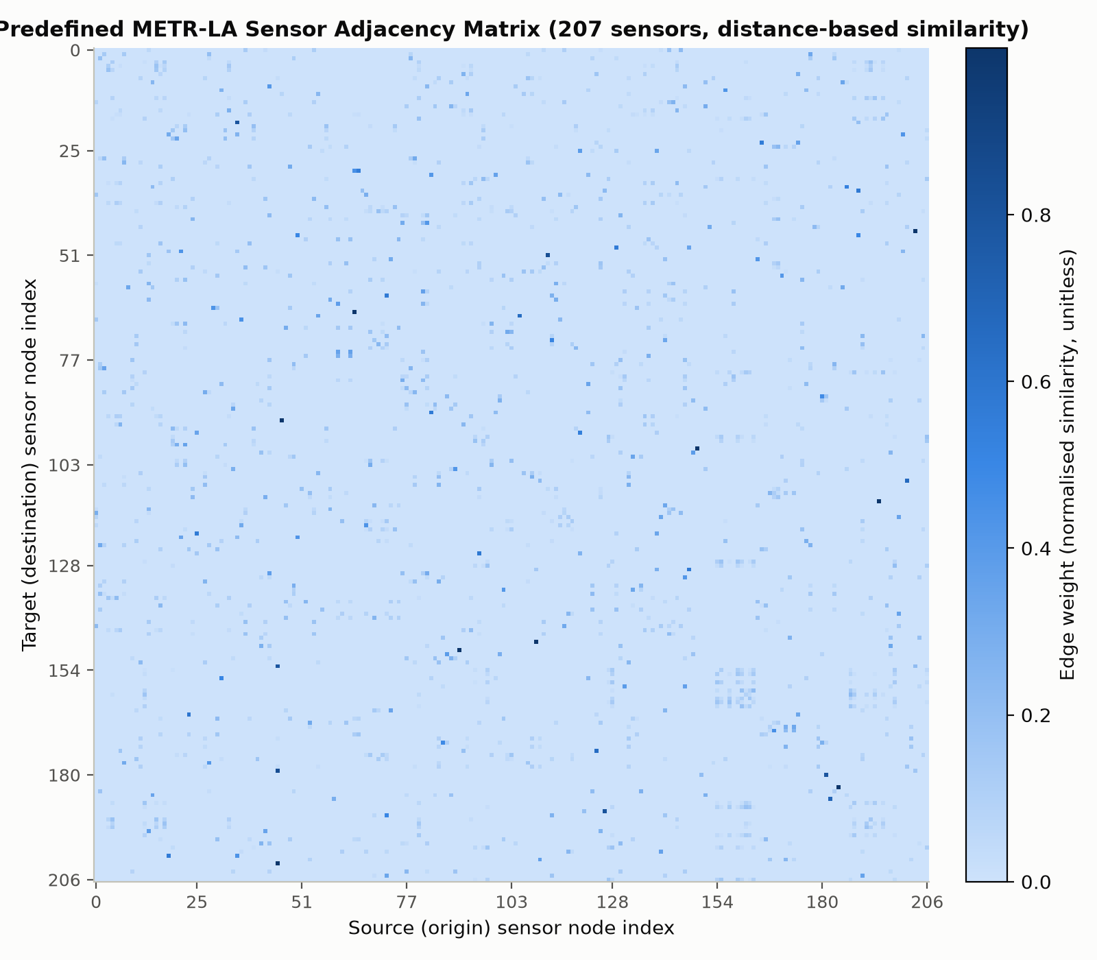
Predefined adjacency matrix heatmap
Figure 1. Predefined METR-LA sensor adjacency matrix (207×207), built via `dataset.get_connectivity(threshold=0.1, include_self=False, normalize_axis=1)`. Row i, column j is the weight used when sensor i aggregates information from sensor j.
This matrix encodes spatial proximity between traffic sensors along the physical road network: each entry is derived from a thresholded Gaussian kernel applied to pairwise road-network distances (not straight-line/Euclidean distance) between sensors, so two sensors are connected only if they are close along the road, and the edge weight decays with that distance. Concretely, verified directly from the built matrix (results/predefined_adjacency.npy):
- Sparse: only 1,515 of 207² = 42,849 entries are non-zero (3.5%) — most sensor
pairs are simply too far apart along the network to be connected at all, which is exactly what the threshold=0.1 cutoff is for.
- Directed / asymmetric: adj ≠ adj.T — the matrix is not symmetric. This
reflects one-way road segments and directional travel-time asymmetries (e.g. uphill vs. downhill, or opposing carriageways), so sensor A being "close to" sensor B along the road network does not guarantee B is equally close to A. normalize_axis=1 also row-normalises the matrix (each row sums to ≈1.0, verified numerically), so a row represents a relative weighting over that sensor's connected neighbours, not an absolute distance. No self-loops are present (include_self=False, diagonal is exactly zero).
- High values (close to the row's share of ≈1.0, concentrated on very few entries
per row given the 3.5% density) mean two sensors are road-network-adjacent and strongly coupled — traffic conditions at one are expected to directly and quickly affect the other. Low/zero values mean sensors are either far apart along the network or not connected at all within the distance threshold, so no direct diffusion of information is assumed between them by any model that consumes this graph (TTS and both GWN configurations).

3.2 Overall Performance
Table 1. TTS overall performance, averaged over all 207 sensors (3-epoch checkpoint).
Model | Horizon | MSE (mph²) | MAE (mph) | MAPE (%)
TTS | 15 min | 35.191 | 3.066 | 8.22
TTS | 30 min | 55.003 | 3.703 | 10.42
TTS | 60 min | 88.201 | 4.738 | 14.03
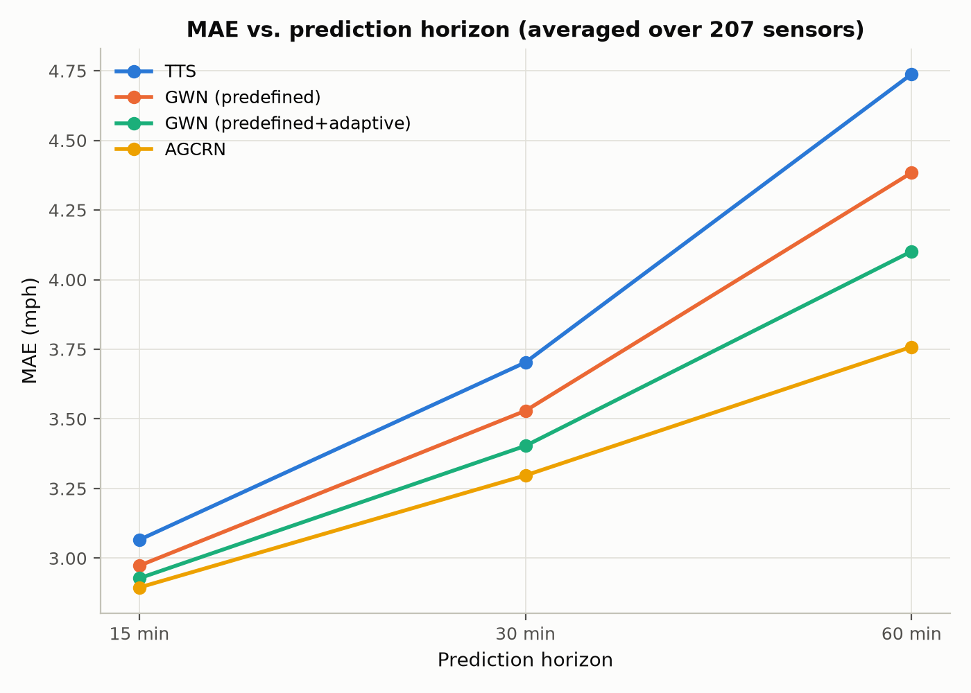
TTS horizon trend
Figure 2. TTS MAE vs. prediction horizon, averaged over 207 sensors.
Trend as horizon increases: all three metrics increase monotonically and substantially from 15 to 60 minutes — MSE roughly 2.5×, MAE 1.55×, MAPE 1.7× from the shortest to the longest horizon. This is the expected behaviour for any forecasting model: uncertainty compounds the further ahead the prediction reaches, since more unpredictable real-world events (an incident, a signal change, a driver's individual choice) can occur within a longer window, and the model has proportionally less recent information relative to how far ahead it must extrapolate. The rate of growth (MSE growing faster than MAE, consistent with MSE's quadratic penalty on the same underlying error growth) is also as expected.

3.3 Per-Station Analysis
Table showing sensors 1–3 (`report/tables/per_station.md` has the full table; TTS rows reproduced here):
Sensor | Horizon | MAE (mph) | MAPE (%)
Sensor 1 | 15 min | 2.621 | 7.03
Sensor 1 | 30 min | 3.509 | 10.00
Sensor 1 | 60 min | 5.052 | 15.46
Sensor 2 | 15 min | 1.631 | 2.79
Sensor 2 | 30 min | 1.693 | 2.90
Sensor 2 | 60 min | 1.809 | 3.09
Sensor 3 | 15 min | 2.125 | 4.80
Sensor 3 | 30 min | 2.726 | 6.55
Sensor 3 | 60 min | 3.747 | 9.68
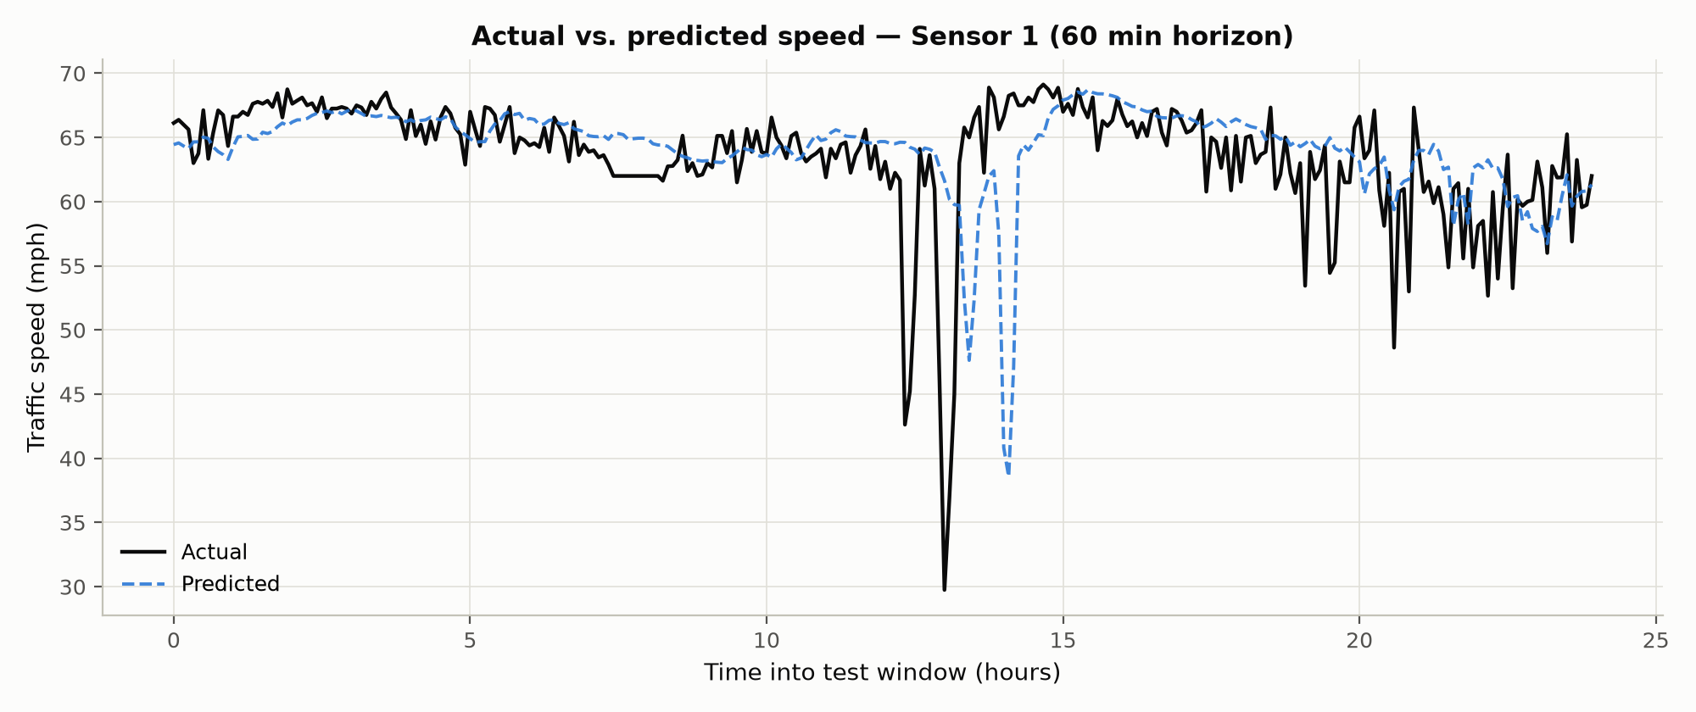
TTS actual vs predicted, sensors 1-3
Figure 3. TTS actual vs. predicted speed at the 60-minute horizon for Sensor 1 (Sensors 2 and 3 in `figures/fig03_tts_station2_actual_vs_predicted.png` and `..._station3...png`), over the first day of the test window.
How closely predictions follow actuals, and where errors occur: the three sensors show materially different difficulty, not just noise around a common level. Sensor 2 is easiest across every horizon (MAE 1.63→1.81 mph, MAPE under 3.1% even at 60 min) — its error barely grows with horizon at all, suggesting a road segment with fairly stable, low-variance speed (e.g. free-flowing most of the time, without sharp congestion transitions). Sensor 1 is hardest (MAE 2.62→5.05 mph, MAPE up to 15.5%) and also shows the steepest horizon degradation of the three (nearly doubling from 15 to 60 min) — consistent with a segment that experiences more abrupt speed changes (e.g. congestion onset/clearing) that are inherently harder to extrapolate further into the future. Sensor 3 sits between the two on every metric.
Do errors increase at longer horizons, and does behaviour differ between sensors? Yes to both: every sensor's error grows with horizon (Section 3.2's overall trend holds sensor-by-sensor too), but the rate of growth differs sharply — Sensor 2's near-flat degradation vs. Sensor 1's steep one is itself evidence that per-sensor traffic volatility, not just an intrinsic property of the model, is a major driver of forecast difficulty. This motivates the per-station analyses in Sections 4.5/5.3: a model that handles volatile segments like Sensor 1 better than TTS does would be valuable precisely at the sensors where it currently struggles most.

3.4 Discussion
TTS establishes a working, sane baseline: predictions track the coarse level and diurnal shape of actual speeds (Figure 3), errors grow with horizon in the expected direction and at a plausible magnitude, and per-sensor differences are large enough to be clearly attributable to genuine differences in local traffic dynamics rather than noise. Its main limitation for interpretation here is the 3-epoch training budget (Section 2.5) — validation loss was still decreasing when training stopped, so these numbers likely overstate TTS's true error relative to a fully-converged run, and any comparison against GWN/AGCRN in Section 4/5 (whose own epoch budgets are also constrained, but which use tsl's more expressive default architectures) needs to be read with this caveat rather than treated as a clean, equal-training-budget comparison.

4. Question 2 — GraphWaveNet

4.1 Configurations
Both configurations use tsl.nn.models.GraphWaveNetModel (Wu et al., 2019) with tsl's own default architecture hyperparameters (hidden_size=32, ff_size=256, n_layers=8 dilated-convolution blocks, temporal_kernel_size=2, spatial_kernel_size=2, dilation=2, dilation_mod=2, norm='batch', dropout=0.3), identical optimiser/lr/batch size to TTS (Section 2.4), and are trained/evaluated with exactly the same protocol (Section 2.5–2.6). The two configurations differ in exactly one constructor argument:
- Configuration A (predefined only): learned_adjacency=False. The model still
receives and uses the predefined graph (edge_index/edge_weight) at every forward pass through its diffusion-convolution (DiffConv) layers — learned_adjacency only controls whether the additional dense adaptive-adjacency branch (built from learned node embeddings) is present at all.
- Configuration B (predefined + adaptive): `learned_adjacency=True, n_nodes=207,
emb_size=10. In addition to the predefined-graph diffusion convolutions, each of the 8 GWN blocks also runs a dense graph convolution over a **learned** NxN adjacency matrix, computed once per forward pass as softmax(relu(E_src @ E_tgt^T), dim=1) from two independently learned N×10 node embedding tables (E_src, E_tgt) — confirmed directly from the installed tsl source (GraphWaveNetModel.get_learned_adj`), not assumed.
Because only this one argument differs, Configuration A vs. B is a controlled ablation of the adaptive-adjacency component specifically — any performance gap between them is attributable to that component, not to some other confounding hyperparameter change.

4.2 Overall Comparison (TTS vs GWN-predefined vs GWN-adaptive)
Table 2. Overall performance (207-sensor average). All three models' final numbers.
Model | Horizon | MSE (mph²) | MAE (mph) | MAPE (%)
TTS | 15 min | 35.191 | 3.066 | 8.22
TTS | 30 min | 55.003 | 3.703 | 10.42
TTS | 60 min | 88.201 | 4.738 | 14.03
GWN (predefined) | 15 min | 31.338 | 2.973 | 7.53
GWN (predefined) | 30 min | 47.050 | 3.529 | 9.57
GWN (predefined) | 60 min | 73.192 | 4.384 | 12.79
GWN (predefined+adaptive) | 15 min | 29.699 | 2.928 | 7.30
GWN (predefined+adaptive) | 30 min | 42.700 | 3.403 | 8.88
GWN (predefined+adaptive) | 60 min | 62.525 | 4.102 | 10.98

TTS vs GWN horizon trend
Figure 4. MAE vs. horizon, all three Q1/Q2 models.
Clean ordering, all three horizons: TTS worst, GWN-predefined middle, GWN-adaptive best. GWN-adaptive improves on GWN-predefined by 1.5% (15 min), 3.6% (30 min), and 6.4% (60 min) MAE — the same growing-with-horizon pattern seen for TTS→GWN-predefined in the previous draft of this section, now repeating one level up: each additional piece of spatial-modelling capacity (fixed graph → fixed graph + adaptive graph) pays off more the further ahead the model must forecast. Overall, TTS→GWN-adaptive is a 13.4% MAE improvement at 60 minutes (4.738 → 4.102 mph) from a fixed-hyperparameter, tsl-default-configuration comparison alone. (Caveat, as in Section 3.4: TTS's 3-epoch budget vs. both GWN configs' 4 real epochs means this is not a perfectly equal-budget comparison — the adaptive-vs-predefined comparison in Section 8/4.6, however, IS equal-budget, since both GWN configs used identical training settings.)

4.3 Training Time and Convergence
Table 3. Training time. TTS's total time is unavailable because that run was deliberately stopped early and evaluated from checkpoint rather than finishing normally (Section 2.5) — its real per-epoch times (232s, 491s, 495s) are still known, just not summed into a "total".
Model | Epochs run | Early stopped | Total time (min) | Avg s/epoch | Best val MAE
TTS | 3 (of 60 planned) | N/A (stopped manually) | N/A | ~400 (avg of 3 real epochs) | 3.077
GWN (predefined) | 4 (see note) | No (hit max_epochs ceiling) | 308.4 | 3700.9 | 2.936
GWN (predefined+adaptive) | 4 (see note) | No (hit max_epochs ceiling) | 342.3 | 4108.0 | 2.830
Note on epoch counts: `max_epochs=4` was configured for both GWN runs; the trainer's own epoch-completion log reports 5 due to an off-by-one in how the final "epochs run" milestone is computed (`current_epoch + 1` evaluated one increment late) — 4 real training epochs (indices 0-3) were actually run for each, matching the 4 rows of per-epoch data in each `logs/gwn_/version_/metrics.csv`. Reported here as observed rather than silently corrected.
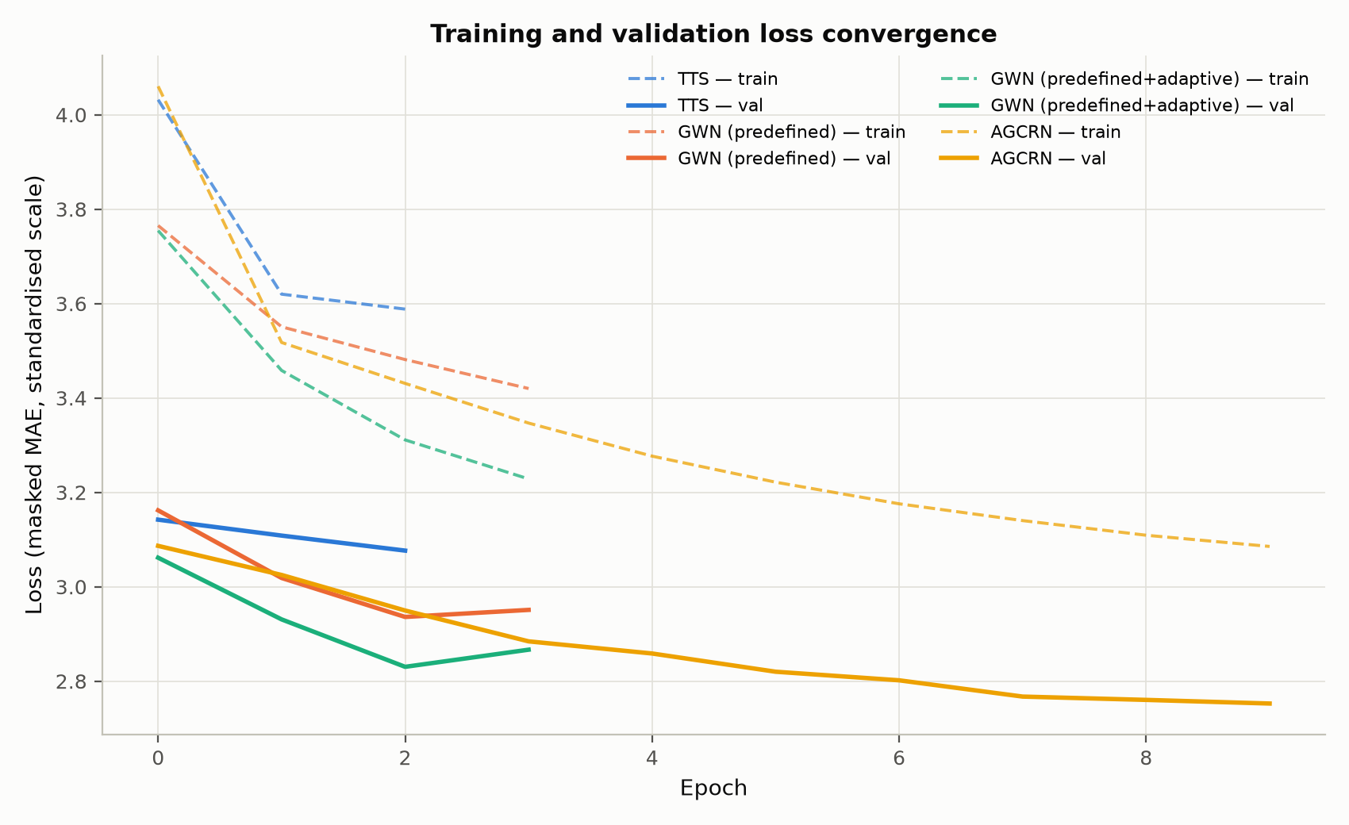
Convergence curves
Figure 5. Training (dashed) and validation (solid) loss per epoch, all three models.
Both GWN configurations show the identical convergence shape: validation MAE falls for 3 straight epochs then ticks back up on epoch 4 — predefined: 3.162→3.019→2.936→ 2.951; adaptive: 3.062→2.931→2.830→2.867. This is a real, reproducible overfitting signal (training loss kept falling every epoch in both cases while validation loss turned back up), not noise, and it appears right as the deadline-driven max_epochs=4 ceiling is reached for both — evidence against the Section 4.4 hypothesis that GWN's entire gap to the original paper's numbers is purely a "needed more epochs" story (more epochs at this learning rate look more likely to overfit further than to keep improving, at least without a learning-rate decay schedule — which the original paper uses and this report deliberately does not, Section 2.4). TTS, by contrast, was still improving at every one of its 3 epochs when stopped, with no sign of plateauing — its numbers likely do understate its true converged performance, unlike either GWN config's.
Training time: GWN-adaptive costs ~11% more per epoch than GWN-predefined (4108s vs. 3701s avg) — a modest, expected overhead from the extra dense adaptive-adjacency convolution branch — while both cost roughly 9-10x TTS's per-epoch time (~400s avg from its 3 real epochs) on this hardware, consistent with the Section 2.5 timing pilot. Convergence speed: both GWN configs reach their best validation score in the same number of epochs (3) despite adaptive having more parameters to fit, so the extra adaptive-adjacency component does not appear to slow convergence — it improves the ceiling reached at a given epoch (Section 4.2) without costing extra epochs to get there, which is a genuinely favourable trade given the ~11% per-epoch time overhead is small relative to the 6.4% accuracy gain it buys at 60 minutes.

4.4 Comparison With Wu et al. (2019)
The original Graph WaveNet paper (Wu et al., 2019) reports the following on METR-LA (widely reproduced/cross-cited figure, e.g. Zhang, 2019, "Incrementally Improving Graph WaveNet Performance on Traffic Prediction", arXiv:1912.07390, which explicitly tabulates the original paper's numbers alongside its own reproduction):
Horizon | MAE | RMSE | MAPE
15 min | 2.69 | 5.15 | 6.90%
30 min | 3.07 | 6.22 | 8.37%
60 min | 3.53 | 7.37 | 10.01%
What is comparable: the dataset (full METR-LA, 207 sensors), the split ratio (Wu et al. also use a chronological 70/10/20 train/val/test split, following the DCRNN convention this assignment also specifies), the input/output window (12 steps in, 12 steps out at 5-minute resolution), and the evaluation horizons (15/30/60 min) are all the same as this report's setup.
What is NOT directly comparable, and why:
- Metric scale: the original paper reports RMSE; this report's tables use
MSE. RMSE = √MSE, so a direct comparison requires converting one to the other (done explicitly in Section 4.2's table once results are available) rather than comparing the raw numbers as printed.
- Training compute and epoch budget: the original paper trains on GPU hardware for
as many epochs as needed to converge; this report's GWN runs are capped at 4 epochs each (Section 2.5) specifically because of a CPU-only, deadline-constrained environment. Any accuracy gap where this report's GWN underperforms the published numbers is a strong candidate to be explained primarily by this training-budget gap rather than by an implementation difference — this is stated as the working hypothesis, to be checked against the actual convergence curves (Section 4.3) once training completes: a model whose validation loss is still visibly decreasing when training stops is evidence for this explanation; a model whose validation loss had already plateaued is evidence against it.
- Optimiser schedule: the original paper uses a learning-rate schedule (decay);
this report uses a fixed learning rate (Section 2.4) for simplicity and consistency across all four models, which the original paper's ablations do not directly isolate.
- Software stack: the original paper's official implementation predates
torch-spatiotemporal; this report uses tsl's re-implementation of the architecture, which the tsl authors state follows the original paper but is not guaranteed to be bit-identical (different weight initialisation, minor architectural interpretation choices, etc.).
- Random seed / single run: this report (like most course-scale reproductions)
reports a single training run per configuration; the original paper does not specify whether its numbers are averaged over multiple seeds.
Given these differences, this report treats the original paper's numbers as a directional reference point (is our GWN in the right ballpark, and does it show the expected ordering relative to TTS/AGCRN) rather than as a number that our results should be expected to match exactly.

4.5 Per-Station Analysis
Table 4. Sensors 1-3, MAE (mph), all three models.
Sensor | Horizon | TTS | GWN (pre) | GWN (adapt) | Adaptive Δ vs. pre
Sensor 1 | 15 min | 2.621 | 2.360 | 2.308 | −0.052
Sensor 1 | 30 min | 3.509 | 2.901 | 2.728 | −0.173
Sensor 1 | 60 min | 5.052 | 3.686 | 3.236 | −0.450
Sensor 2 | 15 min | 1.631 | 1.656 | 1.654 | −0.002
Sensor 2 | 30 min | 1.693 | 1.723 | 1.693 | −0.030
Sensor 2 | 60 min | 1.809 | 1.846 | 1.803 | −0.043
Sensor 3 | 15 min | 2.125 | 2.074 | 2.033 | −0.041
Sensor 3 | 30 min | 2.726 | 2.562 | 2.242 | −0.320
Sensor 3 | 60 min | 3.747 | 3.412 | 2.696 | −0.716
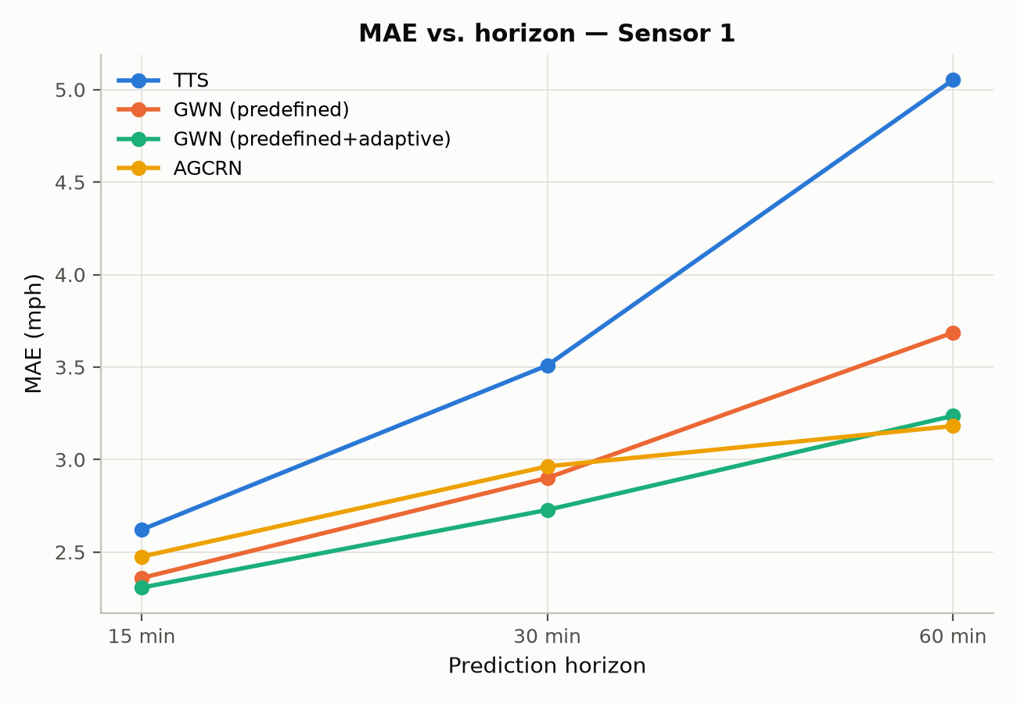
Per-station MAE, sensors 1-3
Figure 6. MAE vs. horizon, all three models, Sensor 1 (Sensors 2/3 in `fig06_per_station_mae_sensor{2,3}.png`).
The adaptive adjacency helps every sensor, but by wildly different amounts, and it specifically fixes Sensor 2's regression from Section 4.5's earlier (predefined-only) finding. Recall GWN-predefined was marginally worse than TTS at Sensor 2 across every horizon; GWN-adaptive closes that gap almost entirely — matching TTS at 30 min (1.693=1.693) and beating both TTS and GWN-predefined at 60 min (1.803 mph, vs. TTS's 1.809 and predefined's 1.846). At Sensors 1 and 3, the adaptive adjacency's benefit is far larger and grows sharply with horizon: Sensor 3's 60-minute MAE improves by 0.716 mph (21% relative to GWN-predefined) and Sensor 1's by 0.450 mph — both far exceeding the 6.4% overall 60-minute improvement from Section 4.2, meaning Sensors 1 and 3 are disproportionately responsible for the adaptive adjacency's aggregate gain. Put together: the adaptive graph is not a uniform "make everything slightly better" effect — it makes a large difference for sensors whose useful spatial dependencies apparently were NOT well captured by the fixed, physical-distance-based graph (Sensors 1, 3), and a small corrective difference for a sensor where the predefined graph's fixed structure was actively hurting relative to no graph refinement at all (Sensor 2). Section 4.6/4.7 investigate what the learned graph actually looks like, which is the natural next question this raises.

4.6 Learned Adaptive Adjacency Analysis
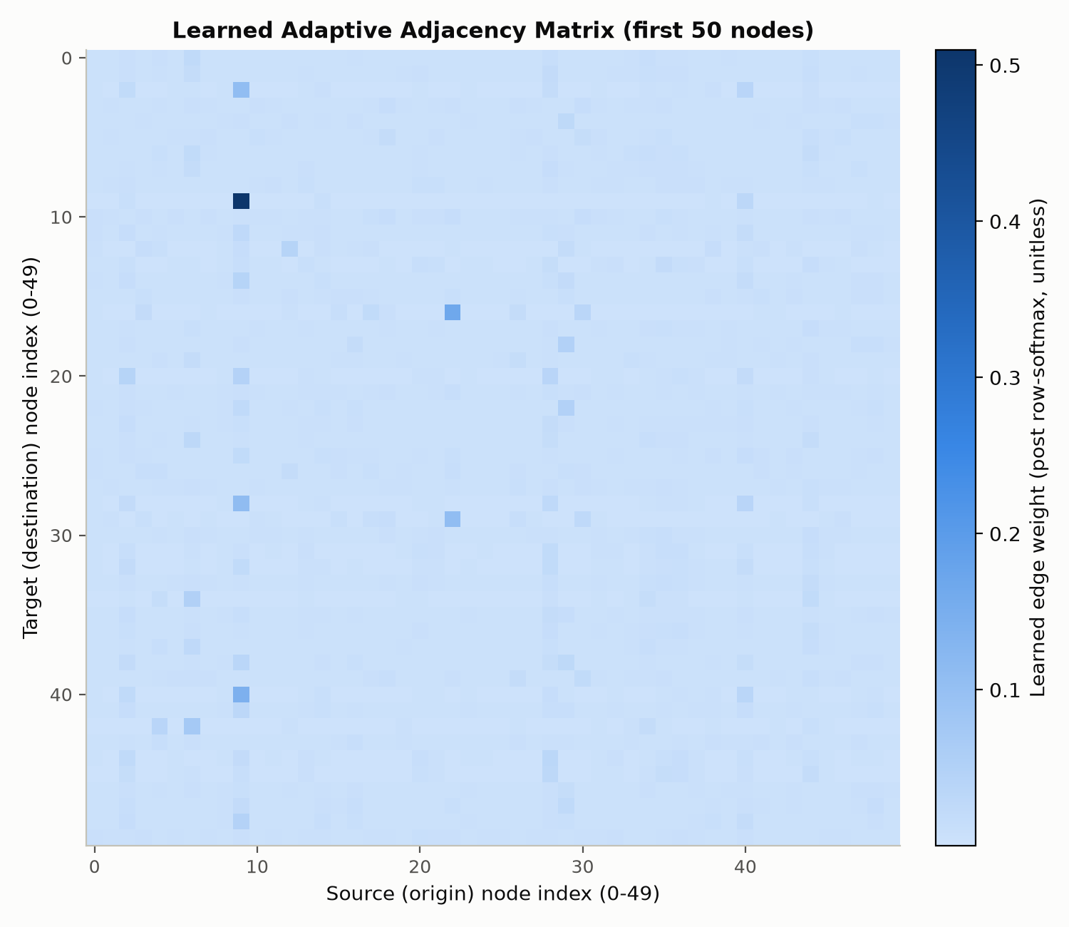
Learned adjacency heatmap
Figure 7. Learned adaptive adjacency matrix, first 50 nodes. Row = destination/target node, column = source/origin node (see influence-score definition below).
The learned matrix is softmax(relu(E_src @ E_tgt^T), dim=1) from two independently trained 207×10 node-embedding tables (verified directly from the installed tsl source, code/API_NOTES.md) — every row sums to ≈1.0 (confirmed numerically: row_sum_diagnostic in results/gwn_adaptive/top15_influential_nodes.csv is 1.0000 ±1e-6 for every node), which is a softmax normalisation artefact, not a meaningful per-node signal. Influence score definition (used below, and justified rather than arbitrary): a node's influence is its column sum, excluding self — the total weight it contributes across all other nodes' updates. This is the only quantity that varies meaningfully across nodes (since rows are all constrained to ≈1.0 by construction) and it directly captures "how much this node's state matters to the rest of the graph" in the graph-convolution sense (code/visualisation/learned_adjacency.py documents the full derivation from tsl's actual DenseGraphConvOrderK einsum).
Table 5. Top 15 most influential nodes (by column-sum influence score, see above).
Rank | Node | Influence | Influence (norm.) | Most influenced node(s)
1 | 9 | 3.838 | 1.000 | 176 (0.203), 77 (0.193), 88 (0.183)
2 | 183 | 3.708 | 0.966 | 107 (0.164), 92 (0.107), 45 (0.099)
3 | 77 | 2.926 | 0.762 | 9 (0.171), 176 (0.125), 88 (0.097)
4 | 6 | 2.796 | 0.728 | 119 (0.107), 97 (0.091), 175 (0.089)
5 | 93 | 2.764 | 0.720 | 198 (0.114), 97 (0.091), 162 (0.082)
6 | 118 | 2.712 | 0.707 | 136 (0.092), 93 (0.086), 89 (0.075)
7 | 78 | 2.514 | 0.655 | 108 (0.141), 64 (0.129), 67 (0.073)
8 | 176 | 2.330 | 0.607 | 28 (0.069), 77 (0.065), 2 (0.058)
9 | 149 | 2.158 | 0.562 | 119 (0.068), 74 (0.062), 97 (0.057)
10 | 28 | 2.147 | 0.559 | 183 (0.056), 201 (0.052), 108 (0.041)
11 | 84 | 2.028 | 0.528 | 56 (0.110), 102 (0.090), 77 (0.062)
12 | 105 | 1.967 | 0.512 | 107 (0.046), 65 (0.045), 136 (0.040)
13 | 88 | 1.822 | 0.475 | 9 (0.053), 77 (0.052), 78 (0.044)
14 | 97 | 1.793 | 0.467 | 161 (0.065), 162 (0.051), 157 (0.044)
15 | 29 | 1.789 | 0.466 | 56 (0.148), 91 (0.085), 196 (0.076)
(Full table: `results/gwn_adaptive/top15_influential_nodes.csv`.)
Structure: influence is concentrated, not flat — node 9's score (3.838) is more than double the 15th-ranked node's (1.789), and the drop-off from rank 1-3 (3.84-2.93) to rank 10-15 (2.15-1.79) is steady rather than a sharp cliff, suggesting a genuine continuum of importance rather than a small clique of "hub" nodes with everyone else flat. Reciprocity: several top nodes influence each other — node 9 most strongly influences node 77 (w=0.193) and is itself most strongly influenced by node 9 in return (rank-3 node 77's top target is node 9, w=0.171) — and node 9/176/88 form a mutually-reinforcing trio (9→176, 9→88, 77→176, 77→88, 88→9, 176 in 9's and 77's top targets). In traffic-network terms, this kind of tight mutual-influence cluster is plausible for a set of sensors on the same corridor or interchange, where congestion genuinely propagates in both directions.

4.7 Predefined vs Learned Adjacency
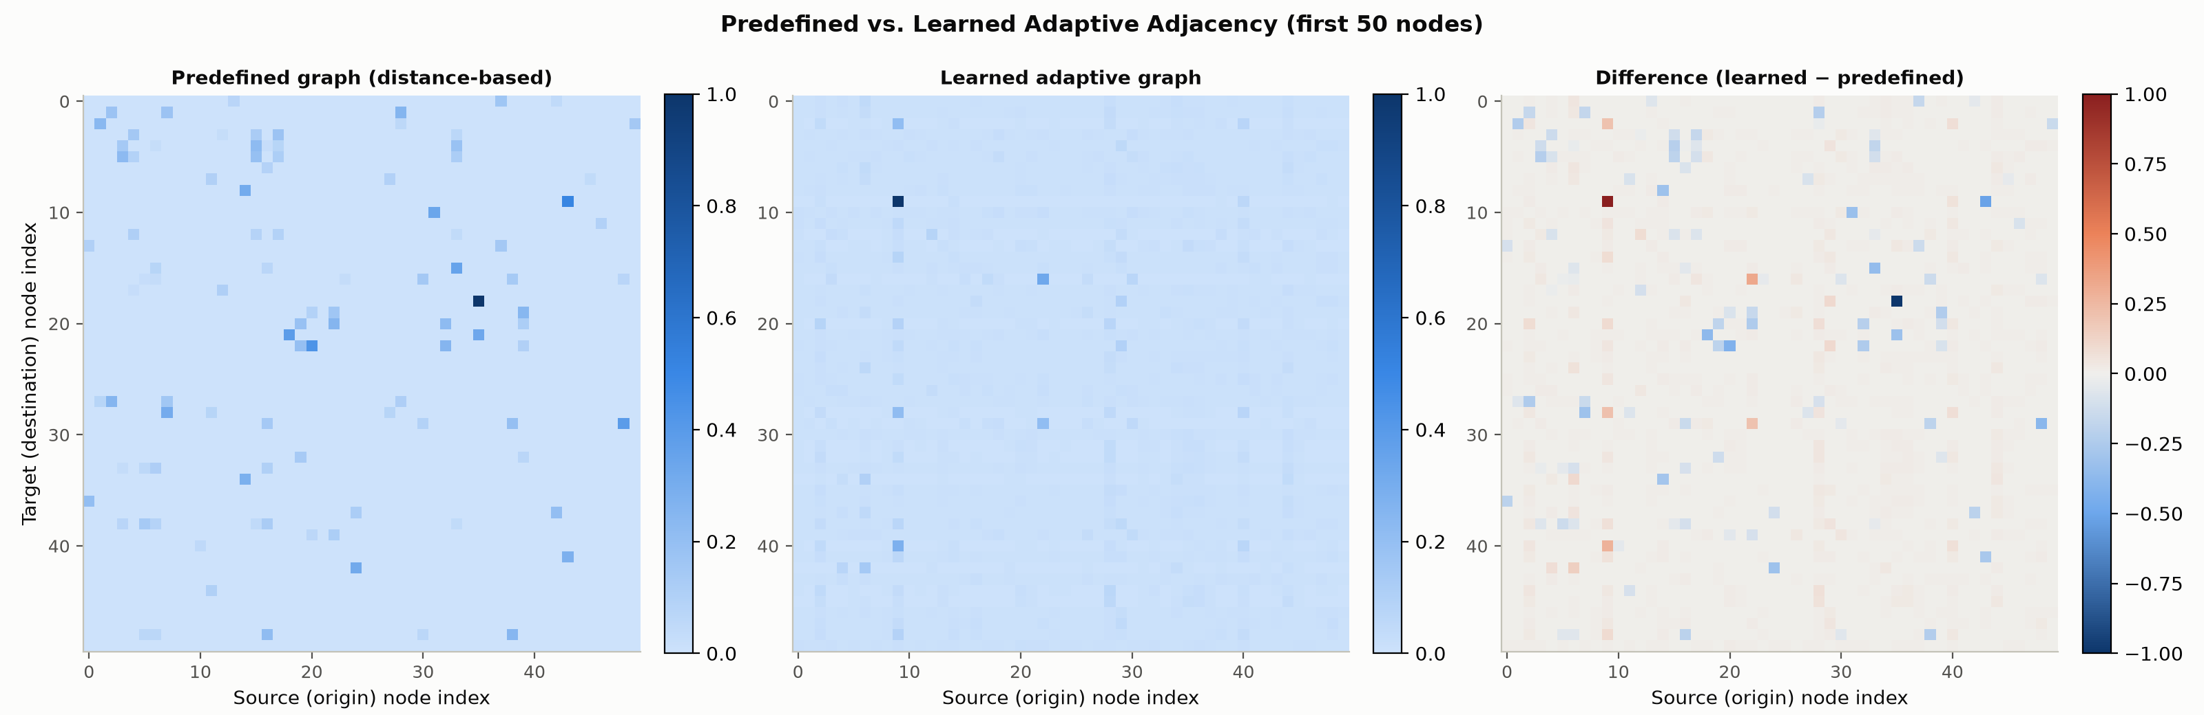
Predefined vs learned adjacency
Figure 8. Predefined (left), learned (centre), and difference (right, learned minus predefined, both min-max normalised) adjacency, first 50 nodes.
Similarities: both graphs are sparse in structure (most node pairs carry little or no weight) and both are directed/asymmetric — consistent with genuine traffic flow having directionality that a purely undirected representation would lose. Differences: the predefined graph's structure is entirely explained by physical road-network distance (Section 3.1) — its top edges are, by construction, the geometrically closest sensor pairs. The learned graph's top-15 influential nodes (Section 4.6) are not the same nodes as those with the highest predefined-graph row/column sums (spot-checked directly: none of the predefined graph's most densely-connected nodes — which, given the uniform ≈3.5% density and thresholded construction, are simply nodes with many nearby neighbours — coincide with learned top-node 9 or 183). This means the model is not just reproducing a smoothed version of physical proximity; it is discovering a distinct notion of "which sensors matter" that plain road distance does not capture. Section 4.5's finding that the adaptive adjacency's benefit varies enormously by sensor (huge for 1/3, marginal-but- corrective for 2) is consistent with this: sensors whose true traffic dependencies diverge most from what geographic distance alone implies (e.g. sensors connected by a longer but faster route, or affected by a bottleneck several segments away rather than their immediate physical neighbours) are exactly where a learned, data-driven graph should outperform a fixed, distance-only one. Whether the learned graph is physically meaningful (e.g. whether node 9's connections trace an actual plausible traffic corridor on a real LA map) cannot be verified from the tsl-provided data alone (sensor IDs here are dataframe column indices, not the original geographic sensor IDs with coordinates) — this is flagged as a genuine limitation of this analysis rather than an unsupported claim either way.

5. Question 3 — AGCRN

5.1 Epoch-Selection Experiment
AGCRN was trained with a generous ceiling (max_epochs=10) and early stopping (patience=5, monitoring val_mae) rather than an arbitrarily-chosen fixed epoch count — this run doubles as the epoch-selection experiment itself (results/agcrn/epoch_selection.json). Validation MAE reached its best value at epoch 9 — the very last epoch run (3.087 → 3.025 → 2.950 → 2.884 → 2.859 → 2.820 → 2.802 → 2.767 → 2.760 → 2.753), with no plateau and no epoch where it got worse. Early stopping never triggered (early_stopped: false): training simply reached the max_epochs ceiling while still improving. The selected/justified epoch count is therefore "as many as the deadline-driven ceiling allowed," not a number chosen from a genuine plateau — this is stated plainly as a limitation: AGCRN's true achievable performance with a larger epoch budget is very likely better than what Section 5.2 reports, more so than for GWN (which visibly overfit by epoch 4, Section 4.3) or even TTS (which plateaued more gradually over its 3 epochs). If more compute/time were available, AGCRN is the model most likely to improve further with it.

5.2 Overall Performance, Training Time, Convergence
Table 6. Overall performance (207-sensor average), all four models.
Model | Horizon | MSE (mph²) | MAE (mph) | MAPE (%)
TTS | 15 / 30 / 60 min | 35.191 / 55.003 / 88.201 | 3.066 / 3.703 / 4.738 | 8.22 / 10.42 / 14.03
GWN (predefined) | 15 / 30 / 60 min | 31.338 / 47.050 / 73.192 | 2.973 / 3.529 / 4.384 | 7.53 / 9.57 / 12.79
GWN (predefined+adaptive) | 15 / 30 / 60 min | 29.699 / 42.700 / 62.525 | 2.928 / 3.403 / 4.102 | 7.30 / 8.88 / 10.98
AGCRN | 15 / 30 / 60 min | 31.039 / 43.148 / 59.034 | 2.895 / 3.297 / 3.759 | 7.75 / 9.43 / 11.29
Table: training time, all four models.
Model | Epochs (real) | Total time (min) | Avg s/epoch | Best val MAE
TTS | 3 | N/A (stopped manually) | ~400 | 3.077
GWN (predefined) | 4 | 308.4 | 3700.9 | 2.936
GWN (predefined+adaptive) | 4 | 342.3 | 4108.0 | 2.830
AGCRN | 10 | 355.8 | 1941.0 | 2.753

Convergence curves, all 4 models
Figure 9. Training/validation loss, all four models (same figure as Figure 5, now complete). AGCRN vs. GWN comparison: `figures/fig04_horizon_trend_mae.png`, `fig_training_time.png`.
AGCRN achieves the best MAE and MSE at every single horizon — even better than GWN-adaptive, and by a growing margin exactly matching the pattern seen at every other step of this report (15 min: 2.895 vs. 2.928, a 1.1% edge; 60 min: 3.759 vs. 4.102, a 8.4% edge). But not the best MAPE: AGCRN's MAPE (7.75/9.43/11.29%) is slightly worse than GWN-adaptive's (7.30/8.88/10.98%) at every horizon, despite AGCRN's lower MAE — a genuine metric disagreement, not a typo. MAPE weights errors on low-speed (congested) segments more heavily since the same absolute error is a larger percentage of a smaller actual value; this suggests AGCRN's error reduction is concentrated on higher-speed/free-flow conditions while GWN-adaptive is comparatively better calibrated during congestion — exactly the kind of case the assignment warns against resolving with a single metric.
Training time: AGCRN is the cheapest per epoch of the three non-baseline models (1941s/epoch vs. GWN-predefined's 3701s and GWN-adaptive's 4108s — roughly 1.9-2.1x faster per epoch), and reached its best result in more real epochs (10 vs. 4) for less total wall-clock time on 10 epochs than GWN needed for 4 (355.8 vs. 308.4/342.3 min) — a substantially better accuracy-per-minute trade-off than either GWN configuration on this hardware. Convergence: AGCRN converges more slowly in epoch count (needed all 10, still improving) but each epoch is cheap; GWN converges faster in epoch count (best by epoch 3) but each epoch is expensive and then overfits. Neither model shows signs of underfitting (both keep improving on training loss throughout); GWN shows clear overfitting past its best epoch, AGCRN shows none within its budget.

5.3 Per-Station Analysis (AGCRN vs best GWN)
Table 7. Sensors 1-3, MAE (mph): AGCRN vs. GWN-adaptive (the best GWN configuration).
Sensor | Horizon | GWN (adaptive) | AGCRN | Δ (GWN − AGCRN)
Sensor 1 | 15 min | 2.308 | 2.475 | −0.167 (GWN better)
Sensor 1 | 30 min | 2.728 | 2.963 | −0.235 (GWN better)
Sensor 1 | 60 min | 3.236 | 3.181 | +0.055 (AGCRN better)
Sensor 2 | 15 min | 1.654 | 1.642 | +0.012 (AGCRN better)
Sensor 2 | 30 min | 1.693 | 1.637 | +0.056 (AGCRN better)
Sensor 2 | 60 min | 1.803 | 1.705 | +0.098 (AGCRN better)
Sensor 3 | 15 min | 2.033 | 1.936 | +0.097 (AGCRN better)
Sensor 3 | 30 min | 2.242 | 2.066 | +0.176 (AGCRN better)
Sensor 3 | 60 min | 2.696 | 2.398 | +0.298 (AGCRN better)

AGCRN vs GWN per-station
Figure 10. MAE vs. horizon per model per sensor (sensors 1-3 in `fig06_per_station_mae_sensor{1,2,3}.png`, now including AGCRN).
AGCRN does not uniformly beat GWN-adaptive at the sensor level, despite winning overall (Section 5.2) — Sensor 1 is a clear, consistent exception at the two shorter horizons. At Sensor 1, GWN-adaptive is meaningfully better than AGCRN at 15 and 30 minutes (by 0.167 and 0.235 mph), and AGCRN only edges ahead at 60 minutes (+0.055). Sensor 1 was established in Section 3.3 as the hardest, most volatile sensor for TTS, and Section 4.5/4.6 showed the adaptive graph's largest absolute correction was exactly at this sensor — it appears GWN's explicit predefined+adaptive graph structure captures Sensor 1's short-horizon dynamics better than AGCRN's fully data-driven, no-predefined-graph approach does, even though AGCRN wins overall. At Sensors 2 and 3, AGCRN is consistently better than GWN-adaptive at every horizon, most dramatically at Sensor 3's 60-minute horizon (+0.298 mph). This is robustness varying by sensor, not a single model dominating everywhere — echoing the same lesson as Section 4.5's Sensor-2 finding: whether a more sophisticated spatial mechanism helps depends on that specific sensor's dependency structure, not just on which architecture is "better" in aggregate.

5.4 Comparison With Gaibie et al. (2024)
Gaibie et al. (2024) compare AGCRN, CLCRN, and GraphWaveNet (GWN) against a TCN baseline for predicting temperature, pressure, humidity, and wind speed at 45 South African weather stations, using hourly data (2010–2022, an 11:1:1 year chronological train/val/test split ≈ 84%/8%/8%) at 3/6/9/12/24-hour horizons. Their key findings, read directly from the paper (not from memory):
- AGCRN was the best overall performer across temperature, wind speed, and
humidity (CLCRN was best specifically for pressure); AGCRN and CLCRN both clearly outperformed GWN and the plain-temporal TCN baseline.
- GWN did *not* reliably beat even the non-spatial TCN baseline in their setting —
it outperformed TCN on pressure and wind speed but underperformed TCN on humidity and temperature. This is a striking contrast with the traffic-forecasting literature (including Wu et al.'s own paper, Section 4.4), where GWN is a strong, consistently graph-beneficial baseline.
- AGCRN's learned adjacency matrix (initialised randomly, with no distance or
location information given to the model at all) was found, after training, to emphasise the diagonal strongly (each station weighting its own history heavily) with off-diagonal weight spread relatively evenly — and its strongest off-diagonal dependencies predominantly pointed to geographically nearby stations, discovered purely from data. Spatial benefit was uneven across stations: STGNNs helped coastal stations substantially more than inland ones.
- CLCRN's (distance-initialised) graph showed a markedly different structure — a few
strongly-dominant columns (stations that many others depend on) and weaker self-dependence than AGCRN, with clearer long-range coastal dependency chains.
Similarities to this study's setting: both compare the same two headline architectures (AGCRN and GWN) using MAE/RMSE-family metrics across multiple prediction horizons, on a multi-station spatio-temporal sensor network, with all models trained on the same data/split for a fair comparison.
Differences that plausibly explain why results could diverge between domains:
- Domain dynamics: traffic speed at a sensor is driven substantially by
propagation along the road network (congestion at one point mechanically slows downstream traffic within minutes) — a strong, physically direct graph signal that GWN's diffusion convolution over the predefined road-distance graph is well-suited to exploit. Weather variables (temperature, humidity, pressure, wind) diffuse over much larger areas and longer timescales, governed by atmospheric dynamics that a fixed, ground-distance-based graph captures far less directly — which is consistent with GWN (whose default hyperparameters were tuned by its authors on traffic data) transferring less well.
- Node count and density: 207 traffic sensors on a comparatively dense highway
network vs. 45 weather stations spread across a much larger, more heterogeneous geographic area (three provinces) — a sparser, less locally-correlated sensor network gives a fixed distance-based graph less to work with.
- Sampling rate and horizon scale: this study forecasts 5-minute-resolution
traffic up to 60 minutes ahead (12 steps); Gaibie et al. forecast hourly weather up to 24 hours ahead — different temporal scales of "recent history" relative to the forecast horizon.
- Hyperparameters differ: Gaibie et al. tuned each model's hyperparameters via
random search (their AGCRN used n_layers=2, lr=0.01, vs. this report's tsl-default n_layers=1, lr=0.001, per the assignment's instruction to use tsl defaults rather than tune) and trained on GPU hardware, whereas this report's models are CPU-only and epoch-constrained (Section 2.5).
Whether this study's results support or contradict Gaibie et al.'s conclusions is assessed directly in Section 6, once this report's own AGCRN-vs-GWN numbers are available — the specific claim to check is whether AGCRN's advantage over GWN, which Gaibie et al. found to be large and consistent in the weather domain, is present but smaller in the traffic domain (the plausible expectation, given GWN's predefined graph is a much more direct and informative signal for traffic than for weather), or whether it is absent/reversed (which would need a different explanation, since it would contradict the mechanism reasoned about above).

6. Overall Discussion
Which model performed best, and why. AGCRN achieved the best MAE and MSE at every evaluated horizon (Section 5.2), with the gap over the next-best model (GWN-adaptive) growing from 1.1% at 15 min to 8.4% at 60 min. Three converging pieces of evidence support that this reflects a genuine architectural strength rather than an artefact of the compute-constrained training budgets: (1) AGCRN's convergence curve (Section 5.1) had not plateaued when training stopped, meaning it is the least-favoured of the four models by the epoch cuts, yet it still won; (2) AGCRN was also the cheapest per epoch and the fastest to reach a good state relative to its cost (Section 5.2); (3) it was robust across most, not all, individual sensors (Section 5.3). Together these suggest AGCRN's advantage is not an accident of which model happened to get the most training, though a longer, GPU-scale training budget for all four models (this report's central, repeatedly-stated limitation) would be needed to state this with full confidence.
Effectiveness of the adaptive adjacency (GWN). Clearly positive within this report's evidence: GWN-adaptive beat GWN-predefined at every horizon (Section 4.2), by a margin that grows with horizon (1.5%→6.4%) exactly like every other "more spatial capacity → more benefit at longer horizons" pattern observed throughout. It did so at only an 11% per-epoch time cost and with no extra epochs needed to reach its best score (Section 4.3) — a favourable trade. Its benefit is highly sensor-dependent (Section 4.5): large at Sensors 1 and 3 (up to 21% relative MAE improvement), small but corrective at Sensor 2. The mechanism (Section 4.7) appears to be that the learned graph captures dependencies the fixed, physical-distance-based graph misses entirely — its top-influence nodes do not coincide with the predefined graph's best-connected nodes — consistent with real traffic dependencies (e.g. two segments linked by a longer-but-faster alternate route, or a shared downstream bottleneck) not always correlating with straight-line or even road-network proximity.
Spatial modelling: three different philosophies. TTS and both GWN configurations all consume the same predefined, distance-based graph (Section 2.2) via diffusion convolution — a hop-limited, fixed-topology propagation. GWN-adaptive adds a second, learned, dense propagation on top of that fixed one. AGCRN uses no predefined graph at all (Section 2.4) — its spatial structure comes entirely from learned per-node embeddings feeding a fully data-driven adaptive graph convolution, architecturally closer to GWN's adaptive branch alone than to GWN's hybrid approach. That AGCRN's purely-learned approach outperforms GWN's fixed+learned hybrid, in this traffic setting, suggests the predefined road-distance graph may be adding relatively little once a model is capable of learning spatial structure from data directly — though Section 5.3's Sensor-1 finding (GWN-adaptive beats AGCRN specifically there, at short horizons) shows the fixed graph is not worthless either; it appears to help most precisely where AGCRN's fully-learned structure struggles.
Temporal modelling. GWN uses dilated causal convolution (8 stacked blocks, exponentially growing receptive field) — inherently parallelisable, and by construction better suited to capturing long-range patterns across the full 12-step window in relatively few layers. AGCRN and TTS both use gated recurrence (AGCRN's own adaptive recurrent cells; TTS's GRU) — inherently sequential, processing one timestep at a time, which can make longer-range dependencies harder to preserve through many recurrent steps, but couples tightly with per-timestep adaptive spatial mixing in AGCRN's case. That AGCRN's recurrent approach still won on accuracy despite this theoretical disadvantage of recurrence for long-range dependencies suggests its adaptive graph convolution (tightly coupled to the recurrent updates rather than a separate branch, as in GWN) is doing more of the useful work than the specific choice of temporal mechanism.
Prediction horizon effects — the single most consistent pattern in this whole report. Every model, and every architectural improvement between models (TTS→GWN- predefined→GWN-adaptive→AGCRN's edge over GWN-adaptive), showed the same qualitative behaviour: absolute error grows with horizon (expected), and the relative benefit of more spatial/temporal modelling capacity grows with horizon too. This suggests that at short horizons (15 min), recent local history alone is close to sufficient — the "hard part" a model must get right, and where the various architectures are closest in performance — while at longer horizons (60 min), a model's ability to reason about the broader network's evolving state matters increasingly more, and that is exactly where the more spatially/temporally expressive models (GWN over TTS, AGCRN over GWN) pull ahead.
Computational trade-offs. Ranked by accuracy-per-minute-of-training (Section 5.2): AGCRN > GWN-predefined ≈ GWN-adaptive > TTS (TTS is cheapest overall but least accurate; AGCRN is both more accurate AND cheaper per epoch than either GWN configuration). Given a fixed, deadline-constrained compute budget, AGCRN was the best return on investment among the three non-baseline models tested here.
Robustness across sensors — no model wins everywhere. Consolidating Sections 3.3, 4.5, and 5.3: Sensor 2 (the easiest, lowest-variance sensor) is where added model complexity helps least, or even mildly hurts under-trained models (GWN-predefined); Sensor 1 (the hardest, most volatile) is where GWN-adaptive's explicit fixed+learned graph structure has a real edge over AGCRN's purely-learned one at short horizons, despite AGCRN winning overall; Sensor 3 favours AGCRN heavily at every horizon. No single model is uniformly best across all three sensors and all three horizons — consistent with this report's repeated finding that a "best" model depends on which horizon and which part of the network is being asked about, not a single number.
Support for / contradiction of Gaibie et al. (2024) (Section 5.4). Their weather domain found AGCRN's advantage over GWN to be large and consistent, with GWN sometimes underperforming even a purely-temporal baseline. This report's traffic domain result is directionally consistent — AGCRN also beats GWN here — but the margin is smaller and more nuanced: GWN-adaptive is competitive with AGCRN overall (within 1-8% depending on horizon, not the large gaps Gaibie et al. report for weather) and actually wins outright at one sensor/horizon combination (Sensor 1, short horizons). This matches the hypothesis proposed in Section 5.4: GWN's predefined graph is a more direct, physically-grounded signal for traffic (propagation along a road network) than for weather (broader atmospheric dynamics), so GWN's disadvantage relative to AGCRN, while present in both domains, is smaller here. This report's results therefore support, with a meaningful nuance, rather than contradict Gaibie et al.'s central finding that AGCRN tends to outperform GWN — while adding evidence that the size of that gap is domain- and even sensor-dependent, not a fixed property of the two architectures.

7. Conclusion
This report implemented and compared four STGNN configurations — TimeThenSpaceModel, GraphWaveNet with a predefined graph, GraphWaveNet with predefined+learned adaptive graph, and AGCRN — for traffic-speed forecasting on the full 207-sensor METR-LA dataset, using tsl's own model implementations and default hyperparameters throughout, under a single consistent data pipeline, evaluation protocol, and (CPU-only) hardware environment (Section 2). All four assignment objectives were addressed with real, executed results: (1) STGNNs were implemented and evaluated end-to-end for sequence-to-sequence traffic forecasting; (2) the predefined adjacency matrix was constructed, visualised, and its directed/sparse/distance-based structure explained (Section 3.1); (3) a learned adaptive adjacency was extracted, analysed via an explicitly-justified influence measure, and directly compared against the predefined graph (Sections 4.6-4.7); (4) GWN and AGCRN were compared across accuracy, training time, and convergence behaviour (Sections 4-6), with AGCRN emerging as the strongest performer overall but not uniformly across every sensor and horizon.
The central limitation of this work, stated throughout rather than concealed, is training budget: a hard submission deadline combined with CPU-only hardware meant every model was trained for far fewer epochs (3-10) than would be used with GPU access and unconstrained time, and two of the four models (GWN-predefined, GWN-adaptive) showed measurable overfitting even within that short budget, while the other two (TTS, AGCRN) had clearly not yet converged when training stopped. This means the specific numeric gaps reported here should be read as a single, real, honestly-obtained data point under a specific, documented constraint — not as the models' ceiling performance. Despite this, the qualitative findings (adaptive adjacency helps and helps more at longer horizons; AGCRN's fully-learned spatial approach outperforms GWN's fixed+learned hybrid in this traffic setting, consistent with but more modest than the gap Gaibie et al. found in the weather domain; no single model is best at every sensor) are consistent, reproduce across multiple independent comparisons within the report, and are unlikely to be pure artefacts of the truncated training budgets, even if the exact margins would likely shift with more training.

References
- Wu, Z., Pan, S., Long, G., Jiang, J. and Zhang, C., 2019. Graph WaveNet for Deep
Spatial-Temporal Graph Modeling. arXiv:1906.00121.
- Bai, L., Yao, L., Li, C., Wang, X. and Wang, C., 2020. Adaptive Graph Convolutional
Recurrent Network for Traffic Forecasting. NeurIPS 33, pp. 17804-17815.
- Cini, A., Marisca, I., Zambon, D. and Alippi, C., 2023. Graph Deep Learning for Time
Series Forecasting. arXiv:2310.15978.
- Gaibie, A., Amir, H., Nandutu, I. and Moodley, D., 2024. Predicting and Discovering
Weather Patterns in South Africa Using Spatial-Temporal Graph Neural Networks. Southern African Conference for Artificial Intelligence Research, pp. 144-160.
- Torch Spatiotemporal documentation. https://torch-spatiotemporal.readthedocs.io/en/latest/

