QUESTION 1

You are given a task a lecturer at your college to write a complete program which will allow the user to calculate Salary Increase

The area formula is:

Salary Increase = (Increase/100*Salary) + Salary

BELOW IS THE GRAPHIC USER INTERFACE (GUI) DIAGRAM

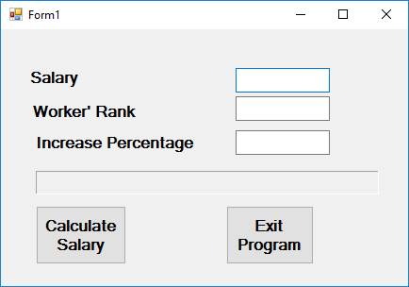

BELOW IS THE UNIFIED MODELLING LANGUAGE (UML) DIAGRAM
Salary

-Increase
-Salary

+SalaryIncrease()

