QUESTION 1

You are given a task by your lecturer at your college to write a complete program which will allow the user to calculate the area of a triangle

The area formula is:

Area = 0.5*Base*Height

BELOW IS THE GRAPHIC USER INTERFACE (GUI) DIAGRAM

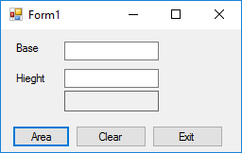

BELOW IS THE UNIFIED MODELLING LANGUAGE (UML) DIAGRAM
Triangle

Class name

-Base
-Height
Data members/ properties/fields/attributes

+Area()

Method

Exercise
Create a UML diagram for a program to calculate area of a rectangle

