### 置换两个变量的值。

a,b = b,a

### 链式比较

a = 3

b = 1

1 <= b <= a < 10 #True

### 字符串反转

s[::-1]

### for…else…语句

for x in xrange(1,5):

if x == 5:

print 'find 5'

break

else:

print 'can not find 5!'

#can not find 5!

for...else...的else部分用来处理没有从for循环中断的情况。有了它，我们不用设置状态变量来检查是否for循环有break出来，简单方便。

### 使用zip创建键值对

keys = ['Name', 'Sex', 'Age']

values = ['Tim', 'Male', 23]

dic = dict(zip(keys, values))

#{'Age': 23, 'Name': 'Tim', 'Sex': 'Male'}

序列乘法¶

Zeroes = [0] * 100

“Print to”语法¶

最近,”>>” 操作符被重载了, 这样你就可以像下面那样在print语句中使用它了:

**print** >> sys.stderr, "this is an error message"

>>右边应该是一个文件对象。

译者注例子(Python2.7)

**print** >> file("myfile", "w"), "hello world"

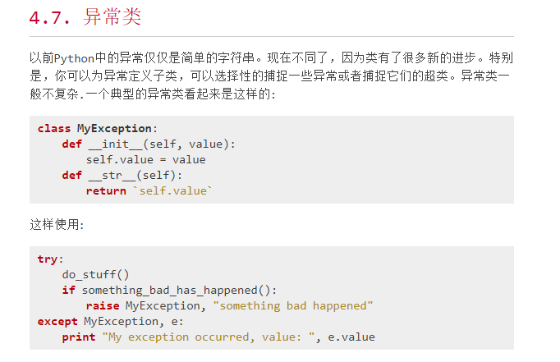

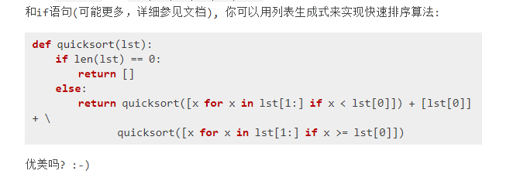

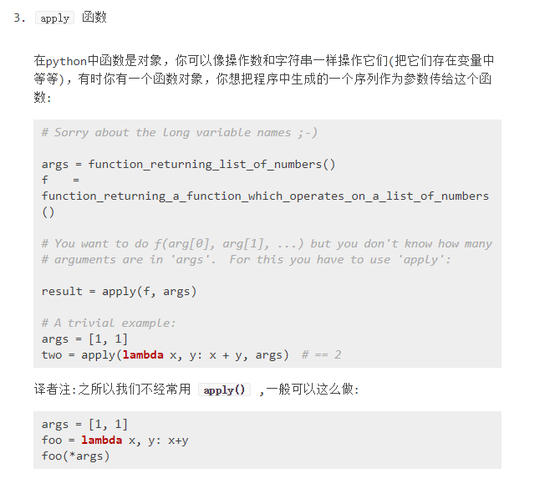

# Python 内置函数

|  |  | **内置函数** |  |  |
| --- | --- | --- | --- | --- |
| [abs()](http://www.runoob.com/python/func-number-abs.html) | [divmod()](http://www.runoob.com/python/python-func-divmod.html) | [input()](http://www.runoob.com/python/python-func-input.html) | [open()](http://www.runoob.com/python/python-func-open.html) | [staticmethod()](http://www.runoob.com/python/python-func-staticmethod.html) |
| [all()](http://www.runoob.com/python/python-func-all.html) | [enumerate()](http://www.runoob.com/python/python-func-enumerate.html) | [int()](http://www.runoob.com/python/python-func-int.html) | [ord()](http://www.runoob.com/python/python-func-ord.html) | [str()](http://www.runoob.com/python/python-func-str.html) |
| [any()](http://www.runoob.com/python/python-func-any.html) | [eval()](http://www.runoob.com/python/python-func-eval.html) | [isinstance()](http://www.runoob.com/python/python-func-isinstance.html) | [pow()](http://www.runoob.com/python/func-number-pow.html) | [sum()](http://www.runoob.com/python/python-func-sum.html) |
| [basestring()](http://www.runoob.com/python/python-func-basestring.html) | [execfile()](http://www.runoob.com/python/python-func-execfile.html) | [issubclass()](http://www.runoob.com/python/python-func-issubclass.html) | [print()](http://www.runoob.com/python/python-func-print.html) | [super()](http://www.runoob.com/python/python-func-super.html) |
| [bin()](http://www.runoob.com/python/python-func-bin.html) | [file()](http://www.runoob.com/python/python-func-file.html) | [iter()](http://www.runoob.com/python/python-func-iter.html) | [property()](http://www.runoob.com/python/python-func-property.html) | [tuple()](http://www.runoob.com/python/att-tuple-tuple.html) |
| [bool()](http://www.runoob.com/python/python-func-bool.html) | [filter()](http://www.runoob.com/python/python-func-filter.html) | [len()](http://www.runoob.com/python/att-string-len.html) | [range()](http://www.runoob.com/python/python-func-range.html) | [type()](http://www.runoob.com/python/python-func-type.html) |
| [bytearray()](http://www.runoob.com/python/python-func-bytearray.html) | [float()](http://www.runoob.com/python/python-func-float.html) | [list()](http://www.runoob.com/python/att-list-list.html) | [raw_input()](http://www.runoob.com/python/python-func-raw_input.html) | [unichr()](http://www.runoob.com/python/python-func-unichr.html) |
| [callable()](http://www.runoob.com/python/python-func-callable.html) | [format()](http://www.runoob.com/python/att-string-format.html) | [locals()](http://www.runoob.com/python/python-func-locals.html) | [reduce()](http://www.runoob.com/python/python-func-reduce.html) | unicode() |
| [chr()](http://www.runoob.com/python/python-func-chr.html) | [frozenset()](http://www.runoob.com/python/python-func-frozenset.html) | [long()](http://www.runoob.com/python/python-func-long.html) | [reload()](http://www.runoob.com/python/python-func-reload.html) | [vars()](http://www.runoob.com/python/python-func-vars.html) |
| [classmethod()](http://www.runoob.com/python/python-func-classmethod.html) | [getattr()](http://www.runoob.com/python/python-func-getattr.html) | [map()](http://www.runoob.com/python/python-func-map.html) | [repr()](http://www.runoob.com/python/python-func-repr.html) | [xrange()](http://www.runoob.com/python/python-func-xrange.html) |
| [cmp()](http://www.runoob.com/python/func-number-cmp.html) | [globals()](http://www.runoob.com/python/python-func-globals.html) | [max()](http://www.runoob.com/python/func-number-max.html) | [reverse()](http://www.runoob.com/python/att-list-reverse.html) | [zip()](http://www.runoob.com/python/python-func-zip.html) |
| [compile()](http://www.runoob.com/python/python-func-compile.html) | [hasattr()](http://www.runoob.com/python/python-func-hasattr.html) | [memoryview()](http://www.runoob.com/python/python-func-memoryview.html) | [round()](http://www.runoob.com/python/func-number-round.html) | [__import__()](http://www.runoob.com/python/python-func-__import__.html) |
| [complex()](http://www.runoob.com/python/python-func-complex.html) | [hash()](http://www.runoob.com/python/python-func-hash.html) | [min()](http://www.runoob.com/python/func-number-min.html) | [set()](http://www.runoob.com/python/python-func-set.html) |  |
| [delattr()](http://www.runoob.com/python/python-func-delattr.html) | [help()](http://www.runoob.com/python/python-func-help.html) | [next()](http://www.runoob.com/python/python-func-next.html) | [setattr()](http://www.runoob.com/python/python-func-setattr.html) |  |
| [dict()](http://www.runoob.com/python/python-func-dict.html) | [hex()](http://www.runoob.com/python/python-func-hex.html) | object() | [slice()](http://www.runoob.com/python/python-func-slice.html) |  |
| [dir()](http://www.runoob.com/python/python-func-dir.html) | [id()](http://www.runoob.com/python/python-func-id.html) | [oct()](http://www.runoob.com/python/python-func-oct.html) | [sorted()](http://www.runoob.com/python/python-func-sorted.html) | [exec 内置表达式](http://www.runoob.com/python/python-func-exec.html) |

### Getattr 函数（）

描述

**getattr()** 函数用于返回一个对象属性值。

语法

getattr 语法：

getattr(object, name[, default])

参数

* object -- 对象。
* name -- 字符串，对象属性。
* default -- 默认返回值，如果不提供该参数，在没有对应属性时，将触发 AttributeError。

### Hasattr（）函数

描述

**getattr()** 函数用于返回一个对象属性值。

语法

getattr 语法：

getattr(object, name[, default])

参数

* object -- 对象。
* name -- 字符串，对象属性。
* default -- 默认返回值，如果不提供该参数，在没有对应属性时，将触发 AttributeError。