Bank CRM Analytics

Objective Questions

Q.1 What is the distribution of account balances across different regions?

Tools: SQL (Q1) · Power BI visual “Q1: Balance by region”

Solution (SQL Query):
SELECT geo.GeographyLocation AS Region, COUNT(*) AS Customers,
SUM(b.Balance) AS Total_Balance, AVG(b.Balance) AS Avg_Balance,
MIN(b.Balance) AS Min_Balance, MAX(b.Balance) AS Max_Balance,
SUM(b.Balance = 0) AS Zero_Balance_Accounts,
100 * SUM(b.Balance) / SUM(SUM(b.Balance)) OVER () AS Pct_Of_Total
FROM CustomerInfo c
JOIN Bank_Churn b ON c.CustomerId = b.CustomerId
JOIN Geography geo ON c.GeographyID = geo.GeographyID
GROUP BY geo.GeographyLocation
ORDER BY Total_Balance DESC;

Dashboard evidence (PowerBI):
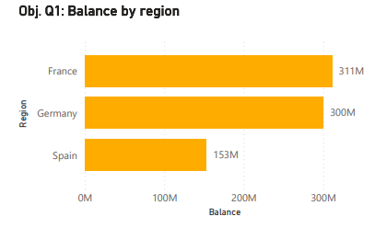

Output:
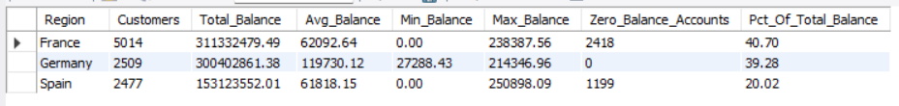

Insights:
France holds the most money (40.70%) simply because it has twice as many customers. Germany has half the customers but almost the same total, because its average balance (119,730) is nearly double France and Spain, and no German customer has a zero balance. France and Spain contain all 3,617 zero-balance accounts. Germany is the high-value region, so any churn there costs more.

Q.2 Identify the top 5 customers with the highest Estimated Salary in the last quarter of the year. (SQL)

Tools: SQL (Q2a, Q2b)

Solution (SQL Query):
-- Q.2a : all years
SELECT c.CustomerId, c.Surname, c.EstimatedSalary, c.Bank_DOJ
FROM CustomerInfo c
WHERE QUARTER(c.Bank_DOJ) = 4
ORDER BY c.EstimatedSalary DESC
LIMIT 5;

-- Q.2b : latest year only
SELECT c.CustomerId, c.Surname, c.EstimatedSalary, c.Bank_DOJ
FROM CustomerInfo c
WHERE QUARTER(c.Bank_DOJ) = 4
AND YEAR(c.Bank_DOJ) = (SELECT MAX(YEAR(Bank_DOJ)) FROM CustomerInfo)
ORDER BY c.EstimatedSalary DESC
LIMIT 5;

Output:
--Q.2a
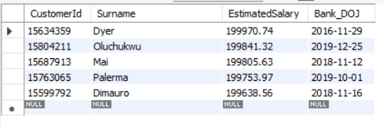

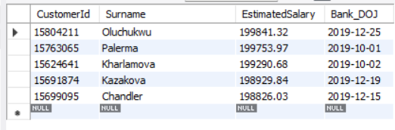
--Q.2b

Insights:
“Last quarter of the year” is read as customers whose joining date falls in Oct-Dec. The top salaries are all just under 200,000, which is the maximum in the data. Four of the five joined in November or December, which matches the year-end peak in new joiners (Q11).

Q.3 Calculate the average number of products used by customers who have a credit card. (SQL)

Tools: SQL (Q3)

Solution (SQL Query):
--Q.3a: Credit card holders
SELECT ROUND(AVG(NumOfProducts), 4) AS Avg_Products_Credit_Card_Holders
FROM Bank_Churn WHERE HasCrCard = 1;

--Q.3b: Non-credit card holders
SELECT cc.Category AS Card_Status,
COUNT(*) AS Customers,
ROUND(AVG(b.NumOfProducts), 4) AS Avg_Products
FROM Bank_Churn b
JOIN CreditCard cc ON b.HasCrCard = cc.CreditID
GROUP BY cc.Category;

Output:
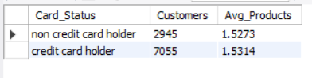
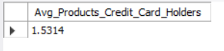
Q3.a Q.3b

Insights:
Card holders and non-holders use almost the same number of products. Owning a credit card does not mean a customer is more engaged with the bank.

Q.4 Determine the churn rate by gender for the most recent year in the dataset.

Tools: SQL (Q4) · Power BI visual “Q4: Churn rate by gender” (series “Churn Rate Latest Year”)

Solution (SQL Query):
SELECT YEAR(c.Bank_DOJ) AS Join_Year, g.GenderCategory AS Gender, COUNT(*) AS Customers,
SUM(b.Exited) AS Exited_Customers,
CAST(100 * SUM(b.Exited) / COUNT(*) AS DECIMAL(5,2)) AS Churn_Rate_Pct
FROM CustomerInfo c
JOIN Bank_Churn b ON c.CustomerId = b.CustomerId
JOIN Gender g ON c.GenderID = g.GenderID
WHERE YEAR(c.Bank_DOJ) = (SELECT MAX(YEAR(Bank_DOJ)) FROM CustomerInfo)
GROUP BY YEAR(c.Bank_DOJ), g.GenderCategory;

Dashboard evidence (PowerBI):
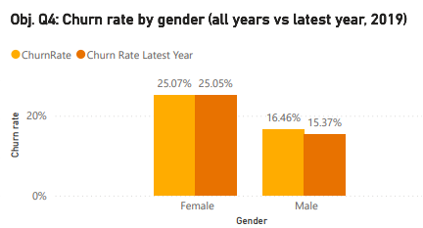

Output:
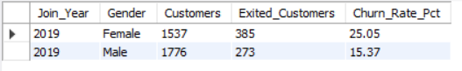

Insights:
Female customers churn at about 1.6 times the male rate. The same gap exists across all years (25.07% vs 16.46%), so it is a stable pattern and not a one-year effect. Women also have a lower active rate (Q6), which points to an engagement gap.

Q.5 Compare the average credit score of customers who have exited and those who remain. (SQL)

Tools: SQL (Q5) · Power BI visual “Q5: Average credit score, exited vs retained”

Solution (SQL Query):
SELECT e.ExitCategory AS Customer_Status, COUNT(*) AS Customers,
ROUND(AVG(b.CreditScore), 2) AS Avg_Credit_Score
FROM Bank_Churn b JOIN ExitCustomer e ON b.Exited = e.ExitID
GROUP BY e.ExitCategory;

Dashboard evidence (PowerBI):
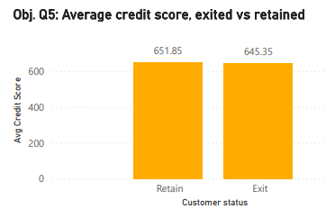

Output:
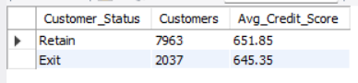

Insights:
Exited customers score only 6.5 points lower, about 1%. Both groups sit in the “Fair” band (580-669). Credit score alone does not explain who leaves.

Q.6 Which gender has a higher average estimated salary, and how does it relate to the number of active accounts?(SQL)

Tools: SQL (Q6)

Solution (SQL Query):
SELECT g.GenderCategory AS Gender, COUNT(*) AS Total_Customers,
ROUND(AVG(c.EstimatedSalary), 2) AS Avg_Estimated_Salary,
SUM(b.IsActiveMember) AS Active_Accounts,
ROUND(100 * SUM(b.IsActiveMember) / COUNT(*), 2) AS Active_Pct
FROM CustomerInfo c
JOIN Bank_Churn b ON c.CustomerId = b.CustomerId
JOIN Gender g ON c.GenderID = g.GenderID
GROUP BY g.GenderCategory ORDER BY Avg_Estimated_Salary DESC;

Output: (active = corrected IsActiveMember, see Q26)
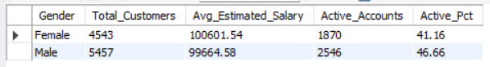

Insights:
Females earn about 937 more on average, but a smaller share of them is active (41.16% vs 46.66%). A higher salary does not lead to more active accounts, so the bank should not assume wealthier customers are more engaged. This matches the higher female churn in Q4.

Q.7 Segment the customers based on their credit score and identify the segment with the highest exit rate. (SQL)

Tools: SQL (Q7) · Power BI visual “Q7: Churn rate by credit score segment”

Solution (SQL Query):
SELECT Credit_Segment, COUNT(*) AS Customers, SUM(Exited) AS Exited_Customers,
ROUND(100 * SUM(Exited) / COUNT(*), 2) AS Exit_Rate_Pct,
RANK() OVER (ORDER BY SUM(Exited) / COUNT(*) DESC) AS Exit_Rate_Rank
FROM (SELECT Exited,
CASE WHEN CreditScore >= 800 THEN 'Excellent (800-850)'
WHEN CreditScore >= 740 THEN 'Very Good (740-799)'
WHEN CreditScore >= 670 THEN 'Good (670-739)'
WHEN CreditScore >= 580 THEN 'Fair (580-669)'
ELSE 'Poor (300-579)' END AS Credit_Segment
FROM Bank_Churn) t
GROUP BY Credit_Segment ORDER BY Exit_Rate_Rank;

Dashboard evidence (PowerBI):
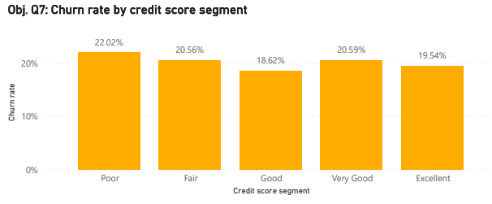

Output:
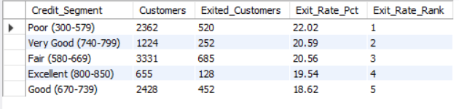

Insights:
The Poor segment has the highest exit rate (22.02%). The whole spread is only 3.4 points and the pattern is not a straight line (Very Good churns more than Good). Credit score is a weak signal, and it should not be used alone to target retention.

Q.8 Find out which geographic region has the highest number of active customers with a tenure greater than 5 years. (SQL)

Tools: SQL (Q8)

Solution (SQL Query):
SELECT geo.GeographyLocation AS Region, COUNT(*) AS Active_Customers_Tenure_Over_5
FROM CustomerInfo c
JOIN Bank_Churn b ON c.CustomerId = b.CustomerId
JOIN Geography geo ON c.GeographyID = geo.GeographyID
WHERE b.IsActiveMember = 1 AND b.Tenure > 5
GROUP BY geo.GeographyLocation ORDER BY 2 DESC;

Output:
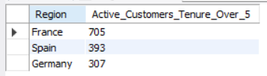

Insights:
France leads because it has the largest customer base. Germany has the fewest loyal active long-term customers despite the highest balances, which fits its 32.44% churn. The bank is relying on France for stable, long-standing relationships.

Q.9 What is the impact of having a credit card on customer churn, based on the available data?

Tools: SQL (Q9) · Power BI visual “Q9: Churn rate, card holders vs non-holders”

Solution (SQL Query):
SELECT cc.Category AS Card_Status, COUNT(*) AS Customers, SUM(b.Exited) AS Exited_Customers,
ROUND(100 * SUM(b.Exited) / COUNT(*), 2) AS Churn_Rate_Pct
FROM Bank_Churn b JOIN CreditCard cc ON b.HasCrCard = cc.CreditID
GROUP BY cc.Category;

Dashboard evidence (PowerBI):
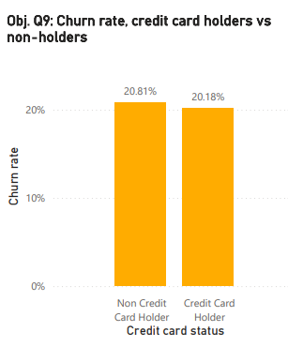

Output:
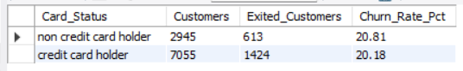

Insights:
The gap is 0.63 points, which is negligible. A credit card does not make a customer meaningfully more loyal. This also holds inside every risk tier (see Subjective Q10).

Q.10 For customers who have exited, what is the most common number of products they have used?

Tools: SQL (Q10) · Power BI visual “Q10: Exited customers by number of products”

Solution (SQL Query):
SELECT NumOfProducts, COUNT(*) AS Exited_Customers,
ROUND(100 * COUNT(*) / SUM(COUNT(*)) OVER (), 2) AS Pct_Of_Exited
FROM Bank_Churn WHERE Exited = 1
GROUP BY NumOfProducts ORDER BY Exited_Customers DESC;

Dashboard evidence (PowerBI):
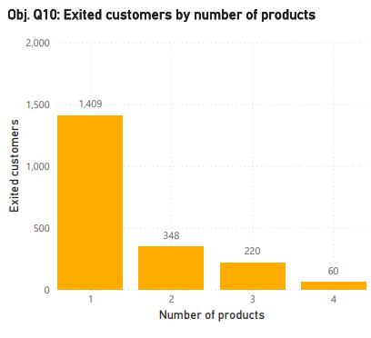

Output:
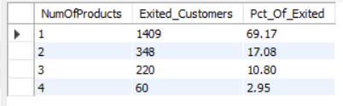

Insights:
One product is the most common among exited customers (69%), because single-product customers are half the base. The more important finding is the churn rate. Two-product customers are the most loyal (7.58%), while 3 and 4 products churn at 82.71% and 100%, which suggests over-selling or poor service on bundled products.

Q.11 Examine the trend of customers joining over time and identify any seasonal patterns (yearly or monthly). Prepare the data through SQL and then visualize it.

Tools: SQL (Q11a to Q11d) · Power BI visuals “Q11: Customers joined by month, 2016-2019”, “Q11: Customers joined per year and YoY growth”, “Q11: Seasonality…”, “Q11: Customers joined by quarter”, “Q11: Year × month heatmap”

Solution (SQL Query):
-- Q11a : year x month series (use this one for the line chart)
SELECT YEAR(Bank_DOJ) AS Join_Year,
MONTH(Bank_DOJ) AS Join_Month,
DATE_FORMAT(Bank_DOJ, '%b') AS Month_Name,
COUNT(*) AS Customers_Joined
FROM CustomerInfo
GROUP BY YEAR(Bank_DOJ), MONTH(Bank_DOJ), DATE_FORMAT(Bank_DOJ, '%b')
ORDER BY Join_Year, Join_Month;

-- Q11b : yearly trend with year-on-year growth (LAG looks at the previous year)
WITH yearly AS (
SELECT YEAR(Bank_DOJ) AS Join_Year, COUNT(*) AS Customers_Joined
FROM CustomerInfo
GROUP BY YEAR(Bank_DOJ)
)
SELECT Join_Year,
Customers_Joined,
LAG(Customers_Joined) OVER (ORDER BY Join_Year) AS Previous_Year,
ROUND(100 * (Customers_Joined - LAG(Customers_Joined) OVER (ORDER BY Join_Year))
/ LAG(Customers_Joined) OVER (ORDER BY Join_Year), 2) AS YoY_Growth_Pct
FROM yearly
ORDER BY Join_Year;

-- Q11c : seasonality - month of the year pooled over all years
SELECT MONTH(Bank_DOJ) AS Join_Month,
DATE_FORMAT(Bank_DOJ, '%b') AS Month_Name,
COUNT(*) AS Customers_Joined,
ROUND(COUNT(*) / COUNT(DISTINCT YEAR(Bank_DOJ)), 1) AS Avg_Per_Year
FROM CustomerInfo
GROUP BY MONTH(Bank_DOJ), DATE_FORMAT(Bank_DOJ, '%b')
ORDER BY Join_Month;

-- Q11d : quarterly pattern by year
SELECT YEAR(Bank_DOJ) AS Join_Year,
CONCAT('Q', QUARTER(Bank_DOJ)) AS Join_Quarter,
COUNT(*) AS Customers_Joined
FROM CustomerInfo
GROUP BY YEAR(Bank_DOJ), QUARTER(Bank_DOJ), CONCAT('Q', QUARTER(Bank_DOJ))
ORDER BY Join_Year, QUARTER(Bank_DOJ);

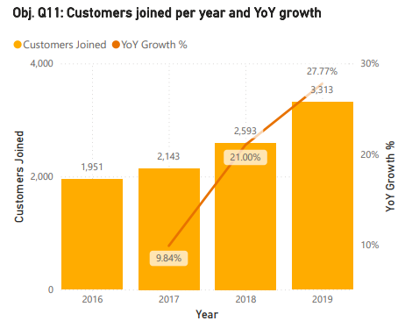
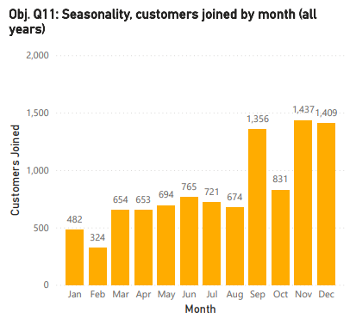
Dashboard evidence (PowerBI):
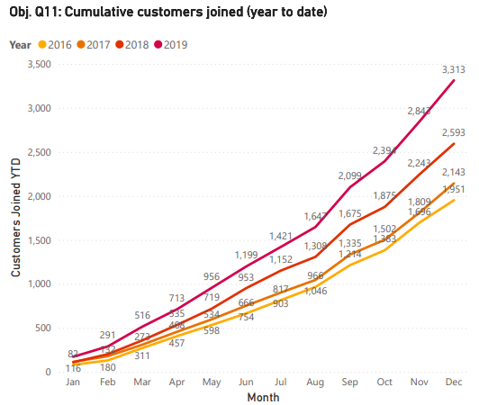
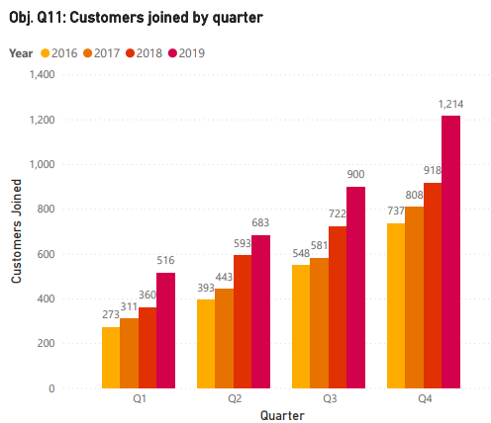

Obj. Q11: Year × month heatmap

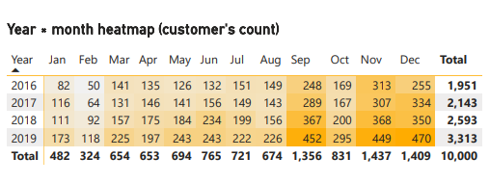
Output:
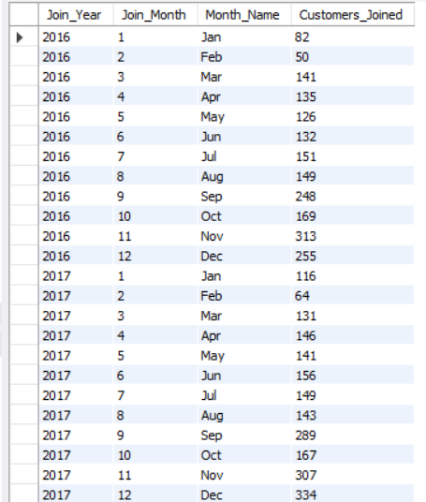
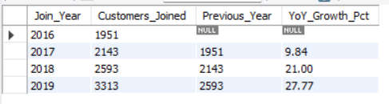
11a. 11.b

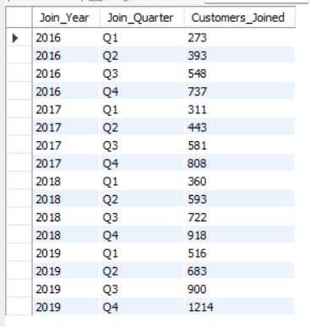
11.d
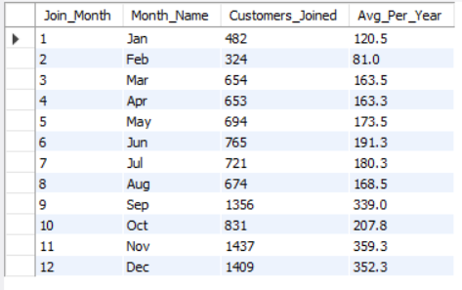
11.c

Insights:
Acquisition grows every year, and the growth rate itself is accelerating (9.84% to 21.00% to 27.77%). There is a clear yearly seasonal pattern. Q4 is the strongest quarter every year (3,677 joiners overall vs 1,460 in Q1), with peaks in September, November and December and a low in February. This fits year-end bonuses, festive spending and year-end marketing pushes, and the bank should schedule campaigns and onboarding staff around Q4.

Q.12 Analyze the relationship between the number of products and the account balance for customers who have exited.

Tools: SQL (Q12) · Power BI visual “Q12: Average balance of exited customers by number of products”

Solution (SQL Query):
SELECT NumOfProducts, COUNT(*) AS Exited_Customers, ROUND(AVG(Balance), 2) AS Avg_Balance,
ROUND(MIN(Balance), 2) AS Min_Balance, ROUND(MAX(Balance), 2) AS Max_Balance
FROM Bank_Churn WHERE Exited = 1
GROUP BY NumOfProducts ORDER BY NumOfProducts;

-- correlation (MySQL has no CORR function)
SELECT ROUND((AVG(NumOfProducts * Balance) - AVG(NumOfProducts) * AVG(Balance))
/ (STDDEV_POP(NumOfProducts) * STDDEV_POP(Balance)), 4) AS Corr_Products_Balance_Exited
FROM Bank_Churn WHERE Exited = 1;

Dashboard evidence (PowerBI):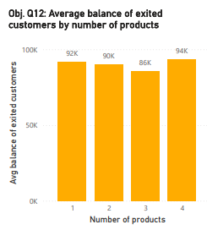

Output:
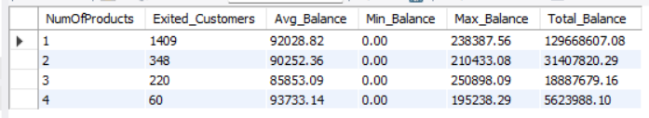
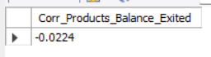

Insights:
There is no meaningful relationship. Average balance stays in a narrow 86K-94K range whatever the number of products. A customer holding more products does not hold more money, so the extra products are not driving deeper relationships.

Q.13 Identify any potential outliers in terms of balance among customers who have remained with the bank.

Tools: SQL (Q13a, Q13b) · Power BI cards “Q13: Retained customers…”, visuals “Q13: Retained customers by balance band” and “Q13: Top 15 retained balances”

Solution (SQL Query):
-- Q13a : all retained customers
WITH ranked AS (
SELECT CustomerId, Balance,
ROW_NUMBER() OVER (ORDER BY Balance) AS rn,
COUNT(*) OVER () AS n
FROM Bank_Churn
WHERE Exited = 0
),
quartiles AS (
SELECT MAX(CASE WHEN rn = CEIL(0.25 * n) THEN Balance END) AS Q1,
MAX(CASE WHEN rn = CEIL(0.75 * n) THEN Balance END) AS Q3
FROM ranked
),
fences AS (
SELECT Q1, Q3, Q3 - Q1 AS IQR,
Q1 - 1.5 * (Q3 - Q1) AS Lower_Fence,
Q3 + 1.5 * (Q3 - Q1) AS Upper_Fence
FROM quartiles
)
SELECT f.Q1, f.Q3, f.IQR, f.Lower_Fence, f.Upper_Fence,
SUM(r.Balance < f.Lower_Fence) AS Low_Outliers,
SUM(r.Balance > f.Upper_Fence) AS High_Outliers
FROM ranked r
CROSS JOIN fences f
GROUP BY f.Q1, f.Q3, f.IQR, f.Lower_Fence, f.Upper_Fence;

-- Q13b : retained customers with a balance above 0
WITH ranked AS (
SELECT CustomerId, Balance,
ROW_NUMBER() OVER (ORDER BY Balance) AS rn,
COUNT(*) OVER () AS n
FROM Bank_Churn
WHERE Exited = 0 AND Balance > 0
),
quartiles AS (
SELECT MAX(CASE WHEN rn = CEIL(0.25 * n) THEN Balance END) AS Q1,
MAX(CASE WHEN rn = CEIL(0.75 * n) THEN Balance END) AS Q3
FROM ranked
),
fences AS (
SELECT Q1, Q3, Q3 - Q1 AS IQR,
Q1 - 1.5 * (Q3 - Q1) AS Lower_Fence,
Q3 + 1.5 * (Q3 - Q1) AS Upper_Fence
FROM quartiles
)
SELECT f.Q1, f.Q3, f.IQR, f.Lower_Fence, f.Upper_Fence,
SUM(r.Balance < f.Lower_Fence) AS Low_Outliers,
SUM(r.Balance > f.Upper_Fence) AS High_Outliers
FROM ranked r
CROSS JOIN fences f
GROUP BY f.Q1, f.Q3, f.IQR, f.Lower_Fence, f.Upper_Fence;

Dashboard evidence (PowerBI):
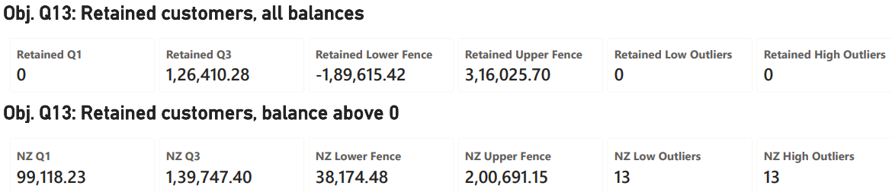
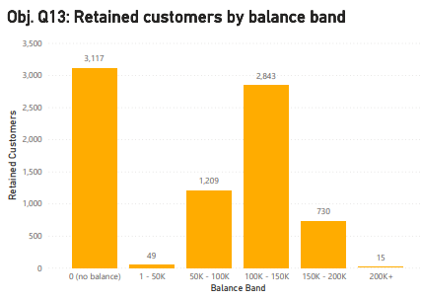
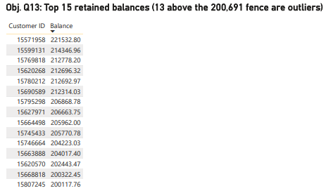

Output: Note - Power BI uses interpolated quartiles (Q3 = 126,410.28 and 139,747.40), so its fences differ slightly, but the outlier counts are the same.
--Q.13a

--Q.13b

Insights:
Across all retained customers there are no outliers, because 3,117 customers (39%) hold exactly zero, which stretches the fences far out. The highest balance, 221,532.80, is well inside the upper fence. Among customers who hold money, 13 have unusually high balances (above about 200,700) and 13 unusually low ones (below about 38,100). The 13 high-balance customers are the retention priority.

Q.14 How many different tables are given in the dataset, out of these tables which table only consists of categorical variables?

Tools: SQL (Part B, information_schema) · Excel (7 sheets) · Power BI model view

Solution (SQL Query):
--Q.14a
SELECT table_name, column_name, data_type FROM information_schema.columns
WHERE table_schema = 'bank_churn_db' ORDER BY table_name, ordinal_position;

--Q.14b
SELECT COUNT(*) AS Total_Tables FROM information_schema.tables
WHERE table_schema = 'bank_churn_db' AND table_type = 'BASE TABLE';

Output:
--Q.14a --Q.14b
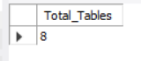
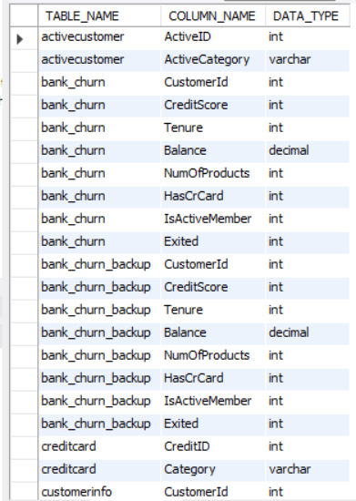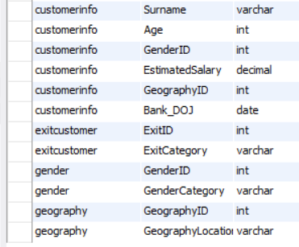

Insights:
The five lookup tables (Gender, Geography, CreditCard, ActiveCustomer, ExitCustomer) contain only categorical variables, because their ID is a code for a category and not a quantity. The two main tables hold the measurable (numeric) data. The 5 lookups act as dimension tables, and the 2 main tables are joined to them with foreign keys.

Q.15 Using SQL, write a query to find out the gender-wise average income of males and females in each geography id. Also, rank the gender according to the average value. (SQL)

Tools: SQL (Q15)

Solution (SQL Query):
WITH avg_income AS (
SELECT c.GeographyID, geo.GeographyLocation AS Geography, g.GenderCategory AS Gender,
ROUND(AVG(c.EstimatedSalary), 2) AS Avg_Income
FROM CustomerInfo c
JOIN Gender g ON c.GenderID = g.GenderID
JOIN Geography geo ON c.GeographyID = geo.GeographyID
GROUP BY c.GeographyID, geo.GeographyLocation, g.GenderCategory)
SELECT GeographyID, Geography, Gender, Avg_Income,
RANK() OVER (PARTITION BY GeographyID ORDER BY Avg_Income DESC) AS Income_Rank
FROM avg_income ORDER BY GeographyID, Income_Rank;

Output:
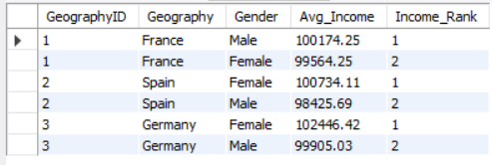

Insights:
Men earn more only in France, while women earn more in Spain and Germany. The gaps are small (about 0.6% to 2.5%). Germany’s women have the highest average income of any group (102,446), and they are also part of the highest-churn region.

Q.16 Using SQL, write a query to find out the average tenure of the people who have exited in each age bracket (18-30, 30-50, 50+).

Tools: SQL (Q16) · Power BI table “Q16: Exited customers by age bracket”

Solution (SQL Query):
SELECT CASE WHEN c.Age <= 30 THEN '18-30' WHEN c.Age <= 50 THEN '31-50' ELSE '50+' END AS Age_Bracket,
COUNT(*) AS Exited_Customers, ROUND(AVG(b.Tenure), 2) AS Avg_Tenure_Years
FROM CustomerInfo c JOIN Bank_Churn b ON c.CustomerId = b.CustomerId
WHERE b.Exited = 1
GROUP BY Age_Bracket ORDER BY MIN(c.Age);

Dashboard evidence (PowerBI):
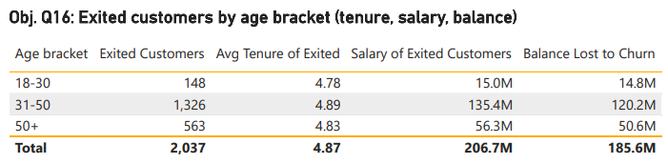

Output:
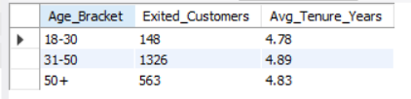

Insights:
Customers leave after about 4.8 to 4.9 years whatever their age, so customers do not leave early in the relationship. Exits come mainly from the 31-50 group (65% of all exits), simply because it is the biggest group.

Q.17 Is there any direct correlation between salary and the balance of the customers? And is it different for people who have exited or not?

Tools: SQL (Q17) · Power BI visual “Q17: Salary vs balance” and the correlation table

Solution (SQL Query):
WITH d AS (SELECT c.EstimatedSalary AS salary, b.Balance AS balance, b.Exited
FROM CustomerInfo c JOIN Bank_Churn b ON c.CustomerId = b.CustomerId)
SELECT 'All customers' AS Segment,
ROUND((AVG(salary*balance) - AVG(salary)*AVG(balance)) / (STDDEV_POP(salary)*STDDEV_POP(balance)), 4) AS Corr_Salary_Balance
FROM d
UNION ALL SELECT 'Exited', ROUND((AVG(salary*balance) - AVG(salary)*AVG(balance)) / (STDDEV_POP(salary)*STDDEV_POP(balance)), 4) FROM d WHERE Exited = 1
UNION ALL SELECT 'Retained', ROUND((AVG(salary*balance) - AVG(salary)*AVG(balance)) / (STDDEV_POP(salary)*STDDEV_POP(balance)), 4) FROM d WHERE Exited = 0;

Dashboard evidence (PowerBI):
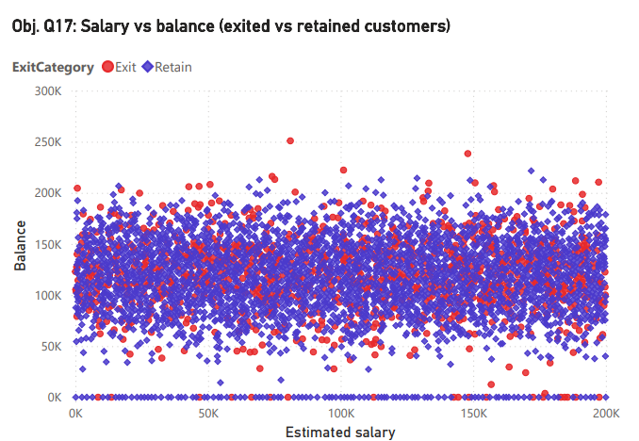

Output:
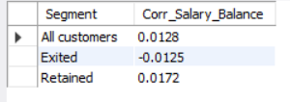

Insights:
There is no direct correlation (all values are close to 0), and the result is the same for exited and retained customers. How much a customer earns does not predict how much they keep in the bank, so salary cannot be used to estimate balance or churn risk.

Q.18 Is there any correlation between the salary and the Credit score of customers?

Tools: SQL (Q18) · Power BI visual “Q18: Salary vs credit score”

Solution (SQL Query):
SELECT ROUND((AVG(c.EstimatedSalary*b.CreditScore) - AVG(c.EstimatedSalary)*AVG(b.CreditScore))
/ (STDDEV_POP(c.EstimatedSalary)*STDDEV_POP(b.CreditScore)), 4) AS Corr_Salary_CreditScore
FROM CustomerInfo c JOIN Bank_Churn b ON c.CustomerId = b.CustomerId;

Dashboard evidence (PowerBI):
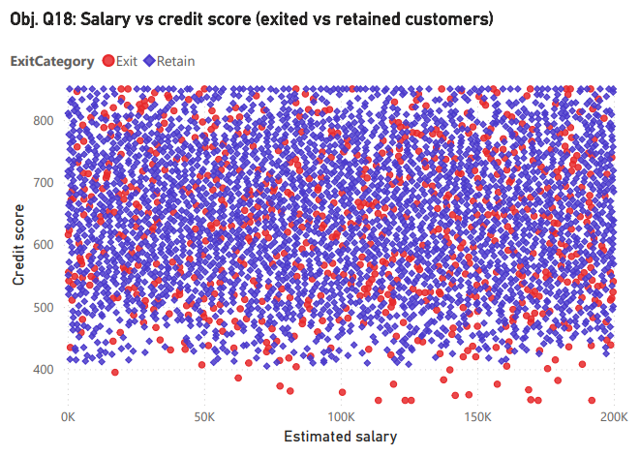

Output:
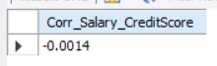

Insights:
There is no correlation. Credit score reflects repayment history, not income, and the scatter plot is an even cloud with no trend. The bank should not use salary as a stand-in for creditworthiness.

Q.19 Rank each bucket of credit score as per the number of customers who have churned the bank.

Tools: SQL (Q19) · Power BI table “Q19: Credit score buckets ranked by churned customers”

Solution (SQL Query):
WITH bucket AS (
SELECT CASE WHEN CreditScore >= 800 THEN 'Excellent (800-850)'
WHEN CreditScore >= 740 THEN 'Very Good (740-799)'
WHEN CreditScore >= 670 THEN 'Good (670-739)'
WHEN CreditScore >= 580 THEN 'Fair (580-669)'
ELSE 'Poor (300-579)' END AS Credit_Bucket,
COUNT(*) AS Customers, SUM(Exited) AS Churned_Customers
FROM Bank_Churn GROUP BY Credit_Bucket)
SELECT Credit_Bucket, Customers, Churned_Customers,
RANK() OVER (ORDER BY Churned_Customers DESC) AS Churn_Rank
FROM bucket ORDER BY Churn_Rank;

Dashboard evidence (PowerBI):
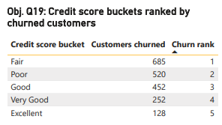

Output:
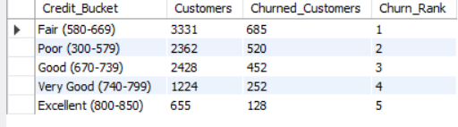

Insights:
Fair has the most churned customers (685), but only because it is the largest bucket. Ranked by rate (Q7), Poor is first. Count shows where the volume of lost customers sits, and rate shows where the risk is highest, so the bank needs both.

Q.20 According to the age buckets find the number of customers who have a credit card. Also retrieve those buckets that have lesser than average number of credit cards per bucket.

Tools: SQL (Q20a, Q20b) · Power BI visual “Q20: Credit card holders by age bucket” and table “Q20: Age buckets below average by card holders”

Solution (SQL Query):
-- Q20a
SELECT CASE WHEN c.Age <= 30 THEN '18-30'
WHEN c.Age <= 50 THEN '31-50'
ELSE '50+' END AS Age_Bucket,
SUM(b.HasCrCard) AS Credit_Card_Customers
FROM CustomerInfo c
JOIN Bank_Churn b ON c.CustomerId = b.CustomerId
GROUP BY Age_Bucket
ORDER BY MIN(c.Age);

-- Q20b
WITH bucket AS (
SELECT CASE WHEN c.Age <= 30 THEN '18-30'
WHEN c.Age <= 50 THEN '31-50'
ELSE '50+' END AS Age_Bucket,
SUM(b.HasCrCard) AS Credit_Card_Customers
FROM CustomerInfo c
JOIN Bank_Churn b ON c.CustomerId = b.CustomerId
GROUP BY Age_Bucket
),
with_avg AS (
SELECT Age_Bucket, Credit_Card_Customers,
ROUND(AVG(Credit_Card_Customers) OVER (), 2) AS Avg_Per_Bucket
FROM bucket
)
SELECT Age_Bucket, Credit_Card_Customers, Avg_Per_Bucket
FROM with_avg
WHERE Credit_Card_Customers < Avg_Per_Bucket;

Dashboard evidence (PowerBI):
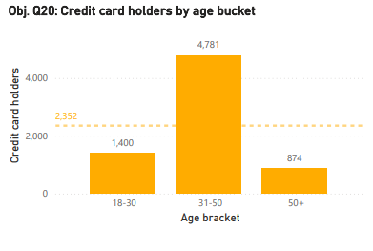

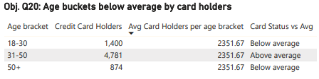

Output:
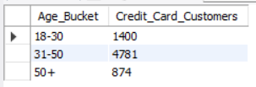
--Q.20a

--Q.20b
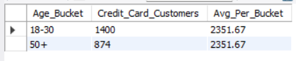

Insights:
The buckets below average are 18-30 and 50+. The 31-50 group has 4,781 card holders, 68% of the total. The 50+ group has a low card count, but it is also the highest-churn age group (Subjective Q4), so card offers alone would not retain them. The 18-30 group is an under-served card market and a growth opportunity.

Q.21 Rank the Locations as per the number of people who have churned the bank and average balance of the customers.

Tools: SQL (Q21) · Power BI table “Q21: Locations ranked by churned customers and average balance”

Solution (SQL Query):
SELECT geo.GeographyLocation AS Location, SUM(b.Exited) AS Churned_Customers,
RANK() OVER (ORDER BY SUM(b.Exited) DESC) AS Churn_Rank,
ROUND(AVG(b.Balance), 2) AS Avg_Balance,
RANK() OVER (ORDER BY AVG(b.Balance) DESC) AS Balance_Rank
FROM CustomerInfo c
JOIN Bank_Churn b ON c.CustomerId = b.CustomerId
JOIN Geography geo ON c.GeographyID = geo.GeographyID
GROUP BY geo.GeographyLocation ORDER BY Churn_Rank;

Dashboard evidence (PowerBI):
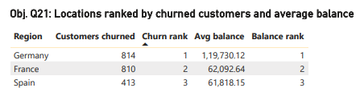

Output:
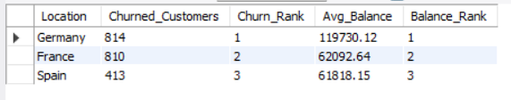

Insights:
Germany ranks first on both: the most churned customers and the highest average balance. It has half of France’s customers but loses almost as many (814 vs 810), and those customers hold about twice the money. Germany is the bank’s most urgent retention problem.

Q.22 As we can see that the “CustomerInfo” table has the CustomerID and Surname, now if we have to join it with a table where the primary key is also a combination of CustomerID and Surname, come up with a column where the format is “CustomerID_Surname”.

Tools: SQL (Q22) · Excel (column CustomerID_Surname in CustomerInfo) · Power BI (custom column)

Solution (SQL Query):
SELECT CustomerId, Surname, CONCAT(CAST(CustomerId AS CHAR), '_', Surname) AS CustomerID_Surname
FROM CustomerInfo ORDER BY CustomerId LIMIT 20;

Output: Excel: =A2&"_"&B2 · Power BI (Power Query custom column): Text.From([CustomerId]) & "_" & [Surname]
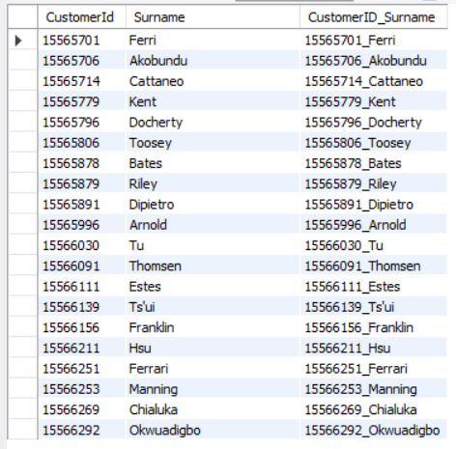

Insights:
The combined key is unique for all 10,000 rows, because CustomerId is already unique. It can be used as a composite primary key when joining to a table keyed on both fields. CAST converts the numeric ID to text before joining.

Q.23 Without using “Join”, can we get the “ExitCategory” from ExitCustomers table to Bank_Churn table?If yes do this using SQL.

Tools: SQL (Q23)

Solution (SQL Query):
SELECT b.CustomerId, b.Exited,
(SELECT e.ExitCategory FROM ExitCustomer e WHERE e.ExitID = b.Exited) AS ExitCategory
FROM Bank_Churn b ORDER BY b.CustomerId LIMIT 20;

Output:
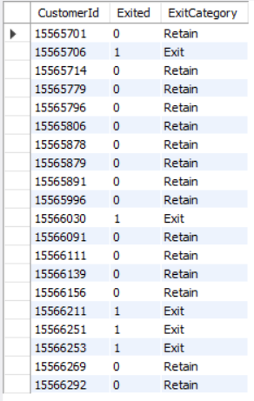

Insights:
Yes, it can be done without a JOIN, using a correlated scalar subquery, which looks up the label for each row. It gives the same result as a join. For two-row lookup tables the speed is the same, and a JOIN is the better choice on large tables.

Q.24 Were there any missing values in the data, using which tool did you replace them and what are the ways to handle them?

Tools: SQL (Part B) · Excel (Data_Quality_Notes sheet) · Power Query (column quality)

Solution (SQL Query):
--24.a
SELECT
SUM(CustomerId IS NULL) AS null_CustomerId,
SUM(CreditScore IS NULL) AS null_CreditScore,
SUM(Tenure IS NULL) AS null_Tenure,
SUM(Balance IS NULL) AS null_Balance,
SUM(NumOfProducts IS NULL) AS null_NumOfProducts,
SUM(HasCrCard IS NULL) AS null_HasCrCard,
SUM(IsActiveMember IS NULL) AS null_IsActiveMember,
SUM(Exited IS NULL) AS null_Exited
FROM Bank_Churn;

--24.b
SELECT
SUM(CustomerId IS NULL) AS null_CustomerId,
SUM(Surname IS NULL OR TRIM(Surname) = '') AS blank_Surname,
SUM(Age IS NULL) AS null_Age,
SUM(GenderID IS NULL) AS null_GenderID,
SUM(EstimatedSalary IS NULL) AS null_EstimatedSalary,
SUM(GeographyID IS NULL) AS null_GeographyID,
SUM(Bank_DOJ IS NULL) AS null_Bank_DOJ
FROM CustomerInfo;

--24.c
SELECT CustomerId, COUNT(*) AS times_repeated -- expect 0 rows
FROM CustomerInfo
GROUP BY CustomerId
HAVING COUNT(*) > 1;

--24.d
SET SQL_SAFE_UPDATES = 0;

--24.e
SELECT COUNT(*) AS surnames_needing_clean -- 0 expected
FROM CustomerInfo
WHERE Surname <> REPLACE(TRIM(Surname), ' ', ' ');

--24.f
UPDATE CustomerInfo
SET Surname = REPLACE(TRIM(Surname), ' ', ' ')
WHERE Surname <> REPLACE(TRIM(Surname), ' ', ' ');

Output:
--Q.24a

--Q.24b
--Q.24c
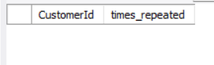

--Q.24d
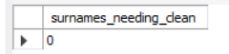

Insights:
There were no missing values, so nothing needed replacing. The checks used Excel (Go To Special → Blanks, COUNTBLANK), SQL (NULL counts) and Power Query (column quality). Had values been missing, the options are:
- delete the rows when very few are affected;
- fill numeric gaps with the mean or median (median when outliers exist, as with Balance);
- fill categories with the mode or “Unknown”;
- use a business rule (for example, 0 for no balance);
- forward-fill time data;
- predict the value with a model (regression or KNN).

Q.25 Write the query to get the customer IDs, their last name, and whether they are active or not for the customers whose surname ends with “on”.

Tools: SQL (Q25)

Solution (SQL Query):
SELECT c.CustomerId, c.Surname, a.ActiveCategory AS Activity_Status
FROM CustomerInfo c
JOIN Bank_Churn b ON c.CustomerId = b.CustomerId
JOIN ActiveCustomer a ON b.IsActiveMember = a.ActiveID
WHERE c.Surname LIKE '%on'
ORDER BY c.CustomerId;

Output: 704 customers (314 active, 390 inactive). First 27 rows:
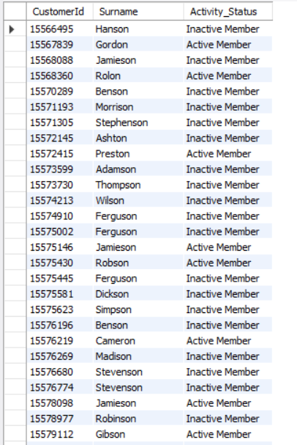

Insights:
LIKE '%on' matches any surname that ends in “on” (Hanson, Gordon, Benson). Only 45% of these customers are active, which is in line with the bank average of 44%. Status here uses the corrected IsActiveMember (Q26).

Q.26 Can you observe any data disrupency in the Customer’s data? As a hint it’s present in the IsActiveMember and Exited columns. One more point to consider is that the data in the Exited Column is absolutely correct and accurate.

Tools: SQL (Part B) · Excel (IsActive_Corrected column) · Power BI (custom column and matrix “Q26: Active status vs exit (original data)”)

Solution (SQL Query):
--26.a
SELECT IsActiveMember, Exited, COUNT(*) AS Customers
FROM Bank_Churn
GROUP BY IsActiveMember, Exited
ORDER BY Exited, IsActiveMember;

--26.b
SELECT COUNT(*) AS Discrepant_Rows -- 735 expected
FROM Bank_Churn
WHERE Exited = 1 AND IsActiveMember = 1;

-- Untouched copy of the original data, then fix the column
CREATE TABLE IF NOT EXISTS Bank_Churn_backup AS
SELECT * FROM Bank_Churn;

UPDATE Bank_Churn
SET IsActiveMember = 0
WHERE Exited = 1 AND IsActiveMember = 1;
--26.c
SELECT COUNT(*) AS Discrepant_Rows_After_Fix -- 0 expected
FROM Bank_Churn
WHERE Exited = 1 AND IsActiveMember = 1;

SET SQL_SAFE_UPDATES = 1;

Output: Excel: =IF(H2=1,0,G2) · Power BI: if [Exited] = 1 then 0 else [IsActiveMember]

--Q.26a
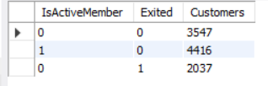

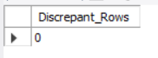
--Q.26b

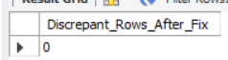
--Q.26c

Insights:
735 customers are recorded as active but have already exited, which is logically impossible. Since Exited is stated to be accurate, IsActiveMember is corrected to 0 for those rows, and the original is kept in a backup table. Without the fix, activity would be overstated by 735 customers (5,151 vs 4,416 active), which would distort every “active” metric.

Subjective Questions

Q.1 Customer Behavior Analysis: What patterns can be observed in the spending habits of long-term customers compared to new customers, and what might these patterns suggest about customer loyalty?

Tools: SQL (Part D, S1)

Solution (SQL Query): The data has no transaction history, so balance, products and activity stand in for spending habits:
SELECT CASE WHEN b.Tenure <= 4 THEN 'New (3-4 yrs)' WHEN b.Tenure = 5 THEN 'Mid (5 yrs)'
ELSE 'Long-term (6-7 yrs)' END AS Tenure_Group,
COUNT(*) AS Customers, ROUND(AVG(b.Balance),2) AS Avg_Balance,
ROUND(AVG(c.EstimatedSalary),2) AS Avg_Salary, ROUND(AVG(b.NumOfProducts),2) AS Avg_Products,
ROUND(AVG(b.CreditScore),0) AS Avg_Credit_Score,
ROUND(100*SUM(b.IsActiveMember)/COUNT(*),2) AS Active_Pct,
ROUND(100*SUM(b.Exited)/COUNT(*),2) AS Churn_Rate_Pct
FROM Bank_Churn b JOIN CustomerInfo c ON b.CustomerId = c.CustomerId
GROUP BY Tenure_Group ORDER BY MIN(b.Tenure);

Output:
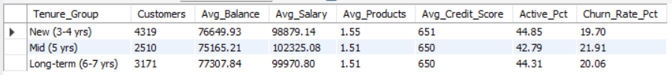

Insights:
Long-term and new customers behave almost identically. Balance (75K-77K), products (about 1.5), activity (43%-45%) and churn (20%-22%) barely differ. In this bank, tenure does not signal loyalty. Long-standing customers do not hold more money, buy more products or leave less often. Loyalty is driven by other factors: age, region, activity and product count (see Subjective Q7 and Q8). The bank should not assume a long-term customer is safe, and should run retention checks on every tenure group. Limit: tenure only spans 3 to 7 years, so behaviour beyond 7 years is unknown.

Q.2 Product Affinity Study: Which bank products or services are most commonly used together, and how might this influence cross-selling strategies?

Tools: SQL (S2) · Power BI matrix “Subj. Q2: Products held by credit card status”

Solution (SQL Query):
SELECT b.NumOfProducts, cc.Category AS Card_Status, COUNT(*) AS Customers,
ROUND(100*COUNT(*)/SUM(COUNT(*)) OVER (PARTITION BY b.NumOfProducts),2) AS Pct_Within_Product_Group,
ROUND(AVG(b.Balance),2) AS Avg_Balance, ROUND(100*SUM(b.Exited)/COUNT(*),2) AS Churn_Rate_Pct
FROM Bank_Churn b JOIN CreditCard cc ON b.HasCrCard = cc.CreditID
GROUP BY b.NumOfProducts, cc.Category ORDER BY b.NumOfProducts, cc.Category;

Dashboard evidence (PowerBI):
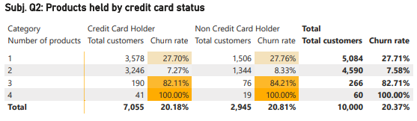

Output:
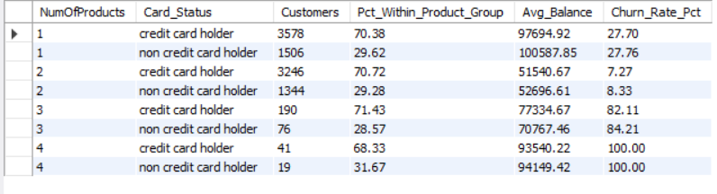

Insights:
- 96.7% of customers hold only 1 or 2 products. The most common combination is a credit card plus one other product (3,578) or plus two (3,246).
- About 70% hold the credit card whatever their product count, so the card is an entry product and not a sign of deeper engagement.
- Two products is the sweet spot: churn falls from 27.7% to 7.6%.
- Cross-selling strategy: target the 5,084 one-product customers, who hold the biggest balances (about 98K-101K), with a second product. Two-product customers churn about 20 points less. Do not push customers to 3 or 4 products, where churn is 82.7% and 100%. Investigate pricing, fees or service on those bundles first.

Q.3 Geographic Market Trends: How do economic indicators in different geographic regions correlate with the number of active accounts and customer churn rates?

Tools: SQL (S3) · Power BI “Subj. Q3: Churn rate by region”

Solution (SQL Query):
SELECT geo.GeographyLocation AS Region, COUNT(*) AS Customers,
SUM(b.IsActiveMember) AS Active_Accounts, ROUND(100*SUM(b.IsActiveMember)/COUNT(*),2) AS Active_Pct,
SUM(b.Exited) AS Exited_Customers, ROUND(100*SUM(b.Exited)/COUNT(*),2) AS Churn_Rate_Pct,
ROUND(AVG(c.EstimatedSalary),2) AS Avg_Salary, ROUND(AVG(b.Balance),2) AS Avg_Balance,
ROUND(AVG(b.CreditScore),0) AS Avg_Credit_Score, ROUND(AVG(b.NumOfProducts),2) AS Avg_Products
FROM CustomerInfo c JOIN Bank_Churn b ON c.CustomerId = b.CustomerId
JOIN Geography geo ON c.GeographyID = geo.GeographyID
GROUP BY geo.GeographyLocation ORDER BY Churn_Rate_Pct DESC;

Dashboard evidence (PowerBI):
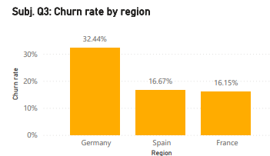

Output:

Insights:
The dataset has no real economic indicators (GDP, unemployment, inflation, interest rates), so I use salary, balance and credit score as proxies. Salary and credit score are almost the same in all three regions (within 1.7%), so they do not explain Germany’s churn. Germany differs in two ways: balances are double, and the active share is lowest (37.94%). Across the three regions, a lower active share goes with higher churn. Possible causes are stronger local competition or a product mismatch for wealthier customers. To test this properly, the bank should add GDP per capita, unemployment, interest rates, competitor density and branch counts per region.

Q.4 Risk Management Assessment: Based on customer profiles, which demographic segments appear to pose the highest financial risk to the bank, and why?

Tools: SQL (S4) · Power BI scatter and matrix “Subj. Q4: …”

Solution (SQL Query):
WITH seg AS (
SELECT CASE WHEN c.Age <= 30 THEN '18-30' WHEN c.Age <= 50 THEN '31-50' ELSE '50+' END AS Age_Bucket,
geo.GeographyLocation AS Region, COUNT(*) AS Customers, SUM(b.Exited) AS Exited_Customers,
ROUND(100*SUM(b.Exited)/COUNT(*),2) AS Churn_Rate_Pct,
ROUND(SUM(CASE WHEN b.Exited = 1 THEN b.Balance ELSE 0 END),2) AS Balance_Lost
FROM CustomerInfo c JOIN Bank_Churn b ON c.CustomerId = b.CustomerId
JOIN Geography geo ON c.GeographyID = geo.GeographyID GROUP BY Age_Bucket, Region)
SELECT *, RANK() OVER (ORDER BY Balance_Lost DESC) AS Risk_Rank FROM seg ORDER BY Risk_Rank;

Dashboard evidence (PowerBI):
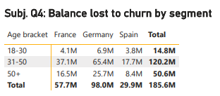

Output:
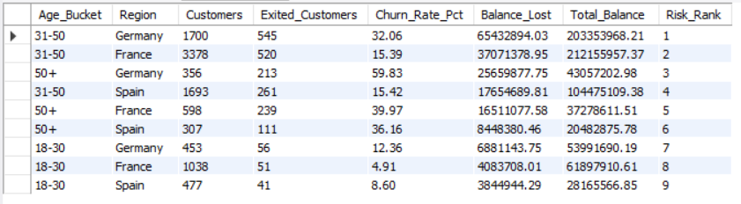

Insights:
- Highest rate: 50+ customers in Germany, at 59.83% (6 in 10 leave).
- Highest money lost: 31-50 in Germany, at 65.43M, or 35% of all lost balance.
- Germany overall accounts for 97.97M, or 53% of all balance lost, from only 25% of customers.
- The safest segment is 18-30 in France (4.91%).
- Other risk markers: 3 or 4 products (82.7% and 100% churn) and inactive members (26.85% vs 14.27%).

Q.5 Customer Tenure Value Forecast: How would you use the available data to model and predict the lifetime (tenure) value in the bank of different customer segments?

Tools: SQL (S5)

Solution (SQL Query):
WITH seg AS (
SELECT CASE WHEN c.Age <= 30 THEN '18-30' WHEN c.Age <= 50 THEN '31-50' ELSE '50+' END AS Age_Bucket,
geo.GeographyLocation AS Region, COUNT(*) AS Customers, AVG(b.Tenure) AS Avg_Tenure,
AVG(b.Balance) AS Avg_Balance, 1 - AVG(b.Exited) AS Retention_Rate
FROM CustomerInfo c JOIN Bank_Churn b ON c.CustomerId = b.CustomerId
JOIN Geography geo ON c.GeographyID = geo.GeographyID GROUP BY Age_Bucket, Region)
SELECT Age_Bucket, Region, ROUND(Avg_Balance,2) AS Avg_Balance, ROUND(100*Retention_Rate,2) AS Retention_Pct,
ROUND(Avg_Balance * Avg_Tenure * Retention_Rate,0) AS Tenure_Value_Score,
RANK() OVER (ORDER BY Avg_Balance * Avg_Tenure * Retention_Rate DESC) AS Value_Rank
FROM seg ORDER BY Value_Rank;

Output:
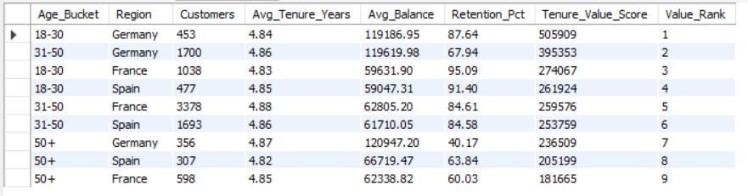

Insights:
- Young customers in Germany are the most valuable per customer: high balance and high retention. Customers aged 50+ are the least valuable, because retention is low, even in Germany where balances are high.
- Real forecasting method: the dataset has only a tenure number (3-7 years) and an exit flag, with no exit date, so true lifetime cannot be observed. With exit dates, the correct tool is survival analysis (Kaplan-Meier curves per segment). Lifetime value = expected remaining years × average balance × margin, discounted. A second route is a logistic regression that gives each customer a churn probability, with expected lifetime of about 1 ÷ churn probability.
- Customers can be bucketed into value tiers and given different service levels.

Q.6 Marketing Campaign Effectiveness: How could you assess the impact of marketing campaigns on customer retention and acquisition within the dataset? What extra information would you need to solve this?

Tools: SQL (supporting query)

Solution (SQL Query): The dataset has no campaign data, so I test the closest proxy: customers acquired in the peak joining months:
SELECT MONTH(c.Bank_DOJ) AS Join_Month, COUNT(*) AS Customers,
ROUND(100*SUM(b.Exited)/COUNT(*),2) AS Churn_Rate_Pct
FROM CustomerInfo c JOIN Bank_Churn b ON c.CustomerId = b.CustomerId
GROUP BY MONTH(c.Bank_DOJ) ORDER BY Join_Month;

Output: churn rate by joining month
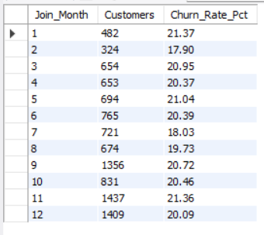

Insights:
The dataset has no campaign information, so the effect of a campaign cannot be measured directly. The peak months suggest acquisition drives (September and Nov-Dec), and customers acquired then churn at a similar rate (20.73% vs 20.11%), so the surge brought volume but not extra loyalty.
Extra information needed:
- Campaign table: ID, name, start and end date, channel, target segment, offer and cost.
- Customer-level exposure and response flags.
- A control group that did not receive the campaign.
- Exit dates, plus transaction and engagement data.
- Revenue per customer.
Method once available:
- A/B test to measure uplift in sign-ups and retention.
- Difference-in-differences on acquisition and churn before and after a campaign.
- Cohort retention curves per campaign.
- ROI = (incremental retained revenue - cost) ÷ cost.

Q.7 Customer Exit Reasons Exploration: Can you identify common characteristics or trends among customers who have exited that could explain their reasons for leaving?

Tools: SQL (S7)

Solution (SQL Query): Activity uses the original IsActiveMember from the backup table, because the corrected one is 0 for every exited customer by design:
SELECT e.ExitCategory AS Customer_Status, COUNT(*) AS Customers, ROUND(AVG(c.Age),1) AS Avg_Age,
ROUND(AVG(b.CreditScore),0) AS Avg_Credit_Score, ROUND(AVG(b.Balance),2) AS Avg_Balance,
ROUND(AVG(c.EstimatedSalary),2) AS Avg_Salary, ROUND(AVG(b.Tenure),2) AS Avg_Tenure,
ROUND(AVG(b.NumOfProducts),2) AS Avg_Products,
ROUND(100*AVG(o.IsActiveMember),2) AS Active_Pct_Original, ROUND(100*AVG(b.HasCrCard),2) AS Credit_Card_Pct,
ROUND(100*AVG(geo.GeographyLocation = 'Germany'),2) AS Germany_Pct,
ROUND(100*AVG(g.GenderCategory = 'Female'),2) AS Female_Pct
FROM Bank_Churn b JOIN Bank_Churn_backup o ON b.CustomerId = o.CustomerId
JOIN CustomerInfo c ON b.CustomerId = c.CustomerId JOIN ExitCustomer e ON b.Exited = e.ExitID
JOIN Geography geo ON c.GeographyID = geo.GeographyID JOIN Gender g ON c.GenderID = g.GenderID
GROUP BY e.ExitCategory;

Output:

Insights:
The dataset has no “reason for leaving” field, so reasons are inferred from patterns. Exited customers are:
- older (about 7 years on average),
- more often German (40% vs 21%),
- more often female (56% vs 43%),
- less active (36% vs 55%),
- holding higher balances (91K vs 73K), and far less likely to be zero-balance accounts.
In short, the bank loses its engaged-looking, wealthier, older customers in Germany, not its dormant ones. Credit score, salary, tenure and card ownership look the same in both groups. Likely reasons to test are competitor offers aimed at higher-balance customers, and poor service for older customers. A short exit survey would confirm the real reasons.

Q.8 Are 'Tenure', 'NumOfProducts', 'IsActiveMember', and 'EstimatedSalary' important for predicting if a customer will leave the bank?

Tools: SQL (S8, two queries) · Power BI “Subj. Q7 and Q8: Churn rate by selected dimension” (field parameter)

Solution (SQL Query):
-- Q8a : churn rate for each value / band
WITH feature AS (
SELECT 'Tenure' AS Feature, CAST(Tenure AS CHAR) AS Value_Group, Exited FROM Bank_Churn
UNION ALL
SELECT 'NumOfProducts', CAST(NumOfProducts AS CHAR), Exited FROM Bank_Churn
UNION ALL
SELECT 'IsActiveMember (original)', CAST(IsActiveMember AS CHAR), Exited FROM Bank_Churn_backup
UNION ALL
SELECT 'EstimatedSalary quartile', CONCAT('Band ', NTILE(4) OVER (ORDER BY c.EstimatedSalary)), b.Exited
FROM CustomerInfo c
JOIN Bank_Churn b ON c.CustomerId = b.CustomerId
)
SELECT Feature, Value_Group,
COUNT(*) AS Customers,
SUM(Exited) AS Exited_Customers,
ROUND(100 * SUM(Exited) / COUNT(*), 2) AS Churn_Rate_Pct
FROM feature
GROUP BY Feature, Value_Group
ORDER BY Feature, Value_Group;

-- Q8b : spread of churn rate per feature (bigger spread = stronger predictor)
WITH feature AS (
SELECT 'Tenure' AS Feature, CAST(Tenure AS CHAR) AS Value_Group, Exited FROM Bank_Churn
UNION ALL
SELECT 'NumOfProducts', CAST(NumOfProducts AS CHAR), Exited FROM Bank_Churn
UNION ALL
SELECT 'IsActiveMember (original)', CAST(IsActiveMember AS CHAR), Exited FROM Bank_Churn_backup
UNION ALL
SELECT 'EstimatedSalary quartile', CONCAT('Band ', NTILE(4) OVER (ORDER BY c.EstimatedSalary)), b.Exited
FROM CustomerInfo c
JOIN Bank_Churn b ON c.CustomerId = b.CustomerId
),
rates AS (
SELECT Feature, Value_Group, 100 * SUM(Exited) / COUNT(*) AS Churn_Rate_Pct
FROM feature
GROUP BY Feature, Value_Group
)
SELECT Feature,
ROUND(MIN(Churn_Rate_Pct), 2) AS Lowest_Churn_Pct,
ROUND(MAX(Churn_Rate_Pct), 2) AS Highest_Churn_Pct,
ROUND(MAX(Churn_Rate_Pct) - MIN(Churn_Rate_Pct), 2) AS Spread_Pct
FROM rates
GROUP BY Feature
ORDER BY Spread_Pct DESC;

Dashboard evidence (PowerBI):
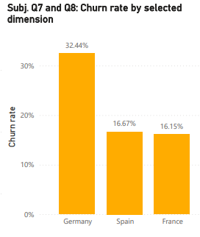

Output:
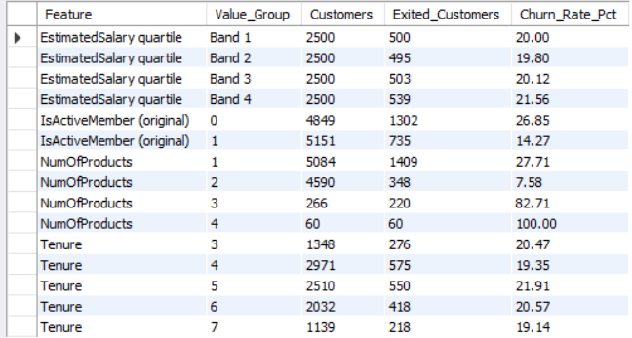
--Q.8a
--Q.8b
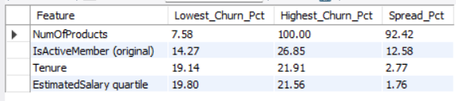

Insights:
NumOfProducts and IsActiveMember are important predictors, and Tenure and EstimatedSalary are not. The two weak features show differences that are statistically indistinguishable from chance. The significance tests are my own check on the SQL spreads. To confirm, fit a logistic regression or random forest and read the feature importance, using age and region as well, since they are strong drivers (Q7 and Subjective Q4).

Q.9 Utilize SQL queries to segment customers based on demographics and account details.

Tools: SQL (S9) · Power BI view “Subj. Q9: Churn rate by age bracket and region”

Solution (SQL Query):
SELECT CASE WHEN c.Age <= 30 THEN '18-30' WHEN c.Age <= 50 THEN '31-50' ELSE '50+' END AS Age_Bucket,
g.GenderCategory AS Gender, geo.GeographyLocation AS Region, COUNT(*) AS Customers,
ROUND(AVG(c.EstimatedSalary),2) AS Avg_Salary, ROUND(AVG(b.Balance),2) AS Avg_Balance,
ROUND(100*SUM(b.Exited)/COUNT(*),2) AS Churn_Rate_Pct
FROM CustomerInfo c JOIN Bank_Churn b ON c.CustomerId = b.CustomerId
JOIN Gender g ON c.GenderID = g.GenderID JOIN Geography geo ON c.GeographyID = geo.GeographyID
GROUP BY Age_Bucket, Gender, Region ORDER BY Churn_Rate_Pct DESC;

Dashboard evidence (PowerBI):

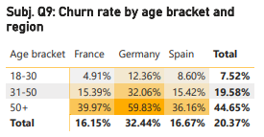

Output:
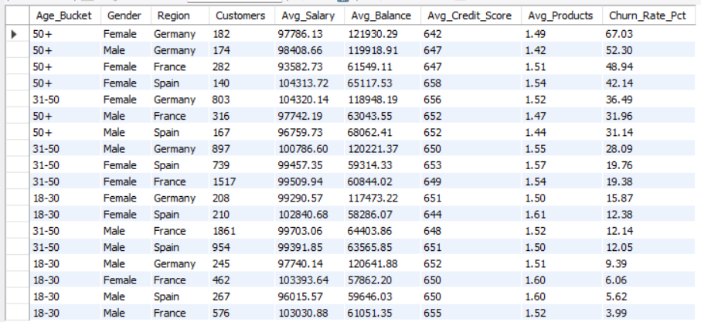

Insights:
Churn climbs steeply with age and from France/Spain to Germany. Women churn more than men in almost every age-region cell (for example 50+ in Germany: 67.03% vs 52.30%). The top segments (50+ in Germany) combine high balances with churn above 50%, so they are the first target. The safest are young men in France, at 3.99%.

Q.10 How can we create a conditional formatting setup to visually highlight customers at risk of churn and to evaluate the impact of credit card rewards on customer retention?

Tools: Excel (Churn_Risk_View sheet) · Power BI (risk columns, table “Subj. Q10: High-risk customers still with the bank”)

Solution (Excel): (Excel formatting rules, applied under Home → Conditional Formatting → New Rule → Use a formula)
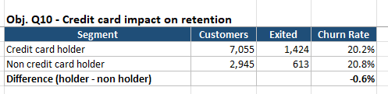

Solution (PowerBI calculated column):
Risk Score =
IF ( BankChurn[NumOfProducts] >= 3, 1, 0 ) + IF ( BankChurn[IsActiveMember] = 0, 1, 0 )
+ IF ( RELATED ( CustomerInfo[Age] ) > 50, 1, 0 ) + IF ( RELATED ( CustomerInfo[GeographyID] ) = 3, 1, 0 )
Risk Level = SWITCH ( TRUE (), BankChurn[Risk Score] >= 3, "High", BankChurn[Risk Score] = 2, "Medium", "Low" )

Dashboard evidence (PowerBI):
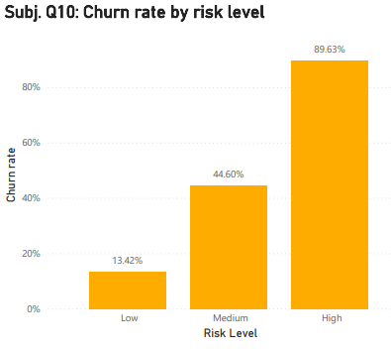

Output:
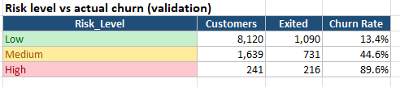

Insights:
The risk score separates customers well: churn rises from 13% to 45% to 90%. 25 high-risk customers are still with the bank, holding 3,012,012.01 in balance, and they should be contacted first. Card holders churn slightly less in every tier, but only by 1 to 4 points, so card rewards alone are a weak retention tool. Their true effect needs reward-usage data (points earned and redeemed).

Q.11 What is the current churn rate per year and overall as well in the bank? Can you suggest some insights to the bank about which kind of customers are more likely to churn and what different strategies can be used to decrease the churn rate?

Tools: SQL (S11) · Power BI “Subj. Q11: Churn rate by joining year”

Solution (SQL Query): The data has no exit date, so “year” means the year the customer joined:
SELECT CAST(YEAR(c.Bank_DOJ) AS CHAR) AS Join_Year, COUNT(*) AS Customers,
SUM(b.Exited) AS Exited_Customers, ROUND(100*SUM(b.Exited)/COUNT(*),2) AS Churn_Rate_Pct
FROM CustomerInfo c JOIN Bank_Churn b ON c.CustomerId = b.CustomerId GROUP BY Join_Year
UNION ALL
SELECT 'Overall', COUNT(*), SUM(b.Exited), ROUND(100*SUM(b.Exited)/COUNT(*),2) FROM Bank_Churn b
ORDER BY Join_Year;

Dashboard evidence (PowerBI):
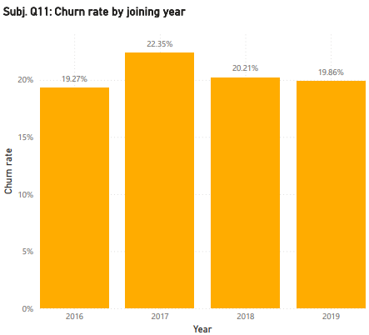

Output:
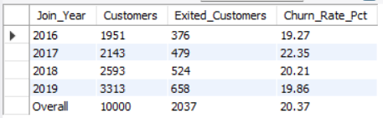

Insights:
who churns most:
- age 50+ (44.65%),
- Germany (32.44%),
- female (25.07%),
- inactive members (26.85%),
- customers with 3 or 4 products (82.71% and 100%).
Churn is stable by joining year (19%-22%), so it is a structural problem and not a recent one.
Strategies:
- Germany programme: a dedicated retention team and local offers. If Germany matched France/Spain (16.3%), about 400 fewer customers would leave, roughly a fifth of all exits (an illustration, not a forecast).
- Customers aged 50+, especially women: personal relationship managers, simplified products and branch or phone support.
- Re-activate inactive members: run engagement offers, because inactive members churn almost twice as much.
- Fix the 3-4 product bundles: review pricing, fees and service, since these customers almost all leave.
- Cross-sell the second product to one-product customers (27.7% churn, vs 7.6% for two products).
- Early-warning risk score (Subjective Q10), contacting the 25 high-risk customers first.
- Concentrate retention effort in Q4, since that is when most customers join.

Q.12 Create a dashboard incorporating all the KPIs and visualization-related metrics. Use a slicer in order to assist in selection in the dashboard.

Tools: Power BI (BankCRM_POWERBI.pbix)

Solution: A 5-tab report. Four slicers (Year, Age Bracket, Region, Gender) are synced across tabs, so one filter applies to every page.

Output:
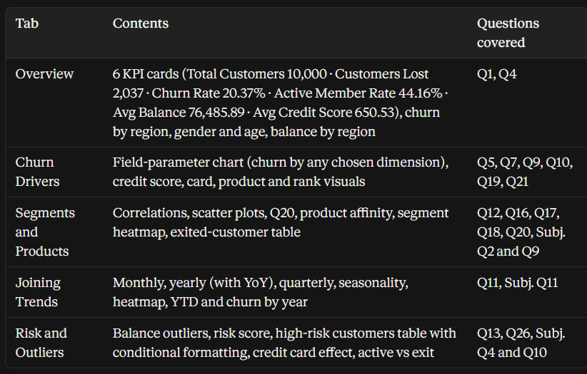
DAX used:
- Aggregation: Total Customers, Exited Customers, ChurnRate, Avg Balance, Total Balance.
- Filter context: Balance Lost to Churn, Credit Card Holders, Avg Balance of Exited.
- Row iteration: Salary of Exited Customers (SUMX), plus the correlation measures.
- Time intelligence: Customers Joined PY (SAMEPERIODLASTYEAR), YoY Growth %, Customers Joined YTD (TOTALYTD), over a marked date table.
- Field parameter: Churn By.

Insights:
The dashboard supports the story in this order: the size of the problem (20.37% churn), where it sits (Germany, 50+, inactive, 3-4 products), what it costs (185.59M of balance lost), and who to contact next (25 high-risk customers).

Q.13 How would you approach this problem, if the objective and subjective questions weren't given?

Solution (Approach):
- Business understanding: the goal is to reduce churn and improve service. Define churn (Exited = 1), choose KPIs (churn rate, active rate, balance at risk) and agree what a good outcome looks like.
- Data audit: list the tables and keys, then check missing values, duplicates, data types and logic (this is how the 735 active-but-exited contradictions were found).
- Clean and prepare: fix the errors, keep the original data, and build features such as age bucket, credit band and joining year/month.
- Exploratory analysis: overall churn first, then churn by every field, to see which fields move it.
- Segmentation: combine the strongest fields (age × region × gender) to find where churn and lost money concentrate.
- Statistical and predictive checks: correlation, chi-square and a logistic regression or tree model to rank the real drivers and score each customer’s risk.
- Prioritise by value: weigh churn rate by balance, so the retention budget goes to customers who are costly to lose.
- Dashboard: KPIs, slicers and drill-downs for managers.
- Recommendations and tracking: specific actions per segment, a pilot with a control group, and monitoring of churn monthly.

Q.14 In the “Bank_Churn” table how can you modify the name of the “HasCrCard” column to “Has_creditcard”?

Tools: SQL (Part E) · Excel and Power Query (header rename)

Solution (SQL Query):
ALTER TABLE Bank_Churn RENAME COLUMN HasCrCard TO Has_creditcard; -- MySQL 8.0+
-- MySQL 5.7: ALTER TABLE Bank_Churn CHANGE HasCrCard Has_creditcard INT NOT NULL;
DESCRIBE Bank_Churn;

Output:
DESCRIBE Bank_Churn shows the column Has_creditcard INT NOT NULL. The data and the foreign key to CreditCard are unchanged.

Insights:
ALTER TABLE changes the structure of a table (DDL) and leaves the data untouched, unlike UPDATE, which changes values. After the rename, queries and views must use the new name, which is why the rename comes at the end of the SQL file and the view uses Has_creditcard. In Excel and Power Query, the same change is done by renaming the column header.

