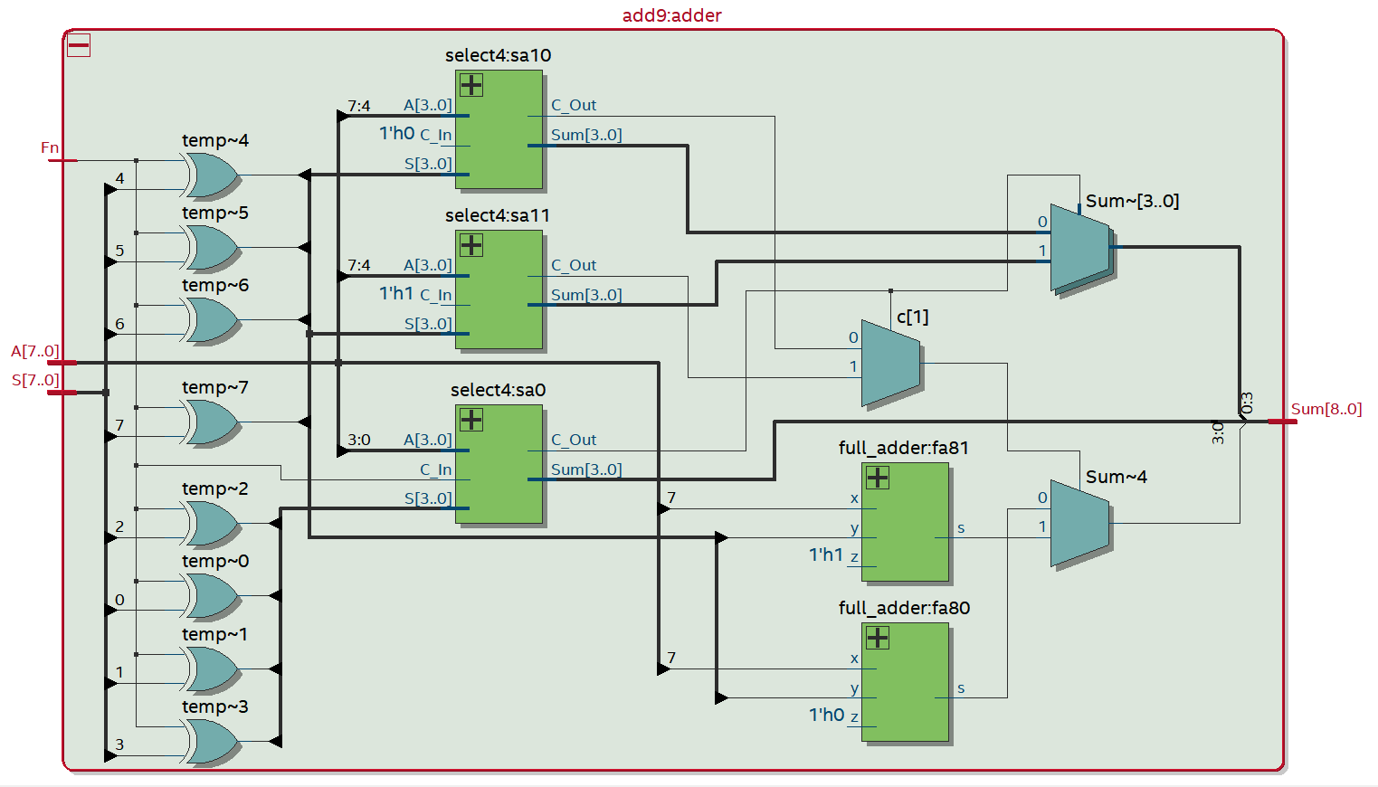

add9:adder

select4:sa 10

*7:4*

A[3..0] l'ho c In

C_Out Sum[3..0]

**temp~4**

S[3...]

Sum-[3..0]

temp~5

select4:sa11

1

*7:4*

temp~6

A[3...] 1'h1 C_In

S[3..0]

C Out Sum[3..0)

c[1]

A[7..0] S[7..0]

temp~7

**select4:sao**

073

Sum[8..]

3:0

3:0

A[3..0]

C In S[3..07

C_Out Sum[3.0)

full_adder:fa81

Sum-4

**temp-2**

temp~0

1'h1 z

full_adder:fa80

temp~1

**temp~3**

1'ho z