**Date:** *18-Jun-2025*

**Name:** *Vivek Samant*

**Empid:** *109085619*

**alias:** *samantvs*

**Task1: Differentiate between a thread and a process**

A process is an independent execution of a program in memory such as opening a media player, opening web browser.

Thread on the other hand is a sub unit of process. A process is divided into many threads and they run on shared memory allocated by the CPU in the most efficient way possible to execute a process.

*Take the case of opening a web browser: it has different aspects such as rendering UI, networking – establishing connection with the internet as per TCP… Now all these individual aspects of this process will be carried out by what’s called as threads. So, these threads work with shared resources allocated for the process.*

**Task2:**

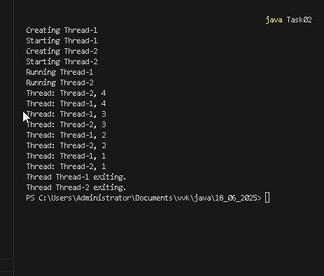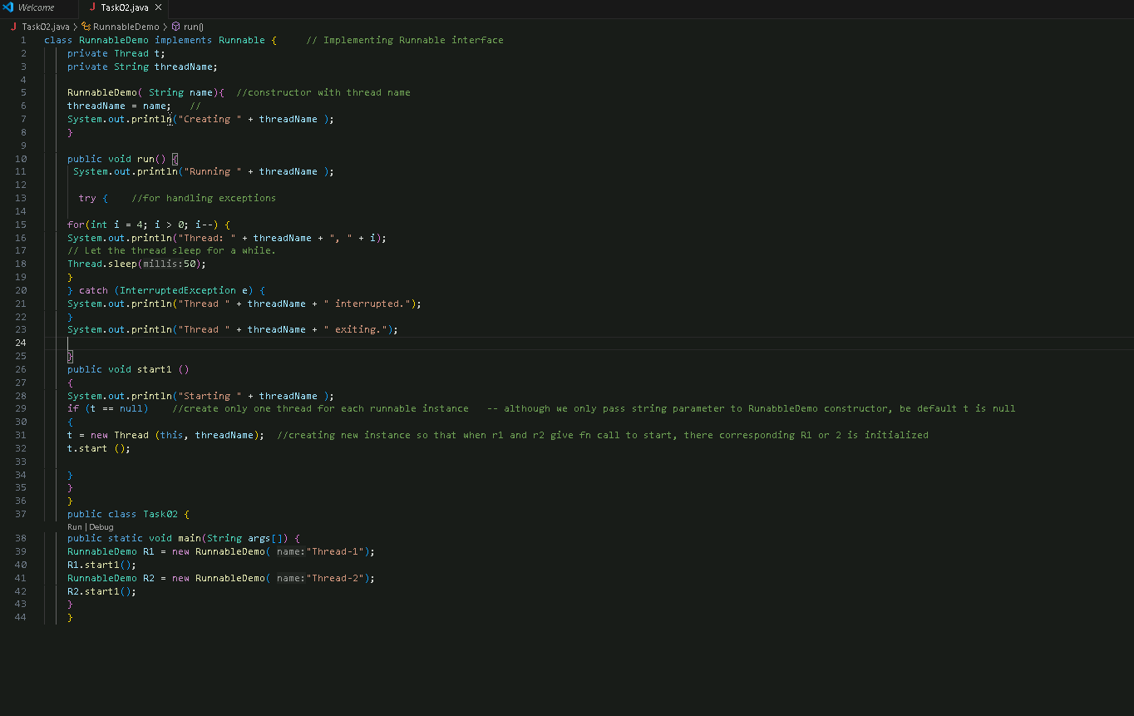

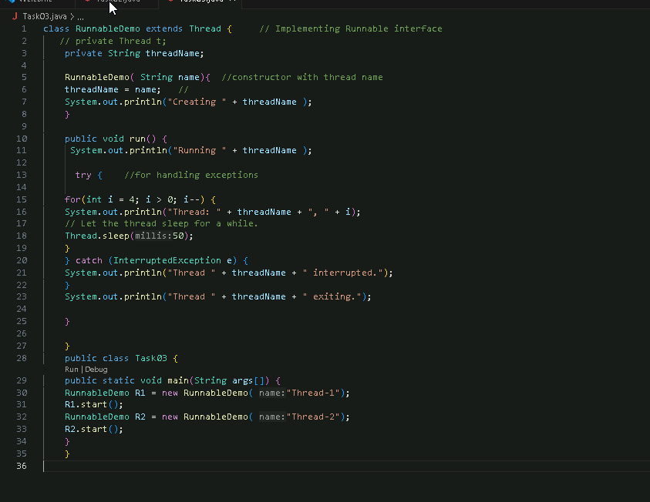Task03:

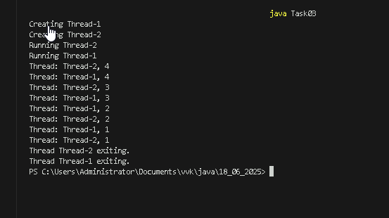

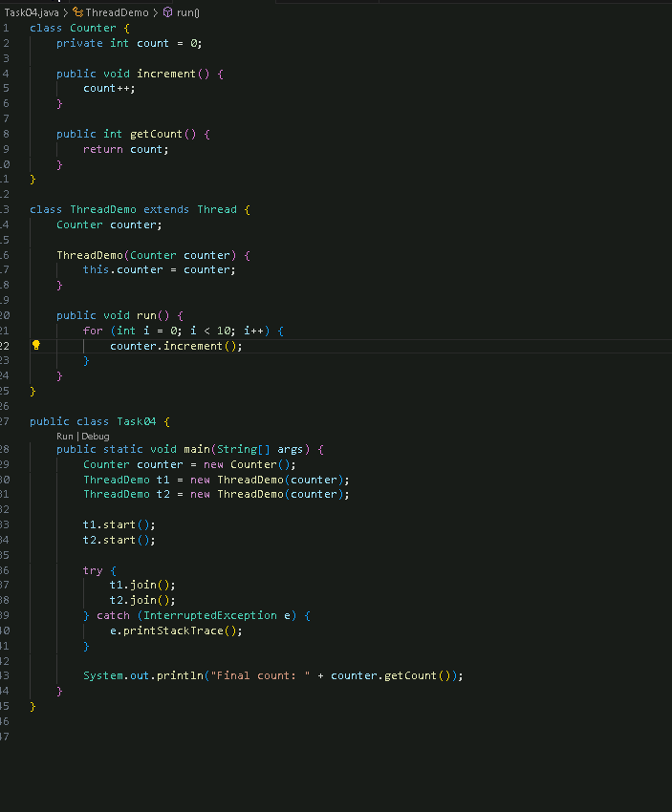**Task04:**



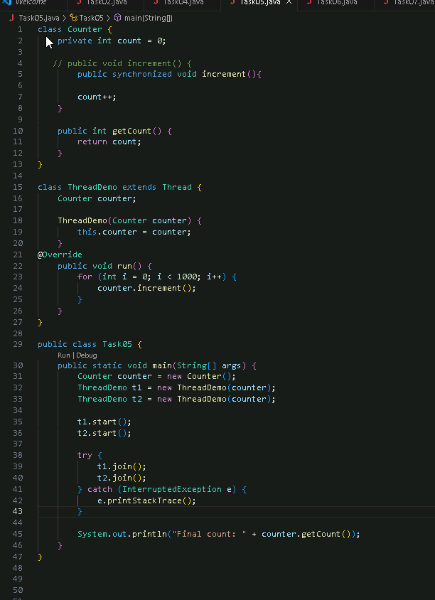**Task 05:**

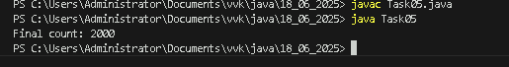**Task 06:**

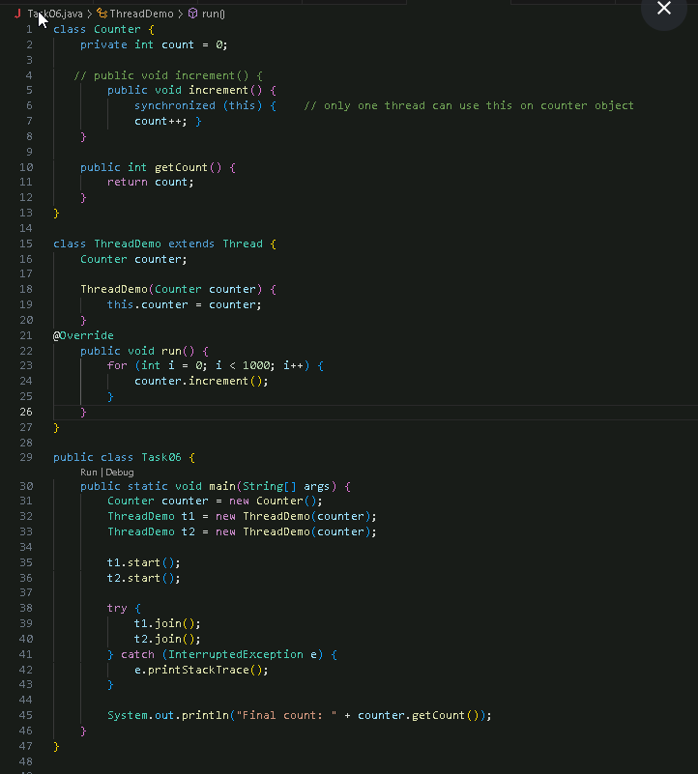



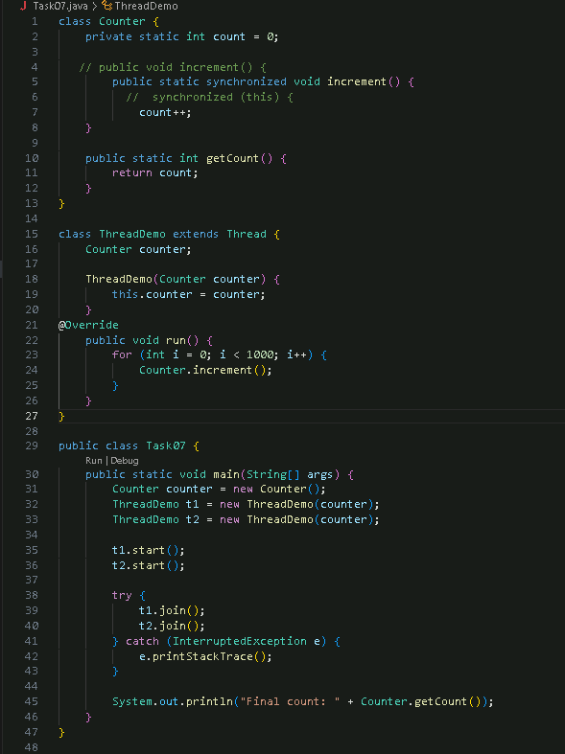**Task 07:**



**Task 08:**

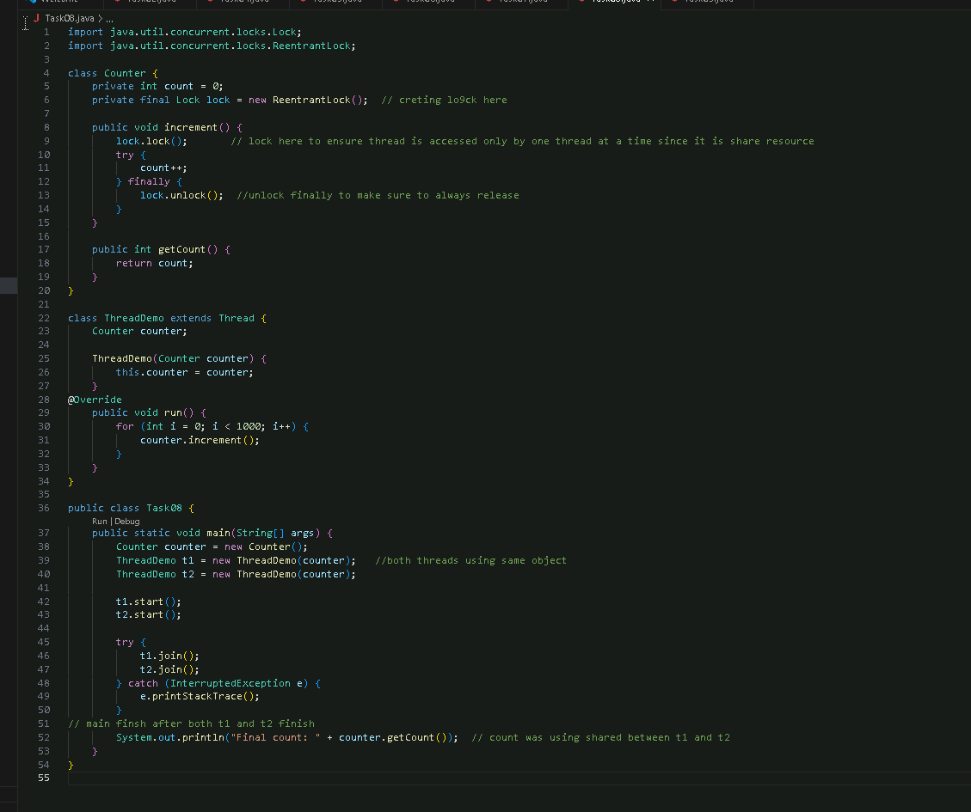



**Task 09**

Rating task. I presented

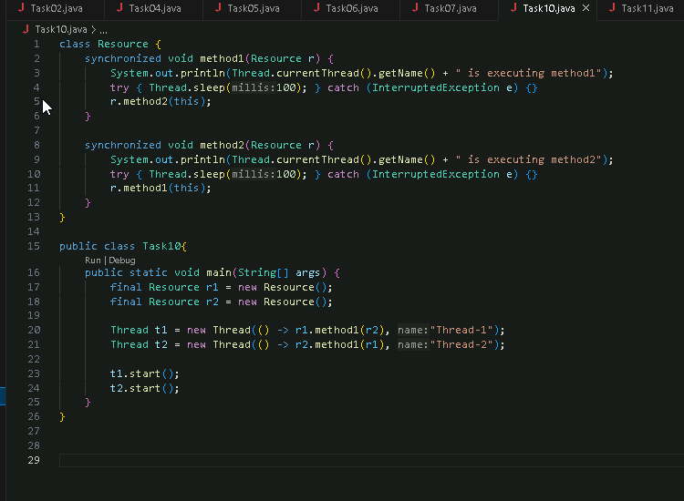**Task 10:**

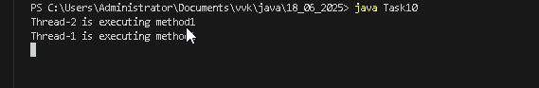

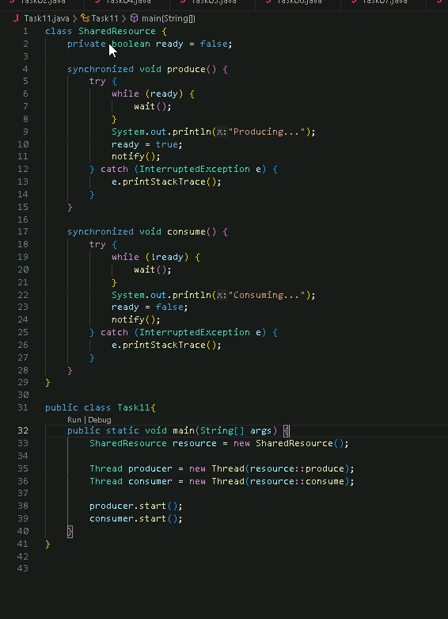Task 11:

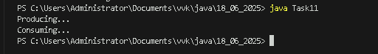

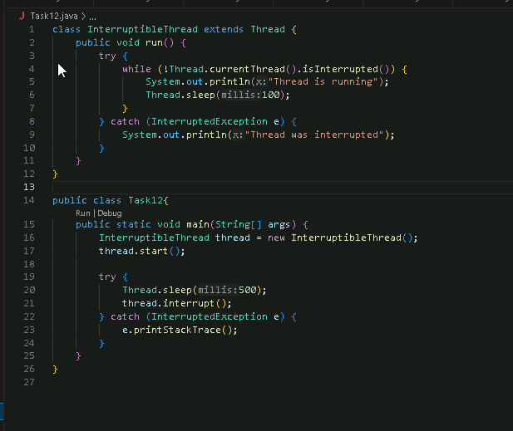Task 12:

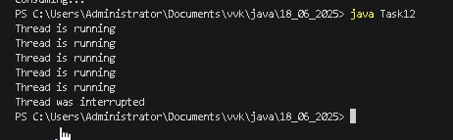

Task 13: Oral, done

Task 14: What is thread pool?

It is free presence of pre initialized group of thread that are available to carry out any immediate task and can be reused. *The Executor Service* is an interface in Java that manages *thread pools* and provides methods to execute tasks asynchronously. It simplifies concurrent programming by handling thread creation, scheduling, and termination. Using a thread pool with Executor Service improves performance and resource management in applications that require concurrent execution of multiple tasks, as it reduces the overhead of creating new threads for each task and allows for better control over the number of threads running simultaneously.

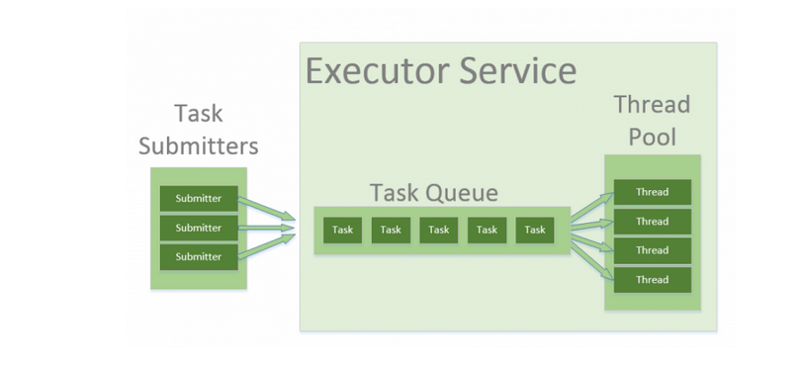

Task 15:

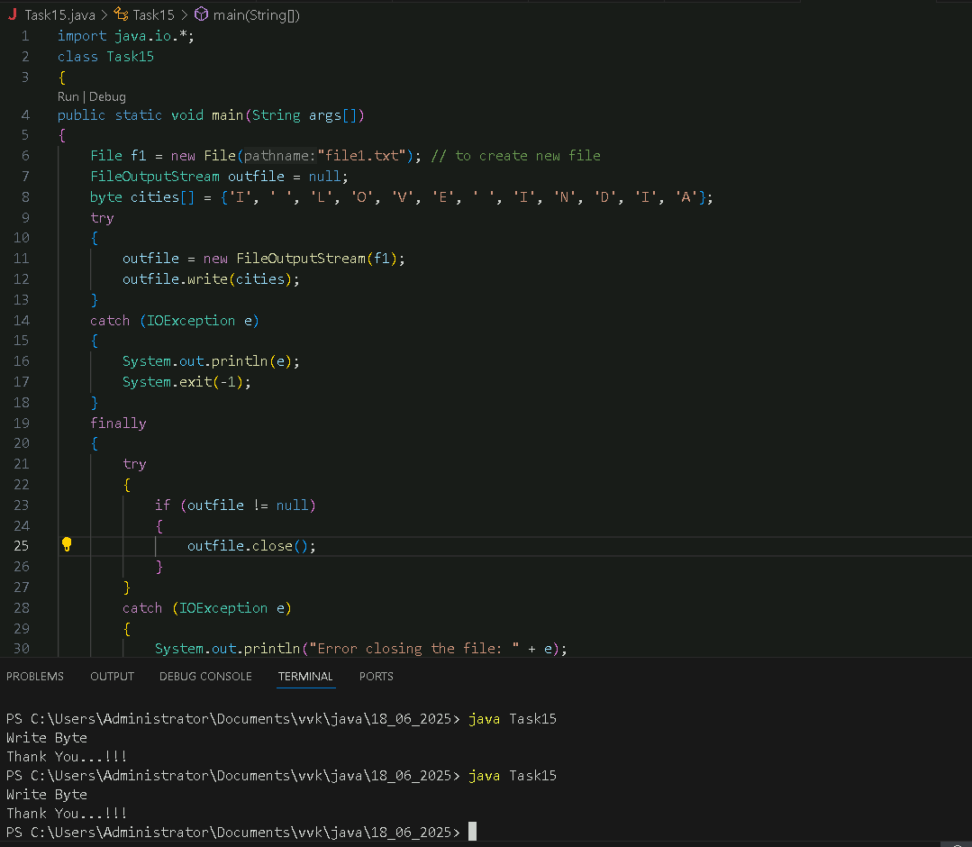

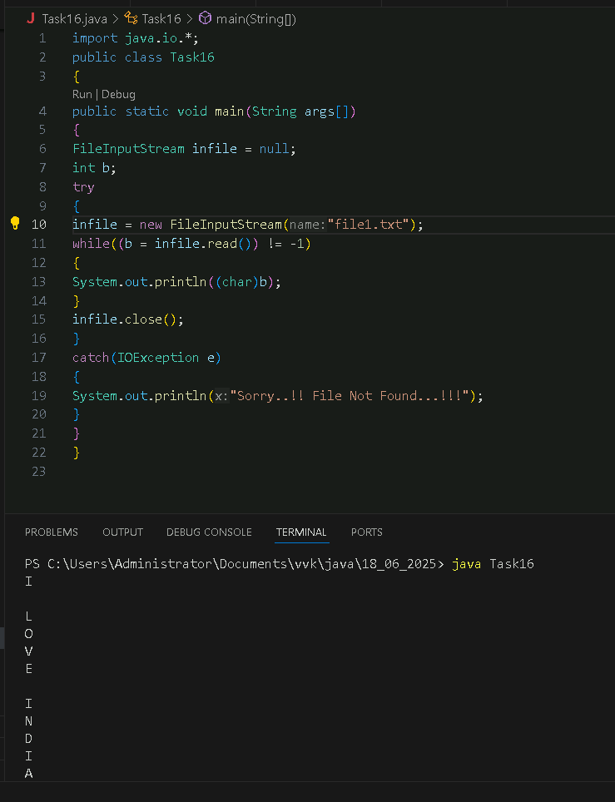Task 16:

Task 17:

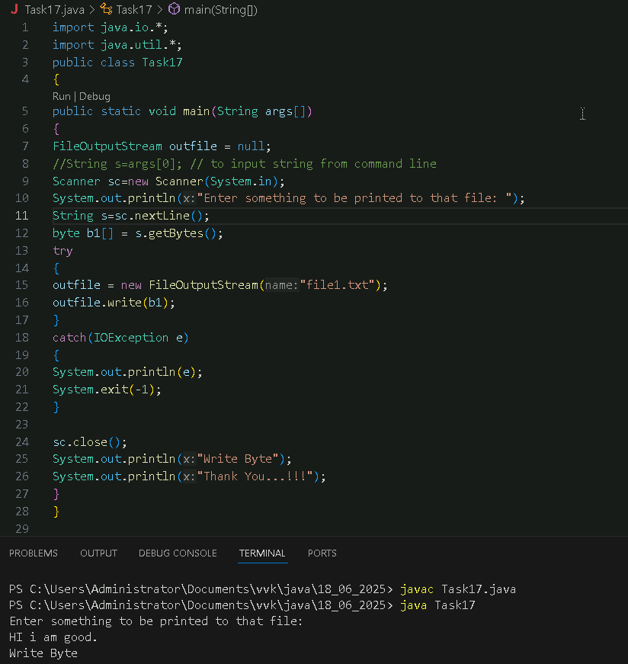

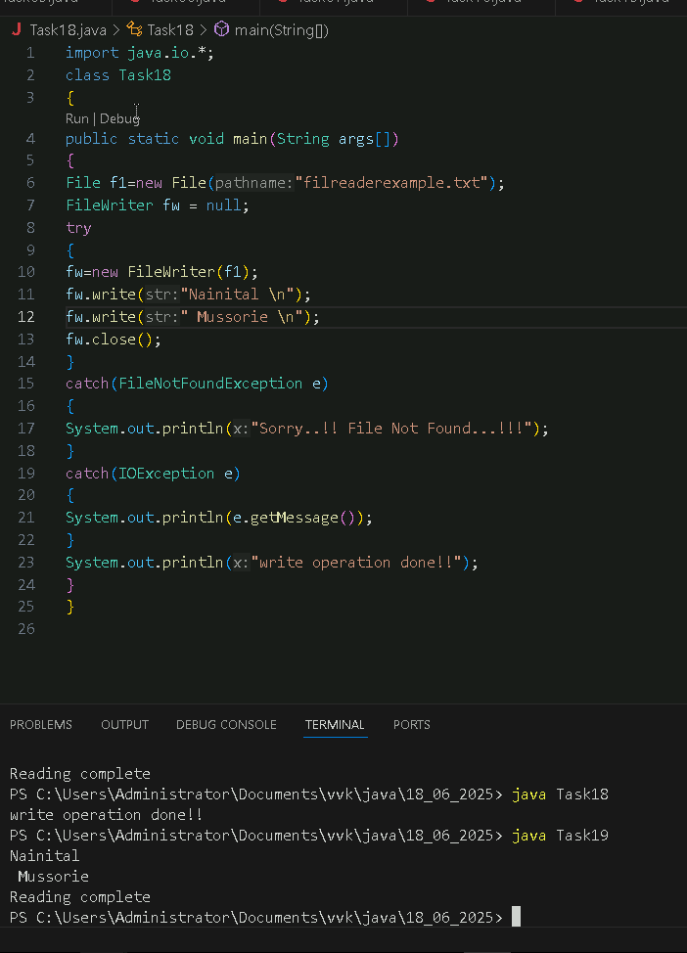Task 18:

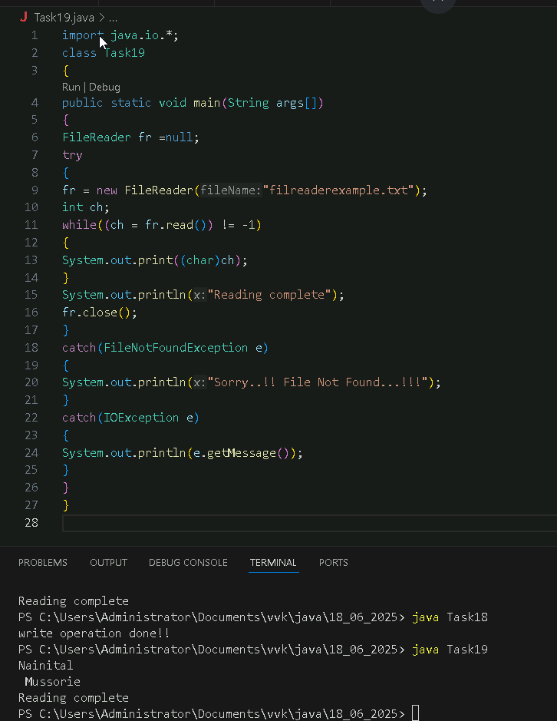Task19:

Task20:

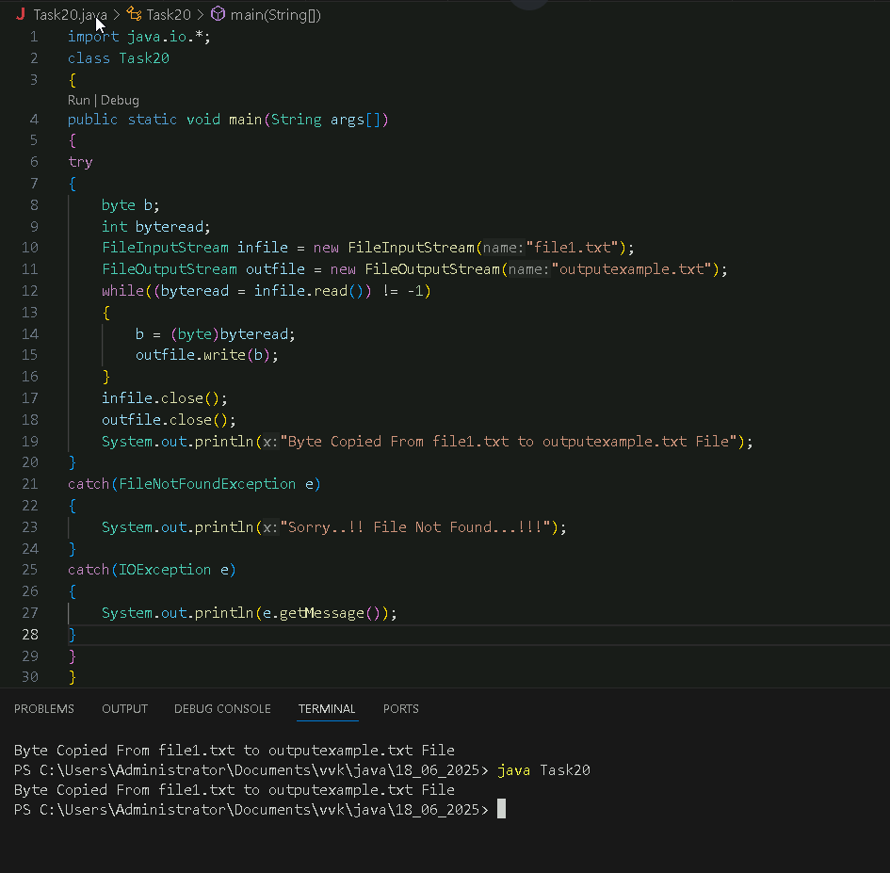

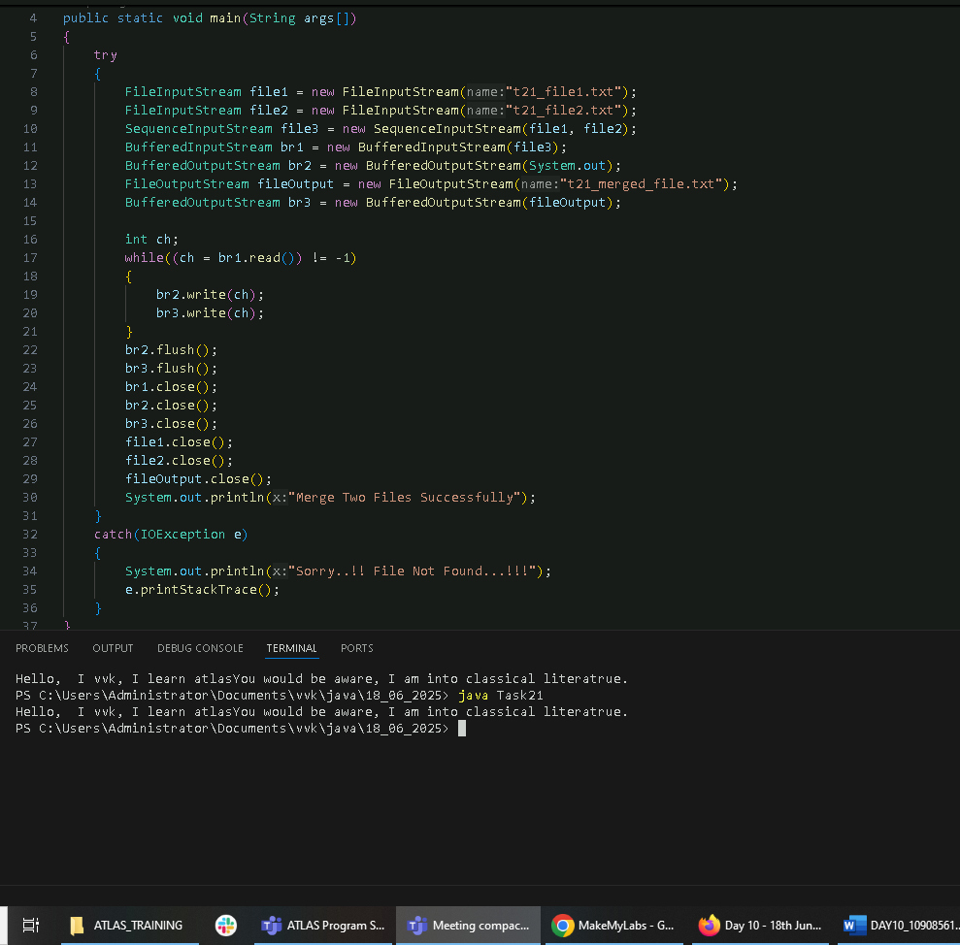Task 21:

Task 22:

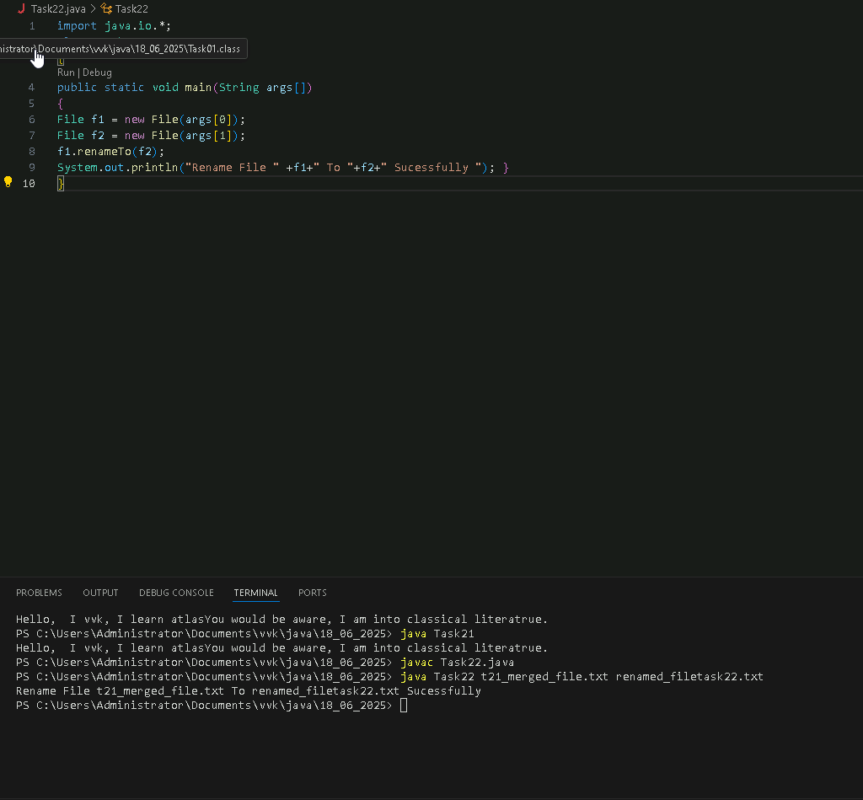

Task 23:

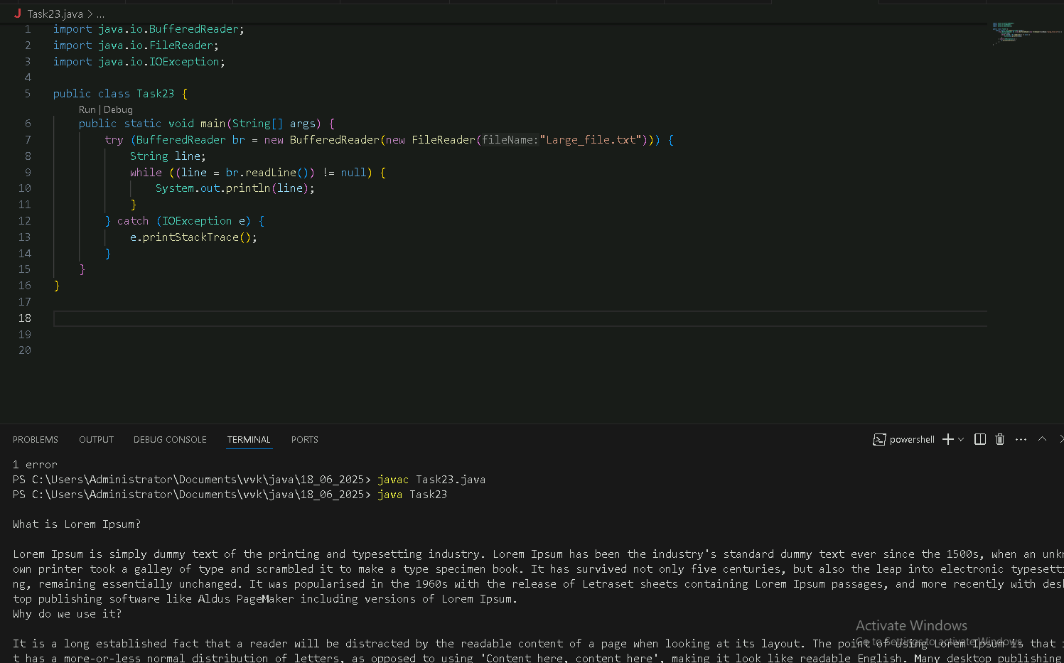

Task 24:

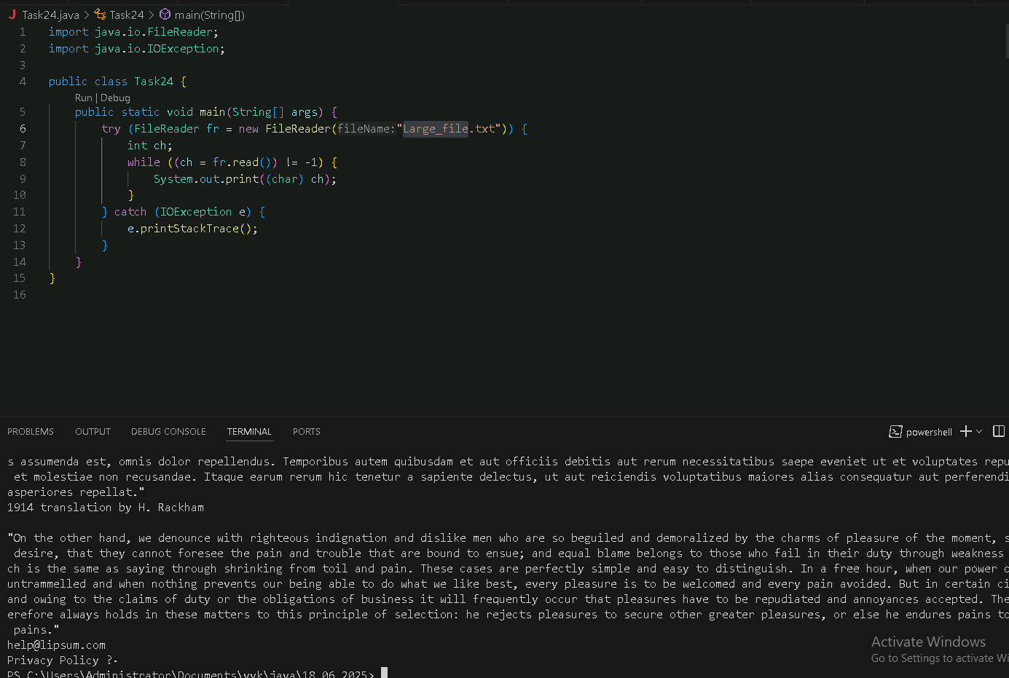

Task 25:

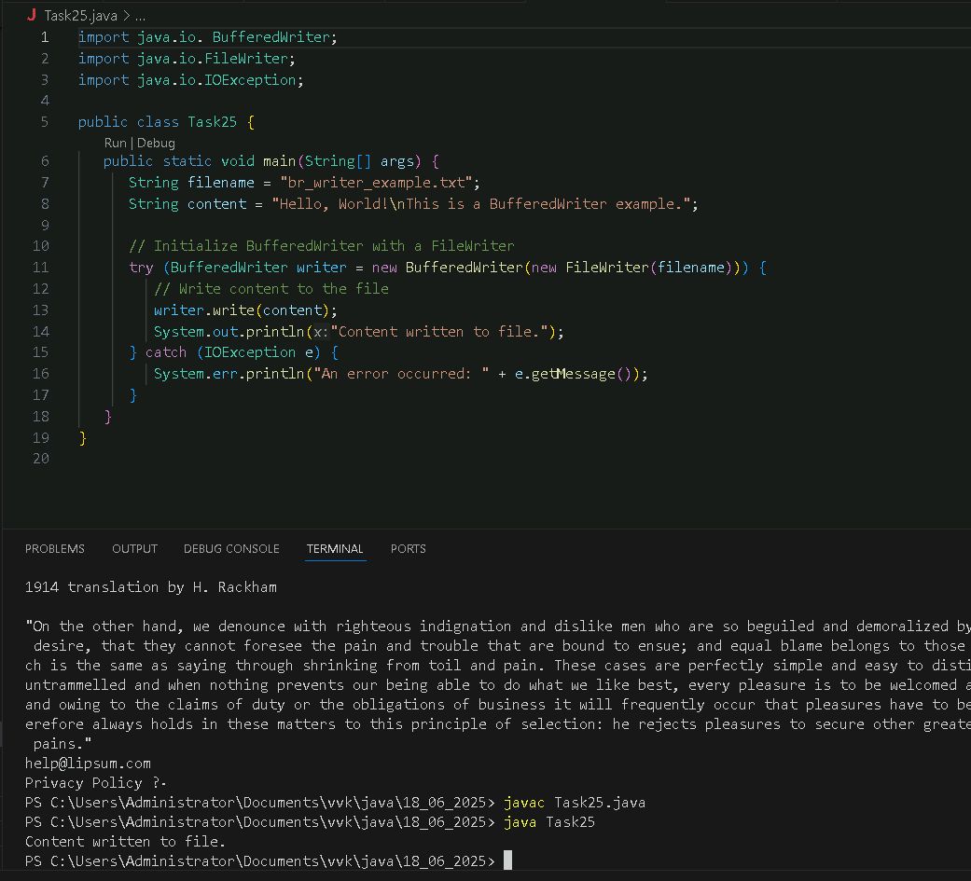

Task 26: (add on to copy image):

