**Date:** *21-may-2025*

**Name:** *Vivek Samant*

**Empid:** *109085619*

**alias:** *samantvs*

**DAY 3 DOC:** [**https://docs.google.com/document/d/1chiRvf0C7uYoCuj77TUvUu0q4M3VSVgXZkGjAswX6hc/edit?usp=sharing**](https://docs.google.com/document/d/1chiRvf0C7uYoCuj77TUvUu0q4M3VSVgXZkGjAswX6hc/edit?usp=sharing)

***On this day many peers had to create git account and further learn to use which was part of the class, I also was able to assist when requested.***

**Atomicity:**

Atomicity is one of the variables in ACID which stand for Atomicity, consistency, Isolation, Durability. An atomic transaction is an indivisible and irreducible series of database.

An example of an atomic transaction is a monetary transfer from bank account A to account B. It consists of two operations, withdrawing the money from account A and saving it to account B. Performing these operations in an atomic transaction ensures that the database remains in a consistent state, that is, money is neither lost nor created if either of those two operations fails.

All or nothing.

**Consistency**: preventing partial updates. All transactions must maintain consistency

* System should prevent invalid operations
* Validation happens before commit
* Rollback if consistency violated

**Isolation**: Transactions do not interfere with each other.

**Durability**: committed are permanent. Survives system crashes, power failures, changes written to permanent storage.

**Task to commit to git remote file named may 21:**

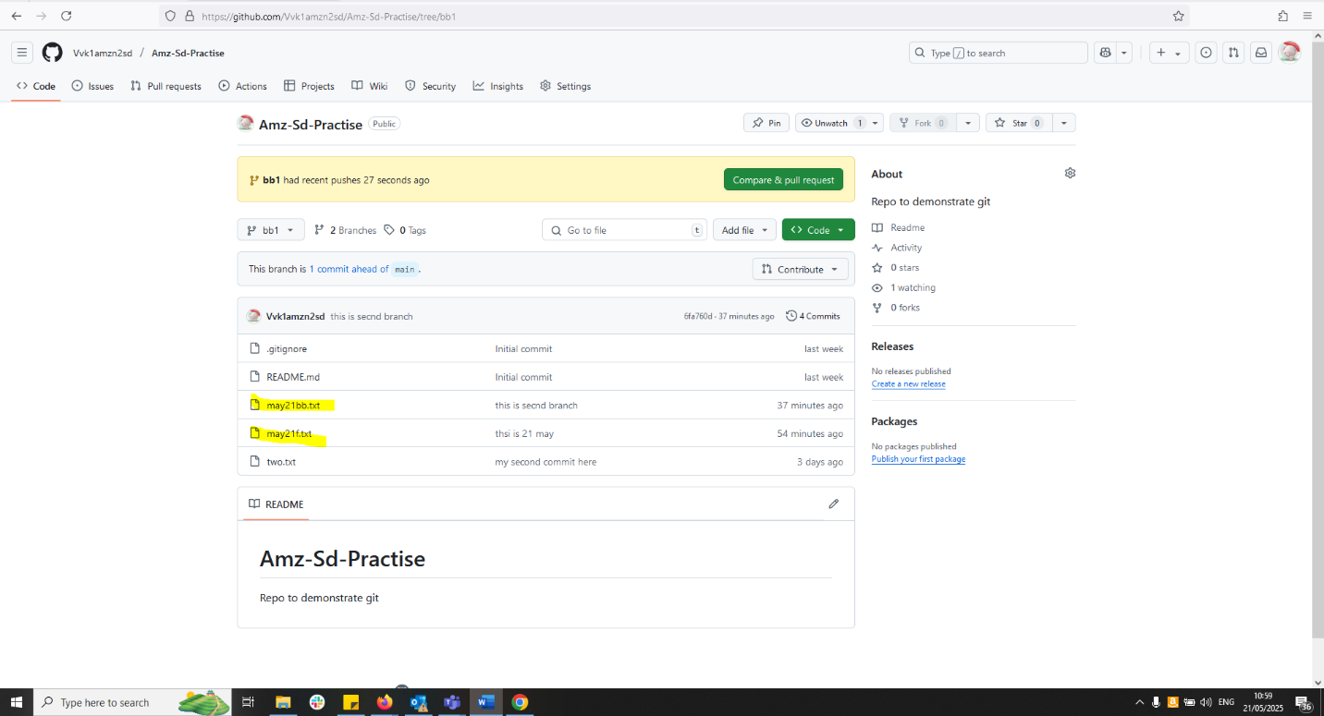**Task to push local to remote:**