**Date:** *28-may-2025*

**Name:** *Vivek Samant*

**Empid:** *109085619*

**alias:** *samantvs*

**DAY 5 DOC:** <https://docs.google.com/document/d/1n5pXzKUyjeJ3D5taTbPh5BzEkzgrv0u58jccRHQRtJI/edit?tab=t.0>

**Tasks:**

**Task 1: Create a Directory with the Name Linux Practice:**

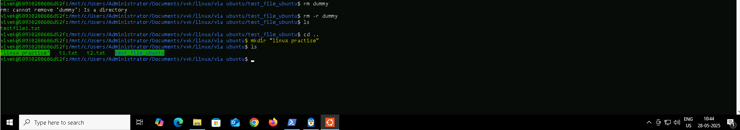

**Task 2: Change to the directory:**

**Task 3: Create a file names TestFile1.txt and add the content to it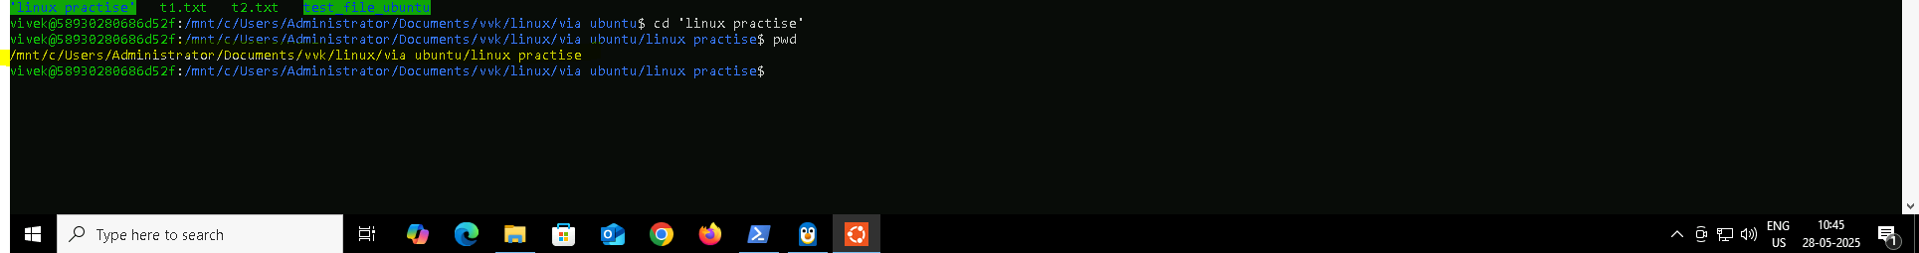:**

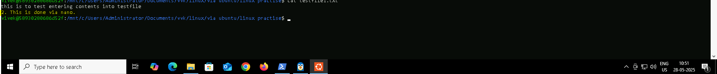

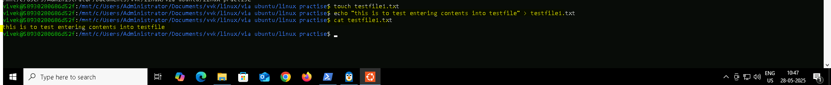

**Task 4: Create a Folder named Dummy and try to delete it.**

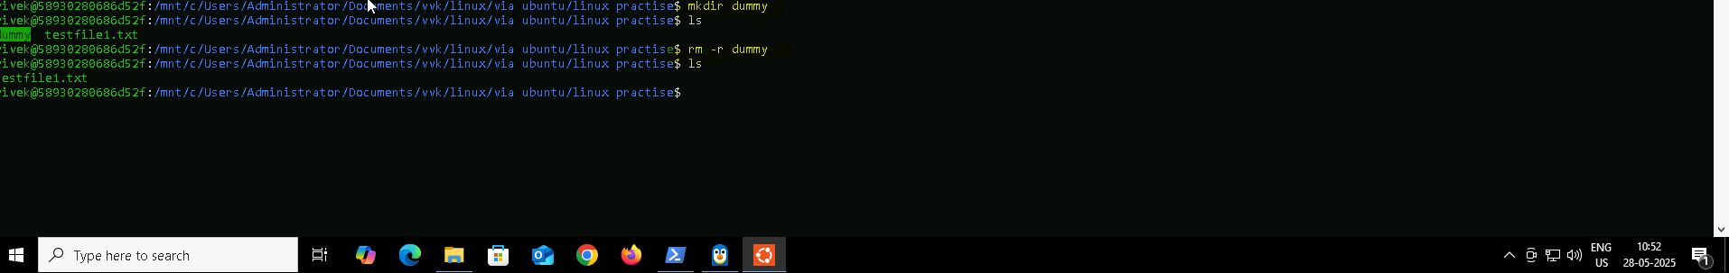

**Task 5: Checking working directory via PWD :**

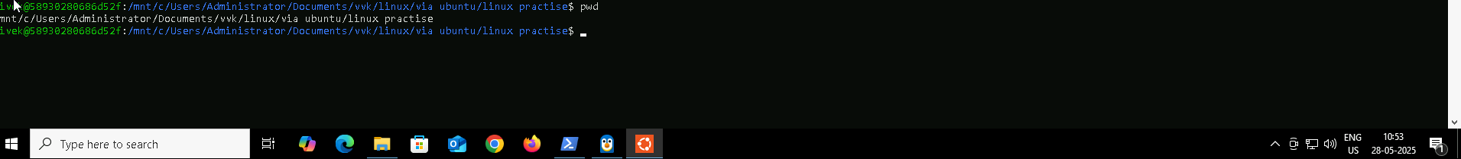

**Task 6: How do you check all the files and directories in the directory you are in?**



**Task 7: Create five files named TestFile2.txt.. TestFile3.txt… and so on**

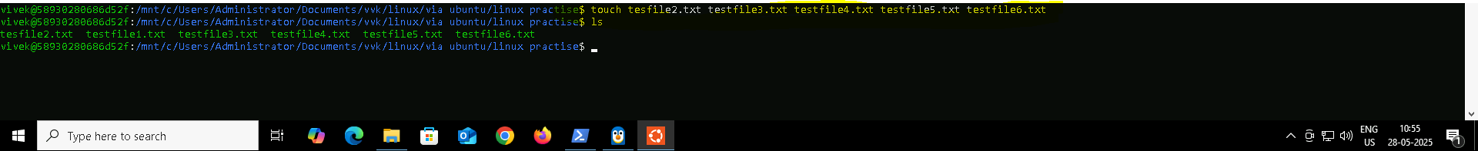

**Task 8: Copy all files from Dir 1 to Dir 2 : cp -r to paste all including subfolders**

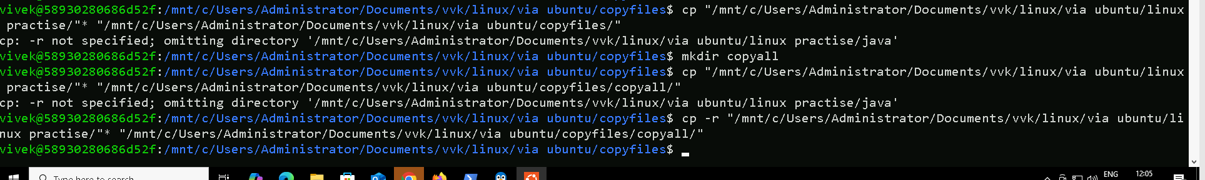

**Task 9: Move all files from Dir 1 to Dir 2 : empty ‘linux practise’ after moving (no -r flag for this)**

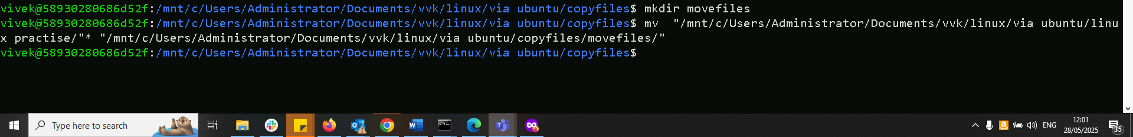

**Task 10: Can you plz show me the diff between *rm* and *rmdir* commands with screen shots ?**

**rm vs rmdir: rmdir only for deleting empty directory, else throws error**



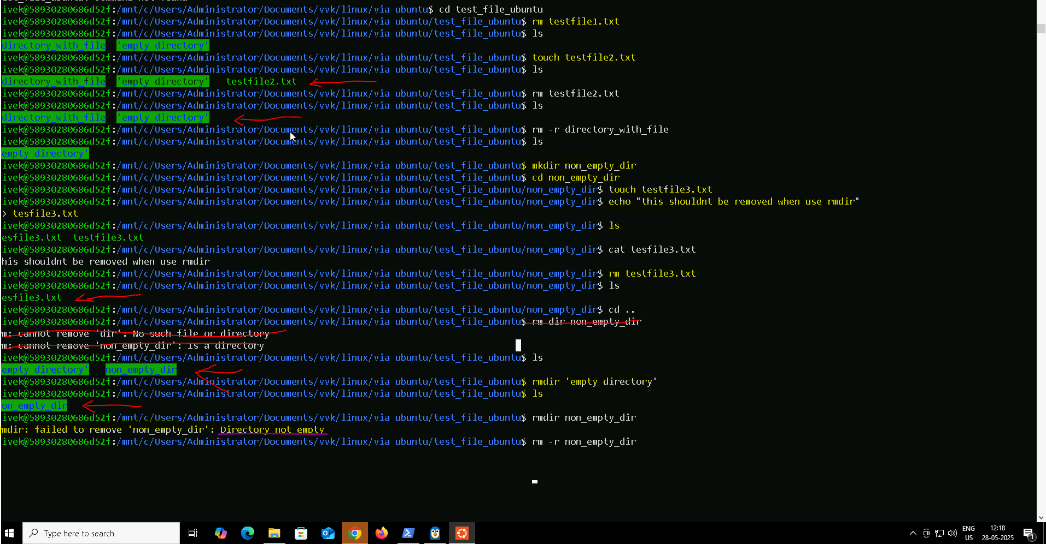

TASK 11 is at the bottom of the page. Please refer

**Task 12: How to get only the top part of your file.. head command**

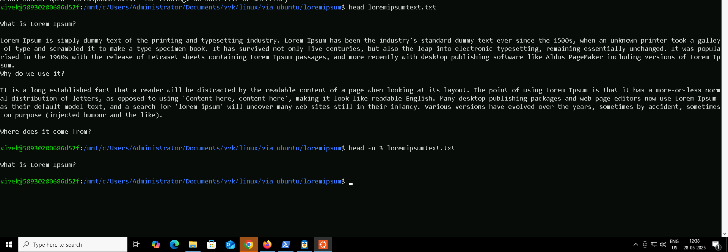

**Task 13: How to get only the last part of your file.. tail command**

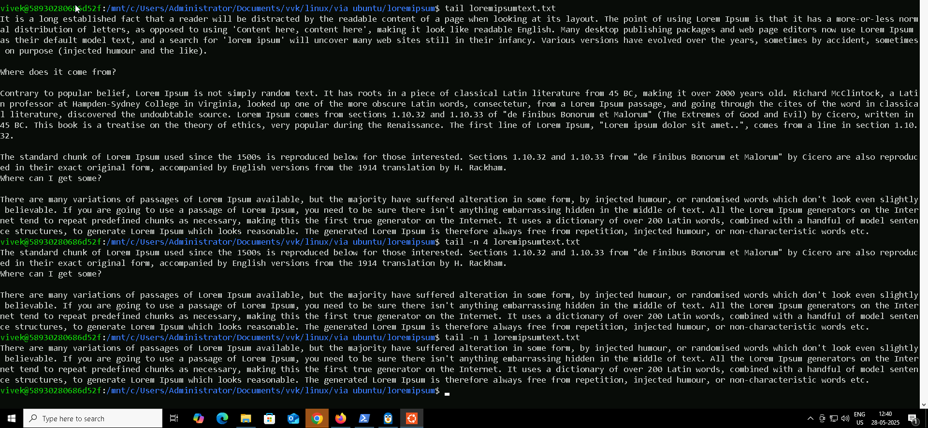

**Task 14: Plz add dummy text of 5 to 6 pages in to the same file and**

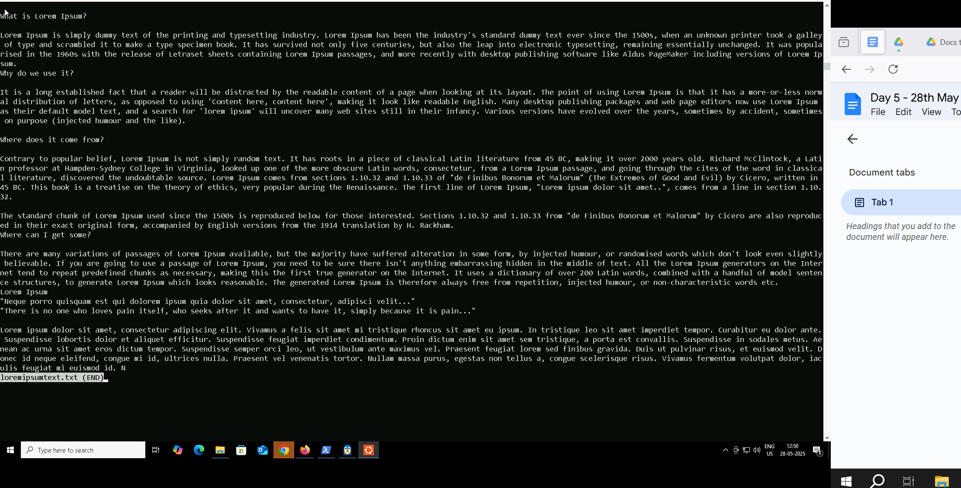**Now show the file in page by page:**

**:**

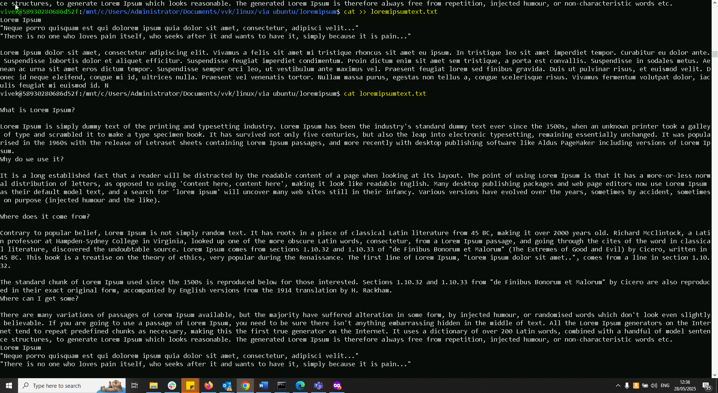

**Task 15: Use more command on the above file and find out the diff between less command and more command.**

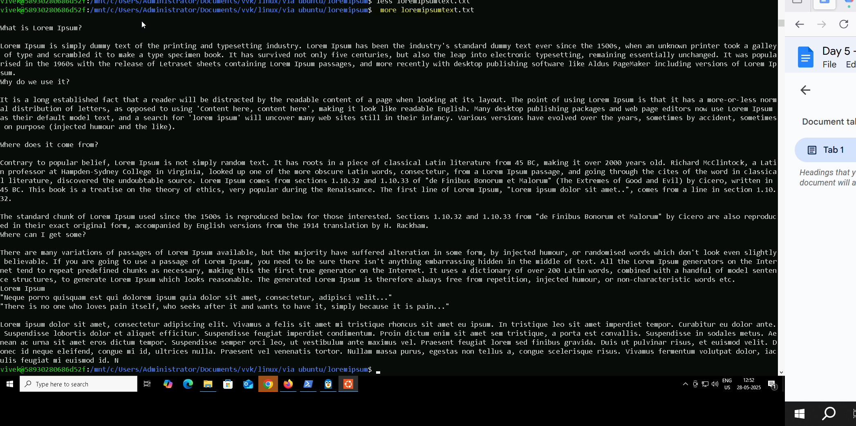m*ore command enables to view file page by page(similar to scrolling) whereas less enables to view one screen at a time(flipping pages of a book)*

**Task 16: Can you use echo command with -e and see the diff.. Also take a ss and paste.**

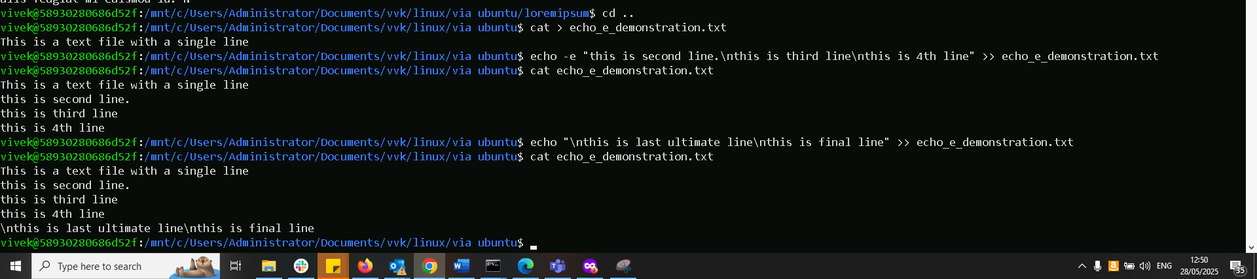

**Task 17: What is diff between ls and ls -l command**

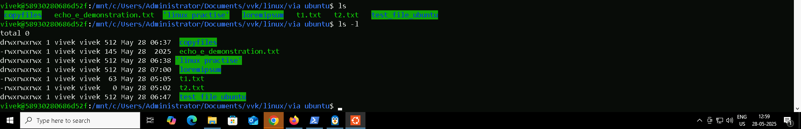

**Task 18: Create a file using touch command, cat command and echo command and take ss (screen shot).. Also write the difference between touch , cat and echo commands.**

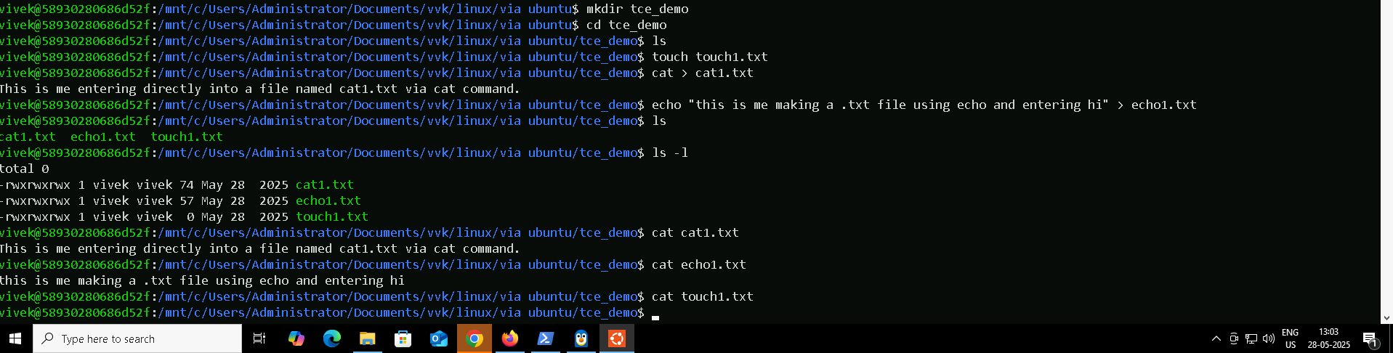

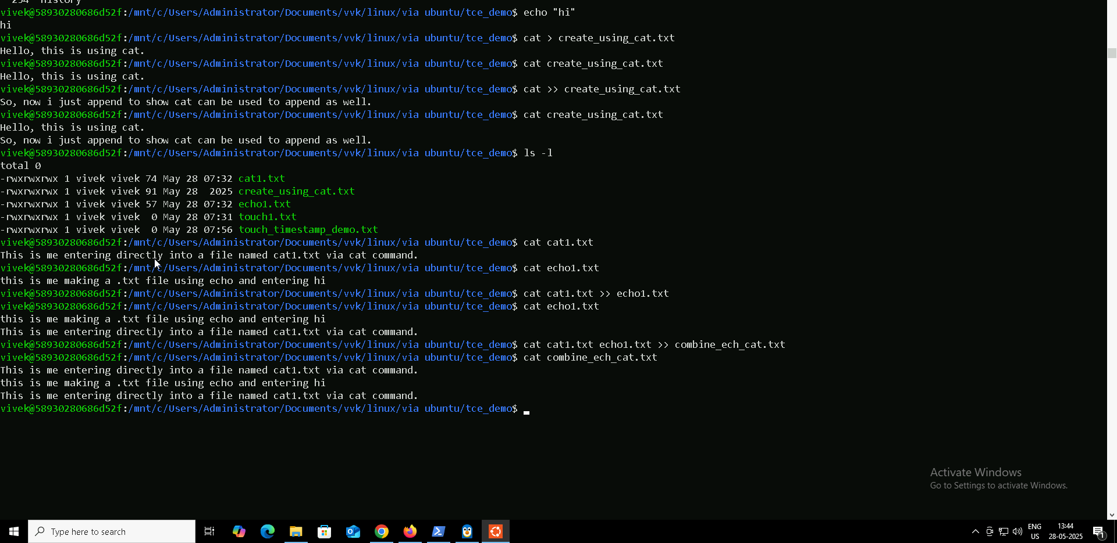

touch command: creates an empty file . updates timestamp if file exists.

cat command: creates a file and allows to type content into the file. After entering, ctrl+ D is used to save and exit. It also allows to combine one file with another and give a resulting new file or append one file to another.

echo command: it creates files and also allows to write single lines of text (can be used to give line breacks using \n when used with echo -e to highlight the line break. It can either overwrite the data present if used with just > (echo “hi” > file.txt) or it can append if used with >> (echo “hello appen” >> file2.txt).

**Task 19: Can you guys try to display the calendar by using a command:**

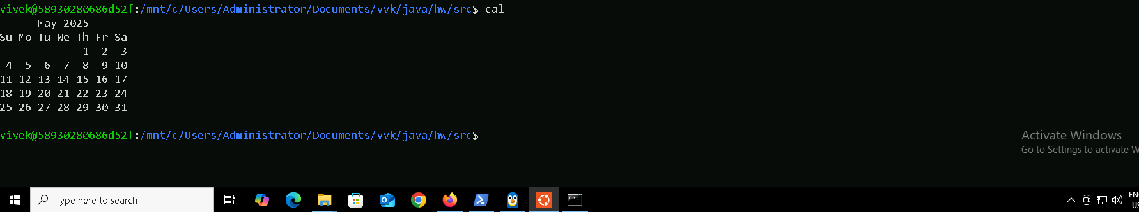

**Task 20: Can you go back to 1 directory .. at a time  whats the command**

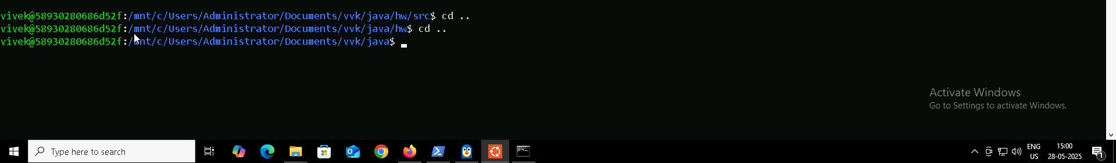

**Task 21: How to know whose user u are working on ?**

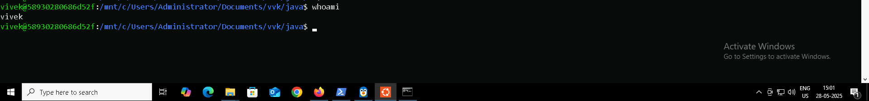

**Task22: try to find out who is peeping into your system (users/ who/ w) ?**

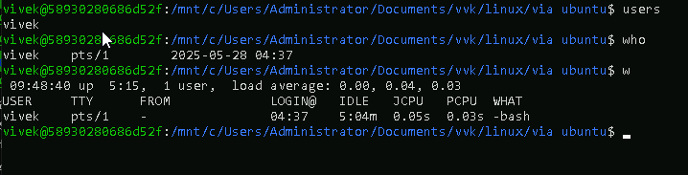

**Task 23: Can you guys try to check how much disk space is consumed..**

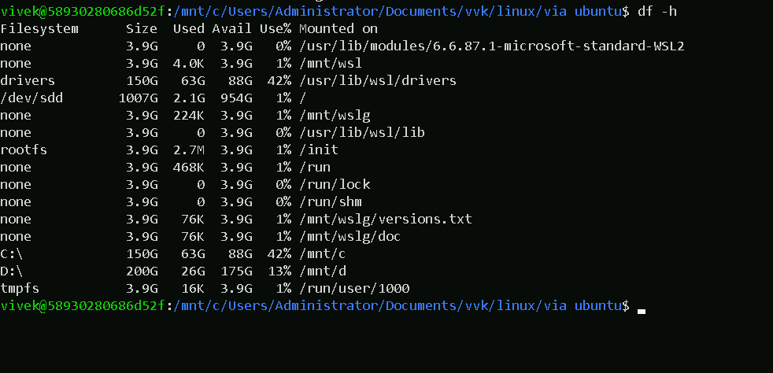

Task 24:

Can you plz try using the below commands

|  |  |
| --- | --- |
| **Prefix** | **Description** |
| **-** | **Regular file**, such as an ASCII text file, binary executable, or hard link. |
| **b** | **Block special file**. Block input/output device file such as a physical hard drive. |
| **c** | **Character special file**. Raw input/output device file such as a physical hard drive. |
| **d** | **Directory** which contains a listing of other files and directories. |
| **l** | **Symbolic link file**. Links on any regular file. |
| **p** | **Named pipe**. A mechanism for interprocess communications. |
| **s** | **Socket** which is used for interprocess communication. |

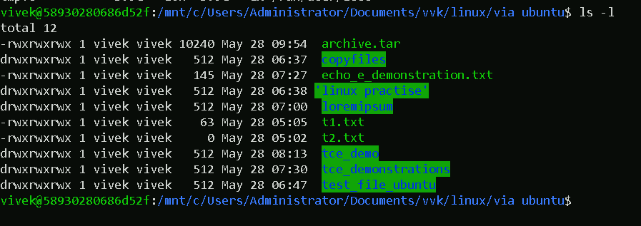

Task 25:

Find the list of all files ending with .txt



Task 26: (period)

How to check all the hidden files in Linux..



Task 27: What is the difference between . and .. in linux

cd . : stays in the same directory

cd .. : moves up one level (e.g.: ls .. : lists contents of parent directory)

**Task 28: Can you create a file using vi editor and show the details in ss**

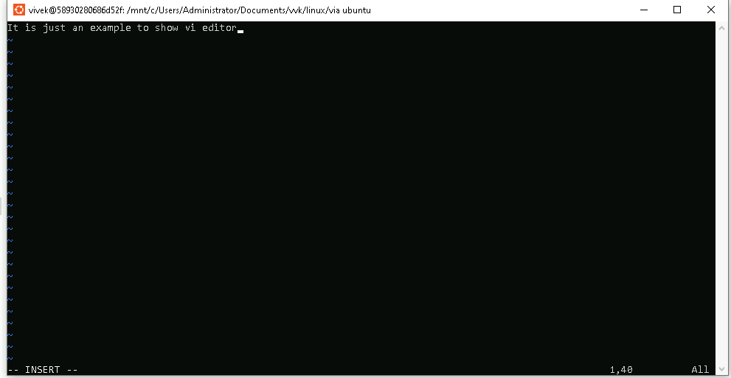



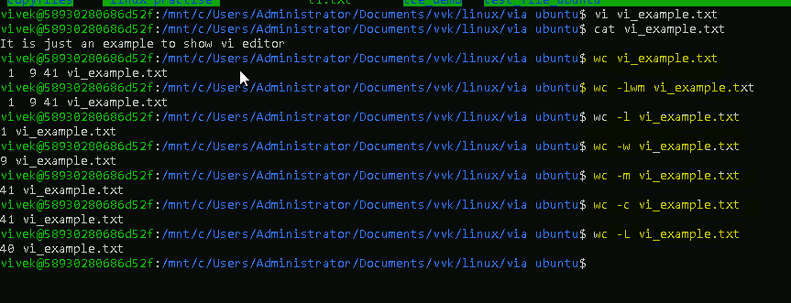**Task 29: How to find the no of words in the file:**

**Task 30: What is the use of cat -b myfilename.txt command?**

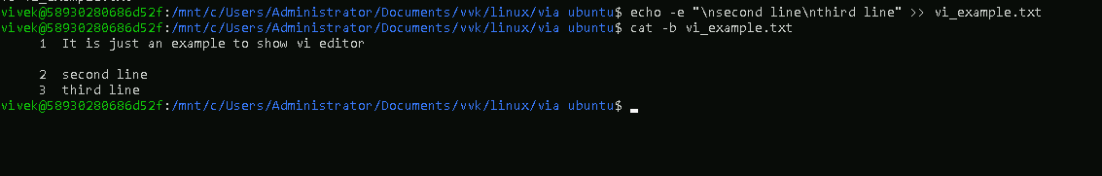

Task 31:  Can I use the wc with 2 or more files? Yes

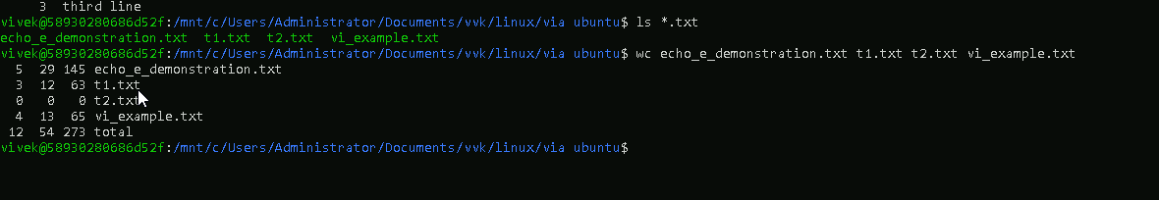

**Task 32:How to copy content of one file to another file**

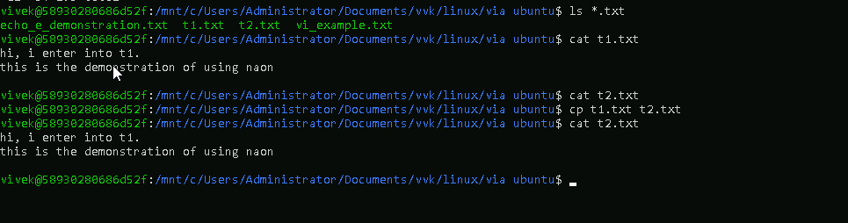

**Task 33: Now I want to rename my file with MYFILENEW can i do that if so how ? using mv**

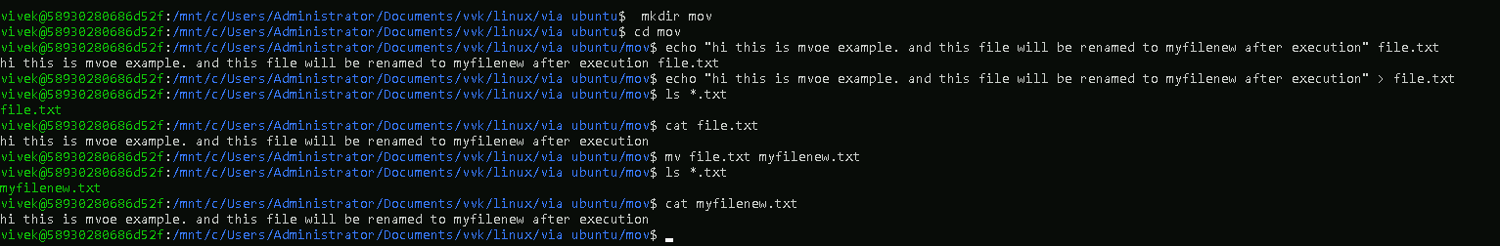

Task 34: Can i remove or delete multiple files in linux..? How? Yes

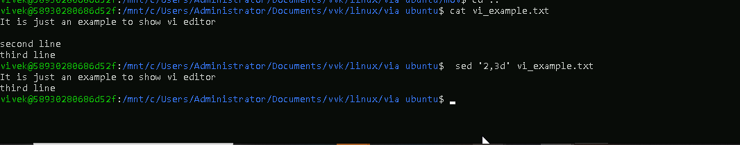

Task 35: In directory / slash is root  …  can you try cd / what is it doing? Changing directory to root



Task 36: What is the way go go to home directory ? cd ~

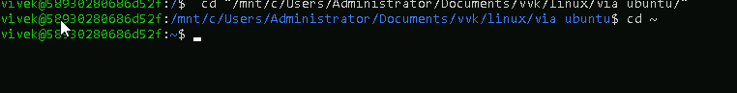

**Task 37: If i want to move to different users home directory : use ~username**



**Task 38: Chmod: used to change permission of files and directories.**

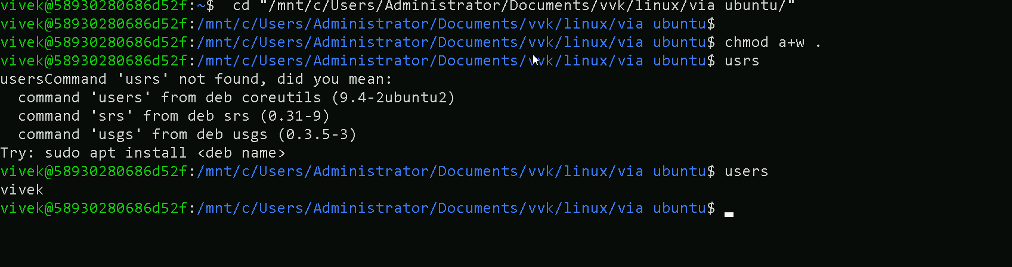

**Task 11: Now use specifically use cat command to create a file**

