**Date:** *29-may-2025*

**Name:** *Vivek Samant*

**Empid:** *109085619*

**alias:** *samantvs*

**Tasks:**

**Task 1: List down the regex symbols in linux with description:**

**1 . (dot):** It is called a wild card character, It matches any one character other than the new line. E.g.: grep “h.t” file.txt

2**. Caret (^):** It matches the start of the string. E.g. : grep "^The" file.txt

3. **Dollar ($):** It matches the end of the string. E.g.: grep "end$" file.txt

4. **Asterisk (*):** It matches up to zero or more occurrences i.e. any number of times of the character of the string. E.g.: grep "ca*t" file..

5. **Backslash \:** It is used for escape following character.e.g.: grep "\." file.txt

6. **():** It is used to match or search for a set of regular expressions. E.g.: grep "(cat|dog)" file.txt

**7. ? :** It matches exactly one character in the string or stream. Eg. grep "colou?r" file.txt

We need to use extended grep (grep -e) for some of these like ?, (), or escape characters in basic grep.

**Task 2: Important features of linux OS:**

1. Open Source: Free to use. Users are able modify and distribute and have access to source code.

2. Security: it has strong user permission system. It is built-in firewall, and resistant to malware.

3. Multitasking & Multiuser: Can run multiple programs simultaneously and handle multiple users.

4. Package Management: Easy software installation and updates through centralized repositories. It can be done quite easily compared to windows.

5. Shell & Commands: Powerful command-line interface (CLI) for system control and task automation.

6. File System Hierarchy: Well-organized directory structure with clear separation of system and user files.

7. Device Support: Extensive hardware compatibility and driver support.

8. Networking: Robust networking capabilities with built-in TCP/IP protocols.

These features make Linux suitable for both personal computers and enterprise servers.

**Task 3: What is kernel and can you explain its functions.**

Kernel acts as intermediary b/w hardware and software. It is like a bridge b/w hardware and software. It forms the core of Operating system (OS). It’s primary functions are managing system resources(CPU, memory, devices) facilitating communication, and making sure multitasking is secure and efficient. It handles tasks like running programs, accessing files, connecting to devices like printers and keyboards.

Kernel manages memory, processes, device drivers making it possible to have smooth operation of apps. It runs in *special mode* (called kernel mode or ring 0) where it has full control over memory.

**Task 4: What is BASH? Full form with explanation.**

Bash stands for Bourne again shell. It is a command line interpreter acting as interface between the user and the OS. In windows we directly have UI, BASH accompolish those tasks using command.

e.g.: double click on windows to open a folder: changing directory via *cd* in bash.

It is often more efficient than the windows.

**Task 5: Difference b/w windows and linux**

Windows and linux are both OS. Linux is an open source based on linux kernel whereas windows is a proprietary developed by Microsoft.

Windows used Windows NT kernel whereas linux uses linux kernel.

Windows: GUI-first OS (all visible in screen and navigating via mouse, keyboard). It also has command-line(bash) but is used rarely by tech people

Linux: GUI available but Command-line (bash) is core and it is very powerful. Forms the basis of many other OS built on Linux kernel.

Windows is preferred in personal, gaming, enterprise environment whereas linux is dominant in servers, cloud, supercomputers, embedded systems.

Since linux has very rigid permission model, it is far less prone to malware compared to windows. Linux hence comes with better security.

Software and package management: windows: uses .exe/.msi installer whereas linux uses package managers (apt, yum, pacman etc.)

Filesystem: windows use ntfs, fat32, exfat

Linux uses ext4, xfs, btrfs etc.

**Task 6: Define the basic components of linux**

1. Kernel: core of os, manages hardware resources, allocates resources to different software for making processes efficient, acts as a bridge b/w hardware and software.
2. Shell: CLI (similar to bash) a way to access file systems and other functionalities. It supports scripting.
3. File system: hierarchial directory structure, everything treated as files. Root directory (/) at the top.
4. Package management. Software installation/ removal. Handles dependencies.
5. System libraries: standard code used by apps,
6. System utilities: basic system tools, file management,
7. Desktop env: gUI, window management
8. Boot system: GRUB bootloader, startup services, boot config

**Task 7: Is it legal to edit kernel?**

Yes, in linux it is legal to edit kernel and redistribute after modifying code as source code is freely available. In windows, it is not legal as it is proprietary of Microsoft.

**Task 8: explain lilo**

Linux Loader (LILO) is an old linux bootloader that was popular before GRUB. It was a bootloader for linux systems. It loads the OS kernel. Provides boot menu for multiple OS.

**Task 9: What is shell? How many shells are there and what are they ? can you explain:**

Shell is a CLI. Interface between user and kernel. Processes user commands. It also supports scripting.

TYPES:

1. Bourne shell (sh)
2. Bash
3. C shell
4. Korn shell (Ksh)
5. Z shell (zsh)
6. T shell (tcsh)

**Task 10: What is Swap space ?**

It is sort of a virtual memory that extends RAM. It uses hard disks as a temporary memory. It is a safety net for when RAM is full. It is similar to windows page file.

**Task 11: What is Mount ? how do you mount and unmount file system in Linux?**

|  |
| --- |
|  |

Mounting means connecting a storage device (partition, usb, iso etc.) to the file system so we can access its contents via a directory. Unlike windows no drive letters like D: or E:. instead devices are attached (mounted) to folders in a *single unified directory tree (starts from /)*

Mounting?:

Identify device: lsblk / sudo fdisk -l

Mount: create a mount point (folder) (sudo mkdir /mnt/usb)

Now the usb is accessible at /mnt/usb

Umount: sudo unmount /mnt/usb

Wsl: by default: /mnt/c/ treat it like a linux folder at /mnt/c/

*fstab takes care of this. It retains memory of where to mount what drive (specially during bootloading as linux doesn’t have automatic drive names)*

**Task 12:** **What is chmod command ? how to use it?**

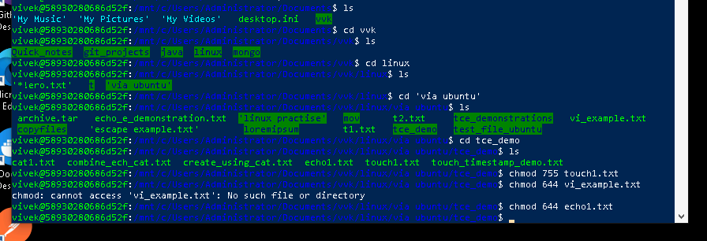The chmod command is used to change file and directory permissions. It is directly related to access right (read/modify/ write/ execute permissions) and hence gives access as per user / folder/ file type as per standing within the org.

**Task 13: Can you add a new user account? Crate a new user in different ways and paste ss**

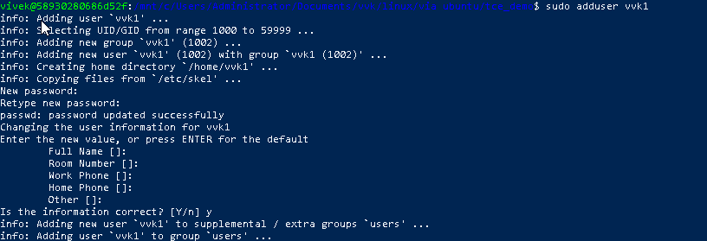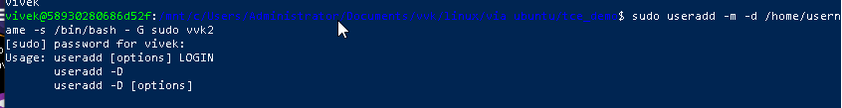

**Task 14: Can you change the password of a user?**

**How do you do that? Plz share ss**

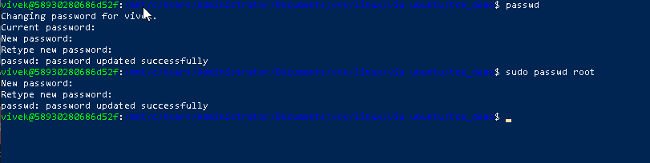

**Task 15: What is diff between Process and Thread?**

Process and thread are two fundamental concepts in operating system.

A process is an independent program in execution and has its own *memory space, resources, and system state*, making it more heavyweight and resource-intensive.

For example: when open Chrome browser, it's a process.

On the other hand, a thread is a *lightweight* unit within a process that shares the process's memory space and resources - like different tabs within Chrome browser.

While processes require Inter-Process Communication (IPC) to communicate with each other, *threads can communicate directly through shared memory.* Process creation is slower and context switching between processes is more expensive compared to threads, which are quicker to create and switch between.

This is why threads are often used for related tasks that need to share resources, while processes are preferred for independent tasks that require isolation and security.

Process is like a complete unit in itself whereas threads are part of that (like rooms in a big house, house being a complete process).

GREP commands:

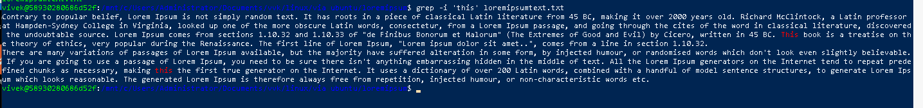case _ sensitive below:

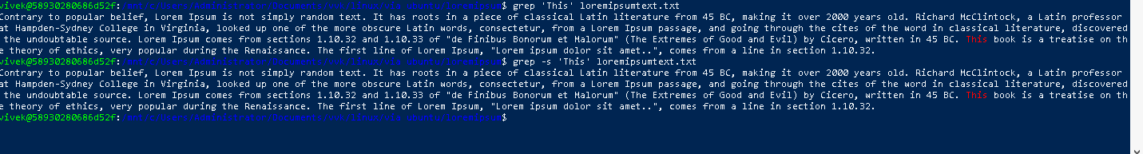count:

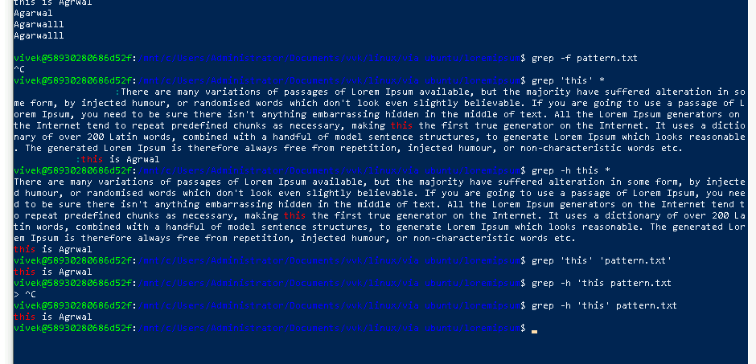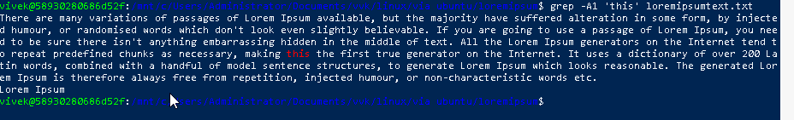

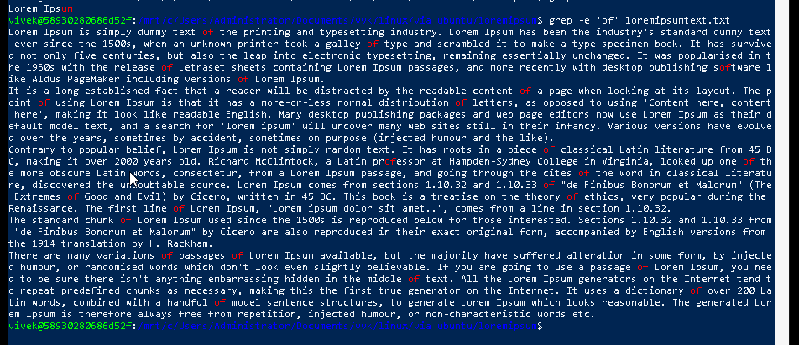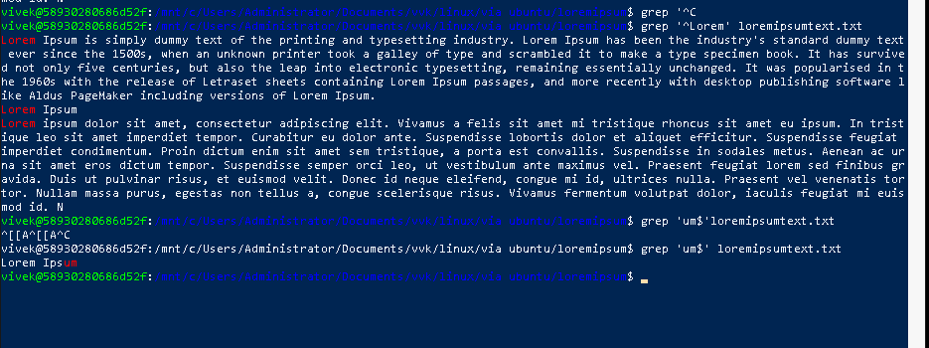

**AWK COMMANDS(task 17)**

awk '{ print }' input_file

awk '{ print $1, $3 }' input_file

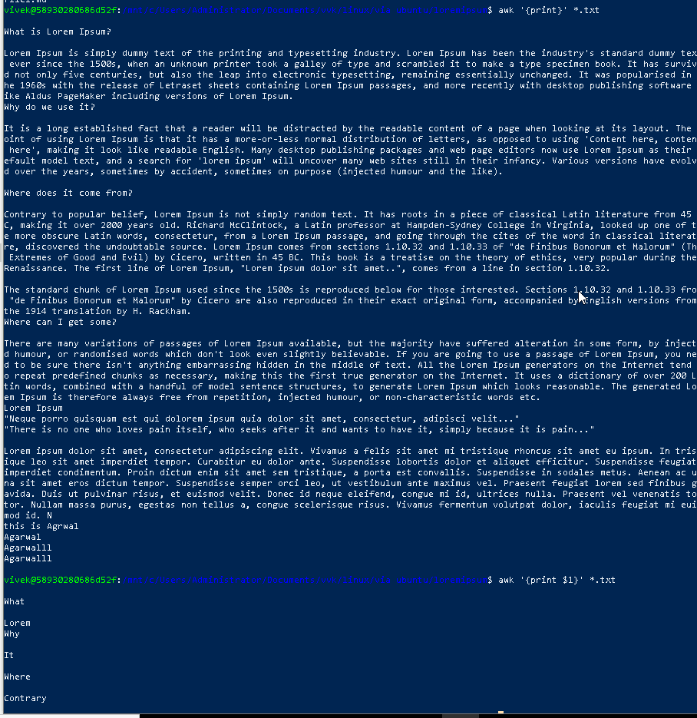

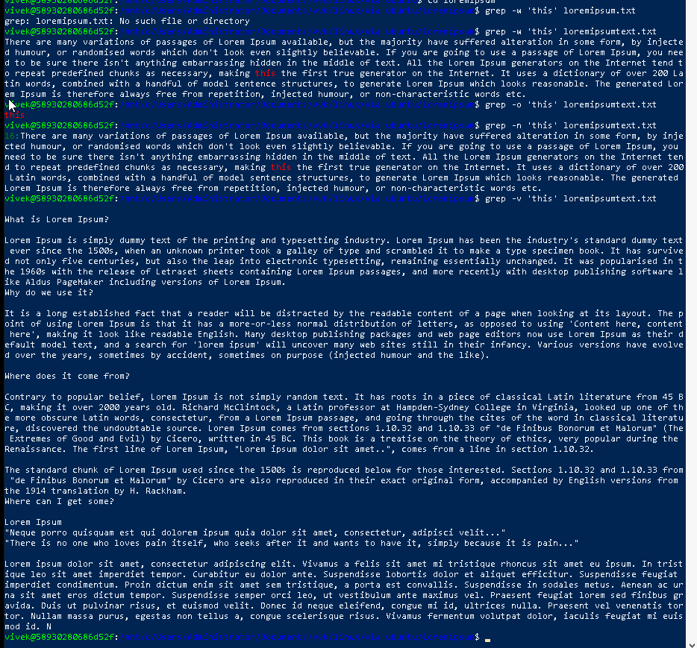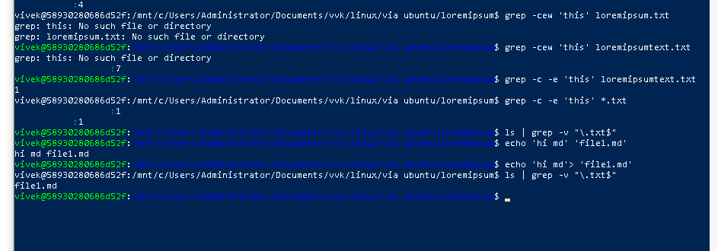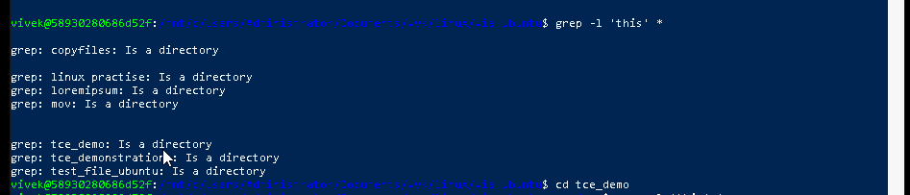

awk '/error/ { print }' input_file

awk '{ sum += $2 } END { print sum }' input_file

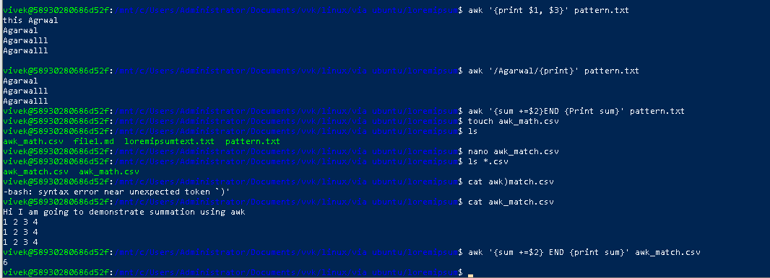

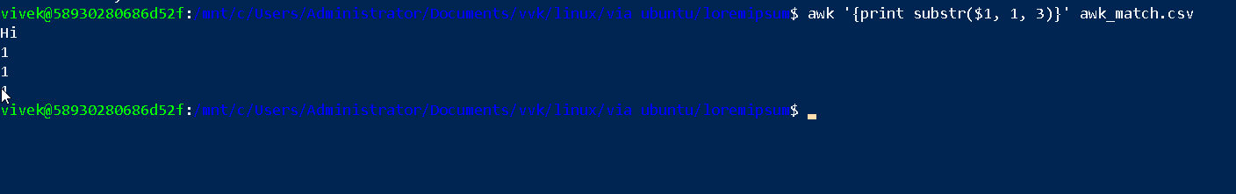

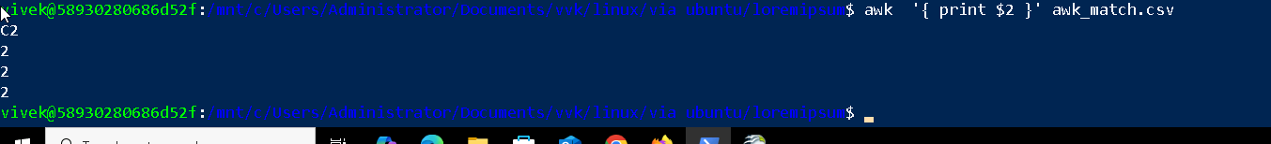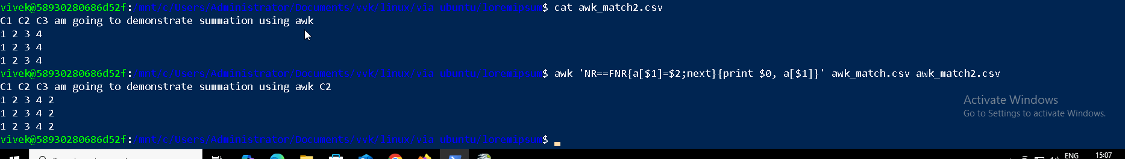

**Task 18: How to check file access permission in Linux? *Using command ls -l filename***

**Task 19: What are the default permissions for a new file ?**



For regular files: Default: 666 (rw-rw-rw), typical unmask: 022, resulting perm: 644(rw-r—r--)

Direcotries: default: 777 (rwxrwxrwx), typical unmask: 022, resulting permissions: 755 (rwxr-xr-x)

Regular Files (644):

Owner (User): rw- (6) Read & Write

Group: r-- (4) Read only

Others: r-- (4) Read only

Numeric: 644

Symbolic: -rw-r--r—

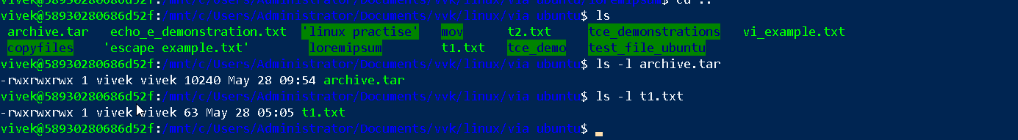Directories (755)

Owner (User): rwx (7) Read, Write & Execute

Group: r-x (5) Read & Execute

Others: r-x (5) Read & Execute

Numeric: 755

Symbolic: drwxr-xr-x

**Task 20: What is the command to change the permisssion to read only for the owner, group and all other users**

HInt: chmod 444 filename

(Since im using wsl,, I also need execute permission along with read, hence -rx equivalent of read only for windows)



**Task 21: Can you change the file permissions to match the following:**

* **owner: Read and Write**
* **group: Read**

**other: no permissions (None)**

* **Task 22:**
* **What was the command for changing the file permissions to -rw-r-----?**

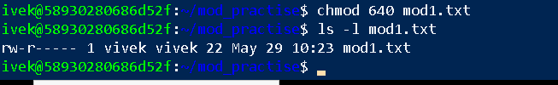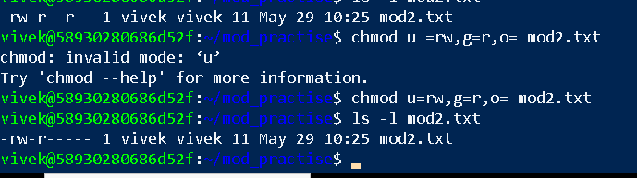

* **Task 23:**
* **Change chmod.exercises permissions to -rwxr-x--x**
* **Change the file permissions to match the following:**
* **owner: Read, Write and Execute**
* **group: Read and Execute**
* **other: Execute**
* **Task 24:**
* **What was the command for changing the file permissions to -rwxr-x--x**

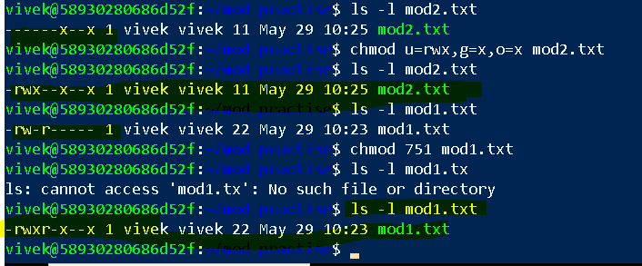

**Task 25: Guys what will this command do?**

chown -c master file1.txt : change owner

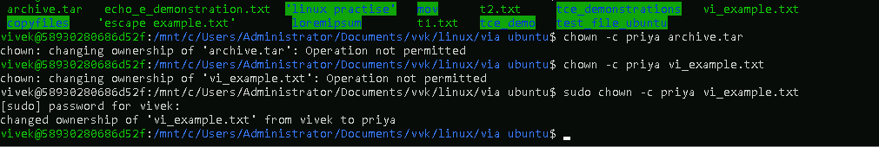

**Task 26/ Task 27/ Task 28: Can you define what is a process?**

**What is command to check foreground process and background process? Can you list all the running process**

A process is an instance of program in execution. It has components like: 1. Program code, program counter, stack, data, heap.

Process states: new, ready, running, waiting, terminated

Process attributes: PID, parents PID, uid, memory usage, cpu usage

View process info command:   
ps(show current foreground process)

ps aux | grep pts (show all processes with details)

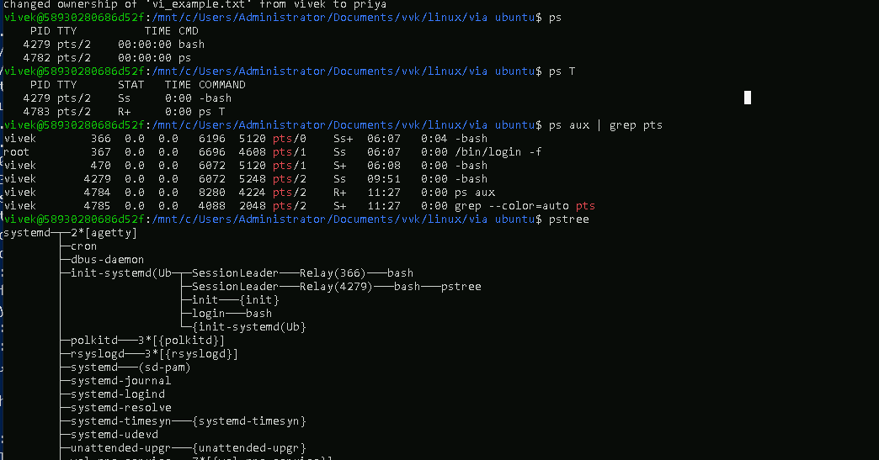

**Task 29:**

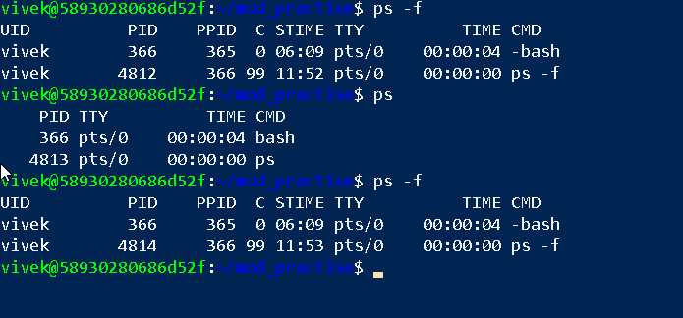**What will ps -f command do ? plz try n check .. ss required.**



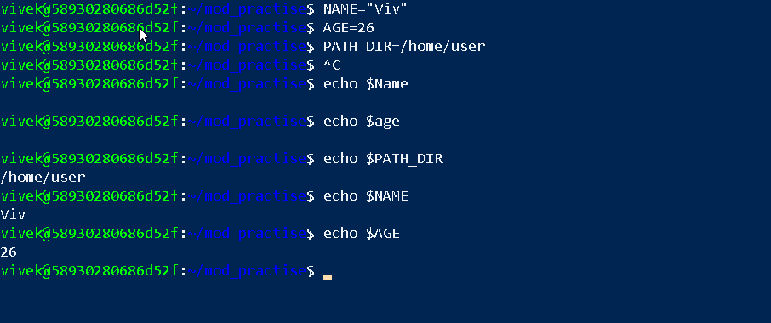**Task 30: Can you create a variable name with your name in it:**

**Task 31: Can you make the above name variable read only..**

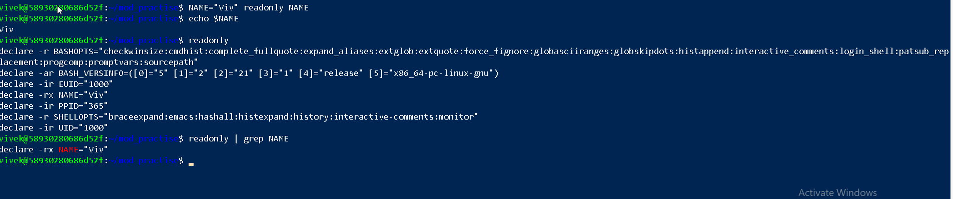

**Task 32: Now will unset or delete the variables:**

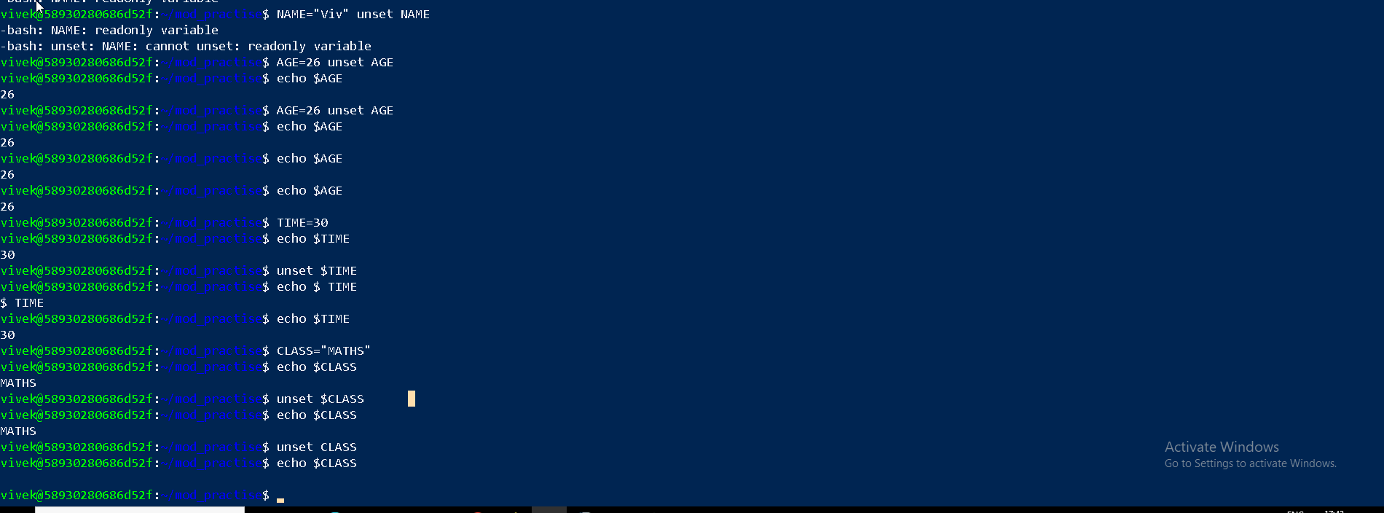

Unsetting using variable name without $ symbol preceding

**Task 33/34:**

**Can u try to add a list of your friends names in an array and try to printout/ print full array at once**

**Ex:**

**NAME[0]="Ram"**

**NAME[1]="Sita"**

**NAME[2]="Tina"**

**NAME[3]="Veena"**

**NAME[4]="Tim"**

**echo "First Index: ${NAME[0]}"**

**echo "Second Index: ${NAME[1]}"**

**echo ${NAME[@]}**

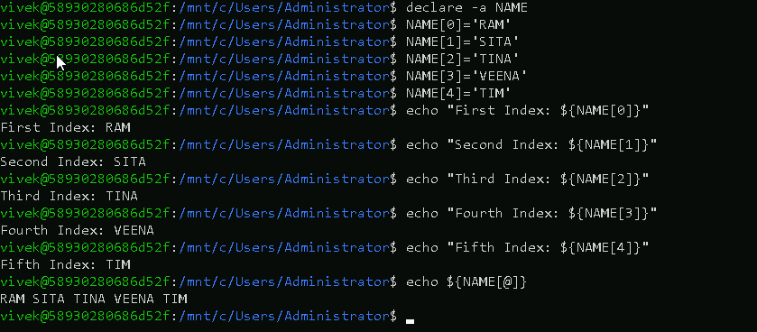

**Task 35: Plz let me know whats the output of the below snippet:**

**a=0**

**while [ "$a" -lt 10 ]    # this is loop1**

**do**

**b="$a"**

**while [ "$b" -ge 0 ]  # this is loop2**

**do**

**echo -n "$b "**

**b=`expr $b - 1`**

**done**

**echo**

**a=`expr $a + 1`**

**Done**

