**Date:** *05-Jun-2025*

**Name:** *Vivek Samant*

**Empid:** *109085619*

**alias:** *samantvs*

**Tasks:**

**Task 19:**

**Enum:**

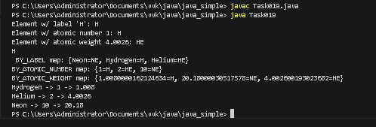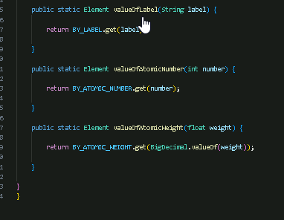

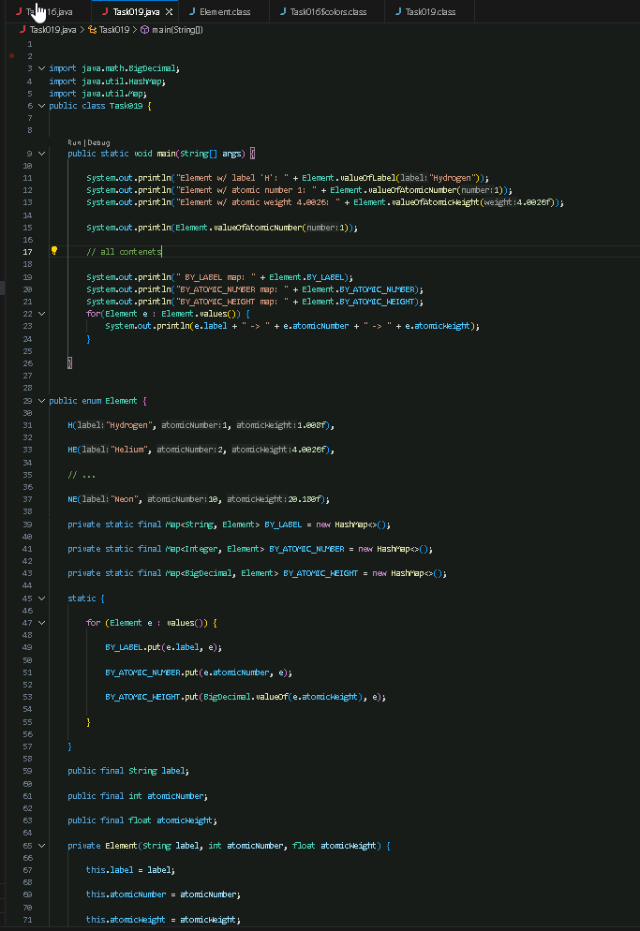

**Task 017:**

Task 017:

Getter and setter

Create a program name Person.java

public class Person {

   private String name;

   // Getter

   public String getName() {

     return name;

   }

   // Setter

   public void setName(String newName) {

     this.name = newName;

   }

}

Create another program named Task017.java

public class Task017{

  public static void main(String[] args) {

    Person myObj = new Person();

    myObj.name = "John";

    System.out.println(myObj.name);

  }

}

We unable to access if we just create myObj of Person and use dot(.) operator to access the name as the name is private in Person class hence, we need to use getter for it.

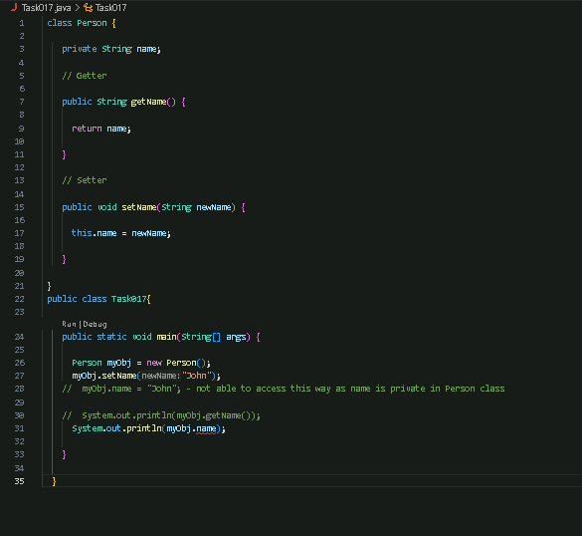



**Task 018**

**Now create one more program named Task018.java**

**public class Main {**

**public static void main(String[] args) {**

**Person myObj = new Person();**

**myObj.setName("John");**

**System.out.println(myObj.getName());**

**}**

**}**

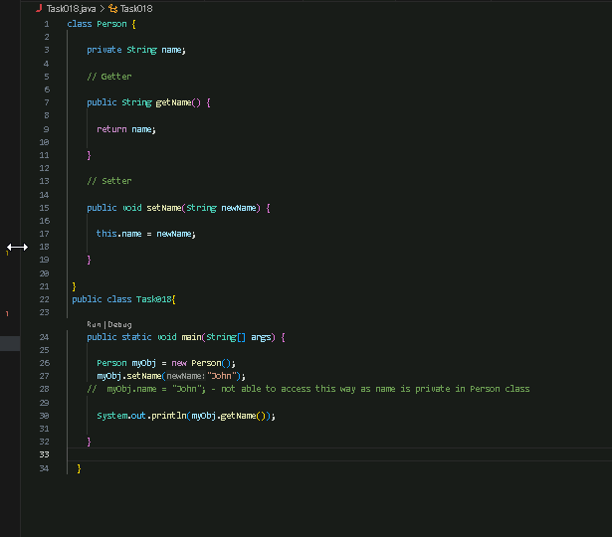



**Task 020:**

**Create an array of your name**

Task 029:

**Shallow cloning (wrapping in integer class)**

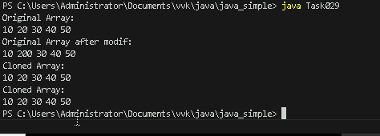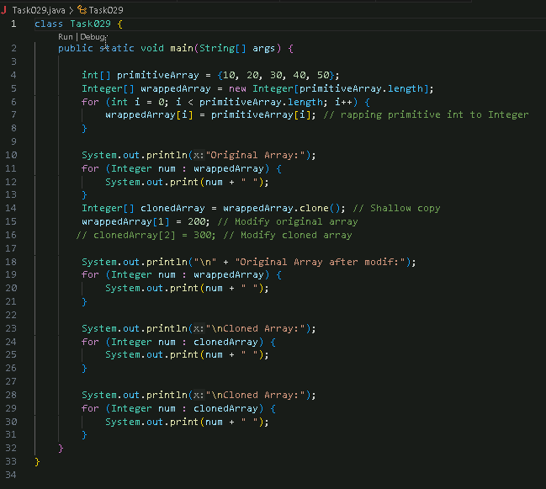

**Task 030: Inheritance example:**

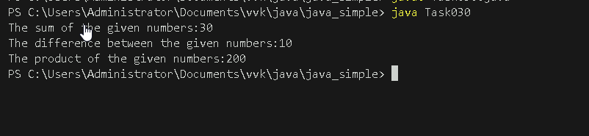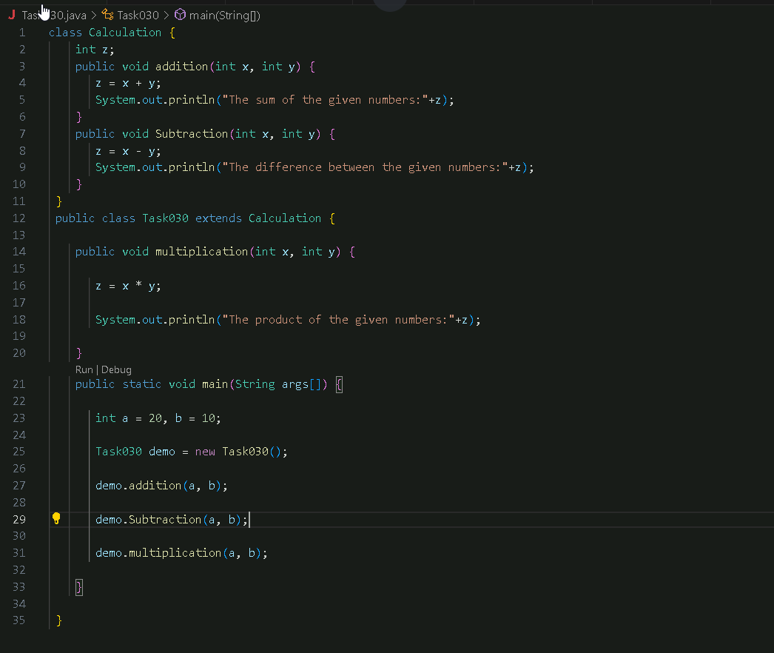

**Task 033: super keyword inheritance**

Task 040: // Working of Abstraction in Java

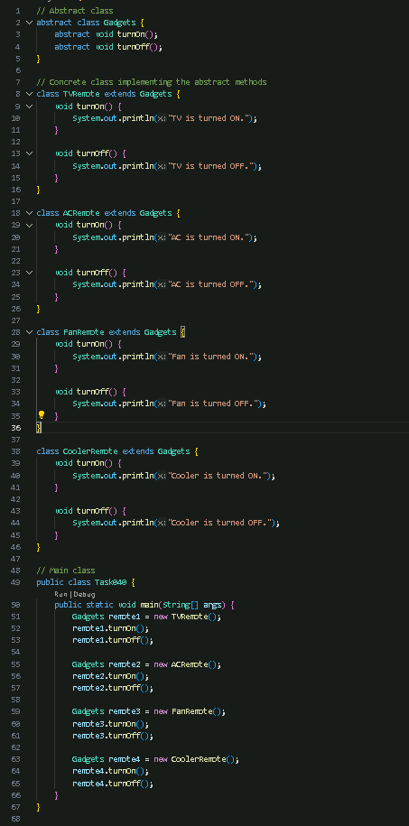

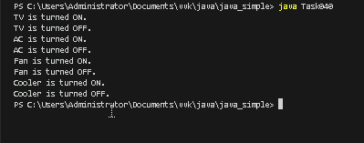

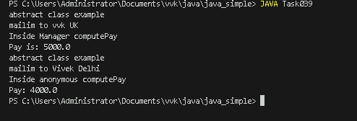**Task 039 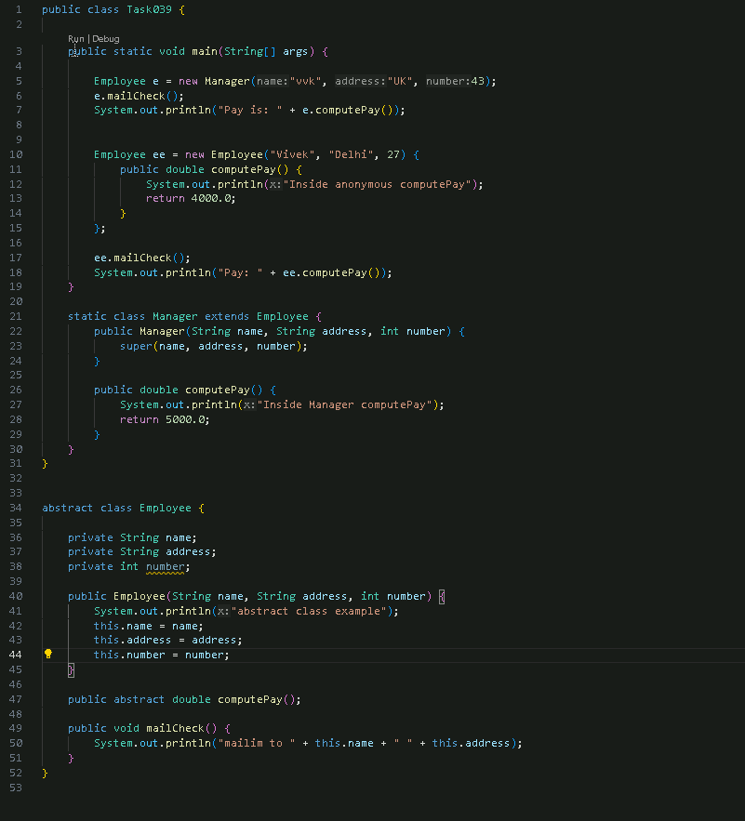: abstract example:**