

**POLITECNICO DI BARI**

**Dipartimento di Ingegneria Elettronica e dell’Informazione - DEI**

**CORSO DI LAUREA MAGISTRALE IN INGEGNERIA INFORMATICA E IN INGEGNERIA DELL’AUTOMAZIONE**

**____________________________________________________________**

**PROGETTO DI**

**HUMAN MACHINE INTERACTION**

**FINGER FORCE ESTIMATION WITH EMG SIGNALS**

**Professore:**

**Vito Antonio Bevilacqua**

**Domenico Buongiorno**

**Studenti:**

**Claudia Coscia**

**Vito Papparrella**

**______________________________________________________________________**

Sommario

I. INTRODUCTION 1

II. MATERIALS AND METHODS 2

II.I. Participants 2

II.II. Experimental setup 2

III. PROCEDURE 4

III.I. Data Pre-processing 4

III.II. Training dataset 4

Autoencoder 4

Double autoencoder 4

III.III. Performance 4

IV. RESULTS 4

V. REFERENCES 4

# INTRODUCTION

The growing interest in wearable robots for assistance and rehabilitation purposes opens the challenge for developing intuitive and natural control strategies [1]. The dexterity of human hand is the result of complex motor patterns that generate a coordinated response of multiple muscles placed intrinsically in the hand and in the forearm. The control signals to move each finger of the hand are generated in separate regions of the primary motor cortex (M1) and are delivered to the muscles via the efferent pathways of the spinal cord and peripheral nervous system. The neural commands elicit muscle electrical activity and a mechanical response. In recent years, it has been demonstrated that the intention to move the hand can be decoded using pattern recognition applied to recorded and processed electromyography (EMG) signals [2]. Myoelectric control commonly relies on decoding human motor intent from non-invasive electromyographic signals (EMG) and on mapping EMG into control outputs, allowing for the establishment of intuitive human-machine interfaces. This control strategy has been applied for multifunctional prostheses and robotic exoskeletons [3].

More recently, different studies have shown how the central nerve systems (CNS) coordinates muscle groups as a synergistic combination, instead of targeting each muscle individually during human motion. These results have encouraged EMG researchers to replicate synergies behavior as a bio-inspired dimensionality reduction method based normally on the Non-Negative Matrix Factorization (NNMF) algorithm [1].

However, autoencoders (AE) are gaining attention for biosignal processing as the computational limitation reduce over time. Vujaklija et al. have presented an autoencoder for mapping the EMG signals of the forearm muscles into one dimensional kinematic space. Bo Lv et al. proposed a sparse autoencoder-based classiﬁer for hand gesture recognition using HD-EMG signals [1].

# MATERIALS AND METHODS

We have used Ninapro (Non-Invasive Adaptive Prosthetics) database which includes data acquired from 67 intact subjects and 11 hand-amputated subjects while performing several repetitive tasks such as hand movements and ﬁnger force patterns. The database aims at allowing worldwide research groups to study the relationship between sEMG, hand/arm kinematics and dynamics, and clinical parameters, with the ﬁnal goal of creating non-invasive, naturally controlled robotic hand prostheses for trans-radial amputees [4].

## Participants

They tested 78 subjects, whose data are split across three sub-databases, according to the acquisition procedure and subject characteristics. We have used the second database that contains data obtained from 40 intact subjects (28 males, 12 females; 34 right-handed, 6 left-handed; age 29.9±3.9 years) [4].

## Experimental setup

The acquisition setup included several sensors, designed to record hand kinematics, dynamics and the corresponding muscular activity. The sensors were connected to a laptop responsible for data acquisition [4].

Electromyographic (EMG) signals were acquired using 12 Trigno Wireless electrodes by Delsys at 2 𝑘𝐻𝑧 with a baseline noise of less than 750 𝑛𝑉 RMS. Electrodes 1-8 were equally spaced around the forearm, 9 and 10 were located in the main activity spot of the muscle Flexor Digitorum Superficialis and of the muscle Extensor Digitorum Superficialis, lastly electrodes 11 and 12 were in the main activity spot of the muscle Biceps Brachii and of the muscle Triceps Brachii [5].

Hand dynamics was measured using the Finger-Force Linear Sensor (FFLS), employing strain gauge sensors to detect ﬂexion and extension forces of all ﬁngers, plus abduction and adduction of the thumb (6 of these sensors were used, one for the flexion of each finger and one for the thumb abduction). This sensor is characterized by high signal repeatability, minimal drift over time, almost perfect linearity [4].

An initial calibration setup was performed to set the rest and maximum voluntary contraction (MVC).

During the exercise the requested stimulus increased up to 80% of this value. Each task was repeated 6 times with this setup. Each repetition lasted 5 𝑠 with rest time in between repetitions of 3 𝑠. These are not randomized in order to encourage unconscious movements by the subject.

The acquired signals were processed in order to get synchronization using high resolution timestamps and cleaned from 50 𝐻𝑧 (and harmonics) power-line interferences using a Hampel filter [5].

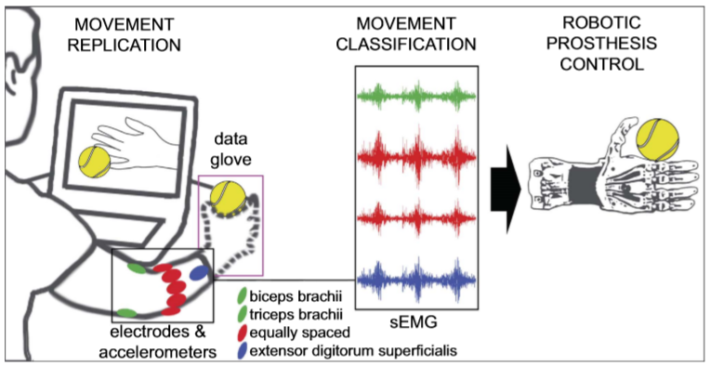

Figure 1. Acquisition procedure scheme for exercises A, B and C. The subjects are asked to mimic movies of movement shown on the screen of the laptop. The sEMG signal is recorded through up to 12 electrodes and can be used to test methods to control robotic hand prostheses naturally (the electrode on the ﬂexor digitorum superﬁcialis is not represented due to perspective reasons).

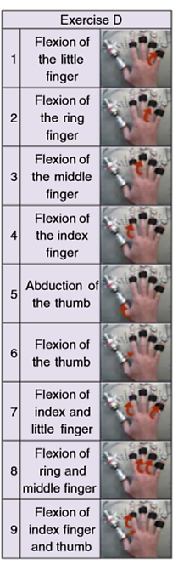

Figure 2. Movements and force patterns divided by exercise. Exercise D (purple): 9 force patterns.

# PROCEDURE

A MATLAB script was implemented to process the data and iterate the calculus.

### Data Pre-processing

The NinaPro database provided various variable to analyze, the ones used during this work were:

* **emg**: EMG signals coming from the electrodes; those were saved in a 12 by n matrix with 12 being the electrodes used and n was the number of samples of the signal;
* **restimulus**: variable that windowed and labeled the different tasks;
* **force**: force value measured by the FFLS sensor; those were saved in a 6 by n matrix with 6 being the number of finger sensors.

All 40 subjects from the NinaPro database were loaded into a struct for ease of use.

Of the 12 EMG signals the ones relative to the Biceps and to the Triceps (electrodes 11 and 12) were chosen not to be used in this work. The EMG signals were filtered in the 20 − 500 𝐻𝑧 band using a second order Butterworth filter. Then a low pass filter at 2 𝐻𝑧 was performed to smooth the signal.

The filtering of the signal introduced a delay that was estimated by cross correlating the signal processed to the one before the filtering. Then, the obtained delay was used to synchronize the signal [5].

### Training dataset

#### Autoencoder

#### Double autoencoder

### Performance

# RESULTS

# REFERENCES

1. V. Bevilacqua, D. Buongiorno, C. Camardella, G. D. Cascarano, L. P. Murciego, M. Barsotti, I. De Feudis and A. Frisoli, “An undercomplete autoencoder to extract muscle synergies for motor intention detection”, (IJCNN 2019) International Joint Conference on Neural Networks, Budapest Hungary, 14-19 July 2019.
2. N. Celadon, S. Došen, I. Binder, P. Ariano and D. Farina, “Proportional estimation of finger movements from high-density surface electromyography”, Celadon et al. Journal of Neuro Engineering and Rehabilitation (2016).
3. M. Barsotti, S. Dupan, I. Vujaklija, S. Došen, A. Frisoli and D. Farina, “Online Finger Control Using High-Density EMG and Minimal Training Data for Robotic Applications”, IEEE robotics and automation letters, vol. 4, no. 2, april 2019.
4. M. Atzori, A. Gijsberts, C. Castellini, B. Caputo, A. G. Mittaz Hager, S. Elsig, G. Giatsidis, F. Bassetto and H. Müller, “Electromyography data for non-invasive naturally-controlled robotic hand prostheses”, [www.nature.com/scentificdata](http://www.nature.com/scentificdata), 23 December 2014.
5. V. Bevilacqua, D. Buongiorno, D. Lotano, R. F. Gentile, “Finger Forces Estimation with EMG signals”, Ottobre 2019.