Part 1

Câu 1)

a.

def KT(arr):

    count =0

    for i in arr:

        if(i<2):

            count=count+1

        else:

            for j in range (2,i-1):

                if(i%j==0 and j<i):

                    count= count+1

                    break

    return len(arr)-count

a= [1,3,7,2,22]

print(KT(a))

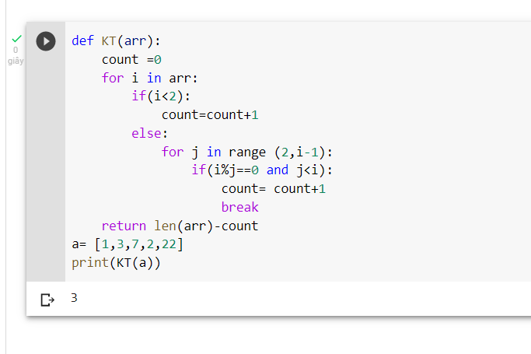

Part 2

Câu 2

a.

select name, commission from salesman

b.

select salesman_id, name, city, commission

from salesman

where (commission > 0.12);