[EXAM id="TOEIC-R04" title="TOEIC Reading Test 04" duration_minutes="75" total_questions="100" schema="TOEIC-TAGS-1"]

PART 5 — Incomplete Sentences
[PART number="5" start="101" end="130"]
[QUESTION number="101" type="SINGLE" passage="NONE"]
The regional manager will arrive tomorrow, so please ensure that all ------- documents are ready.
[OPTION key="A"] she
[OPTION key="B"] her
[OPTION key="C"] hers
[OPTION key="D"] herself
[CORRECT] B
[/QUESTION]
[QUESTION number="102" type="SINGLE" passage="NONE"]
The historic Waldridge Building was constructed nearly 200 years -------.
[OPTION key="A"] away
[OPTION key="B"] enough
[OPTION key="C"] ago
[OPTION key="D"] still
[CORRECT] C
[/QUESTION]
[QUESTION number="103" type="SINGLE" passage="NONE"]
Consumers ------- enthusiastically to the new colors developed by Sanwell Paint.
[OPTION key="A"] responding
[OPTION key="B"] response
[OPTION key="C"] responsively
[OPTION key="D"] responded
[CORRECT] D
[/QUESTION]
[QUESTION number="104" type="SINGLE" passage="NONE"]
The ------- files contain your employment contract and information about our company.
[OPTION key="A"] directed
[OPTION key="B"] attached
[OPTION key="C"] interested
[OPTION key="D"] connected
[CORRECT] B
[/QUESTION]
[QUESTION number="105" type="SINGLE" passage="NONE"]
Please submit each reimbursement request ------- according to its category, as outlined in last month's memo.
[OPTION key="A"] separately
[OPTION key="B"] separateness
[OPTION key="C"] separates
[OPTION key="D"] separate
[CORRECT] A
[/QUESTION]
[QUESTION number="106" type="SINGLE" passage="NONE"]
Customers can wait in the reception area ------- our mechanics complete the car repairs.
[OPTION key="A"] whether
[OPTION key="B"] except
[OPTION key="C"] while
[OPTION key="D"] during
[CORRECT] C
[/QUESTION]
[QUESTION number="107" type="SINGLE" passage="NONE"]
No one without a pass will be granted ------- to the conference.
[OPTION key="A"] admission
[OPTION key="B"] is admitting
[OPTION key="C"] admitted
[OPTION key="D"] to admit
[CORRECT] A
[/QUESTION]
[QUESTION number="108" type="SINGLE" passage="NONE"]
To receive an electronic reminder when payment is due, set up an online account ------- Albright Bank.
[OPTION key="A"] of
[OPTION key="B"] about
[OPTION key="C"] over
[OPTION key="D"] with
[CORRECT] D
[/QUESTION]
[QUESTION number="109" type="SINGLE" passage="NONE"]
The registration fee is ------- refundable up to two weeks prior to the conference date.
[OPTION key="A"] fullest
[OPTION key="B"] fuller
[OPTION key="C"] fully
[OPTION key="D"] full
[CORRECT] C
[/QUESTION]
[QUESTION number="110" type="SINGLE" passage="NONE"]
All identifying information has been ------- from this letter of complaint so that it can be used for training purposes.
[OPTION key="A"] produced
[OPTION key="B"] extended
[OPTION key="C"] removed
[OPTION key="D"] resolved
[CORRECT] C
[/QUESTION]
[QUESTION number="111" type="SINGLE" passage="NONE"]
------- this time next year, Larkview Technology will have acquired two new subsidiaries.
[OPTION key="A"] To
[OPTION key="B"] By
[OPTION key="C"] Quite
[OPTION key="D"] Begin
[CORRECT] B
[/QUESTION]
[QUESTION number="112" type="SINGLE" passage="NONE"]
Table reservations for ------- greater than ten must be made at least one day in advance.
[OPTION key="A"] plates
[OPTION key="B"] meals
[OPTION key="C"] sizes
[OPTION key="D"] parties
[CORRECT] D
[/QUESTION]
[QUESTION number="113" type="SINGLE" passage="NONE"]
Because of ------- weather conditions, tonight's concert in Harbin Park has been canceled.
[OPTION key="A"] worsening
[OPTION key="B"] worsens
[OPTION key="C"] worsen
[OPTION key="D"] worst
[CORRECT] A
[/QUESTION]
[QUESTION number="114" type="SINGLE" passage="NONE"]
Ms. AI-Omani will rely ------- team leaders to develop employee incentive programs.
[OPTION key="A"] onto
[OPTION key="B"] into
[OPTION key="C"] within
[OPTION key="D"] upon
[CORRECT] D
[/QUESTION]
[QUESTION number="115" type="SINGLE" passage="NONE"]
Survey ------- analyze the layout of a land area above and below ground level.
[OPTION key="A"] technicians
[OPTION key="B"] technically
[OPTION key="C"] technical
[OPTION key="D"] technicality
[CORRECT] A
[/QUESTION]
[QUESTION number="116" type="SINGLE" passage="NONE"]
------- assemble your Gessen product, first read all instructions and gather all required tools.
[OPTION key="A"] For the purpose of
[OPTION key="B"] To be sure
[OPTION key="C"] In order to
[OPTION key="D"] For example
[CORRECT] C
[/QUESTION]
[QUESTION number="117" type="SINGLE" passage="NONE"]
Online shoppers who experience long waits for their orders tend ------- the business low ratings.
[OPTION key="A"] have given
[OPTION key="B"] gave
[OPTION key="C"] to give
[OPTION key="D"] giving
[CORRECT] C
[/QUESTION]
[QUESTION number="118" type="SINGLE" passage="NONE"]
------- of the new Delran train station will begin in late September.
[OPTION key="A"] Association
[OPTION key="B"] Construction
[OPTION key="C"] Violation
[OPTION key="D"] Comprehension
[CORRECT] B
[/QUESTION]
[QUESTION number="119" type="SINGLE" passage="NONE"]
The computing power of the new laptop is ------- to any desktop computer in the same price range.
[OPTION key="A"] compare
[OPTION key="B"] comparing
[OPTION key="C"] comparison
[OPTION key="D"] comparable
[CORRECT] D
[/QUESTION]
[QUESTION number="120" type="SINGLE" passage="NONE"]
Dr. Yuina Hashimoto recently added another doctor to her practice, ------- allowing more patients to be seen.
[OPTION key="A"] that
[OPTION key="B"] thus
[OPTION key="C"] which
[OPTION key="D"] so that GO ON TO THENEXTPAGE ..
[CORRECT] B
[/QUESTION]
[QUESTION number="121" type="SINGLE" passage="NONE"]
Graden Hotel ------- its superior reputation thanks to the leadership of its president, Marcia Clemente.
[OPTION key="A"] practiced
[OPTION key="B"] treated
[OPTION key="C"] heard
[OPTION key="D"] earned
[CORRECT] D
[/QUESTION]
[QUESTION number="122" type="SINGLE" passage="NONE"]
Aki Katsuro's latest novel is his most exciting ------- and is sure to make Radin Books' best-seller list.
[OPTION key="A"] just
[OPTION key="B"] later
[OPTION key="C"] yet
[OPTION key="D"] very
[CORRECT] C
[/QUESTION]
[QUESTION number="123" type="SINGLE" passage="NONE"]
Thanks ------- to pastry chef Ana Villagra, Lauducci's Restaurant has become a favorite with local patrons.
[OPTION key="A"] largely
[OPTION key="B"] larger
[OPTION key="C"] large
[OPTION key="D"] largest
[CORRECT] A
[/QUESTION]
[QUESTION number="124" type="SINGLE" passage="NONE"]
At Crintack Manufacturing, we acknowledge our ------- to provide a safe workplace for our employees.
[OPTION key="A"] assumption
[OPTION key="B"] valuation
[OPTION key="C"] perception
[OPTION key="D"] obligation
[CORRECT] D
[/QUESTION]
[QUESTION number="125" type="SINGLE" passage="NONE"]
------- Mr. Donovan had expected the charity event to be a success, the response from the community still overwhelmed him.
[OPTION key="A"] Whenever
[OPTION key="B"] Although
[OPTION key="C"] Even so
[OPTION key="D"] In spite of
[CORRECT] B
[/QUESTION]
[QUESTION number="126" type="SINGLE" passage="NONE"]
This free mobile app provides ------- calendar updates, so salespeople will never miss an appointment.
[OPTION key="A"] casual
[OPTION key="B"] equal
[OPTION key="C"] continual
[OPTION key="D"] eventual
[CORRECT] C
[/QUESTION]
[QUESTION number="127" type="SINGLE" passage="NONE"]
Most senior managers approved the architect's proposal for the office layout, although ------- expressed concerns about the cost.
[OPTION key="A"] one
[OPTION key="B"] one another
[OPTION key="C"] each other
[OPTION key="D"] other
[CORRECT] A
[/QUESTION]
[QUESTION number="128" type="SINGLE" passage="NONE"]
Greenville Library has hired an office assistant not only to perform general office duties ------- to support an ongoing special project.
[OPTION key="A"] but also
[OPTION key="B"] only if
[OPTION key="C"] other than
[OPTION key="D"] as for
[CORRECT] A
[/QUESTION]
[QUESTION number="129" type="SINGLE" passage="NONE"]
The lease with The Pawlicki Group ------- if modifications to the existing offices are made.
[OPTION key="A"] had continued
[OPTION key="B"] will be continued
[OPTION key="C"] was continuing
[OPTION key="D"] has been continuing
[CORRECT] B
[/QUESTION]
[QUESTION number="130" type="SINGLE" passage="NONE"]
Wrazen Associates ------- a summary with a list of recommendations as a routine part of any audit.
[OPTION key="A"] realizes
[OPTION key="B"] induces
[OPTION key="C"] causes
[OPTION key="D"] issues
[CORRECT] D
[/QUESTION]
[/PART]

PART 6 — Text Completion
[PART number="6" start="131" end="146"]

Questions 131–134
[PASSAGE id="R04-P131" part="6" question_start="131" question_end="134" content_type="IMAGE"]
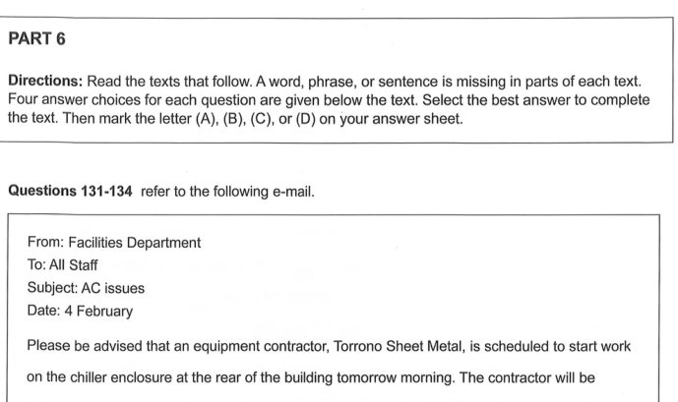
[/PASSAGE]
[QUESTION number="131" type="SINGLE" passage="R04-P131"]
Choose the correct answer for blank 131 in the passage.
[OPTION key="A"] better
[OPTION key="B"] quicker
[OPTION key="C"] sooner
[OPTION key="D"] harder
[CORRECT] A
[/QUESTION]
[QUESTION number="132" type="SINGLE" passage="R04-P131"]
Choose the correct answer for blank 132 in the passage.
[OPTION key="A"] As a result
[OPTION key="B"] Also
[OPTION key="C"] Nevertheless
[OPTION key="D"] However
[CORRECT] A
[/QUESTION]
[QUESTION number="133" type="SINGLE" passage="R04-P131"]
Choose the correct answer for blank 133 in the passage.
[OPTION key="A"] are blocking
[OPTION key="B"] will block
[OPTION key="C"] had blocked
[OPTION key="D"] block
[CORRECT] B
[/QUESTION]
[QUESTION number="134" type="SINGLE" passage="R04-P131"]
Choose the correct answer for blank 134 in the passage.
[OPTION key="A"] Send us your suggestions for a new facility.
[OPTION key="B"] I am writing to let you know about a maintenance issue.
[OPTION key="C"] Rather, they were not my first choice for this contract.
[OPTION key="D"] The work is expected to be completed by 2:00P.M.
[CORRECT] D
[/QUESTION]

Questions 135–138
[PASSAGE id="R04-P135" part="6" question_start="135" question_end="138" content_type="IMAGE"]
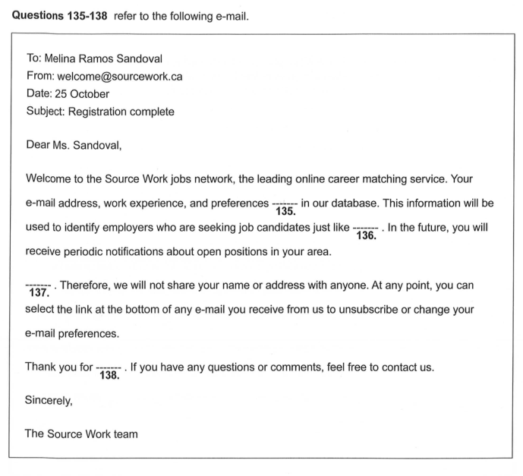
[/PASSAGE]
[QUESTION number="135" type="SINGLE" passage="R04-P135"]
Choose the correct answer for blank 135 in the passage.
[OPTION key="A"] they record
[OPTION key="B"] are recording
[OPTION key="C"] that the record
[OPTION key="D"] have been recorded
[CORRECT] D
[/QUESTION]
[QUESTION number="136" type="SINGLE" passage="R04-P135"]
Choose the correct answer for blank 136 in the passage.
[OPTION key="A"] us
[OPTION key="B"] me
[OPTION key="C"] you
[OPTION key="D"] ours
[CORRECT] C
[/QUESTION]
[QUESTION number="137" type="SINGLE" passage="R04-P135"]
Choose the correct answer for blank 137 in the passage.
[OPTION key="A"] Privacy is important to us.
[OPTION key="B"] Finding the perfect job can be difficult.
[OPTION key="C"] Our jobs database is updated weekly.
[OPTION key="D"] Your resume has recently been reviewed.
[CORRECT] A
[/QUESTION]
[QUESTION number="138" type="SINGLE" passage="R04-P135"]
Choose the correct answer for blank 138 in the passage.
[OPTION key="A"] investing
[OPTION key="B"] attending
[OPTION key="C"] competing
[OPTION key="D"] registering
[CORRECT] D
[/QUESTION]

Questions 139–142
[PASSAGE id="R04-P139" part="6" question_start="139" question_end="142" content_type="IMAGE"]
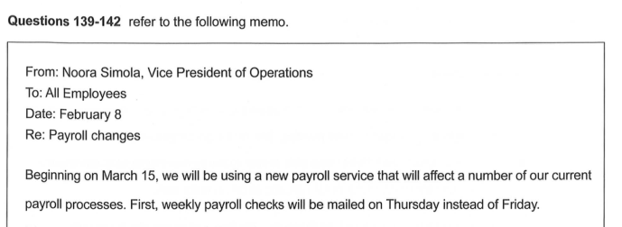
[/PASSAGE]
[QUESTION number="139" type="SINGLE" passage="R04-P139"]
Choose the correct answer for blank 139 in the passage.
[OPTION key="A"] twice
[OPTION key="B"] following
[OPTION key="C"] earlier
[OPTION key="D"] previously
[CORRECT] C
[/QUESTION]
[QUESTION number="140" type="SINGLE" passage="R04-P139"]
Choose the correct answer for blank 140 in the passage.
[OPTION key="A"] view
[OPTION key="B"] correct
[OPTION key="C"] reject
[OPTION key="D"] enter
[CORRECT] A
[/QUESTION]
[QUESTION number="141" type="SINGLE" passage="R04-P139"]
Choose the correct answer for blank 141 in the passage.
[OPTION key="A"] Please note the change of day and time.
[OPTION key="B"] Most employees begin work at 8:00A.M.
[OPTION key="C"] The payroll department is not operational.
[OPTION key="D"] Old time card forms will also still be valid.
[CORRECT] D
[/QUESTION]
[QUESTION number="142" type="SINGLE" passage="R04-P139"]
Choose the correct answer for blank 142 in the passage.
[OPTION key="A"] will distribute
[OPTION key="B"] will be distributed
[OPTION key="C"] was distributed
[OPTION key="D"] distributing GO ON TO THENEXT PAGE
[CORRECT] B
[/QUESTION]

Questions 143–146
[PASSAGE id="R04-P143" part="6" question_start="143" question_end="146" content_type="IMAGE"]
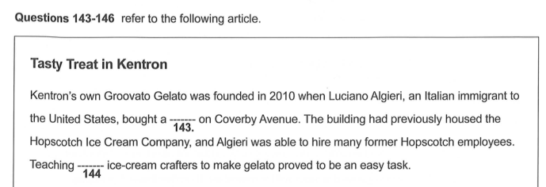
[/PASSAGE]
[QUESTION number="143" type="SINGLE" passage="R04-P143"]
Choose the correct answer for blank 143 in the passage.
[OPTION key="A"] dessert
[OPTION key="B"] vehicle
[OPTION key="C"] machine
[OPTION key="D"] factory
[CORRECT] D
[/QUESTION]
[QUESTION number="144" type="SINGLE" passage="R04-P143"]
Choose the correct answer for blank 144 in the passage.
[OPTION key="A"] experiences
[OPTION key="B"] experience
[OPTION key="C"] experiencing
[OPTION key="D"] experienced
[CORRECT] D
[/QUESTION]
[QUESTION number="145" type="SINGLE" passage="R04-P143"]
Choose the correct answer for blank 145 in the passage.
[OPTION key="A"] To create
[OPTION key="B"] Creates
[OPTION key="C"] Had created
[OPTION key="D"] Creation
[CORRECT] A
[/QUESTION]
[QUESTION number="146" type="SINGLE" passage="R04-P143"]
Choose the correct answer for blank 146 in the passage.
[OPTION key="A"] Banana walnut is slightly more expensive.
[OPTION key="B"] Some people still prefer Hopscotch ice cream.
[OPTION key="C"] The result is a rich and satisfying mixture of flavors.
[OPTION key="D"] Please try a sample and give us your feedback.
[CORRECT] C
[/QUESTION]
[/PART]

PART 7 — Reading Comprehension
[PART number="7" start="147" end="200"]

Questions 147–148
[PASSAGE id="R04-P147" part="7" question_start="147" question_end="148" content_type="IMAGE"]
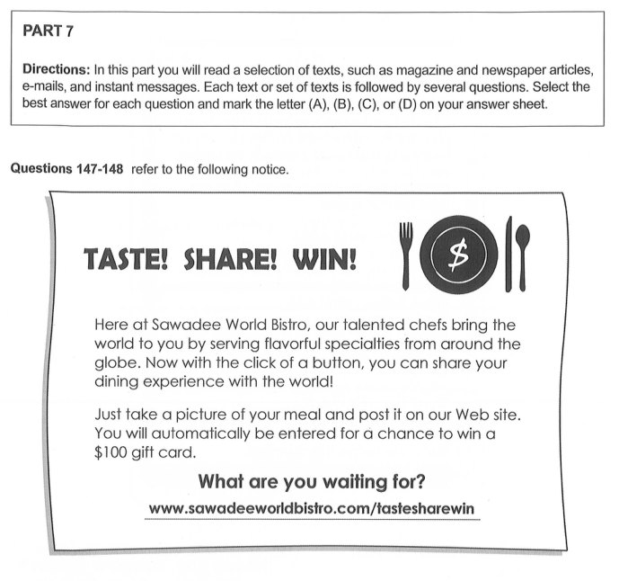
[/PASSAGE]
[QUESTION number="147" type="SINGLE" passage="R04-P147"]
Where would the notice most likely be posted?
[OPTION key="A"] On the wall of a restaurant
[OPTION key="B"] On the back page of a cookbook
[OPTION key="C"] On the cover of a photography magazine
[OPTION key="D"] On the door of a kitchen supply store
[CORRECT] A
[/QUESTION]
[QUESTION number="148" type="SINGLE" passage="R04-P147"]
How can readers enter a contest?
[OPTION key="A"] By writing a review
[OPTION key="B"] By creating a recipe
[OPTION key="C"] By making a donation
[OPTION key="D"] By submitting a photograph
[CORRECT] D
[/QUESTION]

Questions 149–150
[PASSAGE id="R04-P149" part="7" question_start="149" question_end="150" content_type="IMAGE"]
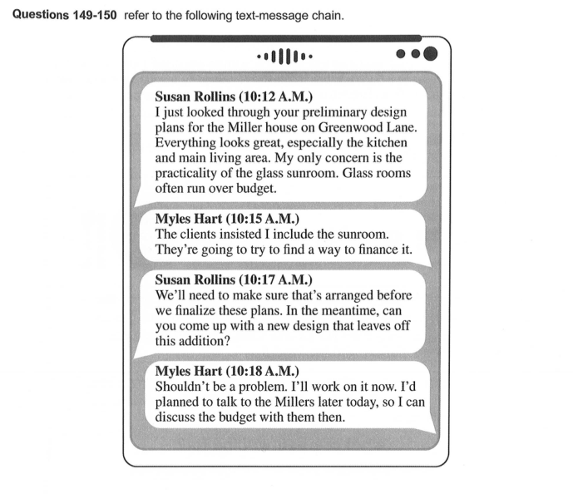
[/PASSAGE]
[QUESTION number="149" type="SINGLE" passage="R04-P149"]
Where do the writers most likely work?
[OPTION key="A"] At a bank
[OPTION key="B"] At a glass factory
[OPTION key="C"] At an architectural firm
[OPTION key="D"] At a home-furnishings store
[CORRECT] C
[/QUESTION]
[QUESTION number="150" type="SINGLE" passage="R04-P149"]
At 10:18 A.M., what does Mr. Hart mean when he writes, "Shouldn't be a problem"?
[OPTION key="A"] The project is well within the budget.
[OPTION key="B"] He is willing to draft an alternate plan.
[OPTION key="C"] He can meet with the Millers later today.
[OPTION key="D"] The Millers have agreed with a suggestion.
[CORRECT] B
[/QUESTION]

Questions 151–152
[PASSAGE id="R04-P151" part="7" question_start="151" question_end="152" content_type="IMAGE"]
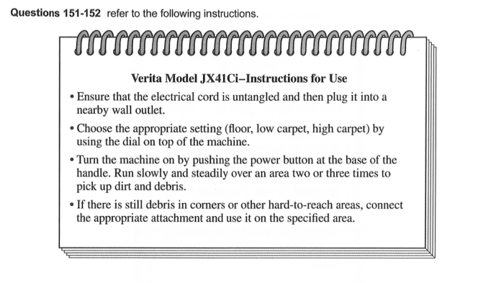
[/PASSAGE]
[QUESTION number="151" type="SINGLE" passage="R04-P151"]
What is the purpose of the machine referred to in the instructions?
[OPTION key="A"] Preparing food
[OPTION key="B"] Heating
[OPTION key="C"] Packaging
[OPTION key="D"] Cleaning
[CORRECT] D
[/QUESTION]
[QUESTION number="152" type="SINGLE" passage="R04-P151"]
What are users instructed to do each time before using the machine?
[OPTION key="A"] Connect all of the machine's attachments
[OPTION key="B"] Adjust the machine's controls
[OPTION key="C"] Clean every part of the machine
[OPTION key="D"] Allow the machine to warm up
[CORRECT] B
[/QUESTION]

Questions 153–154
[PASSAGE id="R04-P153" part="7" question_start="153" question_end="154" content_type="IMAGE"]
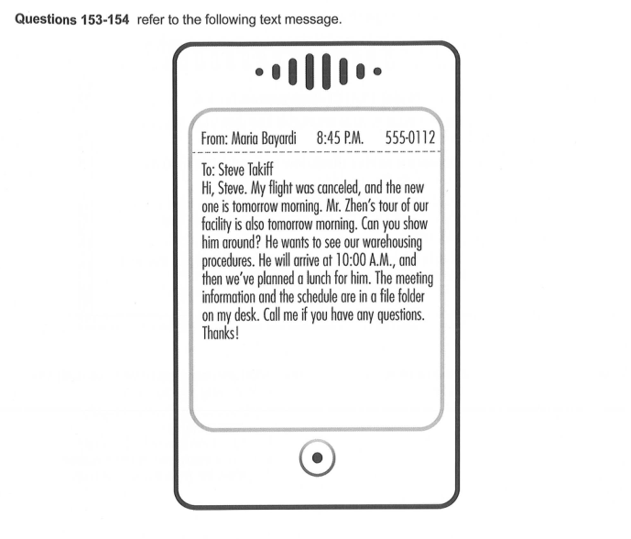
[/PASSAGE]
[QUESTION number="153" type="SINGLE" passage="R04-P153"]
Why did Ms. Bayardi send the text to Mr. Takiff?
[OPTION key="A"] To find out when his flight arrives
[OPTION key="B"] To ask for directions to the warehouse
[OPTION key="C"] To give him an update
[OPTION key="D"] To cancel an appointment
[CORRECT] C
[/QUESTION]
[QUESTION number="154" type="SINGLE" passage="R04-P153"]
What does Ms. Bayardi ask Mr. Takiff to do?
[OPTION key="A"] Plan a lunch
[OPTION key="B"] Give a tour
[OPTION key="C"] Reschedule an event
[OPTION key="D"] Call Mr. Zhen
[CORRECT] B
[/QUESTION]

Questions 155–157
[PASSAGE id="R04-P155" part="7" question_start="155" question_end="157" content_type="IMAGE"]
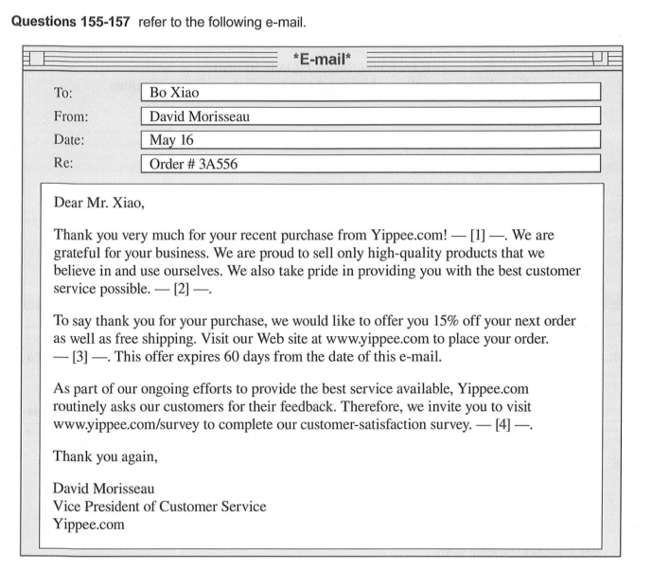
[/PASSAGE]
[QUESTION number="155" type="SINGLE" passage="R04-P155"]
What is the main purpose of the e-mail?
[OPTION key="A"] To offer a refund
[OPTION key="B"] To clarify some information
[OPTION key="C"] To express appreciation
[OPTION key="D"] To advertise a new product
[CORRECT] C
[/QUESTION]
[QUESTION number="156" type="SINGLE" passage="R04-P155"]
What is Mr. Xiao asked to do?
[OPTION key="A"] Attend a celebratory event
[OPTION key="B"] Evaluate a company's service
[OPTION key="C"] Send an e-mail within 60 days
[OPTION key="D"] Visit a new store that is opening soon
[CORRECT] B
[/QUESTION]
[QUESTION number="157" type="SINGLE" passage="R04-P155"]
In which of the positions marked [1], [2], [3], and [4] does the following sentence best belong? "Please use code XB84RD when completing your order to receive the discount."
[OPTION key="A"] [1]
[OPTION key="B"] [2]
[OPTION key="C"] [3]
[OPTION key="D"] [4]
[CORRECT] C
[/QUESTION]

Questions 158–160
[PASSAGE id="R04-P158" part="7" question_start="158" question_end="160" content_type="IMAGE"]
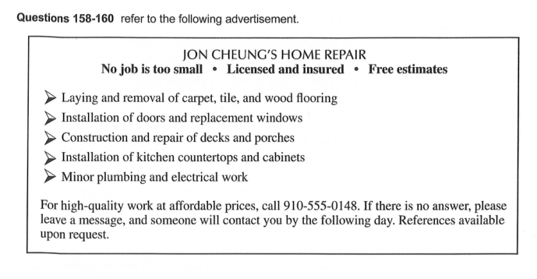
[/PASSAGE]
[QUESTION number="158" type="SINGLE" passage="R04-P158"]
What is indicated about Mr. Cheung?
[OPTION key="A"] He recently started a business.
[OPTION key="B"] His company is hiring.
[OPTION key="C"] His rates are reasonable.
[OPTION key="D"] He works part-time.
[CORRECT] C
[/QUESTION]
[QUESTION number="159" type="SINGLE" passage="R04-P158"]
What is NOT mentioned as a task Mr. Cheung can do?
[OPTION key="A"] Fixing porches
[OPTION key="B"] Painting houses
[OPTION key="C"] Replacing floor coverings
[OPTION key="D"] Putting in new windows
[CORRECT] B
[/QUESTION]
[QUESTION number="160" type="SINGLE" passage="R04-P158"]
According to the advertisement, what may a customer ask for?
[OPTION key="A"] Tile and carpet samples
[OPTION key="B"] Recommendations from other clients
[OPTION key="C"] Bigger work crews for rush jobs
[OPTION key="D"] Discounts for large-scale work
[CORRECT] B
[/QUESTION]

Questions 161–163
[PASSAGE id="R04-P161" part="7" question_start="161" question_end="163" content_type="IMAGE"]
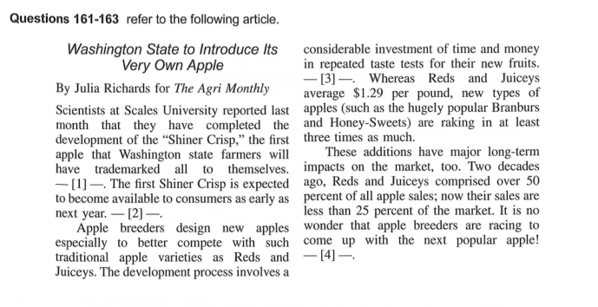
[/PASSAGE]
[QUESTION number="161" type="SINGLE" passage="R04-P161"]
What is the purpose of the article?
[OPTION key="A"] To give an opinion on Shiner Crisp prices
[OPTION key="B"] To recruit students for Scales University
[OPTION key="C"] To provide a detailed explanation of price differences in the apple industry
[OPTION key="D"] To announce the design of a new apple
[CORRECT] D
[/QUESTION]
[QUESTION number="162" type="SINGLE" passage="R04-P161"]
According to the article, what is true about Reds and Juiceys?
[OPTION key="A"] They are uniquely trademarked to Washington state.
[OPTION key="B"] They are less expensive than Honey-Sweets.
[OPTION key="C"] They have increased their sales recently.
[OPTION key="D"] They were bred by university scientists.
[CORRECT] B
[/QUESTION]
[QUESTION number="163" type="SINGLE" passage="R04-P161"]
In which of the positions marked [1], [2], [3], and [4] does the following sentence best belong? "In other words, these new types of apples are designed for big flavor and big profits."
[OPTION key="A"] [1]
[OPTION key="B"] [2]
[OPTION key="C"] [3]
[OPTION key="D"] [4]
[CORRECT] C
[/QUESTION]

Questions 164–167
[PASSAGE id="R04-P164" part="7" question_start="164" question_end="167" content_type="IMAGE"]
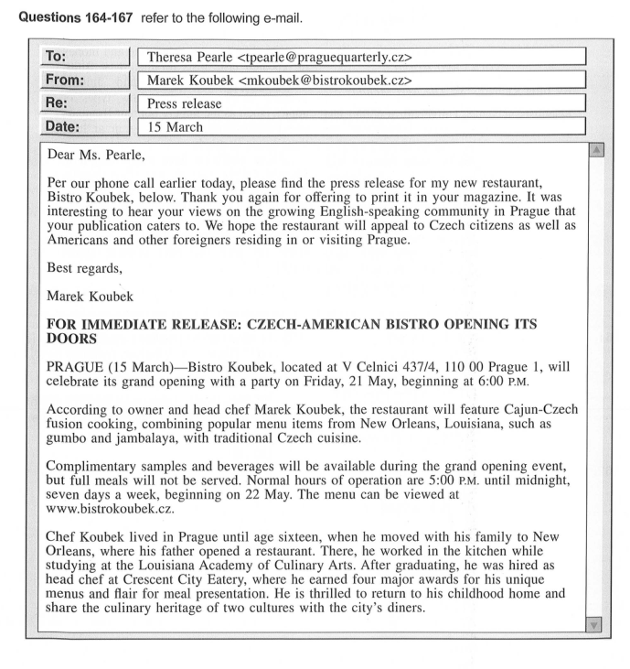
[/PASSAGE]
[QUESTION number="164" type="SINGLE" passage="R04-P164"]
Why did Mr. Koubek e-mail Ms. Pearle?
[OPTION key="A"] To invite her to a party
[OPTION key="B"] To provide content for an article
[OPTION key="C"] To announce the launch of a new Web site
[OPTION key="D"] To request her assistance in editing some text
[CORRECT] B
[/QUESTION]
[QUESTION number="165" type="SINGLE" passage="R04-P164"]
The phrase "appeal to" in paragraph 1, line 4, is closest in meaning to
[OPTION key="A"] attract
[OPTION key="B"] join together
[OPTION key="C"] benefit
[OPTION key="D"] call upon
[CORRECT] A
[/QUESTION]
[QUESTION number="166" type="SINGLE" passage="R04-P164"]
What is indicated about the event on May 21?
[OPTION key="A"] It will begin at 5:00P.M.
[OPTION key="B"] Only a few people have been invited.
[OPTION key="C"] All items will be served free of charge.
[OPTION key="D"] Patrons must have a ticket to enter.
[CORRECT] C
[/QUESTION]
[QUESTION number="167" type="SINGLE" passage="R04-P164"]
What is NOT stated about Mr. Koubek?
[OPTION key="A"] He grew up in Prague.
[OPTION key="B"] He has traveled extensively in Europe.
[OPTION key="C"] He worked in his father's restaurant.
[OPTION key="D"] He has won several cooking prizes.
[CORRECT] B
[/QUESTION]

Questions 168–171
[PASSAGE id="R04-P168" part="7" question_start="168" question_end="171" content_type="IMAGE"]
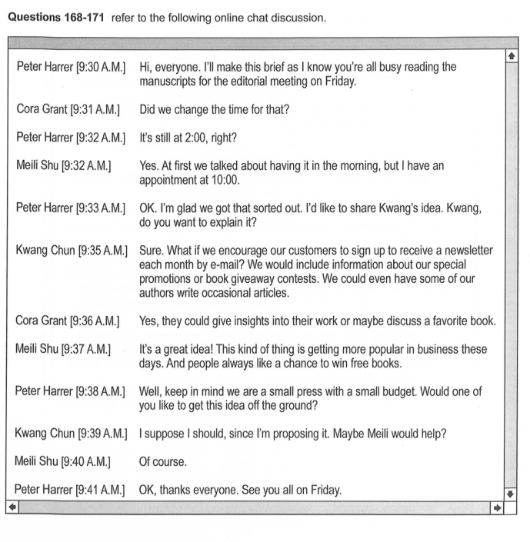
[/PASSAGE]
[QUESTION number="168" type="SINGLE" passage="R04-P168"]
Who most likely are the participants in the online chat discussion?
[OPTION key="A"] Staff at a marketing firm
[OPTION key="B"] Reporters at a local newspaper
[OPTION key="C"] Presenters at a conference
[OPTION key="D"] Colleagues at a publishing company
[CORRECT] D
[/QUESTION]
[QUESTION number="169" type="SINGLE" passage="R04-P168"]
At 9:33A.M., what does Mr. Harrer mean when he writes, "we got that sorted out"?
[OPTION key="A"] The manuscripts have all been assigned.
[OPTION key="B"] A meeting time has been agreed upon.
[OPTION key="C"] An appointment has been canceled.
[OPTION key="D"] New work policies have been followed.
[CORRECT] B
[/QUESTION]
[QUESTION number="170" type="SINGLE" passage="R04-P168"]
What project is Mr. Chun taking on?
[OPTION key="A"] Developing a newsletter
[OPTION key="B"] Revising a budget
[OPTION key="C"] Reviewing a book
[OPTION key="D"] Writing an advice column
[CORRECT] A
[/QUESTION]
[QUESTION number="171" type="SINGLE" passage="R04-P168"]
What does Ms. Shu agree to do?
[OPTION key="A"] Assist a colleague
[OPTION key="B"] Change her schedule
[OPTION key="C"] Interview an author
[OPTION key="D"] Take a business trip
[CORRECT] A
[/QUESTION]

Questions 172–175
[PASSAGE id="R04-P172" part="7" question_start="172" question_end="175" content_type="IMAGE"]
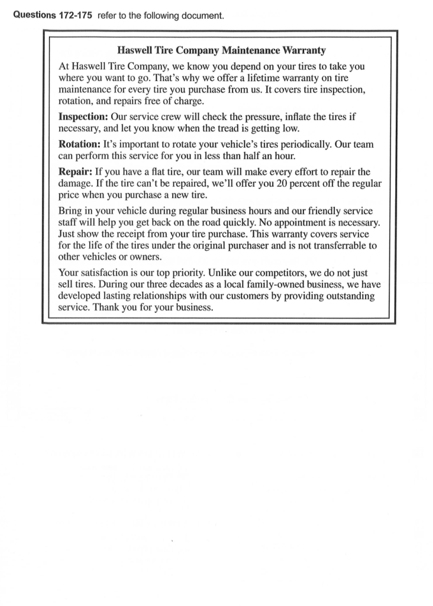
[/PASSAGE]
[QUESTION number="172" type="SINGLE" passage="R04-P172"]
The word "perform" in paragraph 3, line 2, is closest in meaning to
[OPTION key="A"] entertain
[OPTION key="B"] operate
[OPTION key="C"] portray
[OPTION key="D"] complete
[CORRECT] D
[/QUESTION]
[QUESTION number="173" type="SINGLE" passage="R04-P172"]
According to the document, when will Haswell Tire Company provide a discount?
[OPTION key="A"] When a customer buys a replacement tire
[OPTION key="B"] When service takes longer than half an hour
[OPTION key="C"] When the company holds a special sale day
[OPTION key="D"] When a customer purchases tires for more than one vehicle
[CORRECT] A
[/QUESTION]
[QUESTION number="174" type="SINGLE" passage="R04-P172"]
What must a customer have in order to receive a service covered by the warranty?
[OPTION key="A"] Proof of tire purchase
[OPTION key="B"] Documentation of a previous inspection
[OPTION key="C"] A copy of the warranty
[OPTION key="D"] A scheduled appointment
[CORRECT] A
[/QUESTION]
[QUESTION number="175" type="SINGLE" passage="R04-P172"]
What is suggested about Haswell Tire Company?
[OPTION key="A"] It offers lower prices than other tire stores.
[OPTION key="B"] It emphasizes good customer relations.
[OPTION key="C"] It manufactures the tires that it sells.
[OPTION key="D"] It is an international corporation. GO ON TO THENEXTPAGE
[CORRECT] B
[/QUESTION]

Questions 176–180
[PASSAGE id="R04-P176" part="7" question_start="176" question_end="180" content_type="IMAGE"]
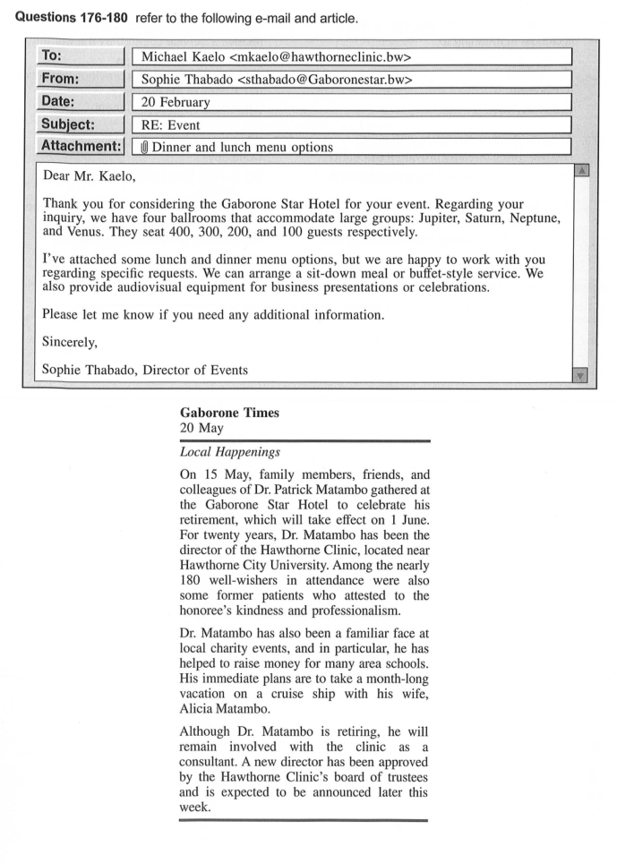
[/PASSAGE]
[QUESTION number="176" type="SINGLE" passage="R04-P176"]
Why did Ms. Thabado send the e-mail?
[OPTION key="A"] To promote a new hotel
[OPTION key="B"] To offer special hotel discounts
[OPTION key="C"] To confirm her attendance at an event
[OPTION key="D"] To respond to a request for information
[CORRECT] D
[/QUESTION]
[QUESTION number="177" type="SINGLE" passage="R04-P176"]
What was sent with the e-mail?
[OPTION key="A"] Photographs of event ballrooms
[OPTION key="B"] Information about meal choices
[OPTION key="C"] A list of hotel services
[OPTION key="D"] A form for ordering audio equipment
[CORRECT] B
[/QUESTION]
[QUESTION number="178" type="SINGLE" passage="R04-P176"]
In what ballroom was the celebration most likely held?
[OPTION key="A"] Jupiter
[OPTION key="B"] Saturn
[OPTION key="C"] Neptune
[OPTION key="D"] Venus
[CORRECT] C
[/QUESTION]
[QUESTION number="179" type="SINGLE" passage="R04-P176"]
What is NOT mentioned about Dr. Matambo?
[OPTION key="A"] He is planning leisure travel.
[OPTION key="B"] He moved to Hawthorne City twenty years ago.
[OPTION key="C"] He was in charge of a medical facility.
[OPTION key="D"] He has helped many local schools.
[CORRECT] B
[/QUESTION]
[QUESTION number="180" type="SINGLE" passage="R04-P176"]
According to the article, what does Dr. Matambo plan to do?
[OPTION key="A"] Remain professionally active
[OPTION key="B"] Spend more time on hobbies
[OPTION key="C"] Teach some classes
[OPTION key="D"] Interview his replacement
[CORRECT] A
[/QUESTION]

Questions 181–185
[PASSAGE id="R04-P181" part="7" question_start="181" question_end="185" content_type="IMAGE"]
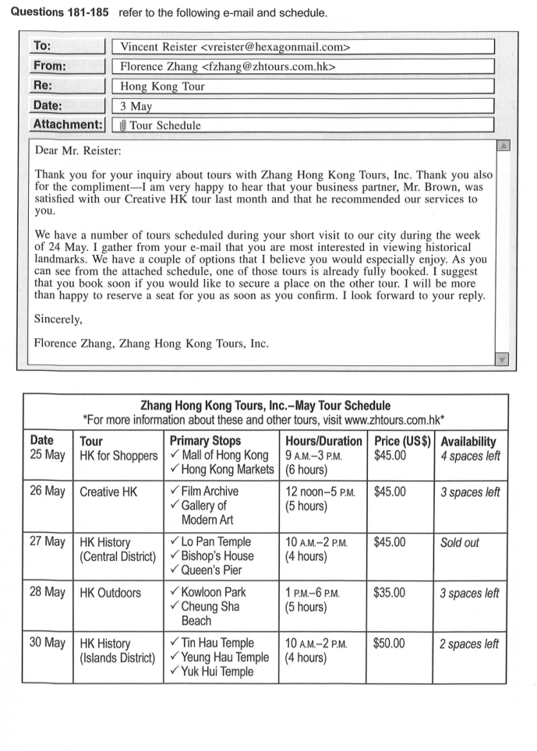
[/PASSAGE]
[QUESTION number="181" type="SINGLE" passage="R04-P181"]
What is the purpose of the e-mail?
[OPTION key="A"] To provide a referral
[OPTION key="B"] To answer a question about a company's service
[OPTION key="C"] To update an itinerary for a new customer
[OPTION key="D"] To confirm a booking
[CORRECT] B
[/QUESTION]
[QUESTION number="182" type="SINGLE" passage="R04-P181"]
How did Mr. Reister hear about Zhang Hong Kong Tours?
[OPTION key="A"] From a colleague
[OPTION key="B"] From a travel agent
[OPTION key="C"] From an advertisement
[OPTION key="D"] From an Internet search
[CORRECT] A
[/QUESTION]
[QUESTION number="183" type="SINGLE" passage="R04-P181"]
What did Mr. Brown most likely see on his tour?
[OPTION key="A"] Markets
[OPTION key="B"] Temples
[OPTION key="C"] Paintings
[OPTION key="D"] Parks and beaches
[CORRECT] C
[/QUESTION]
[QUESTION number="184" type="SINGLE" passage="R04-P181"]
What is suggested about Mr. Reister?
[OPTION key="A"] He is on a limited budget.
[OPTION key="B"] He will soon start a business.
[OPTION key="C"] He is interested in Chinese cuisine.
[OPTION key="D"] He will be in Hong Kong temporarily.
[CORRECT] D
[/QUESTION]
[QUESTION number="185" type="SINGLE" passage="R04-P181"]
According to Ms. Zhang, what tour is most suitable for Mr. Reister?
[OPTION key="A"] HK Outdoors
[OPTION key="B"] HK for Shoppers
[OPTION key="C"] HK History (Islands District)
[OPTION key="D"] HK History (Central District)
[CORRECT] C
[/QUESTION]

Questions 186–190
[PASSAGE id="R04-P186" part="7" question_start="186" question_end="190" content_type="IMAGE"]
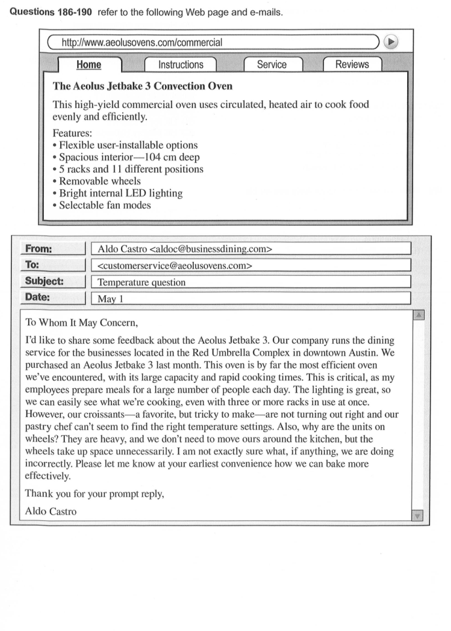
[/PASSAGE]
[QUESTION number="186" type="SINGLE" passage="R04-P186"]
In the first e-mail, the word "critical" in paragraph 1, line 4, is closest in meaning to
[OPTION key="A"] judgmental
[OPTION key="B"] important
[OPTION key="C"] dangerous
[OPTION key="D"] unexpected
[CORRECT] B
[/QUESTION]
[QUESTION number="187" type="SINGLE" passage="R04-P186"]
What feature of the oven listed on the Web page is NOT referred to in Mr. Castro's e-mail?
[OPTION key="A"] Ability to select fan modes
[OPTION key="B"] Spacious interior
[OPTION key="C"] Use of multiple racks
[OPTION key="D"] Bright internal LED lighting
[CORRECT] A
[/QUESTION]
[QUESTION number="188" type="SINGLE" passage="R04-P186"]
What does Mr. Castro's company do?
[OPTION key="A"] Prepare meals for business employees
[OPTION key="B"] Design food service equipment
[OPTION key="C"] Supply baked goods to local restaurants
[OPTION key="D"] Publish an online food magazine
[CORRECT] A
[/QUESTION]
[QUESTION number="189" type="SINGLE" passage="R04-P186"]
Why does Ms. Martz write to Mr. Castro?
[OPTION key="A"] To provide information on how to remove the oven's wheels
[OPTION key="B"] To give him guidance in addressing an installation issue
[OPTION key="C"] To request his assistance with a cooking seminar
[OPTION key="D"] To offer a solution to a baking problem
[CORRECT] D
[/QUESTION]
[QUESTION number="190" type="SINGLE" passage="R04-P186"]
What does Ms. Martz ask Mr. Castro to do?
[OPTION key="A"] Ship a part to her
[OPTION key="B"] Send her some product information
[OPTION key="C"] Consult an online resource
[OPTION key="D"] Write a follow-up review
[CORRECT] B
[/QUESTION]

Questions 191–195
[PASSAGE id="R04-P191" part="7" question_start="191" question_end="195" content_type="IMAGE"]
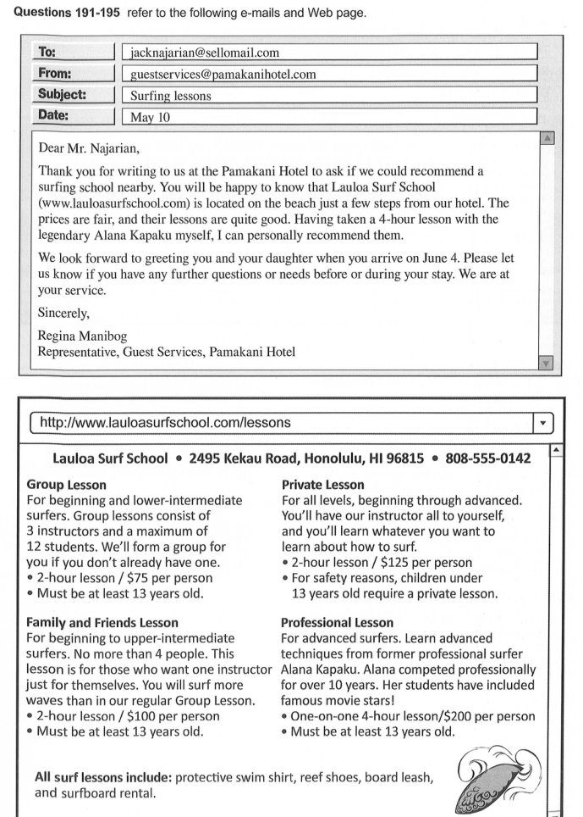
[/PASSAGE]
[QUESTION number="191" type="SINGLE" passage="R04-P191"]
Why did Ms. Manibog write the first e-mail?
[OPTION key="A"] To confirm a reservation
[OPTION key="B"] To reply to an inquiry
[OPTION key="C"] To obtain a recommendation
[OPTION key="D"] To introduce an instructor
[CORRECT] B
[/QUESTION]
[QUESTION number="192" type="SINGLE" passage="R04-P191"]
In the first e-mail, the word "fair" in paragraph 1, line 4, is closest in meaning to
[OPTION key="A"] generous
[OPTION key="B"] objective
[OPTION key="C"] reasonable
[OPTION key="D"] light
[CORRECT] C
[/QUESTION]
[QUESTION number="193" type="SINGLE" passage="R04-P191"]
What is most likely true about Ms. Manibog?
[OPTION key="A"] She is an advanced-level surfer.
[OPTION key="B"] She is the manager of Guest Services at Pamakani Hotel.
[OPTION key="C"] She previously worked for Lauloa Surf School.
[OPTION key="D"] She is a close friend of Mr. Najarian's family.
[CORRECT] A
[/QUESTION]
[QUESTION number="194" type="SINGLE" passage="R04-P191"]
How much did Mr. Najarian pay for his daughter's lesson?
[OPTION key="A"] $75
[OPTION key="B"] $100
[OPTION key="C"] $125
[OPTION key="D"] $200
[CORRECT] C
[/QUESTION]
[QUESTION number="195" type="SINGLE" passage="R04-P191"]
What is indicated about Mr. Najarian and his daughter?
[OPTION key="A"] They met Ms. Kapaku on the beach.
[OPTION key="B"] They travel on vacation to Hawaii every year.
[OPTION key="C"] They plan to stay at the Pamakani Hotel again.
[OPTION key="D"] They expect to take a surfing lesson together.
[CORRECT] D
[/QUESTION]

Questions 196–200
[PASSAGE id="R04-P196" part="7" question_start="196" question_end="200" content_type="IMAGE"]
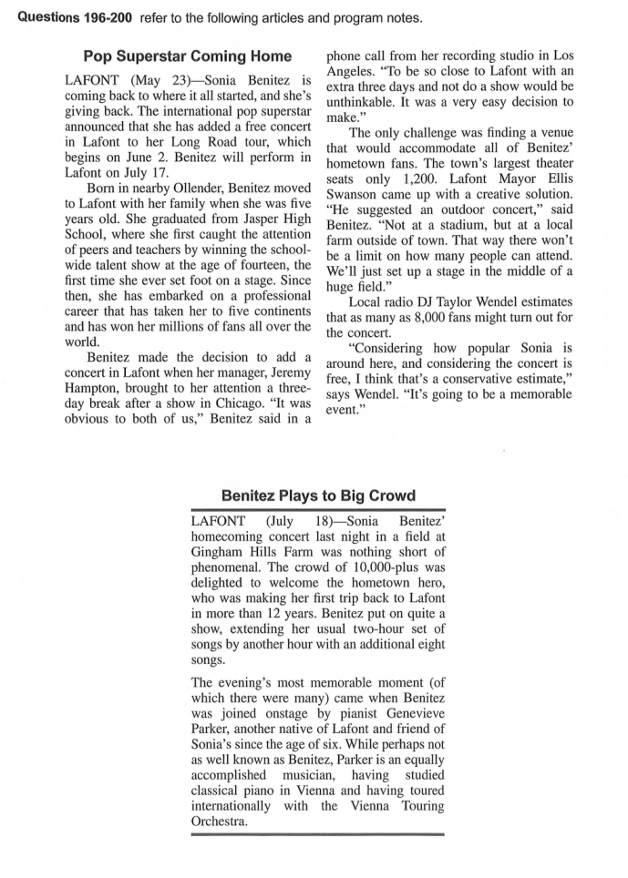
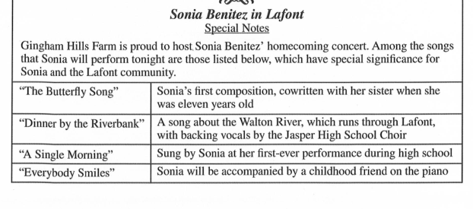
[/PASSAGE]
[QUESTION number="196" type="SINGLE" passage="R04-P196"]
What is suggested about Lafont?
[OPTION key="A"] It has a new mayor.
[OPTION key="B"] It is Ms. Benitez' birthplace.
[OPTION key="C"] It is located near Chicago.
[OPTION key="D"] It will be the first stop on a concert tour.
[CORRECT] C
[/QUESTION]
[QUESTION number="197" type="SINGLE" passage="R04-P196"]
According to the first article, what problem with the concert had to be addressed?
[OPTION key="A"] Finding extra musicians
[OPTION key="B"] Locating a large enough space
[OPTION key="C"] Determining a possible date
[OPTION key="D"] Setting an affordable ticket price
[CORRECT] B
[/QUESTION]
[QUESTION number="198" type="SINGLE" passage="R04-P196"]
What is indicated about the song "A Single Morning"?
[OPTION key="A"] It is about life in Lafont.
[OPTION key="B"] It is usually performed with a choir.
[OPTION key="C"] It was Ms. Benitez' first song played on the radio.
[OPTION key="D"] It was sung by Ms. Benitez at a talent show. Stop! This is the end of the test. If you f back to Parts 5, 6, and
[CORRECT] D
[/QUESTION]
[QUESTION number="199" type="SINGLE" passage="R04-P196"]
How did the concert in Lafont differ from Ms. Benitez' usual concerts?
[OPTION key="A"] It was an hour longer.
[OPTION key="B"] It was held in the daytime.
[OPTION key="C"] Attendees were seated in a stadium.
[OPTION key="D"] The Vienna Touring Orchestra opened the show.
[CORRECT] A
[/QUESTION]
[QUESTION number="200" type="SINGLE" passage="R04-P196"]
What song did Ms. Parker perform in?
[OPTION key="A"] "The Butterfly Song"
[OPTION key="B"] "Dinner by the Riverbank"
[OPTION key="C"] "A Single Morning"
[OPTION key="D"] "Everybody Smiles"
[CORRECT] D
[/QUESTION]
[/PART]
[/EXAM]

