FPT ACADEMY INTERNATIONAL

FPT - APTECH COMPUTER EDUCATION



Batch no: T1.2207.E1

Group 2

- EPROJECT REPORT -

La Imperial

Supervisor: Nguyễn Hạ Vy

Group leader: Vũ Thảo Vy ∗*Student*1396501

Members: Huỳnh Nhật Quang ∗*Student*1400977

Chu Văn Nam ∗*Student*1396969

Nguyễn Phúc Minh Châu ∗*Student*1396948

HO CHI MINH CITY, October 2022

Acknowledgements

Eventually, we now come to our very first eProject in this course. As worried and concerned as we are, we feel so much thankful for the things that we have learnt throughout this semester.

For the first time we, our team, take a look at it, the eProject seems quite overwhelming and too hard for us, to be honest. But right then when we realized how much knowledge and experiences we had gained, which are partly proved by how many files of codes and programs we have created from the beginning of this semester to now. By this moment, we are so proud to say that we are able to create our own HTML pages, use CSS, JavaScript and jQuery to decorate them. Moreover, more importantly, we have also made a lot of new friends that actually share tons of the same hobbies, one of which is programming obviously. And it is impossible not to mention about our chance to meet and to know our dedicated and beloved professor, Ms. Vy, the one that has always been with us and support us on this journey. We all love and appreciate every efforts that you made for our team and for our class, in general.

We would like to send a great thank you to our professor, Ms. Nguyen Ha Vy, and also the other students from other groups for all the supports during the time of the eProject.

Our last product is not perfect, however we, the members of Group 2, are always looking forward to any feedbacks and constructive critisms to enhanced our pages.

Lastly, thank you Aptech for giving us the chance to fullfill our dream and help us to have a better foundation for further development.

Sincerely,

All members of Group 2.

Contents

1 Synopsis 3

2 Analysis 3

2.1 Requirement Specification 3

2.2 User 4

2.2.1 Input: 4

2.2.2 Process: 4

2.2.3 Output: 5

2.3 Hardware and Software Requirement 5

3 Architecture and design 5

4 Sitemap 7

5 Screenshots 8

5.1 Header and footer 8

5.2 Home page 8

5.3 Product page and product details 10

5.4 Compare 15

5.5 Contact 15

5.6 About us 17

5.7 Login / Register 18

# 

# Synopsis

In this project, we’ll design a website named La Imperial, which has been selling products for over 20 years. They have a wide range of appliances such as TVs, washing machines, refrigerators and so on. As the Internet has become more central in our lives, the company decides to launch a website where customers can have a much better access to the available products.

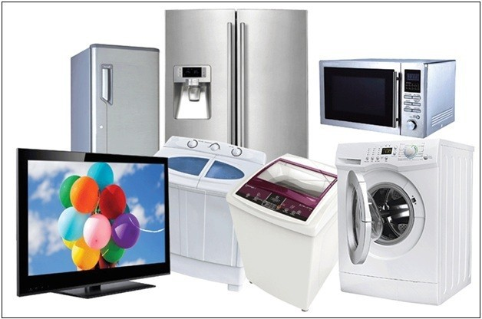

Figure 1: Household appliances

Just like other selling websites, there will be some basic information about the shop, places for showing the goods, placing orders and contacting the sellers,.. Our goal is to make these pages practical for real-life scenarios and avaiable for uses.

We will use HTML/JavaScript and Bootstrap to build up the website. As we know, this project is meant for students like us who have just completed the module of HTML5. So we’ll be doing it with the assistance of our professor.

# Analysis

## Requirement Specification

The Web site is to be created based on the following requirements.

* Home Page should contain logo of the site with proper sections and details of Appliances with suitable images.
* The site should display a menu which will contain the options for brief introduction about the various appliances available, location of the shop and any other information if required.
* The information should be categorized according to the brand names of the products like if a User wants to see only “HAIER” products or any other companies products then he/she can click on a Link/button/menu etc and can see only that Brand products.
* Another category option for different appliances, like ‘Washers ang Dryers’ etc.
* When a user selects any particular brand, a list of products for that brand will be displayed • A brief summary of features of individual products should be displayed on the Web Page along with the product but detailed Features should be stored in Individual Word documents which can be downloaded or viewed by the User who wishes to see the same. • The user should also be able to compare the various products of different as well as similar brands.
* There should be a “Contact Us” page which will have the Address of the Company which is as follows and the mail address which when clicked will invoke the local mail client from where they can send an email. Address of the Company should be displayed using GeoLocation API (eg. GoogleMaps).

## User

### Input:

* Information on search • Choose a category of products.
* Data of registered members.
* Feedback to the webmaster.
* Select and add product to cart. • Create a new account • Comment on random products.
* Rating products.

### Process:

* Find the searching.
* Filter out products.
* Check the data of registered members.
* Check the feedback of users.
* Add the data of selected products to cart.
* Get customer information.
* Get customers’ comments.
* Get customers’ ratings.

### Output:

* Result of searching.
* Show only the wanted group of products.
* Confirm the data of registered members.
* Confirm the feedback of the users.
* Show selected products in cart.
* Save the data of the new account.
* Show comments below the products.
* Calculate and show the average rating of products.

## Hardware and Software Requirement

* A minimum computer system that will help you access all the tools in the courses is a Pentium 166 or better
* 64 Megabytes of RAM or better

Hardware/ software requirement: Software:

* Notepad/HTML editor
* Dreamweaver
* IE 5.0/ Netscape 6.0

Hardware:

* A minimum computer system that will help you access all the tools in the courses is a Pentium 166 or better
* 64 Megabytes of RAM or better

# Architecture and design

HTTP (full name Hypertext Transfer Protocol) is a protocol designed for clients applications to communicate with servers. Usually, a client sends the request and a server receives that, performs some action and sends a response back to the client. The response usually contains status information about the request and could contain other additional information.

When making HTTP requests, the client has to specify the particular action to be performed on a given resource. HTTP has a set of request methods for this purpose.

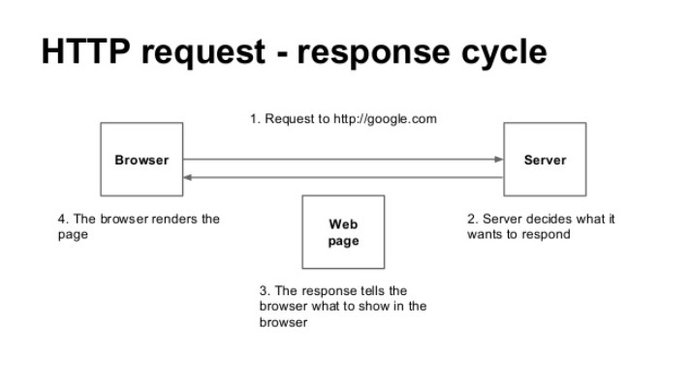

Figure 3.1: HTML request-rsponse cycle.

When developing a Rails app, the request/response cycle is a useful guide to see how all the app’s files and folders fit together. The request/response cycle traces how a user’s request flows through the app. Understanding the request/response cycle is helpful to figure out which files to edit when developing an app (and where to look when things aren’t working).

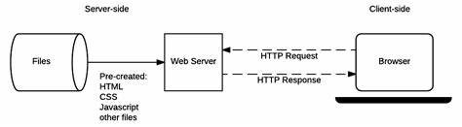

Figure 3.2: HTML request methods.

How it works:

1. A user opens their browser, types in a URL, and presses Enter.
2. When a user presses Enter, the browser makes a request for that URL.
3. The request hits the Rails router (config/routes.rb). The router maps the URL to the correctcontroller and action to handle the request.
4. The action receives the request and passes it on to the view.
5. The view renders the page as HTML.

6 The controller sends the HTML back to the browser. The page loads and the user sees it.

# Sitemap

For the layout of the pages, all the members of our group agreed to follow minimalism style ( as much as we could). Basically, the background will be white and the section’s color would be pale, additionally, the design of the pages would be simple and easy to follow, even for new customers.

In terms of the structure of the web, there will be 5 main pages including home page, blog page, shop page, about-us page and contact page. Besides, there are also login and register page for customers.

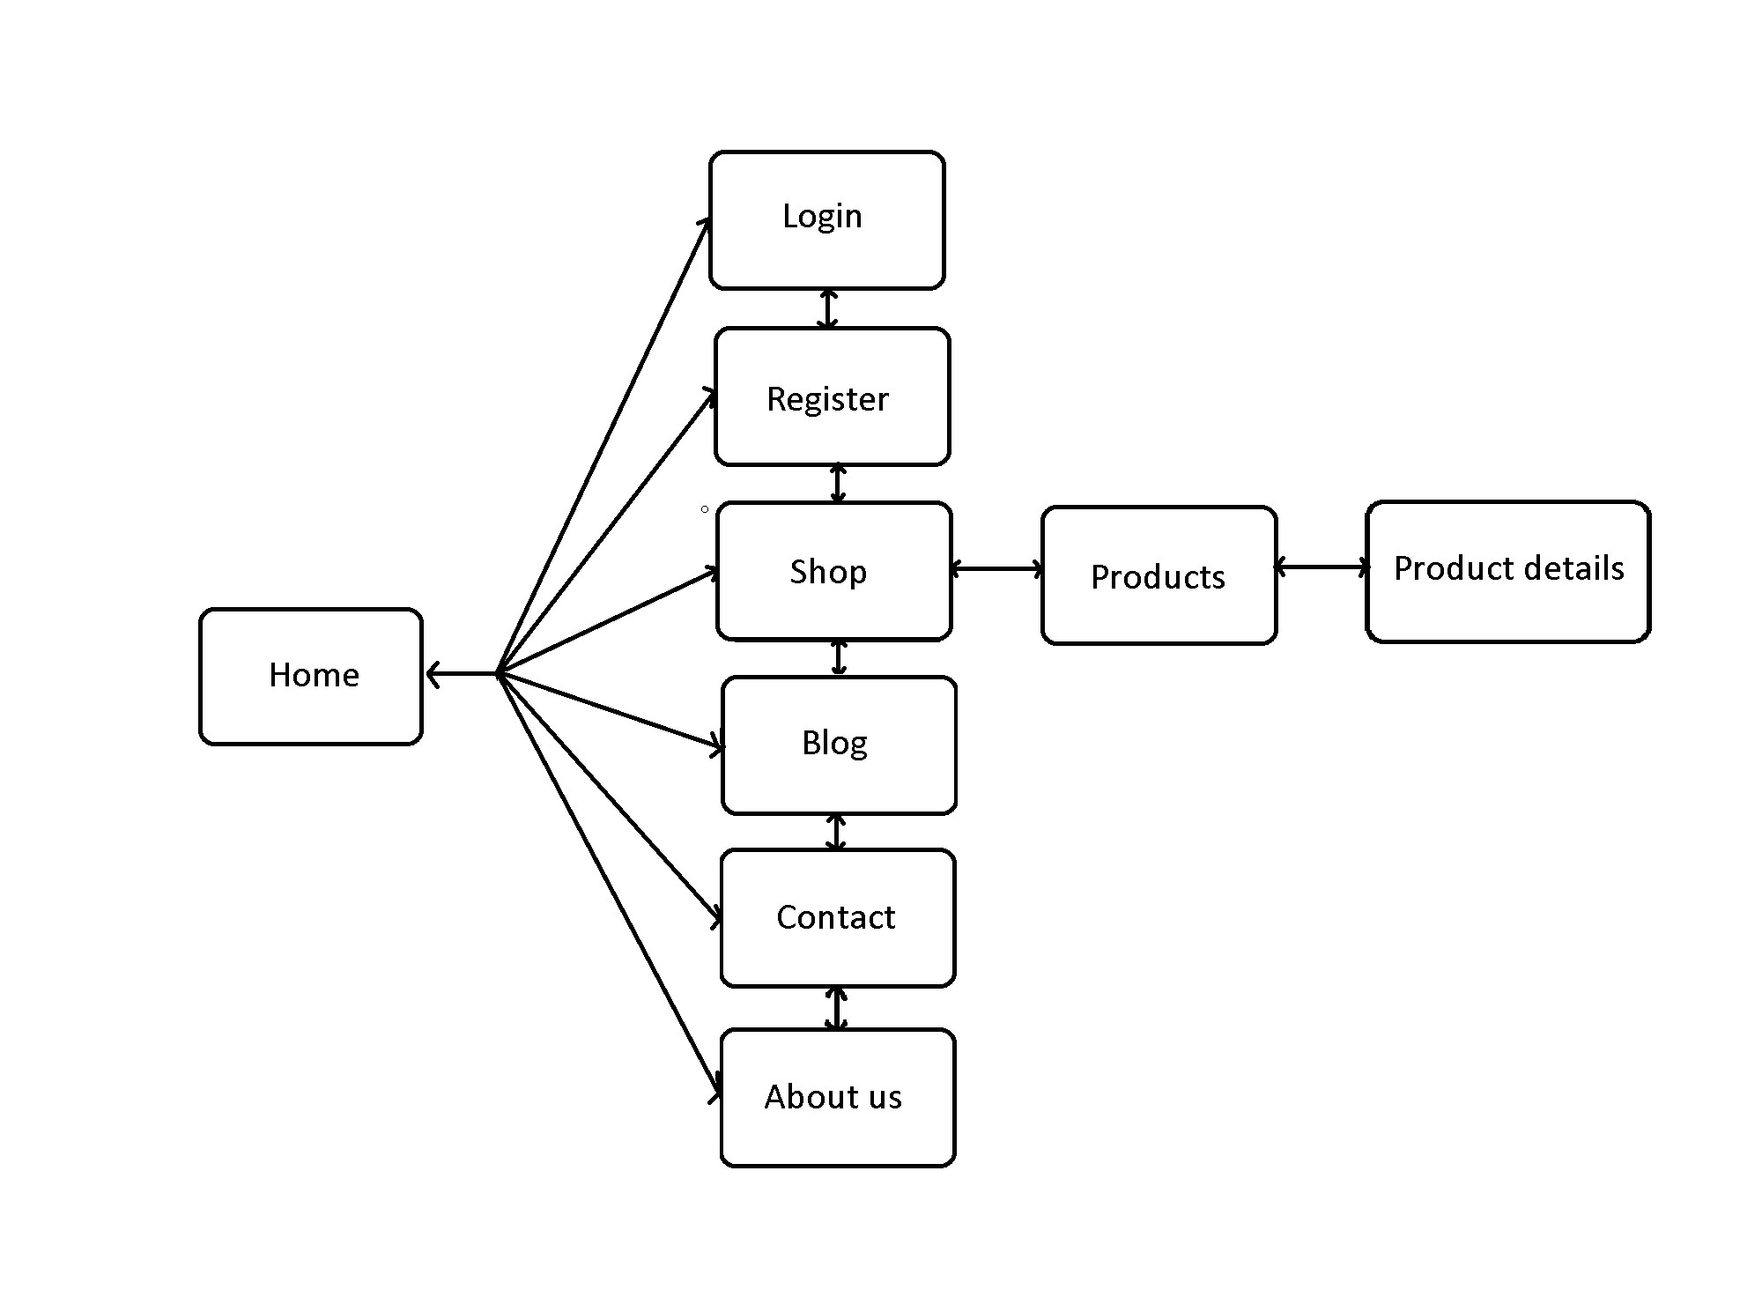

Figure 4: La imperial Website structure

# Screenshots

We have 7 pages in total and there are things to consider in each page.

## Header and footer

In header section, we have 8 clickable areas including the title, "HOME", "SHOP", "COMPARE", "CONTACT", "ABOUT US", "LOG IN" and "REGISTER" which will lead you to different pages.



Figure 5.1: Header

Below we have the footer area, we have our links turning white when hovering. And the three blocks that get you to our admin’s account like Github, Facebook and Instagram. Furthermore, we have the input area where you can send us anything you like, just for fun. When submitted, there will be an alert "Succesfully".

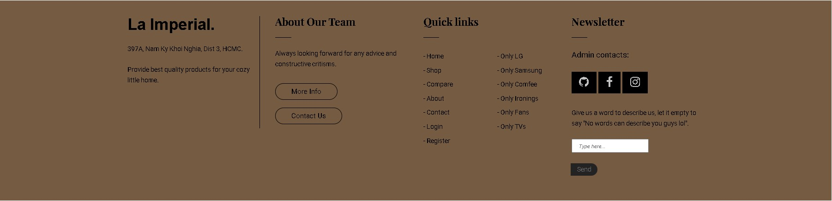

Figure 5.2: Footer

## Home page

When you click on the ">" or "<" button, a new slider will appear with its animation and product information.

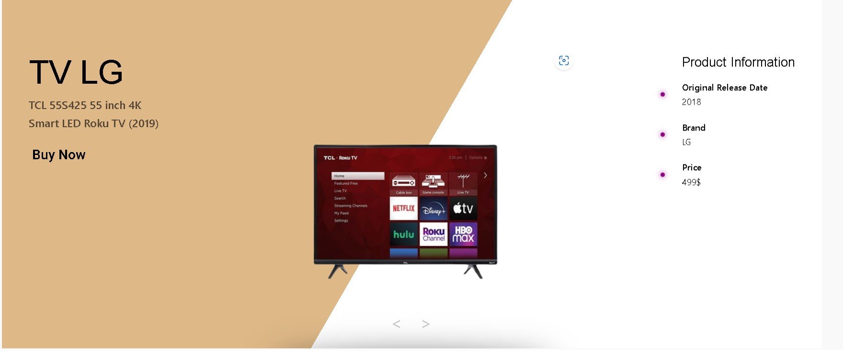

Figure 5.3: Home page’s carousel slides.

When click show all products will appear.

When you click on best sale and hot sale, the corresponding products will appear.

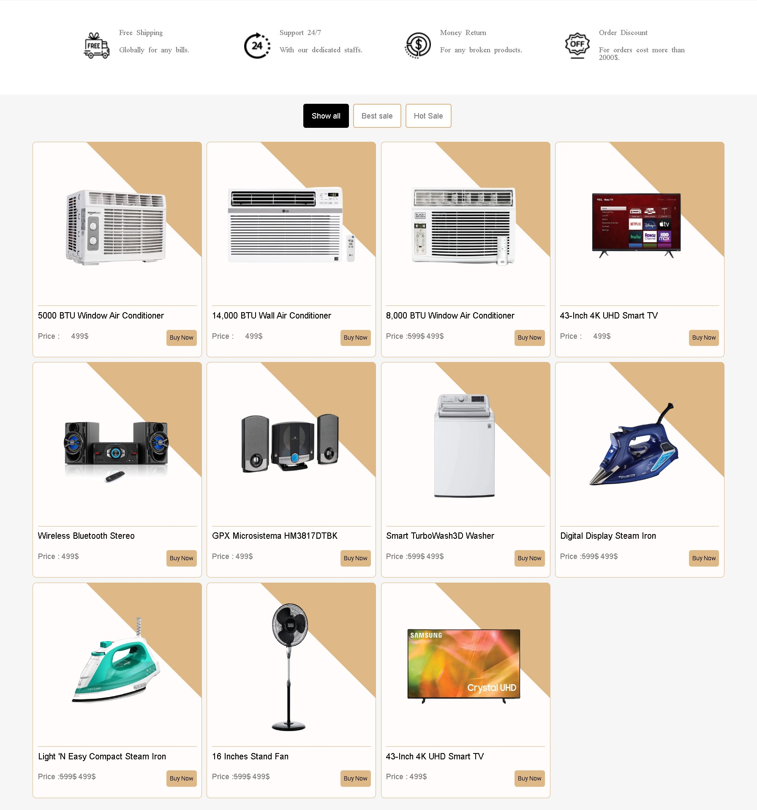

Figure 5.4: "Show all" on home page

Product sale time will decrease by time, which stands for the time left for sale products.

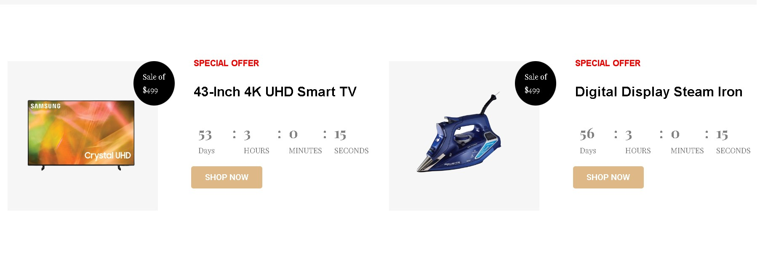

Figure 5.5: Time-decrease on home page.

## Product page and product details

At the very first sight at the product page, you can see the banner, we made it just for decoration.

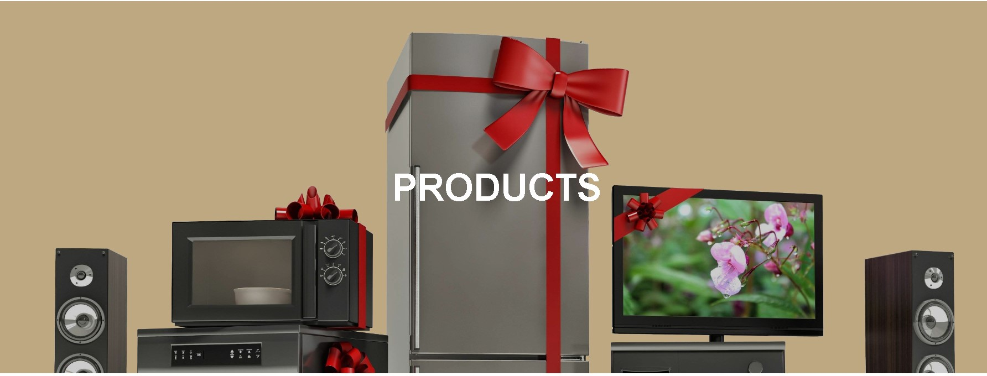

Figure 5.6: Banner of Shop page

The products will be displayed like this, when you hover over them, the buttons for more details of that product will appear.

And at the bottom there are 5 clickable buttons for you to switch between the 3 pages of the products page.

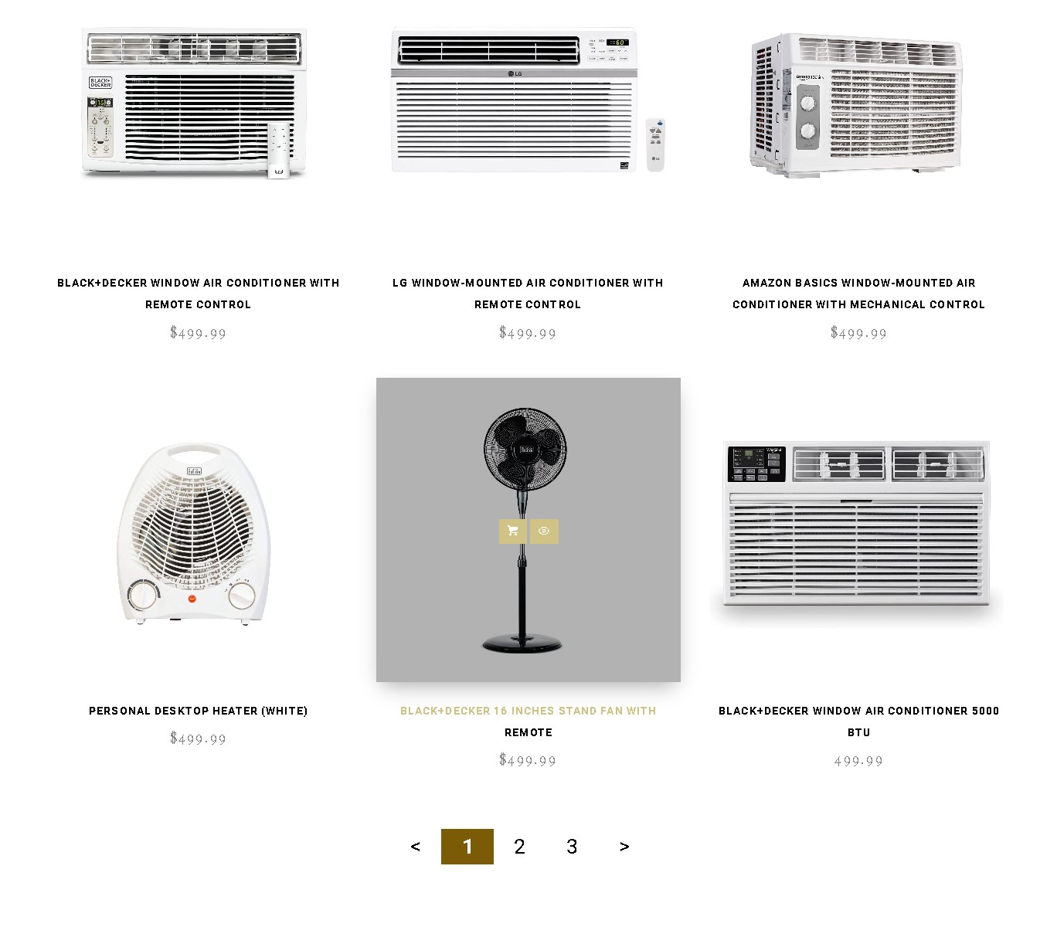

Figure 5.7: The products

In this section, you can see many brands of appliances. You should choose the products of which specific brand you want to see and the page will filter out all the proper products for you.



Figure 5.8: The brands of product

Now let’s see what we have in the product details page.

Product details page or single page is the page to display features of individual product. Basically, this page have 3 parts: product description, customer review and related items/brands part.

In order to make the page simple and informative, product description contain only a brief summary of features on the right column and the image locate on the left column provide further visual details via 4 different click selections using Java Script. For users who interest in the item, more information can be viewed/ downloaded in the link embedded below the summary paragraph. Beside, there are 2 links on top right column that will navigate user to the same appliance (ex:“Air Conditioner”) or the same brand (ex: “BLACK+DECKER”).

In the configuration part of right column, there are 3 colors and 3 choices for user to choose. Everytime user choose different color, or different choice, or different quantity, the price below will be changed according to your selection. For example, if user choose color gray, choice 1, quantity 2, the price will be changed from the standard price 499.99$ (standard combo price for white color, choice 1 and quantity 1) to 498.99$. Then, if user want to buy 2 of them, and click “Add to cart” button, a small box with inform “Buy 2 item(s) with gray color, choice 1 in total 997.98$ success!”.

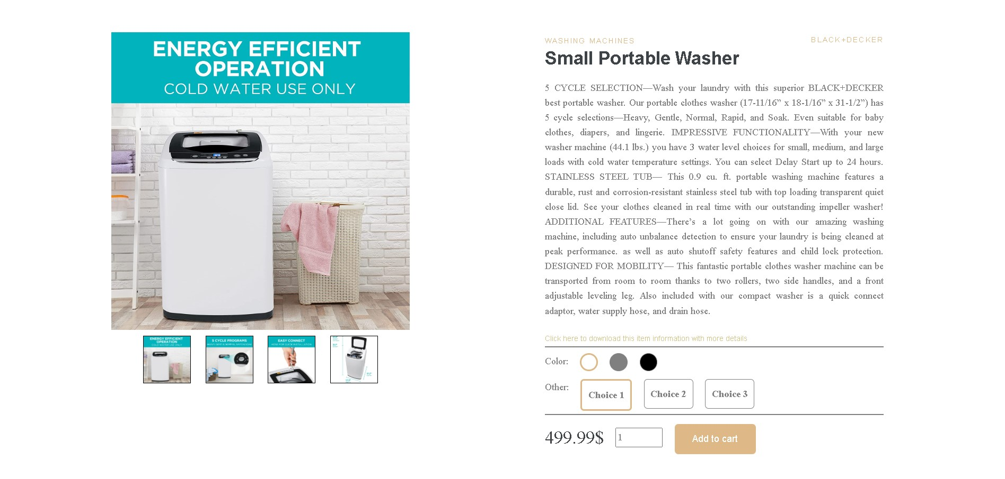

Figure 5.9: Small protable washer

One more added feature is that every time the page is loaded, the progress bar will run automatically from left to right to display the percentage of each 5 stars, 4 stars, etc. To know why old user rating for each types of stars, their comments are displayed in the “Reviews of customer” section. If user see any of them useful, he/she can hit the heart icon at the right corner. More comments will be hide unless he/she click “More Comments” button to explore more.

Below the "Review of customer" is the new comment section where user can rating stars and comment. After hitting the "Submit" button, a small box will inform how many stars you have rated and what have you commented.

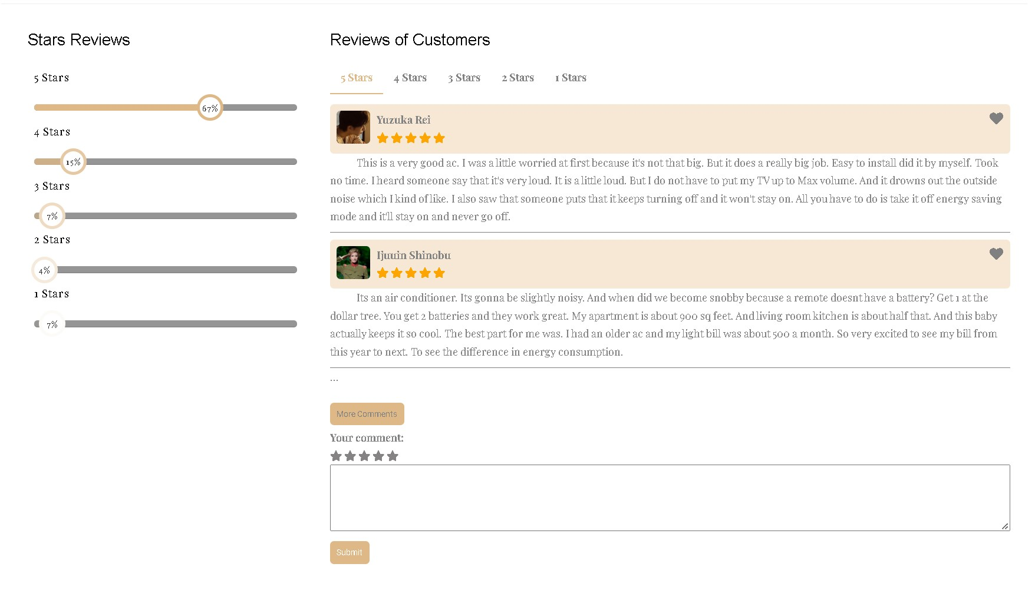

Figure 5.10: The rating and comment section

Finally, 2 carousels to suggest other products which are related to its type or brand are running automatically at the bottom of the page. To interact to those product cards inside these sliders, user only have to hover to the product card they are interest in, the carousel will be stopped, and that specific product card will be enlarged more than the others. If user continue to hover to its image, the image will be shaked and a “Buy me” dialog will be displayed on top of it. Then, to know more about the product, just click the price button and user will be navigated to that item’s product detail page. But this cant be done for unavailable/sold out product cards. The purpose of sold out product cards is just to make the carousel longer, so that user can have an overview that carousels can run automatically and can be controlled by left and right arrows.

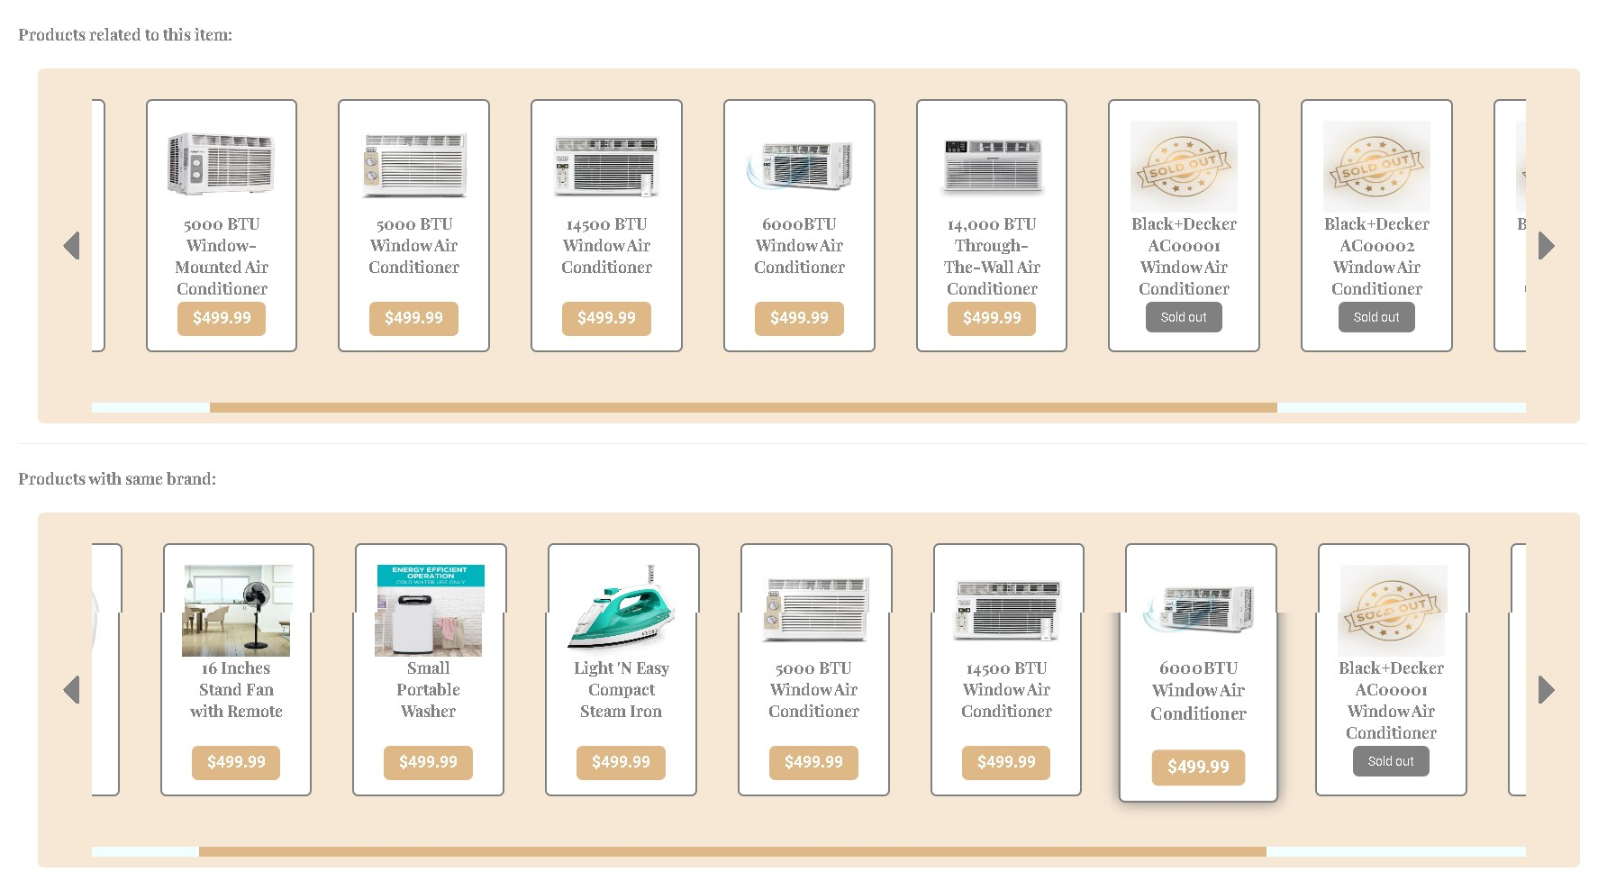

Figure 5.11: The slides of products

Besides, we also made a different footer for these product details because we want to collect some feedbacks of customers.

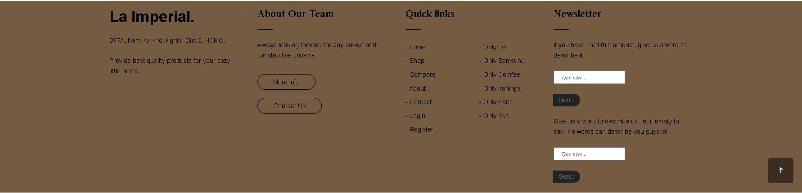

Figure 5.12: Footer for product details

## Compare

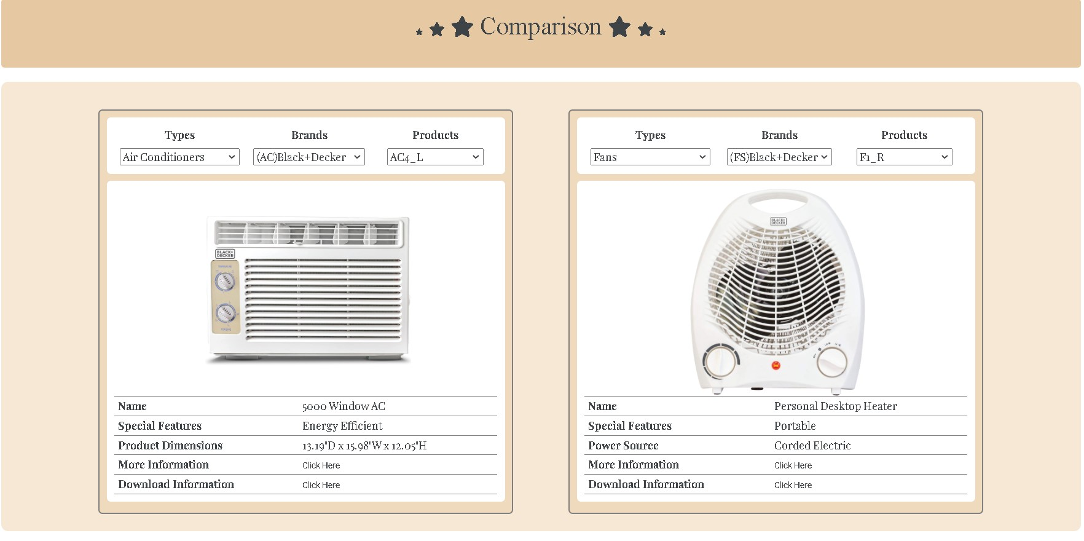

Figure 5.13: Compare page.

According to the requirement specification number 7 of the e-project, i have made a separate compare page for user to compare between 2 items they have chosen each time by types, dependent brands and the dependent products. For each items, there will be a link for more information which leads to item’s product detail page, and a link to download information which help user download the word document with more details, too.

## Contact



Figure 5.14: Contact page

This is the banner for contact-us page.

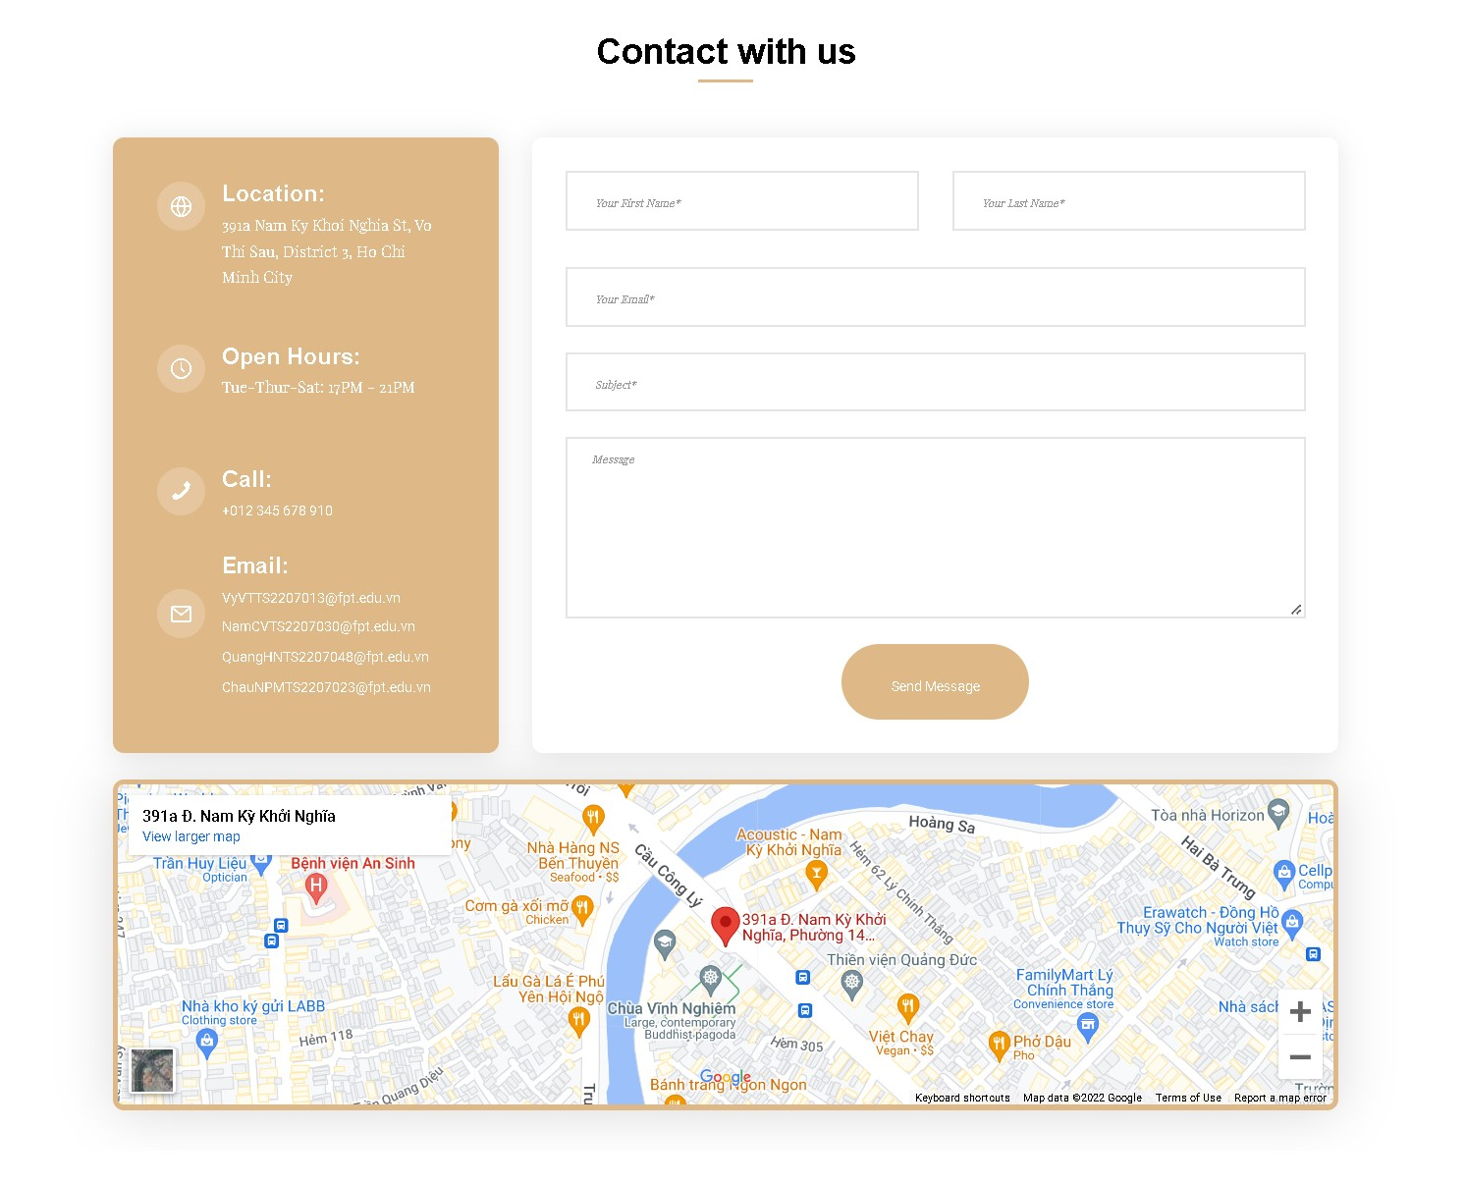

Figure 5.15: Contact page

As you can see, in this page we can input information, we have made suitable retrictions for each blanks. And the google map here as required in the given mail.

## About us

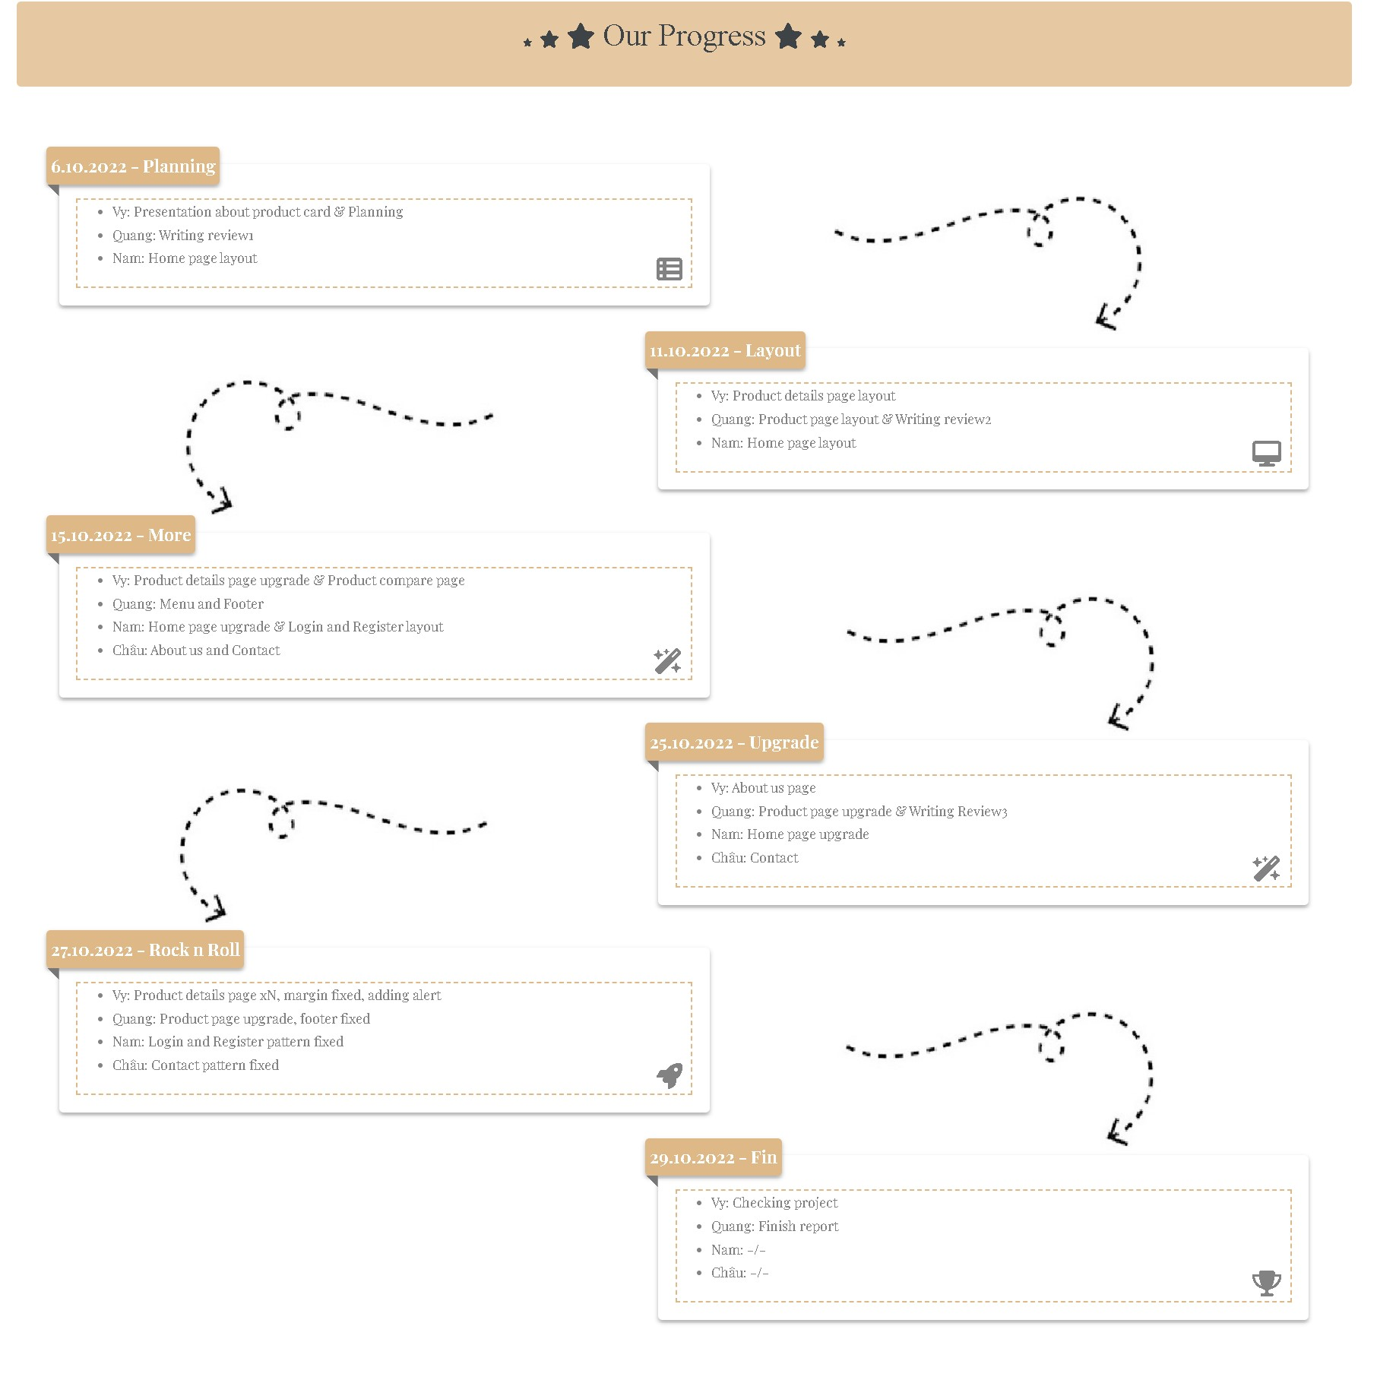

Figure 5.16: About-us progess part

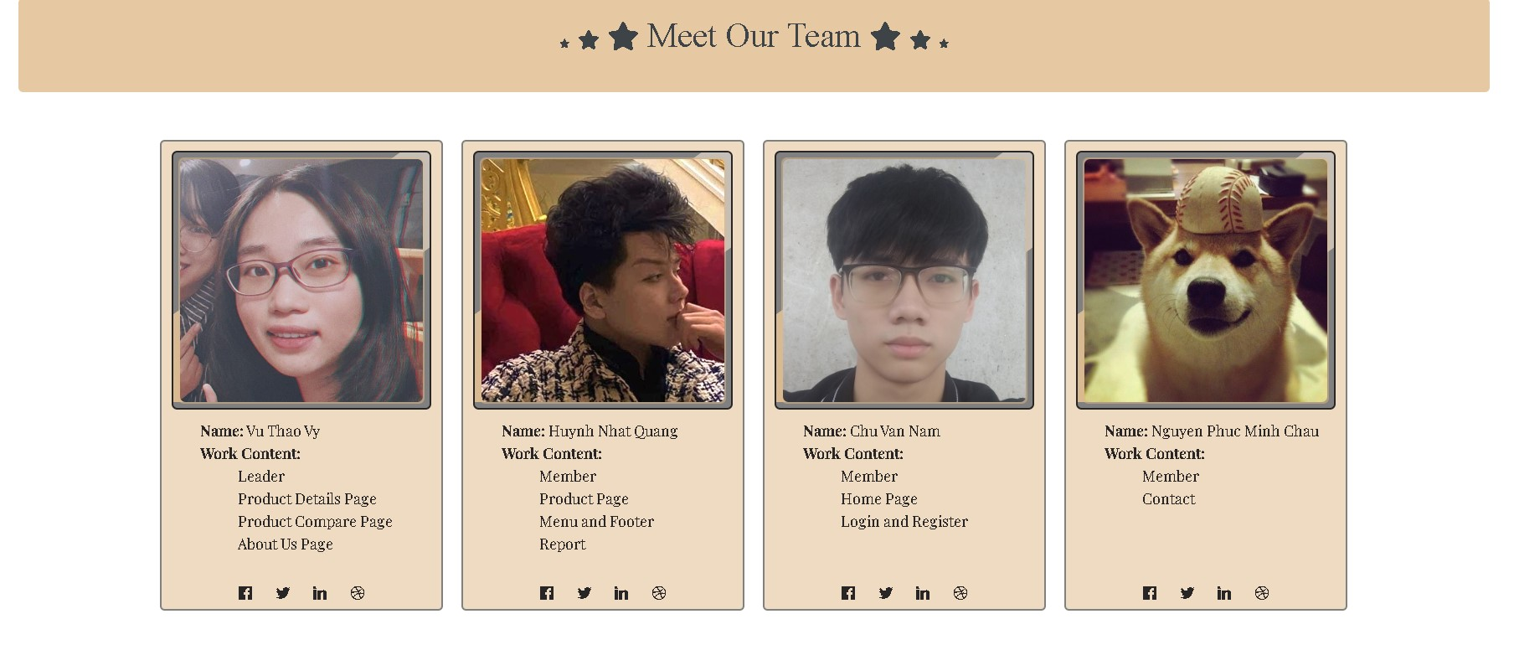

Figure 5.17: About-us member’s details part

The About us page has 2 parts: Our progress part, which describes how we schedule our timeline to finish this project, and “Meet our team” part, which show our team biography. The borders of our images are running around automatically to highlight our avatars.

## Login / Register

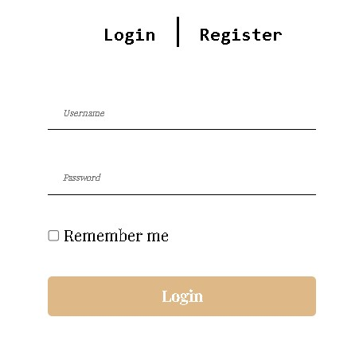

Figure 5.18: Login page

Login page we have some restrictions for each blanks.

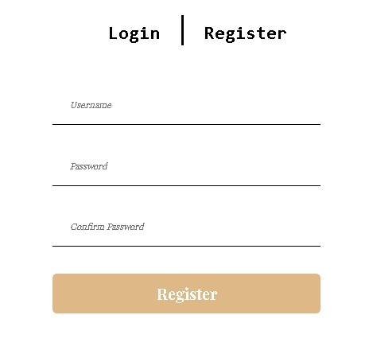

Figure 5.19: Register page

As well as register page we have some restrictions for each blanks.

And this is the end of our report, we really appreciate your time and effort in reading this and in checking our work.

Best wishes.