STAT 5350

Forecasting Methods for Management

HW5

1. The plot for the Returns vs Time has been plotted below,

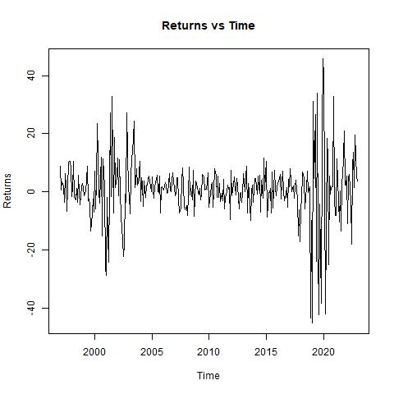

From sources across the internet including nytimes.com which is free for Penn students, we can conclude that the two bankruptcies of Pacific Gas and Electric (PG&E) in 2001 and 2019, as well as the high volatility of their stock returns during these periods, can be attributed to a combination of regulatory, environmental, financial, and operational factors.

In the mid-1990s, California embarked on an ambitious experiment to deregulate its electricity market. The goal was to create a more competitive environment that would lower the prices for consumers. Under this new system, utilities like PG&E were required to sell off their power generation facilities and buy electricity from the open market to sell to their customers. The expectation was that market forces would drive down prices.

As time passed, the situation began to unravel. Energy demand in California was increasing, but the supply was not keeping up. There are several factors that contributed to this imbalance. The booming of the tech industry led to a rise in demand for electricity. The most famous being apple and Sony PlayStation. Long queues spanning across multiple streets would wait to purchase these products and the craze was quite high.

There wasn’t any significant investment in new powerplants which resulted in a low generation capacity.

Energy companies, most notably Enron, began to manipulate the market. They would create artificial shortages by shutting down power plants for "maintenance," causing prices to spike.

PG&E was now forced to buy power at fluctuating market rates but sell it at fixed rates set by regulators. They found themselves in an increasingly troublesome financial position.

Since they could not pass down on the increased costs to its customers, they accumulated billions in debt and their credit rating also plummeted, which made it incredibly expensive for them to borrow money.

By April 2001, PG&E filed for bankruptcy, more specifically Chapter 11 bankruptcy protection. It was one of the largest utility bankruptcies in U.S. history. The bankruptcy filing was a clear indication of the failure of the energy deregulation experiment in California.

This event contributed to increased public scrutiny of both utility companies and energy market regulation. It prompted a re-examination and overhaul of energy regulations in California as PG&E set out on their journey of financial restructuring.

In 2017 and 2018, California faced some of the most devastating wildfires in its history. The Camp Fire of November 2018, in particular, marked a tragic milestone as the deadliest and most destructive wildfire in California's history.

Investigations into these fires revealed that PG&E's equipment was responsible for igniting several of them, including the catastrophic Camp Fire. These findings were rooted in a couple of critical issues- aging infrastructure and vegetation management. PG&E's electrical infrastructure, some of which were decades old, had not been adequately maintained or upgraded and the company had also failed in some areas to properly manage vegetation around power lines, which is crucial in fire-prone regions.

The revelation of PG&E's equipment's role in the wildfires opened the floodgates to legal troubles. The company faced a barrage of lawsuits from fire victims, insurers, and local governments. The potential liabilities were staggering, running into tens of billions of dollars, far exceeding PG&E's insurance coverage.

PG&E, faced with insurmountable liabilities, filed for Chapter 11 bankruptcy protection in January 2019. This filing was a strategic move to manage its liabilities and reorganize its finances. The bankruptcy marked one of the first major financial casualties directly linked to climate change-induced natural disasters. This reminds me a lot about the Bhopal gas tragedy in India where safety was not given a high priority. People far away travelling in trains were collapsing and they had no idea what was happening. It was the gas that had diffused to such distances and poisoned them.

Consequently, PG&E committed to significant operational changes, including upgrading its infrastructure and improving its vegetation management practices. The company came under intense regulatory scrutiny, with calls for more stringent oversight of utility companies' safety practices. The crisis ignited a debate in California over the structure of the utility industry, with some advocating for public ownership or more decentralized power generation models.

The high volatility returns can be sufficiently explained by these three reasons- market sensitivity to regulatory and environmental issues, uncertainty and risk and speculative trading.

The utility sector, particularly in a state like California with evolving environmental and regulatory landscapes, is highly sensitive to such changes. As such, the stock market reacts strongly to both perceived and real risks in this sector.

Both bankruptcies introduced significant uncertainty about PG&E's future, impacting investor confidence and leading to high volatility. The potential for large-scale liabilities, regulatory changes, and operational disruptions contributed to this uncertainty.

During times of crisis or significant corporate events, stocks often attract speculative trading, which can increase volatility. Traders looking to capitalize on rapid price movements can exacerbate this effect.

2. First, we will take a closer look at the returns data by plotting a normal quantile plot.

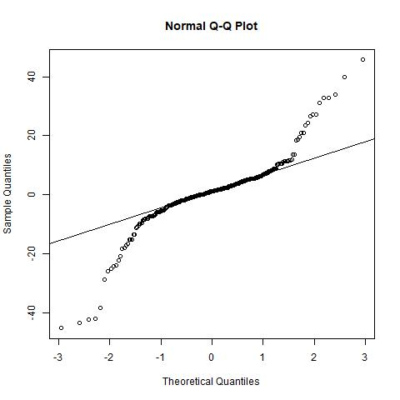

The normal quantile plot of the returns data has been plotted above. The data distribution is obviously non-normal and the values of kurtosis and skewness are,

> kurtosis(r1)

[1] 8.547033

> skewness(r1)

[1] -0.4160099

Let us now take a look at its acf and pacf plots. The plots are enlarged because it was occupying the whole page anyways.

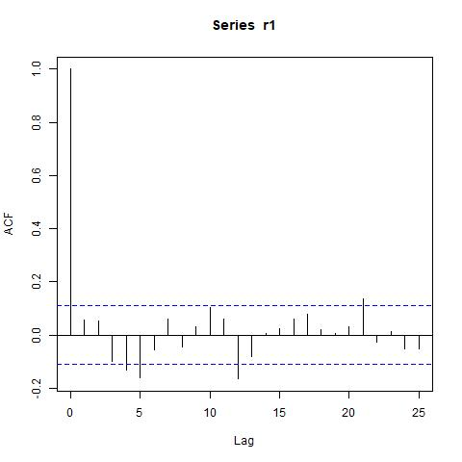

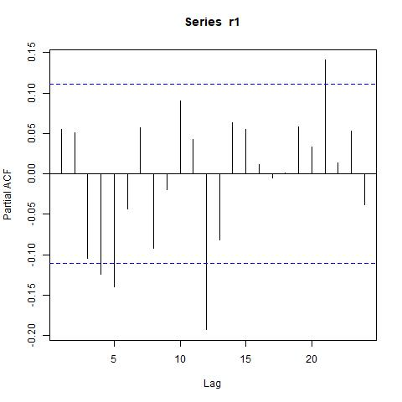

We can see that there are a few significant lag variables and they are lags 4,5,12 and 21.

We make use of the ARIMA(5,0,0)(3,0,0)4 to address the partial autocorrelations at lags 4,5 and 12.

We ran library(“lmtest”) and utilised its coeftest on this ARMA model.

We then proceeded to perform the residual analysis of this model.

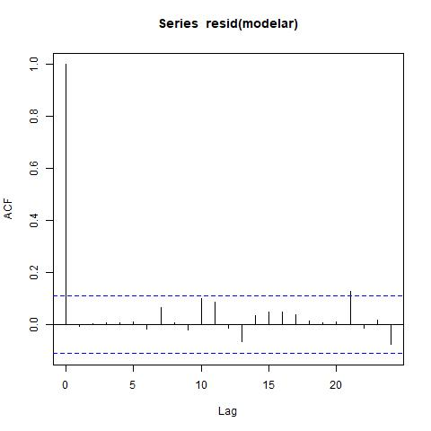

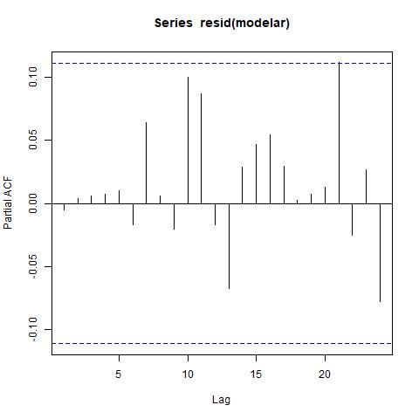

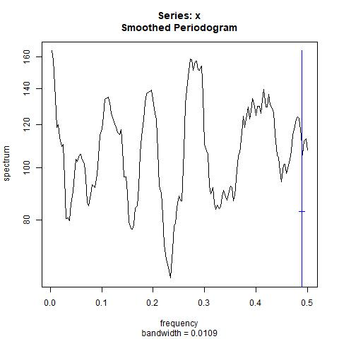

We can see that the partial autocorrelations at lags 4,5 and 12 have come down and even lag 21 is just barely sticking out. This is why this model was chosen.

The bartlettB test was performed on the residuals and we obtained a very good value of 0.9993 and it is not rejecting the null hypothesis of white noise.

However, the kurtosis value is still high at 8.23.

> kurtosis(resid(modelar))

[1] 8.238266

> skewness(resid(modelar))

[1] -0.8998409

We now plot the squared ARIMA residuals to see if there is any volatility structure that requires modelling.

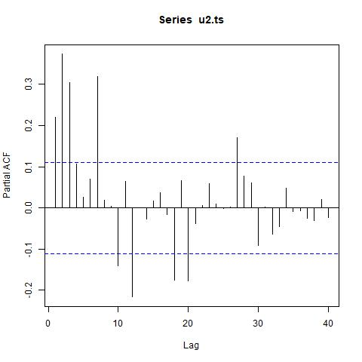

We can certainly see some structure in the squared residuals. So, we start fitting a GARCH(1,1) model to capture the changing volatility as instructed in the question.

Most importantly, we should remember to fit it to the time series of the residuals of the ARMA model and not the squared residuals.

The code where I fit the GARCH(1,1) model and its summary is given below,

> u.ts<-ts(resid(modelar))

> library("fGarch")

> modelgarch11<-garchFit(~garch(1,1),data=u.ts,trace=FALSE)

> summary(modelgarch11)

Title:

GARCH Modelling

Call:

garchFit(formula = ~garch(1, 1), data = u.ts, trace = FALSE)

Mean and Variance Equation:

data ~ garch(1, 1)

<environment: 0x00000171c9e73a20>

[data = u.ts]

Conditional Distribution:

norm

Coefficient(s):

mu omega alpha1 beta1

0.35508 2.05564 0.17931 0.81285

Std. Errors:

based on Hessian

Error Analysis:

Estimate Std. Error t value Pr(>|t|)

mu 0.35508 0.37462 0.948 0.3432

omega 2.05564 0.95232 2.159 0.0309 \*

alpha1 0.17931 0.04174 4.296 1.74e-05 \*\*\*

beta1 0.81285 0.03405 23.873 < 2e-16 \*\*\*

---

Signif. codes: 0 ‘\*\*\*’ 0.001 ‘\*\*’ 0.01 ‘\*’ 0.05 ‘.’ 0.1 ‘ ’ 1

Log Likelihood:

-1080.418 normalized: -3.462878

Description:

Tue Dec 19 02:18:29 2023 by user: vyaas

Standardised Residuals Tests:

Statistic p-Value

Jarque-Bera Test R Chi^2 519.9982870 0.000000e+00

Shapiro-Wilk Test R W 0.9456791 2.601892e-09

Ljung-Box Test R Q(10) 9.7069847 4.665657e-01

Ljung-Box Test R Q(15) 19.5177475 1.912230e-01

Ljung-Box Test R Q(20) 20.8280239 4.073165e-01

Ljung-Box Test R^2 Q(10) 3.1927759 9.765163e-01

Ljung-Box Test R^2 Q(15) 18.0965727 2.576225e-01

Ljung-Box Test R^2 Q(20) 19.5355471 4.872994e-01

LM Arch Test R TR^2 4.9782407 9.587018e-01

Information Criterion Statistics:

AIC BIC SIC HQIC

6.951398 6.999385 6.951075 6.970577

Now, we will proceed to plot the residuals and compute the kurtosis and skewness.

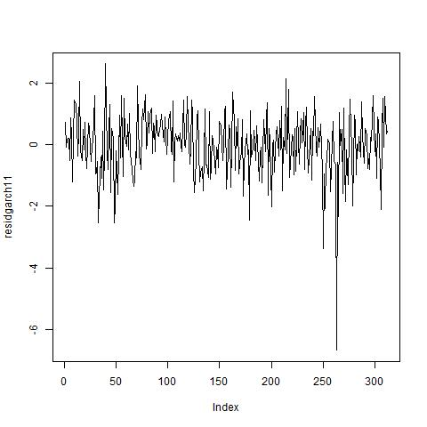

The kurtosis of these residuals is still very high. But from the 5th December notes, it was explained that having one residual outlier in the results of our model need not be a big worry or a concern. When the model is fitting well overall, it will do a pretty good job in forecasting and the current model is more than enough. In fact, removing that outlier gives the following kurtosis,

> kurtosis(residgarch11[-263]) #263 is the outlier.

[1] 3.373839

We can see that the kurtosis is very close to 3 and is at 3.37, which is very close to normality. All the estimated parameters are positive and the sum of the last two, i.e., alpha1 and beta1, is equal to 0.992 which is less than 1 as well.

The residual plot shows that the GARCH(1,1) model did a very good job in capturing the volatility structure. The standardised residuals exhibit very little changing volatility.