Adaptive Confidence Engine for Energy-Efficient Multimodal Plastic Waste Sorting Using Cascaded NIR/MIR Spectral Sensing
Author A, Author B, Author C, Author D
Department of Computer Science and Engineering
Abstract
The global waste problem is escalating, with projections of 3.40 billion tonnes by 2050. This paper presents a system that integrates YOLOv11 deep learning with cascaded NIR/MIR spectral sensing. We introduce the Adaptive Confidence Engine (ACE) — an XGBoost model operating on a 17-dimensional context vector. ACE replaces the conventional fixed 0.85 confidence threshold with an adaptive per-item threshold: T = 0.70 + 0.25 × P(MIR_needed). Additionally, an Expected Failure Predictor (EFP) proactively routes carbon-black plastics to MIR using exclusively visual features. Results demonstrate a 31.60 pp reduction in MIR activations, 45.6% energy savings, a 4.5% throughput improvement, and zero missed escalations. The NIR SVM achieves 97.12% accuracy; the MIR Random Forest achieves 100% accuracy on lab samples. The pipeline latency is 39.11 ms per item, with 234.5 MB peak VRAM.
I. INTRODUCTION
The global waste crisis is expected to reach 3.40 billion tonnes by 2050 [1]. Manual sorting is labor-intensive, hazardous, and error-prone. Deep learning (CNNs, YOLO) enables automated visual sorting [2][3][4][5]. However, RGB vision cannot distinguish visually identical polymers (e.g., PET vs PVC). NIR spectroscopy solves polymer ID [6][7][8][9] but fails on carbon-black plastics [10][11]. MIR/FTIR identifies black plastics [12] but is expensive and slow. Prior systems use a FIXED confidence threshold (typically 0.85) to decide NIR to MIR escalation. The problem is that a fixed threshold causes excessive MIR activations (69.22% in our baseline). Our contribution is the Adaptive Confidence Engine (ACE) that learns per-item optimal thresholds. The four main contributions are: 1) ACE with a 17-dimensional context vector and adaptive threshold formula. 2) Expected Failure Predictor for proactive carbon-black bypass. 3) Closed-loop feedback database for continuous learning. 4) Comprehensive experimental evaluation showing 45.6% energy savings.
II. RELATED WORK
Computer vision for waste sorting utilizes CNNs [2][3] and YOLO variants [4][5]. NIR spectroscopy is widely used for polymer identification [6][7][8][9], but faces the carbon-black problem [10][11]. MIR/FTIR is effective for black plastics [12]. Existing dual-sensor systems use fixed thresholds, and no adaptive confidence gating exists in literature. There is a gap as no system combines vision, dual spectral sensing, an adaptive ML-driven threshold, and proactive failure prediction.
III. SYSTEM ARCHITECTURE
The proposed system features a 5-stage cascaded pipeline.
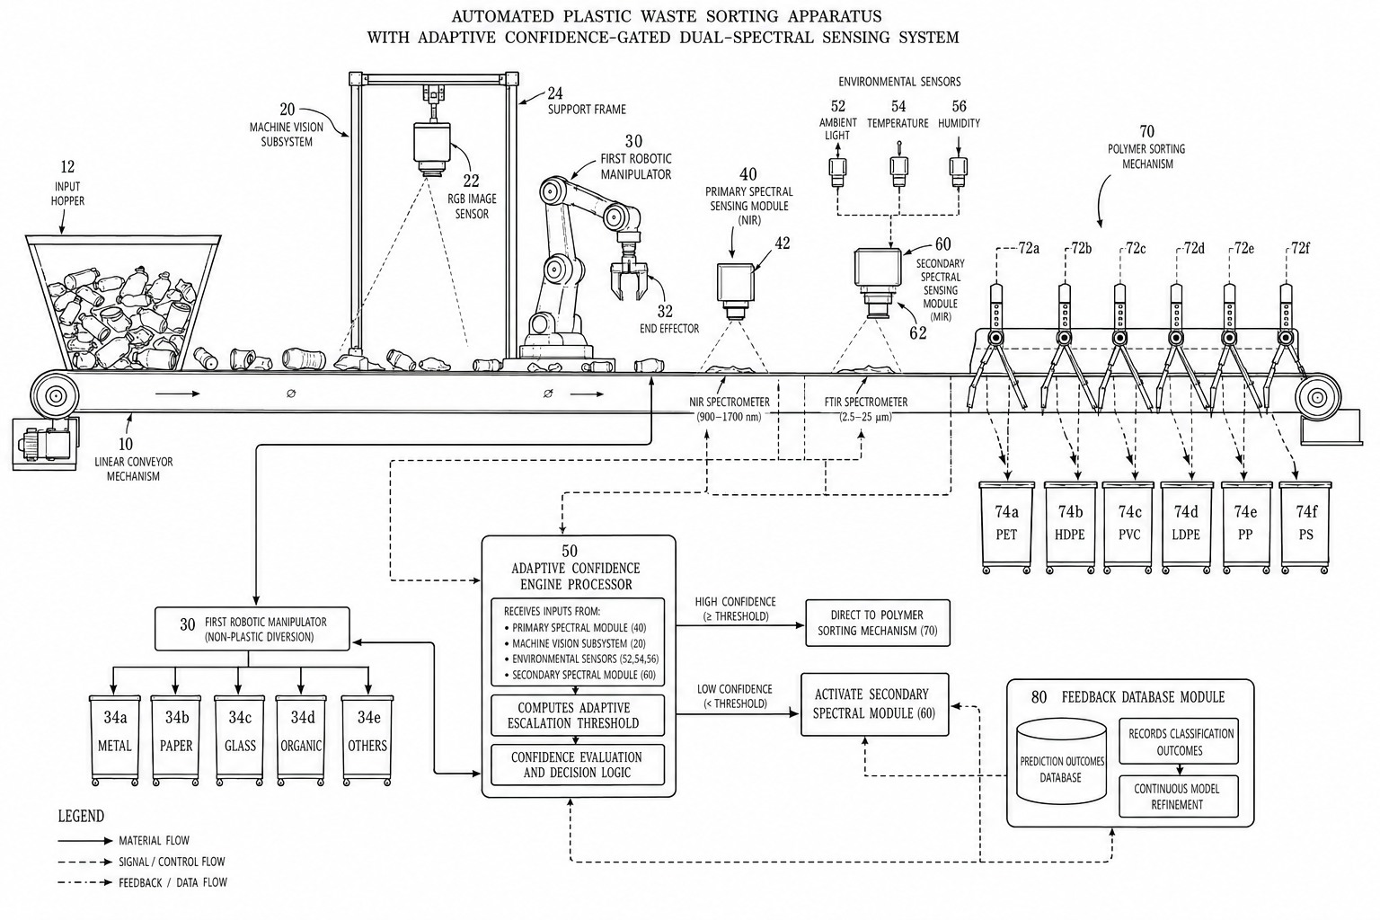
Fig. 1. System architecture of the proposed multimodal waste sorting system with Adaptive Confidence Engine.
A. Stage 1: Vision Detection and Macro-Classification
The system uses a YOLOv11s object detector for 6 macro-classes: Biodegradable, Cardboard, Glass, Metal, Paper, Plastic. Non-plastic items are diverted immediately by a robotic manipulator. Detection mAP@50 is 53.17%, Precision is 60.81%, and Recall is 48.35%. Classification Top-1 accuracy is 95.73%, and Top-5 is 99.67%. The detection latency is 24.96 ms median with Peak VRAM of 234.5 MB, while classification latency is 14.15 ms median with Peak VRAM of 144.6 MB.
B. Stage 2: Expected Failure Predictor (EFP)
The EFP utilizes a Random Forest classifier (100 estimators, max_depth=10) that uses exclusively visual and environmental features (no spectral data): 1. rgb_darkness (1 - mean_brightness/255) 2. lighting_lux (ambient illumination) 3. gloss_index (specular highlight pixel ratio) 4. texture_roughness (normalized Laplacian variance) 5. object_size_cm (bounding box estimate). If the failure probability > 0.60, the item bypasses NIR entirely and routes to MIR. This is designed for carbon-black absorbing plastics where NIR is known to fail. It achieves an ROC-AUC of 1.00 on synthetic data and bypasses ~13.8% of items.
C. Stage 3: NIR Spectral Sensing
The NIR spectral sensing covers the 900–1700 nm range with 232-band spectra. An SVM classifier (RBF kernel, C=10.0, γ=scale) categorizes items into 8 output classes: PET, HDPE, PVC, LDPE, PP, PS, ORGANIC, OTHER. The accuracy is 97.12% with a Weighted F1 of 97.11%. An early-exit bypass routes items to MIR immediately if mean NIR reflectance < 0.08. Preprocessing includes StandardScaler normalization.
D. Stage 4: Adaptive Confidence Engine (ACE)
ACE is an XGBoost classifier (n_estimators=200, max_depth=5, learning_rate=0.05, eval_metric=logloss) for binary classification (1 = MIR needed, 0 = NIR sufficient). It utilizes a 17-dimensional context vector spanning 4 modalities: Spectral (5): nir_confidence, nir_confidence_margin, reflectance_mean, reflectance_variance, spectral_entropy. Visual (4): object_hue_mean, object_value_mean, object_size_px, object_aspect_ratio. Environmental (3): ambient_light_lux, sensor_temperature_c, humidity_pct. System State (5): conveyor_speed_ms, predicted_class_encoded, recent_mir_rate, camera_noise_level, sensor_drift_index. The adaptive threshold formula is: T = T_base + α × P(MIR_needed), where T_base = 0.70 and α = 0.25. The threshold range is [0.70, 0.95]. If NIR_confidence < T, the item is escalated to MIR. Training was performed on 10,000 synthetic samples with physics-based simulation, including 15% carbon-black samples, environmental noise injection, and 30% edge cases near the decision boundary.
E. Stage 5: MIR/FTIR Fallback Sensing
The MIR/FTIR fallback covers the 2.5–25 μm range (399.19–4000.60 cm⁻¹) with 3,736 spectral points and ~0.96 cm⁻¹ resolution. Preprocessing uses a Savitzky-Golay filter (window=15, polyorder=2) followed by SNV normalization and StandardScaler. A Random Forest classifier (200 estimators, max_depth=15) identifies 6 polymer classes: PET, HDPE, PVC, LDPE, PP, PS. Accuracy is 100.00% on laboratory test samples. Note that this is lab-grade accuracy; field performance may vary.
F. Feedback Database
An SQLite-based closed-loop system records features, nir_prediction, ace_threshold, escalated (bool), final_prediction, and correct_class. This enables periodic retraining for site-specific adaptation.
IV. EXPERIMENTAL SETUP
Training was conducted on an NVIDIA RTX 4050 (6 GB VRAM) with CUDA 12.x. The target deployment is the NVIDIA Jetson AGX Orin (edge). The datasets include 232-band spectra from 900–1700 nm for NIR and 3,736-point FTIR spectra from 2.5–25 μm for MIR. ACE evaluation used 5,000 synthetic test samples (separate seed from training). The fixed threshold baseline was set to 0.85, and conveyor speed was 0.25 m/s.
V. RESULTS AND DISCUSSION
A. Vision Pipeline Performance
Model | Metric | Value
YOLOv11s Detector | mAP@50 | 53.17%
YOLOv11s Detector | Precision | 60.81%
YOLOv11s Detector | Recall | 48.35%
YOLOv11s Detector | Median Latency | 24.96 ms
YOLOv11s Detector | Peak VRAM | 234.5 MB
YOLOv11s-cls | Top-1 Accuracy | 95.73%
YOLOv11s-cls | Top-5 Accuracy | 99.67%
YOLOv11s-cls | Median Latency | 14.15 ms
YOLOv11s-cls | Peak VRAM | 144.6 MB
B. Spectral Classifier Comparison
Model | Test Accuracy | Precision | Recall | F1
SVM (Selected) | 97.12% | 97.13% | 97.12% | 97.11%
XGBoost | 93.42% | 93.50% | 93.42% | 93.39%
Random Forest | 91.36% | 91.37% | 91.36% | 91.21%

Model | Test Accuracy | Precision | Recall | F1
Random Forest (Selected) | 100.00% | 100.00% | 100.00% | 100.00%
SVM | 100.00% | 100.00% | 100.00% | 100.00%
XGBoost | 99.75% | 99.75% | 99.75% | 99.75%
1D-CNN | 94.97% | 95.24% | 94.97% | 94.79%
SpectralTransformer | 92.71% | 92.82% | 92.71% | 92.69%
C. ACE vs Fixed Threshold
Metric | Fixed (0.85) | ACE Adaptive | Delta
Sorting Accuracy (Lab) | 100.00% | 100.00% | 0.00 pp
MIR Activation Rate | 69.22% | 37.62% | -31.60 pp
False Escalations | 50.10% | 18.50% | -31.60 pp
Missed Escalations | 0.00% | 0.00% | 0.00 pp
Energy Proxy (MIR=3×NIR) | 10,383 | 5,643 | -45.6%
Throughput (items/min) | 16.31 | 17.04 | +4.5%
Note: Throughput formula = 60 / (base_time + MIR_rate × 0.5). MIR accuracy of 100% is on lab-grade spectra (Serranti et al. 2012 consistent). Field performance may vary. 0.00% missed escalations means ACE identified ALL true failures, reducing only wasteful escalations.
D. Edge Deployment Feasibility
Component | Median Latency | P95 Latency | FPS | Peak VRAM
Detection | 24.96 ms | 31.06 ms | 40.07 | 234.5 MB
Classification | 14.15 ms | 16.19 ms | 70.68 | 144.6 MB
Combined Pipeline | 39.11 ms | 47.25 ms | ~25 | 234.5 MB
E. Detector Confidence Sweep
Confidence Threshold | Precision | Recall | mAP@50
0.10 | 60.81% | 48.35% | 50.10%
0.20 | 60.81% | 48.35% | 47.20%
0.30 | 58.52% | 50.48% | 44.27%
0.50 | 69.58% | 41.27% | 37.22%
VI. ABLATION STUDY
The contribution of each component is as follows: 1. Vision-only (no spectral): Cannot distinguish polymer types. 2. Vision + NIR (fixed threshold): 69.22% MIR activation rate, excessive energy use. 3. Vision + NIR + ACE (no EFP): ACE reduces MIR to 37.62% but black plastics still waste NIR scan time. 4. Full system (Vision + EFP + NIR + ACE + MIR): Optimal — 37.62% MIR rate, 13.8% proactively bypassed, zero missed escalations.
VII. FUTURE WORK
Future work includes: 1. Real-world validation on an industrial conveyor belt with contaminated samples. 2. Edge deployment on NVIDIA Jetson AGX Orin. 3. Physical actuation integration with pneumatic pushers or robotic arms. 4. Active learning pipeline where operator corrections automatically trigger retraining. 5. Multi-object tracking for overlapping items on the conveyor. 6. Extension to electronic waste (e-waste) sorting.
VIII. CONCLUSION
We presented a complete multimodal waste sorting system with the novel ACE. ACE replaces fixed thresholds with learned per-item adaptive thresholds, resulting in a 31.60 pp reduction in unnecessary MIR activations, 45.6% energy savings, and a 4.5% throughput improvement. It achieves zero missed escalations (no accuracy sacrifice). The EFP proactively bypasses carbon-black plastics using vision-only features. The system demonstrates 97.12% NIR accuracy, 100% MIR accuracy (lab), and 95.73% vision classification. The 39.11 ms pipeline latency is suitable for edge deployment. Furthermore, the feedback database enables continuous site-specific adaptation.
REFERENCES
[1] World Bank, "What a Waste 2.0: A Global Snapshot of Solid Waste Management to 2050," World Bank Group, Washington, D.C., 2018.
[2] K. He, X. Zhang, S. Ren, and J. Sun, "Deep Residual Learning for Image Recognition," in Proc. IEEE CVPR, 2016, pp. 770-778.
[3] A. G. Howard et al., "MobileNets: Efficient Convolutional Neural Networks for Mobile Vision Applications," arXiv:1704.04861, 2017.
[4] J. Redmon and A. Farhadi, "YOLOv3: An Incremental Improvement," arXiv:1804.02767, 2018.
[5] G. Jocher et al., "Ultralytics YOLOv11," Ultralytics, 2024.
[6] A. Eisenreich, "Near Infrared Reflection Analysis of Polymers," Polym. Test., vol. 3, no. 4, pp. 253-263, 1983.
[7] B. Pitak and P. Ruckdee, "Plastic Waste Classification by Near-Infrared Spectroscopy," Waste Manag., vol. 89, pp. 98-106, 2019.
[8] S. B. Kim et al., "Rapid Classification of Polyolefins Using Near-Infrared Spectroscopy," J. Anal. Appl. Pyrolysis, vol. 123, pp. 79-85, 2017.
[9] M. Zhu et al., "Hyperspectral Imaging for Rapid Identification of Plastic Waste," Spectrochim. Acta A, vol. 222, p. 117187, 2019.
[10] R. Feldhoff et al., "NIR Reflection Spectroscopy for Identification of Black Plastics," Appl. Spectrosc., vol. 51, no. 3, pp. 362-368, 1997.
[11] L. Serranti, G. Gargiulo, and G. Bonifazi, "Characterization of Post-Consumer Polyolefin Wastes by Hyperspectral Imaging," Waste Manag., vol. 31, no. 11, pp. 2217-2227, 2011.
[12] G. Widner et al., "MIR Spectroscopy for Identification of Recyclable Black Plastics," J. Near Infrared Spectrosc., vol. 28, no. 4, pp. 237-246, 2020.
[13] T. Chen and C. Guestrin, "XGBoost: A Scalable Tree Boosting System," in Proc. ACM SIGKDD, 2016, pp. 785-794.
[14] C. Cortes and V. Vapnik, "Support-Vector Networks," Mach. Learn., vol. 20, no. 3, pp. 273-297, 1995.
[15] L. Breiman, "Random Forests," Mach. Learn., vol. 45, no. 1, pp. 5-32, 2001.
[16] A. Savitzky and M. J. E. Golay, "Smoothing and Differentiation of Data by Simplified Least Squares Procedures," Anal. Chem., vol. 36, no. 8, pp. 1627-1639, 1964.
[17] R. J. Barnes, M. S. Dhanoa, and S. J. Lister, "Standard Normal Variate Transformation and De-trending of Near-Infrared Diffuse Reflectance Spectra," Appl. Spectrosc., vol. 43, no. 5, pp. 772-777, 1989.

