PROJECT

PRICE BY ZIPCODE

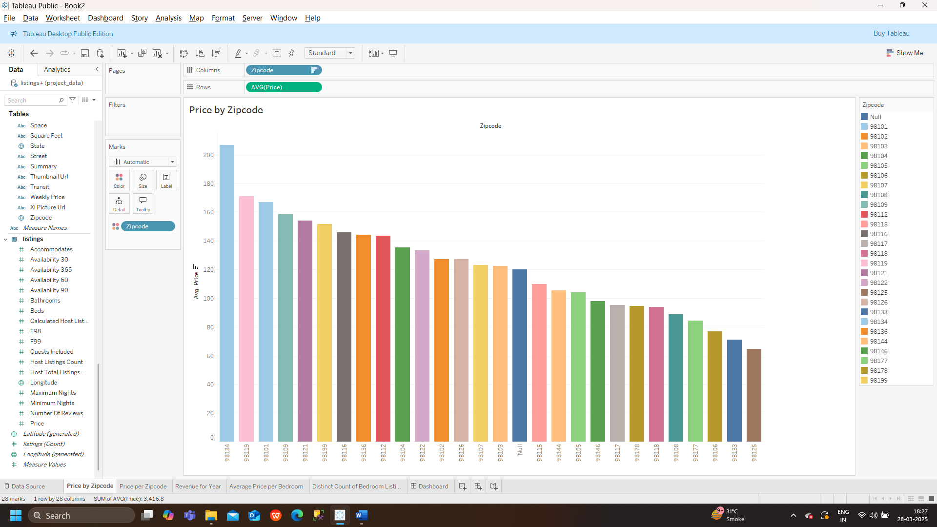

PRICE PER ZIPCODE

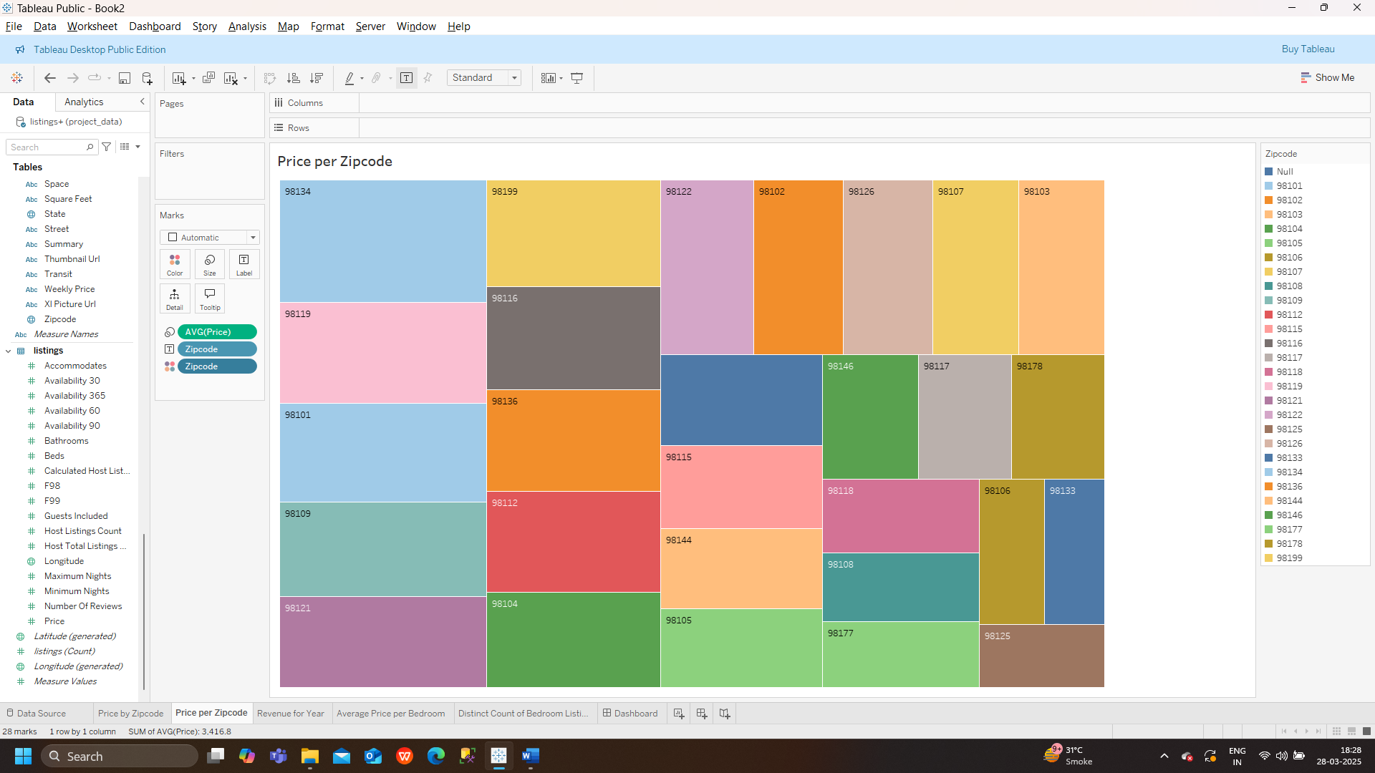

REVENUE FOR YEAR

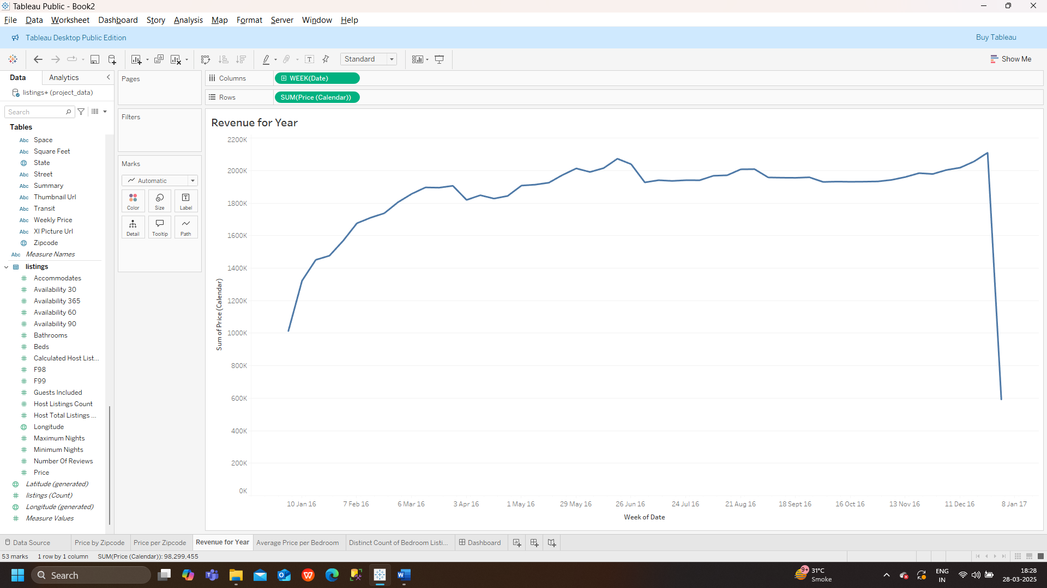

AVERAGE PRICE PER BEDROOM

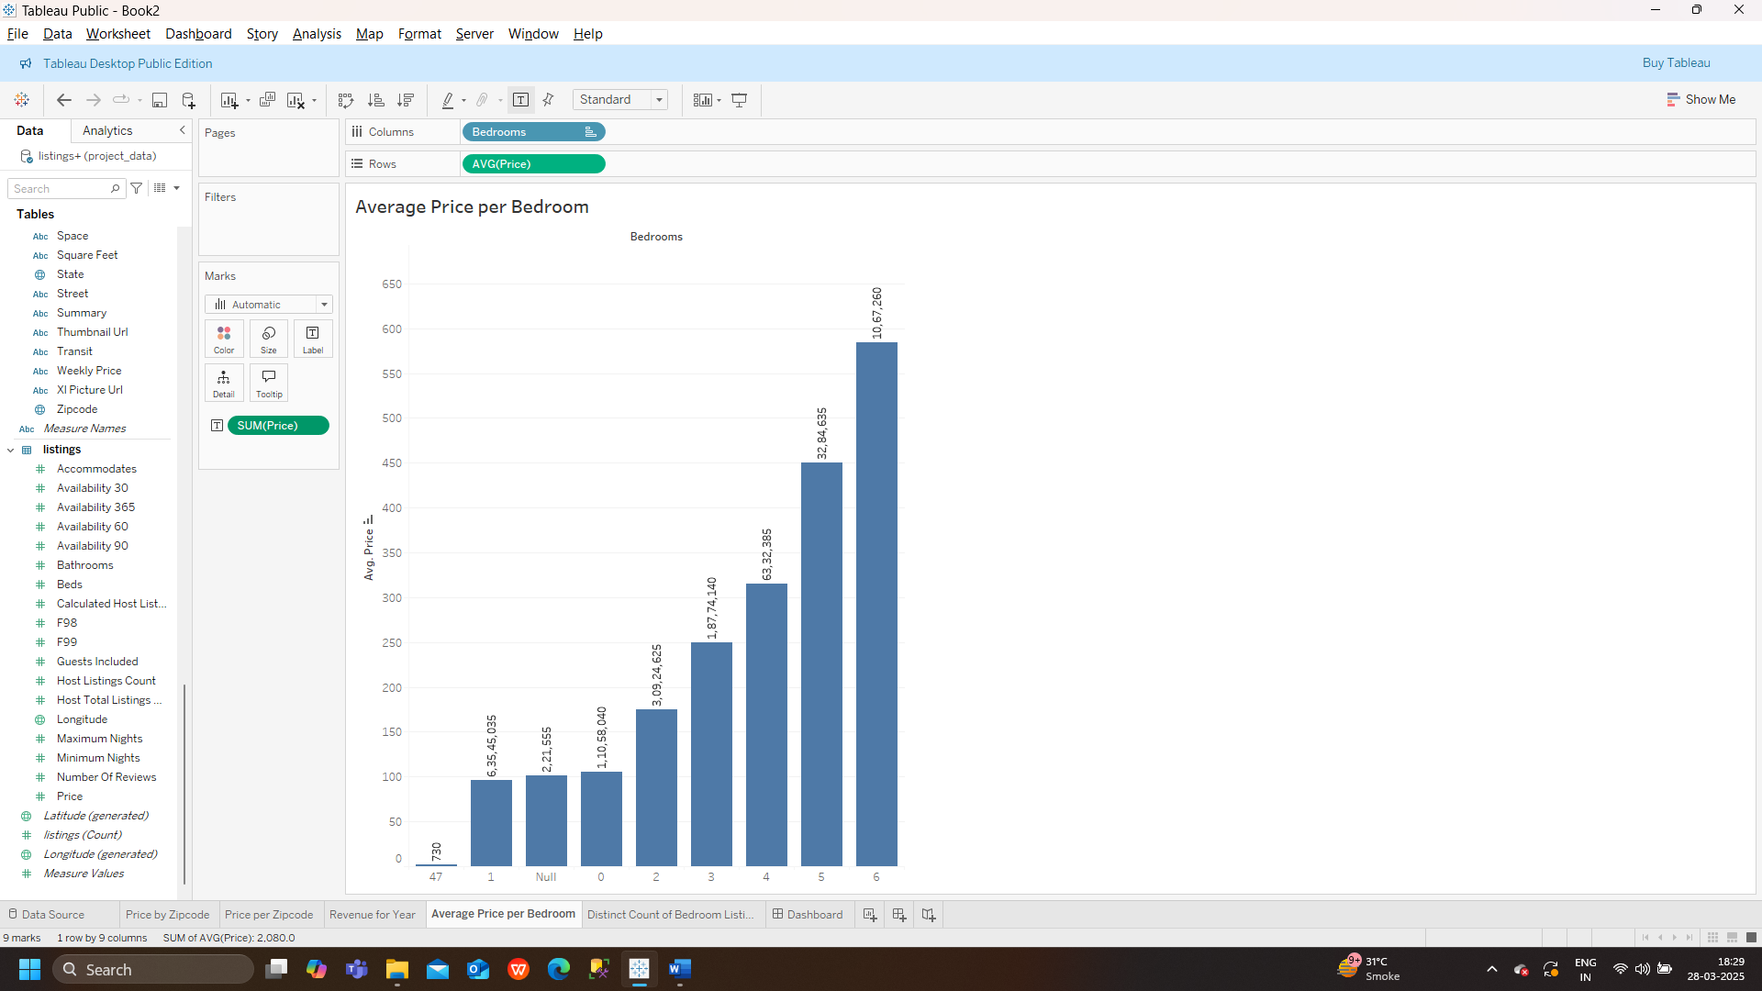

DISTINCT COUNT OF BEDROOM LISTINGS

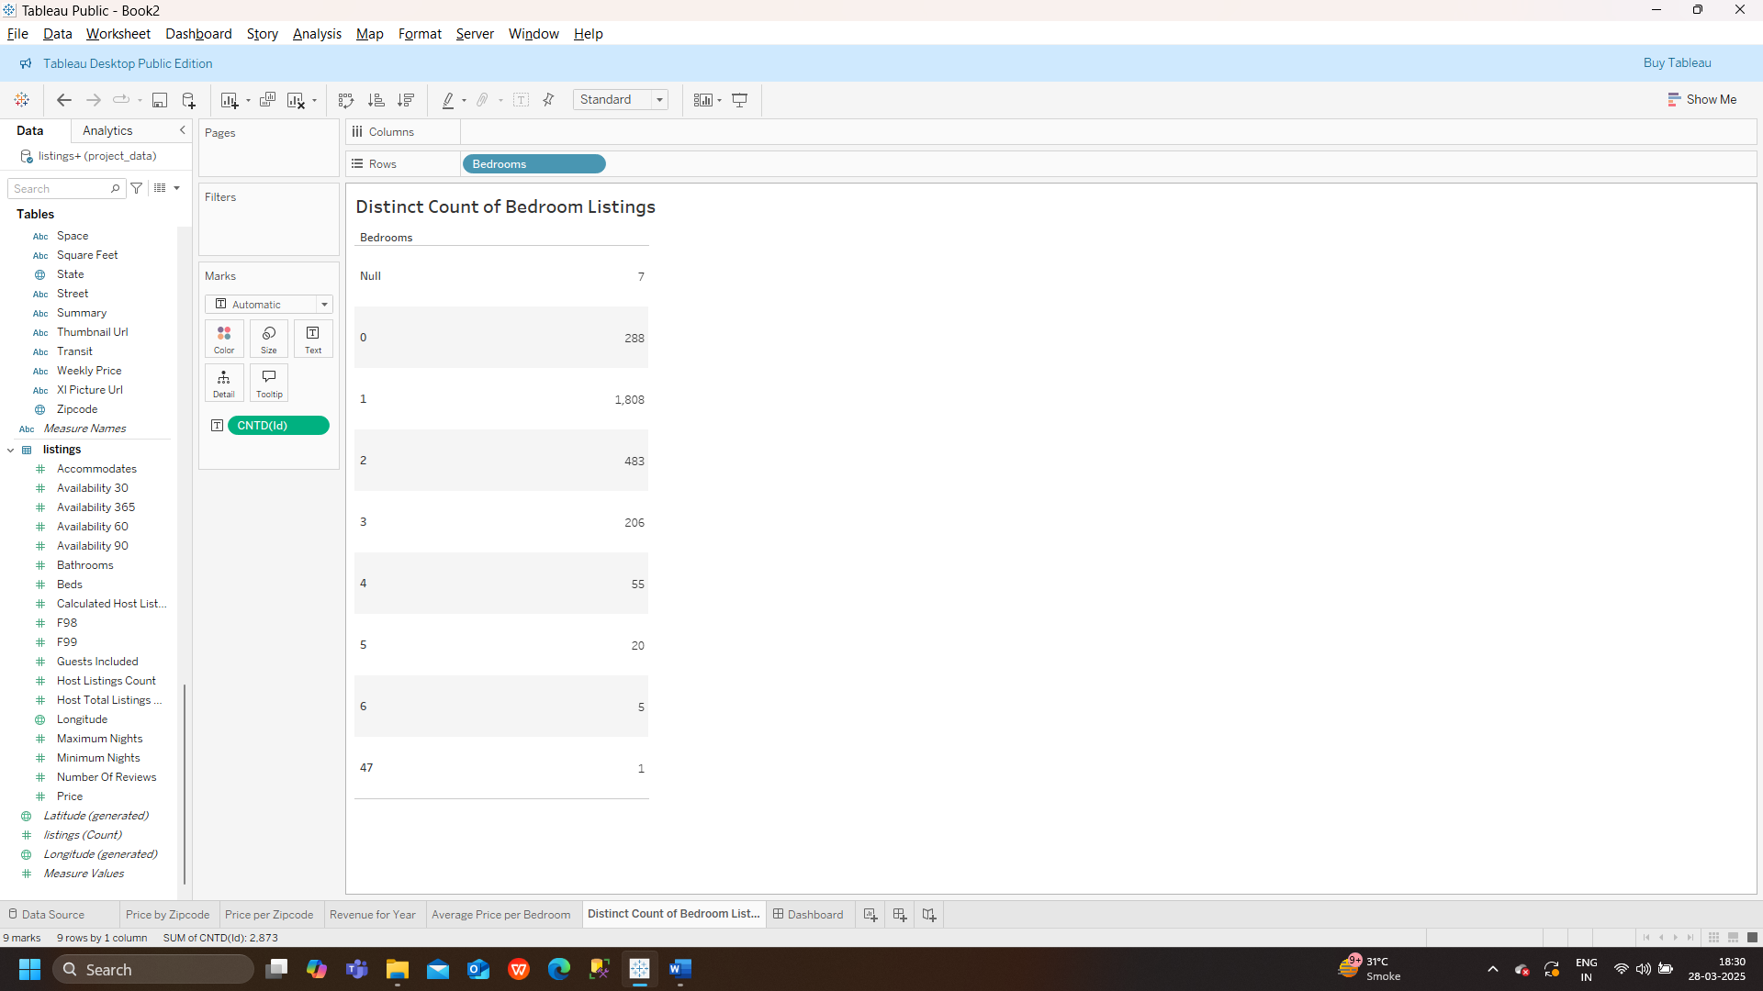

DASHBOARD

