CHAPTER 1
SUMMARY OF THE BASE PAPER

1.1 Base Paper

S.NO | Title | Journal Name | Publisher | Year
1. | Intelligent security system based on face recognition and IoT | Materials Today: Proceedings 62 (2022) 2133-2137 | Trinanjana Bagchi, Ankita Mahapatra, Dipesh Yadav, Daiwik Mishra, Anish Pandey, P. Chandrasekhar, Ashwani Kumar | 2022
Table. 1 Base paper

1.2 Summary

The paper proposes the use of a door lock system based on face recognition using the ESP32-CAM development board. The system aims to provide a cost and energy-efficient alternative for home protection by avoiding manual operations that involve touching surfaces, thus preventing the spread of diseases like COVID-19. The paper describes the different methods currently used for security systems, such as wired or wireless alarms, RFID keys, and biometrics recognition, and highlights their limitations.

Facial recognition is considered a universal, collectible, and accessible biometrics system that is based on the same identifier that humans use to distinguish one person from another. Face recognition does not require physical touch, making it more user-friendly and easier to use in various applications. The proposed system is designed to detect and recognize faces in real-time using a camera and compare them to the information in the database. The system can distinguish between known and unknown persons based on the match confidence value.

It is then provided by a detailed explanation of the proposed methodology, which involves uploading images by the user to the database, extracting various facial parameters, and creating a unique signature of the face. The system captures images when a person is nearby and transfers them to the facial recognition service to compare the stored features. If the match confidence value is 90% or more, the door will open, allowing known persons to enter.
The paper concludes that the proposed system can be used to enhance human life and security for commercial and residential purposes. The system offers several benefits, including touchless operations, real-time detection and recognition, and high reliability. However, the paper acknowledges some limitations, such as the need for a stable internet connection, the potential for false positives or negatives, and the ethical concerns surrounding the use of facial recognition technology. The authors suggest further research to address these limitations and improve the system's performance and usability.

1.3 Correctness of the Base Paper

The paper describes the development and successful implementation of a door lock system based on face recognition. It highlights the potential of the system to help businesses save time and money and create new revenue opportunities. It suggests that the developed system can be used in organized environments, and recognition procedures may take advantage of these constraints to achieve high recognition precision in the coming future. The future work includes developing a payroll system for daily wages workers based on their Face ID recognition, and the possibility of adding the iris recognition system to the existing system to improve efficiency and effectiveness.

Overall, the paper is well written and provides a clear description of the developed system, its potential applications, and future work. However, without additional evidence or data, it is difficult to evaluate the level of success achieved by the system and its potential impact. Therefore, it is important to conduct further testing and analysis to validate the effectiveness and reliability of the system.

1.4 Work Flow

Fig. 1.1.Work Flow

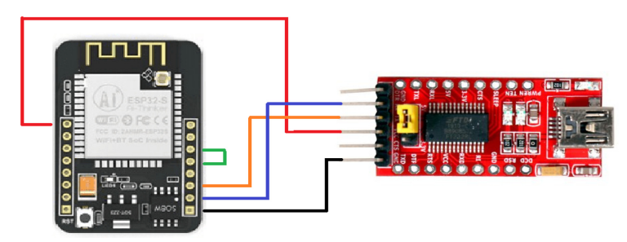
Fig 1.2. Circuit Diagram for uploading code to ESP camera

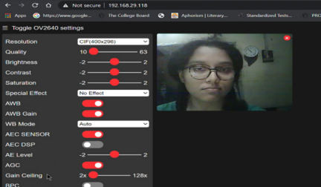

Fig 1.3. Enrollment of face in the browser

CHAPTER 2
MERITS AND DEMERITS OF THE BASE PAPER

2.1 MERITS :
- The proposed face recognition-based door lock system offers a touchless and efficient way to enhance human security and prevent the spread of COVID-19 by reducing surface contact.
- The system is based on the AI-Thinker ESP32-CAM module, which is a low-cost development board with a small camera and a micro SD card slot, making it a cost-effective solution.
- The system is capable of performing real-time face detection and recognition, providing a reliable and efficient security solution for both commercial and residential purposes.
- The facial recognition technology used in the system is easy to use and does not require physical touch, making it a convenient and user-friendly solution.
- The system can be customized to add new features and functionalities, such as remote access and control, making it a versatile and scalable solution.

2.2 DEMERITS:
- The accuracy of the facial recognition system depends on the quality of the images in the database and the lighting conditions, which can affect its reliability.
- Facial recognition technology raises privacy concerns, as it involves capturing and storing people's biometric data, which can be misused if it falls into the wrong hands.
- The system relies on a single biometric identifier, which may not be sufficient for high-security applications and can be circumvented by using fake faces or masks.
- The system may not be suitable for people with certain facial features or disabilities, such as facial paralysis or blindness, which can affect the accuracy of the facial recognition technology.
- The system requires a stable internet connection and may be vulnerable to cyber attacks, which can compromise the security of the system and the privacy of the users.

CHAPTER 3

SOURCE CODE

3.1 Face Recognition Code using Pre-trained Face_Recognition Model

import json
import cv2 as cv
import face_recognition
import time
from imutils.video import WebcamVideoStream
import requests
#from sort import *
print("..............")
Conf_threshold = 0.8
NMS_threshold = 0.4
COLORS = [(0, 255, 0), (0, 0, 255), (255, 0, 0),
(255, 255, 0), (255, 0, 255), (0, 255, 255)]
image = face_recognition.load_image_file("C:/Users/kesha/OneDrive/Pictures/Camera Roll/Srivatsan.jpg")
encoding = face_recognition.face_encodings(image)[0]
image2 = face_recognition.load_image_file("C:/Users/kesha/OneDrive/Pictures/Camera Roll/Srivatsan.jpg")
encoding2 = face_recognition.face_encodings(image2)[0]
image3 = face_recognition.load_image_file("C:/Users/kesha/OneDrive/Pictures/Camera Roll/Keshav.jpg")
encoding3 = face_recognition.face_encodings(image3)[0]
known_face_encodings = [
encoding,encoding2,encoding3
]
known_face_names = [
"Srivatsan","Srivatsan","keshav"
]
face_locations = []
face_encodings = []
face_names = []
def get_faces(frame):
try:
small_frame = frame
cv.imshow("frame3",frame)
rgb_small_frame = small_frame[:, :, ::-1]
face_locations = face_recognition.face_locations(rgb_small_frame)
face_encodings = face_recognition.face_encodings(rgb_small_frame, face_locations)
name = "Unknown"
face_names = []
for face_encoding in face_encodings:
matches = face_recognition.compare_faces(known_face_encodings, face_encoding)
name = "Person"
if True in matches:
first_match_index = matches.index(True)
name = known_face_names[first_match_index]
if name!="Unknown":
face_names.append(name)
if name=="Unknown":
print(".//.//.///.")
serverToken = 'AAAABD-Z7oI:APA91bF4_D-3E9BbHgg8t_GWxxAhPlEEuceAP9tgh5rMCOhAtZY1kz7sY9pPPfi1YVtVpmH-2lj9I7ITMOU2H8W5SopGrIyT4XWkIaod-0GhUxok48BUZZTDFD-_WEC5ZjBEIn4d8p0Z'
deviceToken = 'device token here'

headers = {
'Content-Type': 'application/json',
'Authorization': 'key=' + serverToken,
}

body = {
'notification': {'title': 'Sending push form python script',
'body': 'New Message'
},
'to':
"d85-XdArTxufWQSLAimkVp:APA91bHJVfR6stB6xalUJ4MAWOmPjaiL15X-gkyqbHQo6K_1ZaSmHL2cpiVpb--qFv1yRZqiBLUnN17QsBa2XcgExDG1ttWMS_JKoSxFWDRCAaNdx56U9jdkITm921aM-ZavOLHxdfZC",
'priority': 'high',
# 'data': dataPayLoad,
}
response = requests.post("https://fcm.googleapis.com/fcm/send",headers = headers, data=json.dumps(body))
print(response.status_code)
print(face_locations,name)
for (top, right, bottom, left), name in zip(face_locations, face_names):
top *= 10
right *= 10
bottom *= 10
left *= 10
cv.rectangle(frame, (left, top), (right, bottom), (0, 0, 255), 2)
cv.rectangle(frame, (left, bottom - 35), (right, bottom), (0, 0, 255), cv.FILLED)
font = cv.FONT_HERSHEY_DUPLEX
cv.putText(frame, name, (left + 6, bottom - 6), font, 1.0, (255, 255, 255), 1)
try:
cv.imshow(name,frame)
pass
except:
pass
except:
pass
class_name = []
with open('C:/Studies and Applications/Mini Project/classes.txt', 'r') as f:
class_name = [cname.strip() for cname in f.readlines()]
net = cv.dnn.readNet('C:/Studies and Applications/Mini Project/yolov4-tiny.weights', 'C:/Studies and Applications/Mini Project/yolov4-tiny.cfg')
model = cv.dnn_DetectionModel(net)
model.setInputParams(size=(416, 416), scale=1/255, swapRB=True)

#cap = cv.VideoCapture("http://192.168.167.72:81/stream")
cap = cv.VideoCapture(0)
print("video started")
starting_time = time.time()
frame_counter = 0
while True:
_,frame = cap.read()
frame_counter += 1

classes, scores, boxes = model.detect(frame, Conf_threshold, NMS_threshold)
for (classid, score, box) in zip(classes, scores, boxes):
color = COLORS[int(classid) % len(COLORS)]
label = "%s : %f" % (class_name[classid], score)
cv.rectangle(frame, box, color, 1)

if (class_name[classid]=="person"):
get_faces(frame=frame[box[1]:box[3]+box[1],box[0]:box[2]+box[0]])

endingTime = time.time() - starting_time
fps = frame_counter/endingTime

cv.putText(frame, f'FPS: {fps}', (20, 50),
cv.FONT_HERSHEY_COMPLEX, 0.7, (0, 255, 0), 2)

cv.imshow('frame', frame)
key = cv.waitKey(1)
if key == ord('q'):
break
cap.release()
cv.destroyAllWindows()
3.2 Custom Model trained using our faces

3.2.1 Custom CNN Model

import numpy as np
import tensorflow as tf
import keras
from keras.models import Sequential
from keras.layers import Conv2D,MaxPooling2D,Dense,Flatten,Dropout
import matplotlib.pyplot as plt
from tensorflow.keras.layers import BatchNormalization
from keras_preprocessing import image
from tensorflow.keras.preprocessing.image import ImageDataGenerator,DirectoryIterator

train_dir="C:/Studies and Applications/Mini Project/New face training thingy/newfaces"
generator = ImageDataGenerator()
train_ds = generator.flow_from_directory(train_dir,target_size=(224, 224),batch_size=32)
classes = list(train_ds.class_indices.keys())
print(classes)

type(train_ds)

model = Sequential()
model.add(Conv2D(32, kernel_size = (3, 3), activation='relu', input_shape=(224,224,3)))
model.add(MaxPooling2D(pool_size=(2,2)))
model.add(BatchNormalization())
model.add(Conv2D(64, kernel_size=(3,3), activation='relu'))
model.add(MaxPooling2D(pool_size=(2,2)))
model.add(BatchNormalization())
model.add(Conv2D(64, kernel_size=(3,3), activation='relu'))
model.add(MaxPooling2D(pool_size=(2,2)))
model.add(BatchNormalization())
model.add(Conv2D(96, kernel_size=(3,3), activation='relu'))
model.add(MaxPooling2D(pool_size=(2,2)))
model.add(BatchNormalization())
model.add(Conv2D(96, kernel_size=(3,3), activation='relu'))
model.add(MaxPooling2D(pool_size=(2,2)))
model.add(BatchNormalization())
model.add(Conv2D(32, kernel_size=(3,3), activation='relu'))
model.add(MaxPooling2D(pool_size=(2,2)))
model.add(BatchNormalization())
model.add(Dropout(0.2))
model.add(Flatten())
model.add(Dense(128, activation='relu'))
model.add(Dense(len(classes),activation='softmax'))

model.compile(
loss = 'categorical_crossentropy',
optimizer = 'adam',
metrics = ["accuracy"])
model.summary()

history = model.fit(train_ds,epochs= 30, batch_size=32)

plt.plot(history.history['accuracy'])
plt.plot(history.history['loss'])
plt.xlabel('Time')
plt.legend(['accuracy', 'loss'])
plt.show()

def predict_image(image_path):
img = image.load_img(image_path, target_size=(224,224,3))
plt.imshow(img)
plt.show()
x = image.img_to_array(img)
x = np.expand_dims(x, axis=0)
images = np.vstack([x])
pred = model.predict(images, batch_size=32)
print(image_path)
print("Actual: "+(image_path.split("/")[-1]).split("_")[0])
print(pred)
print("Predicted: "+classes[np.argmax(pred)])

predict_image("C:\\Studies and Applications\\Mini Project\\New face training thingy\\newfaces\\Srivatsan_121.jpg")

from sklearn.metrics import classification_report
test_dir = "C:/Studies and Applications/Mini Project/New face training thingy/newfaces"
test_generator = ImageDataGenerator().flow_from_directory(
directory=test_dir,
target_size=(224, 224),
batch_size=32,
shuffle=False,
)
y_true = test_generator.classes
y_pred = model.predict(test_generator)
class_indices = test_generator.class_indices
classes = list(class_indices.keys())
report = classification_report(y_true, y_pred.argmax(axis=-1), target_names=classes)
print(report)

model.save('model2.h5')

3.2.2 Cropping out detected faces using YOLO

import cv2 as cv
Conf_threshold = 0.8
NMS_threshold = 0.4
COLORS = [(0, 255, 0), (0, 0, 255), (255, 0, 0),
(255, 255, 0), (255, 0, 255), (0, 255, 255)]
class_name = []
with open('C:/Studies and Applications/Mini Project/classes.txt', 'r') as f:
class_name = [cname.strip() for cname in f.readlines()]
net = cv.dnn.readNet('C:/Studies and Applications/Mini Project/yolov4-tiny.weights', 'C:/Studies and Applications/Mini Project/yolov4-tiny.cfg')
model = cv.dnn_DetectionModel(net)
model.setInputParams(size=(416, 416), scale=1/255, swapRB=True)
for i in range(1,76):
path="C:/Studies and Applications/Mini Project/New face training thingy/Og images/Vyas/Vyas ("+str(i)+").jpg"
out="C:/Studies and Applications/Mini Project/New face training thingy/newfaces/Vyas/Vyas ("+str(i)+").jpg"
frame=cv.imread(path)
classes, scores, boxes = model.detect(frame, Conf_threshold, NMS_threshold)
for (classid, score, box) in zip(classes, scores, boxes):
color = COLORS[int(classid) % len(COLORS)]
label = "%s : %f" % (class_name[classid], score)
cv.rectangle(frame, box, color, 1)

if (class_name[classid]=="person"):
new_frame=frame[box[1]:box[3]+box[1],box[0]:box[2]+box[0]]
cv.imwrite(out,new_frame)

import cv2 as cv
Conf_threshold = 0.8
NMS_threshold = 0.4
COLORS = [(0, 255, 0), (0, 0, 255), (255, 0, 0),
(255, 255, 0), (255, 0, 255), (0, 255, 255)]
class_name = []
with open('C:/Studies and Applications/Mini Project/classes.txt', 'r') as f:
class_name = [cname.strip() for cname in f.readlines()]
net = cv.dnn.readNet('C:/Studies and Applications/Mini Project/yolov4-tiny.weights', 'C:/Studies and Applications/Mini Project/yolov4-tiny.cfg')
model = cv.dnn_DetectionModel(net)
model.setInputParams(size=(416, 416), scale=1/255, swapRB=True)

path="C:\\Studies and Applications\\Mini Project\\New face training thingy\\newfaces\\WIN_20230510_11_42_42_Pro.jpg"
out="C:\\Studies and Applications\\Mini Project\\New face training thingy\\newfaces\\Srivatsan_121.jpg"
frame=cv.imread(path)
print(frame.shape)
classes, scores, boxes = model.detect(frame, Conf_threshold, NMS_threshold)
print(scores)
for (classid, score, box) in zip(classes, scores, boxes):
print("inside....")
color = COLORS[int(classid) % len(COLORS)]
label = "%s : %f" % (class_name[classid], score)
cv.rectangle(frame, box, color, 1)
if (class_name[classid]=="person"):
print("yess")
new_frame=frame[box[1]:box[3]+box[1],box[0]:box[2]+box[0]]
cv.imwrite(out,new_frame)

3.2.3 Face Recognition using custom trained model

import cv2 as cv
import face_recognition
import time
from imutils.video import WebcamVideoStream
from tensorflow.keras.models import load_model
import tensorflow as tf
print("..............")
Conf_threshold = 0.4
NMS_threshold = 0.4
COLORS = [(0, 255, 0), (0, 0, 255), (255, 0, 0),
(255, 255, 0), (255, 0, 255), (0, 255, 255)]

# Load a sample picture and learn how to recognize it.
image = face_recognition.load_image_file("C://Studies and Applications//Mini Project//webcam_face_recognition-master//faces//WIN_20230212_10_46_36_Pro.jpg")
encoding = face_recognition.face_encodings(image)[0]

# Create arrays of known face encodings and their names
known_face_encodings = [
encoding
]
known_face_names = [
"elon",
]

# Initialize some variables
face_locations = []
face_encodings = []
face_names = []

def get_faces(frame):
print(frame.shape)
facemodel = load_model('model2.h5')
small_frame=cv.resize(frame,(224,224),interpolation = cv.INTER_AREA)
print("reached .........")
print(small_frame.shape)
small_frame=tf.expand_dims(small_frame,axis=0)
print(facemodel.predict([small_frame]))
print("[[ Keshav Srivatsan Vyas]]")

try:
cv.imshow("frame2",frame)
except:
pass
class_name = []
with open('C://Studies and Applications//Mini Project//classes.txt', 'r') as f:
class_name = [cname.strip() for cname in f.readlines()]
net = cv.dnn.readNet('C:\Studies and Applications\Mini Project\yolov4-tiny.weights', 'C:\Studies and Applications\Mini Project\yolov4-tiny.cfg')
# net.setPreferableBackend(cv.dnn.DNN_BACKEND_CUDA)
# net.setPreferableTarget(cv.dnn.DNN_TARGET_CUDA_FP16)

model = cv.dnn_DetectionModel(net)
model.setInputParams(size=(320, 320), scale=1/511, swapRB=True)

# cap = WebcamVideoStream(0).start()
cap = cv.VideoCapture(0)
print("video started")
starting_time = time.time()
frame_counter = 0
while True:
_,frame = cap.read()
frame_counter += 1
classes, scores, boxes = model.detect(frame, Conf_threshold, NMS_threshold)
for (classid, score, box) in zip(classes, scores, boxes):
color = COLORS[int(classid) % len(COLORS)]
label = "%s : %f" % (class_name[classid], score)
cv.rectangle(frame, box, color, 1)
get_faces(frame=frame[box[1]:box[3]+box[1],box[0]:box[2]+box[0]])
# cv.putText(frame, label, (box[0], box[1]-10),
# cv.FONT_HERSHEY_COMPLEX, 0.3, color, 3)
endingTime = time.time() - starting_time
fps = frame_counter/endingTime
# print(fps)
cv.putText(frame, f'FPS: {fps}', (20, 50),
cv.FONT_HERSHEY_COMPLEX, 0.7, (0, 255, 0), 2)
cv.imshow('frame', frame)
key = cv.waitKey(1)
if key == ord('q'):
break
cap.release()
cv.destroyAllWindows()

3.3.1 Code to stream the video via ESP-cam

#include "esp_camera.h"
#include <WiFi.h>

#define CAMERA_MODEL_AI_THINKER /
#include "camera_pins.h"

const char* ssid = "Vyas Redmi";
const char* password = "12345678";

void startCameraServer();

void setup() {
Serial.begin(115200);
Serial.setDebugOutput(true);
Serial.println();

camera_config_t config;
config.ledc_channel = LEDC_CHANNEL_0;
config.ledc_timer = LEDC_TIMER_0;
config.pin_d0 = Y2_GPIO_NUM;
config.pin_d1 = Y3_GPIO_NUM;
config.pin_d2 = Y4_GPIO_NUM;
config.pin_d3 = Y5_GPIO_NUM;
config.pin_d4 = Y6_GPIO_NUM;
config.pin_d5 = Y7_GPIO_NUM;
config.pin_d6 = Y8_GPIO_NUM;
config.pin_d7 = Y9_GPIO_NUM;
config.pin_xclk = XCLK_GPIO_NUM;
config.pin_pclk = PCLK_GPIO_NUM;
config.pin_vsync = VSYNC_GPIO_NUM;
config.pin_href = HREF_GPIO_NUM;
config.pin_sscb_sda = SIOD_GPIO_NUM;
config.pin_sscb_scl = SIOC_GPIO_NUM;
config.pin_pwdn = PWDN_GPIO_NUM;
config.pin_reset = RESET_GPIO_NUM;
config.xclk_freq_hz = 20000000;
config.frame_size = FRAMESIZE_UXGA;
config.pixel_format = PIXFORMAT_JPEG; // for streaming
config.grab_mode = CAMERA_GRAB_WHEN_EMPTY;
config.fb_location = CAMERA_FB_IN_PSRAM;
config.jpeg_quality = 12;
config.fb_count = 1;

if(config.pixel_format == PIXFORMAT_JPEG){
if(psramFound()){
config.jpeg_quality = 10;
config.fb_count = 2;
config.grab_mode = CAMERA_GRAB_LATEST;
} else {
config.frame_size = FRAMESIZE_SVGA;
config.fb_location = CAMERA_FB_IN_DRAM;
}
} else {
// Best option for face detection/recognition
config.frame_size = FRAMESIZE_240X240;
#if CONFIG_IDF_TARGET_ESP32S3
config.fb_count = 2;
#endif
}

#if defined(CAMERA_MODEL_ESP_EYE)
pinMode(13, INPUT_PULLUP);
pinMode(14, INPUT_PULLUP);
#endif

// camera init
esp_err_t err = esp_camera_init(&config);
if (err != ESP_OK) {
Serial.printf("Camera init failed with error 0x%x", err);
return;
}

sensor_t * s = esp_camera_sensor_get();

if (s->id.PID == OV3660_PID) {
s->set_vflip(s, 1); // flip it back
s->set_brightness(s, 1); // up the brightness just a bit
s->set_saturation(s, -2); // lower the saturation
}
if(config.pixel_format == PIXFORMAT_JPEG){
s->set_framesize(s, FRAMESIZE_QVGA);
}

#if defined(CAMERA_MODEL_M5STACK_WIDE) || defined(CAMERA_MODEL_M5STACK_ESP32CAM)
s->set_vflip(s, 1);
s->set_hmirror(s, 1);
#endif

#if defined(CAMERA_MODEL_ESP32S3_EYE)
s->set_vflip(s, 1);
#endif

WiFi.begin(ssid, password);
WiFi.setSleep(false);

while (WiFi.status() != WL_CONNECTED) {
delay(500);
Serial.print(".");
}
Serial.println("");
Serial.println("WiFi connected");

startCameraServer();

Serial.print("Camera Ready! Use 'http://");
Serial.print(WiFi.localIP());
Serial.println("' to connect");
}

void loop() {
delay(10000);
}

CHAPTER 4

Snapshots

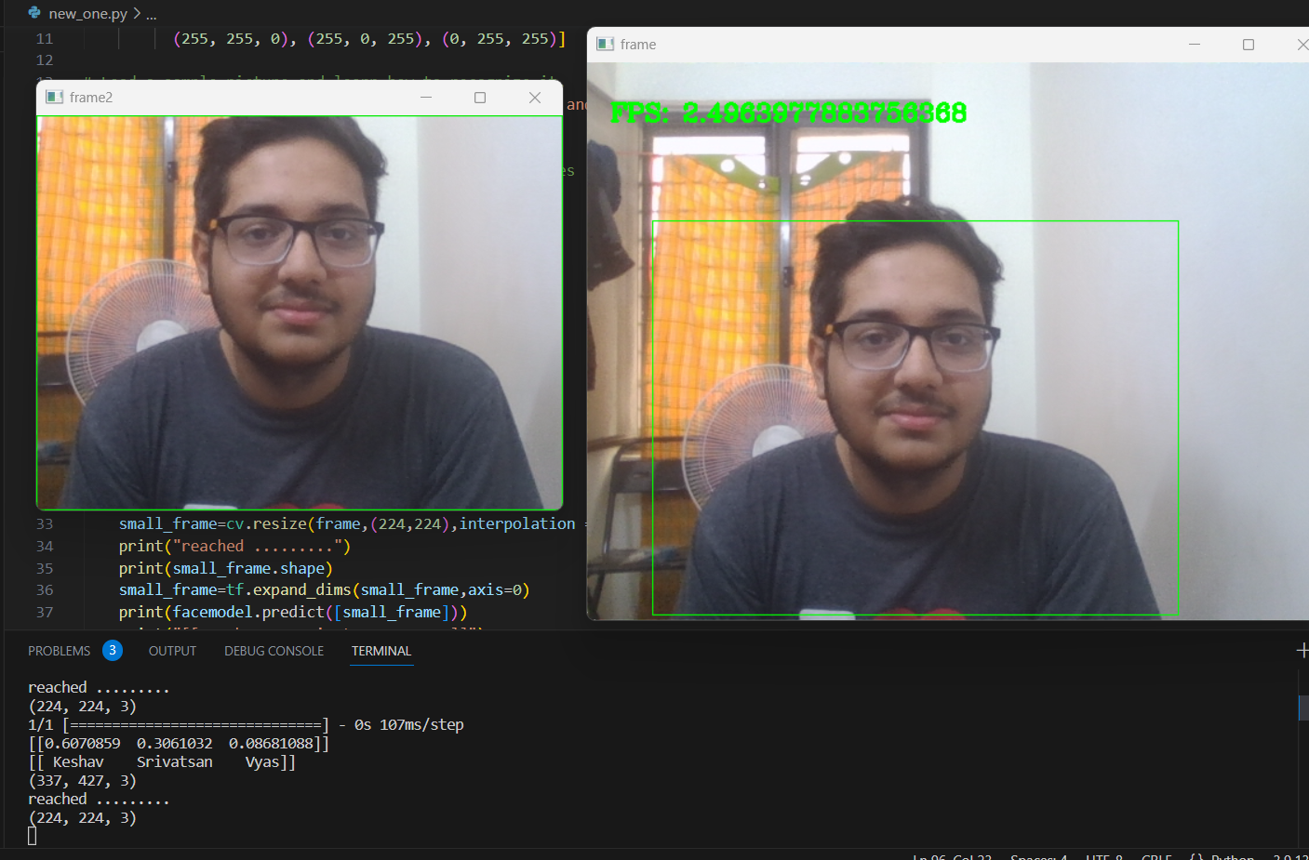
Fig 4.1. Face Detection and Recognition using Custom model

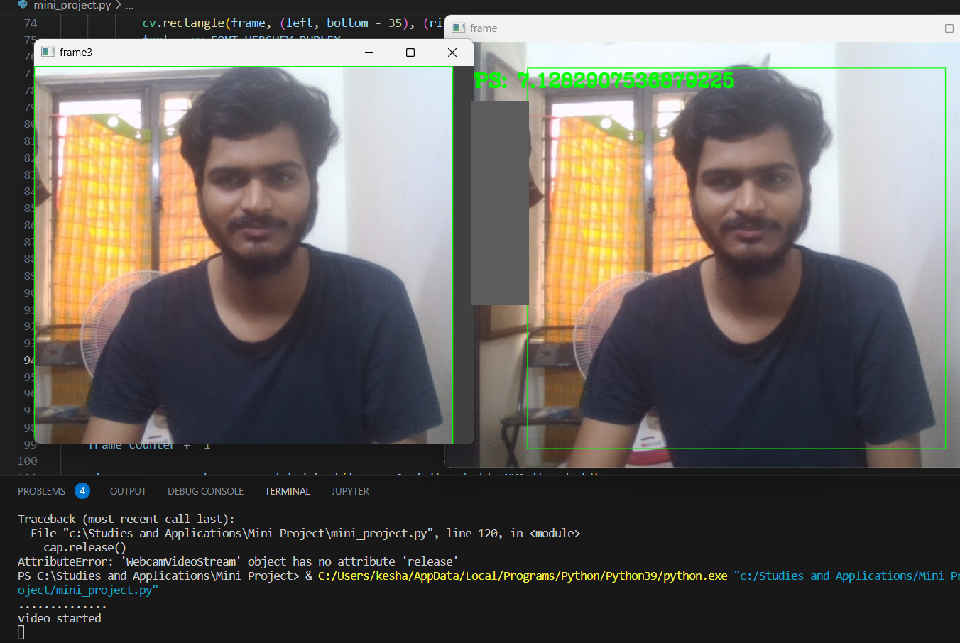
Fig 4.1. Face Detection and Recognition using Pre-trained model

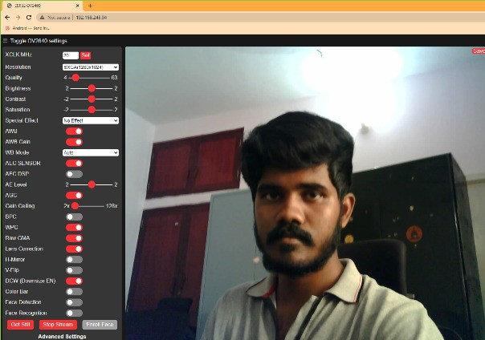
Fig 4.3. Streaming of video via ESP-cam

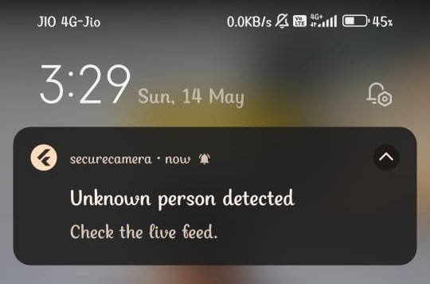
Fig 4.4. Notification from Mobile App

CHAPTER 5
Conclusion and Future Plans

5.1 Conclusion

The use of video surveillance systems and smart surveillance has revolutionized the way we approach security. With the advancement of technology, the implementation of artificial intelligence and machine learning algorithms has significantly improved the accuracy and efficiency of these systems. Facial recognition technology is one such example, which has proven to be an effective method of authentication in video surveillance systems. The ability to extract specific features from images and classify them into different categories has enabled security systems to identify and track individuals, ultimately making it easier to prevent crime.

Furthermore, smart surveillance systems have a range of benefits, including an increased sense of security, improved productivity, reduced costs, and real-time monitoring. The ability to monitor and analyze surroundings in real-time helps to detect potential threats and prevent them from escalating. The integration of mobile applications allows users to monitor their premises remotely, providing them with peace of mind and enabling them to take action when necessary.

5.2 Future Plans

The future of surveillance systems lies in the integration of artificial intelligence and machine learning. The technology will enable the development of sophisticated algorithms that can accurately recognize faces, detect suspicious activities and monitor surroundings in real-time. The implementation of these advanced systems will not only increase security and productivity, but also provide valuable data for businesses to analyze and improve their operations. Furthermore, the scalability and mobile monitoring capabilities of these systems will make them more accessible and convenient for users. As technology continues to evolve, it is imperative to keep up with the latest developments to ensure maximum safety and security.

CHAPTER 6
References
- Meddeb, Abdellaoui, Houaidi, Development of surveillance robot based on face recognition using Raspberry-PI and IOT , Microprocessors and Microsystems 96 (2023) 104728, 2023, https://www.sciencedirect.com/science/article/pii/S0141933122002575
- V. Kushnir, B. Koman, V. Yuzevych, IoT image recognition system implementation for blind peoples using esp32, mobile phone and convolutional neural network, in: 2019 XIth International Scientific and Practical Conference on Electronics and Information Technologies (ELIT), 2019, pp. 183–187, https://doi.org/10.1109/ELIT.2019.8892289
- R. Khalimov, Z. Rakhimbayeva, A. Shokayev, B. Kamalov, M.H. Ali, Development of intelligent door locking system based on face recognition technology, in: 2020 11th International Conference on Mechanical and Aerospace Engineering (ICMAE), 2020, pp. 244–248, https://doi.org/10.1109/ICMAE50897.2020.9178866
- A.P. Raut, A. Raj, S. Patil, A. Katkar, Internet controlled techrobot using raspberry Pi, Int. J. Eng. Res. Technol. (IJERT) 9 (8) (2020) 594–600, https://doi.org/10.17577/IJERTV9IS080275
- M. Sunitha, P.V.S.S. Datta Vinay, V.S.N. Lokeshand, B. Dinesh, Kumar IP based surveillance robot using IOT, in: Proceedings of the IEEE 4th International Conference on I-SMAC, Palladam, India, 2020, https://doi.org/10.1109/I-SMAC49090.2020.9243519

