|  |
| --- |
| Rest-Crud-Demo |
|  |
|  |

* **Purpose and scope:-**

This document analyses the process of creating a Rest Service and the project which serve the purpose of CRUD operation with Customer entity.

With the help of Spring initializr, the project structure has been created and imported in eclipse and further subsequent classes has been added.

The Technology stack used and dependency used while creating the project structure are:-

-Spring boot version-2.2.5

-maven 4.0

-spring web

-Spring data MongoDb

-and Junit dependency

* **Flow Diagram:-**

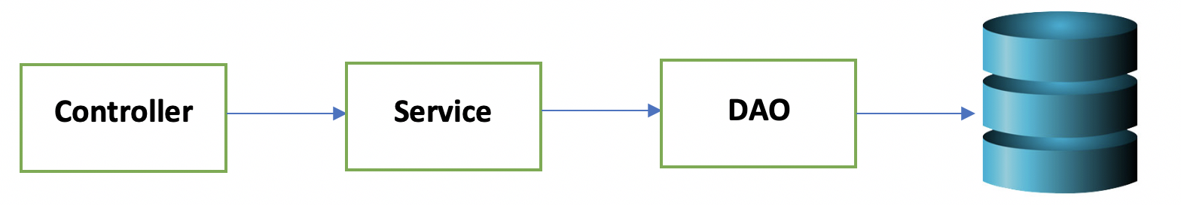

* **Folder Structure:-**

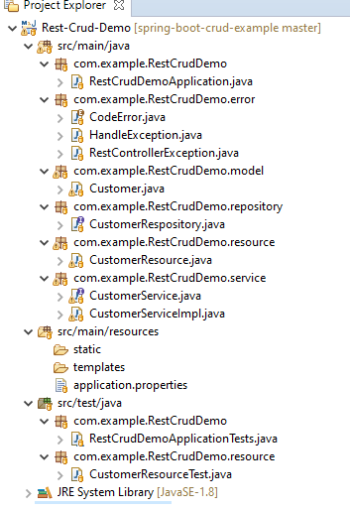

List of Rest service :-

Save Customer data:-

|  |  |
| --- | --- |
| **REST Service** | Save customer data |
| Path | **POST** /api/customer/addCustomer |
| Input | Customer object |
| Output | Customer object |
| Java class | CustomerResource.java |
| Produces | MediaType.APPLICATION_JSON) |
| consumes | MediaType.APPLICATION_JSON) |

Update Customer data:-

|  |  |
| --- | --- |
| **REST Service** | update customer data |
| Path | **PUT** /api/customer/ updateCustomer |
| Input | Customer object |
| Output | Customer object |
| Java class | CustomerResource.java |
| Produces | MediaType.APPLICATION_JSON) |
| consumes | MediaType.APPLICATION_JSON) |

Get Customer data:-

|  |  |
| --- | --- |
| **REST Service** | get customer data |
| Path | **GET** /api/customer/ {custId} |
| Input | Customer customerId |
| Output | Customer object |
| Java class | CustomerResource.java |
| Produces | MediaType.APPLICATION_JSON) |

Get List of Customer data:-

|  |  |
| --- | --- |
| **REST Service** | List of all customer data |
| Path | **GET** /api/customer/ findAllCustomers |
| Output | List of Customer object |
| Java class | CustomerResource.java |
| Produces | MediaType.APPLICATION_JSON) |

Delete Customer data:-

|  |  |
| --- | --- |
| **REST Service** | Delete customer data |
| Path | **DELETE** /api/customer/{custId} |
| Input | Customer customerId |
| Output | String message |
| Java class | CustomerResource.java |

* **Unit Testing Feature:-**

Service layer unit testing has been applied in the default class which has created while creating the folder structure. It **is src/test/java/com.example.RestCrudDemo/ RestCrudDemoApplicationTests.java**

With the help of mockito and junit feature this has been applied. Service layer dependency has been autowired and dao layer bean has been mocked. Call to data base has been mocked.

All rest crud operation has been covered.

-Subsequent controller testing class has been implemented. It is being created in the separate folder which is **src/test/java/com.example.RestCrudDemo.resource/ CustomerResourceTest.java**

With the help of mockmvc, mockito and junit feature this has been applied. Service layer dependency has been autowired and bean has been mocked.

All rest crud operation has been covered.