SPAM HAM CLASSIFIER

import pandas as pd

import numpy as np

import matplotlib.pyplot as plt

import re

import string

import nltk

from nltk.corpus import stopwords

from sklearn.feature_extraction.text import CountVectorizer

from sklearn.model_selection import train_test_split

from sklearn.model_selection import cross_val_score

from sklearn.metrics import accuracy_score, f1_score, precision_score

nltk.download('punkt')

nltk.download('stopwords')

nltk.download('wordnet')

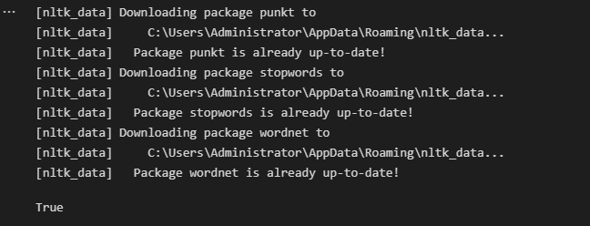

df = pd.read_csv('spam.csv', encoding='latin-1')

df = df.drop(['Unnamed: 2','Unnamed: 3','Unnamed: 4'],axis=1)

df.head()



def cleaning_reviews(df):

messages = list()

lines = df['v2'].values.tolist()

for i in lines:

text = i.lower()

pattern = re.compile('http[s]?://(?:[A-Za-z]|[0-9]|[$-_@.&+]|[!*\(\),]|(?:[0-9a-fA-F][0-9a-fA-F]))+')

text = pattern.sub("", text)

tokens = nltk.word_tokenize(text)

table = str.maketrans('', '', string.punctuation)

stripped = [w.translate(table) for w in tokens]

words = [word for word in stripped if word.isalpha()]

stop_word = set(stopwords.words('english'))

stop_word.discard("not")

words = [nltk.WordNetLemmatizer().lemmatize(w) for w in words if not w in stop_word]

words = ' '.join(words)

messages.append(words)

return(messages)

corpus = cleaning_reviews(df)

corpus.__len__()



corpus[0:5]

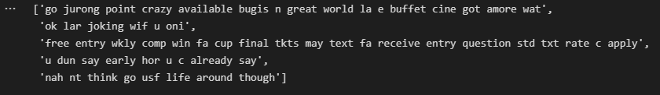

df.v1.value_counts()

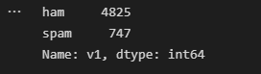

CV = CountVectorizer(max_features= 500)

X = CV.fit_transform(corpus).toarray()

Y=pd.get_dummies(df['v1'])

Y = Y.iloc[:, 1].values

print(X[0:3])

print(Y)

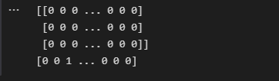

feature_names = CV.get_feature_names_out()

print(feature_names.__len__())

print(feature_names)

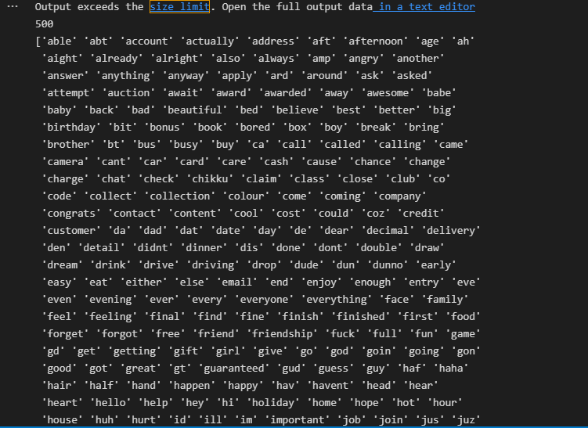

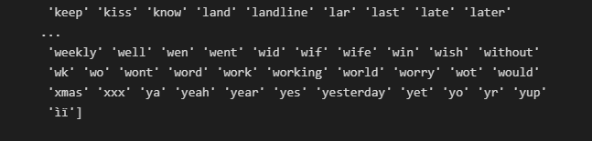

from sklearn.model_selection import train_test_split

X_train, X_test, Y_train, Y_test = train_test_split(X, Y, test_size=0.3, random_state=42)

from sklearn.naive_bayes import MultinomialNB

spam_detect = MultinomialNB().fit(X_train, Y_train)

Y_pred = spam_detect.predict(X_test)

print(accuracy_score(Y_test, Y_pred))

print(f1_score(Y_test, Y_pred))

print(precision_score(Y_test, Y_pred))

