Real Estate System

Software System Design

Document Specification

Version 1.1

Date: 12/15/15

Prepared by:

Matthew Chiappa

Danny Lin

Helen Lin

Steven O’Brien

**Table of Contents**

1 Introduction 3

2 Application Architecture 3

3 Required System Functions 4

4 User Interface 5

4.1 Customer’s User Interface 7

4.2 Agent’s User Interface 9

5 System Components 13

6 Database 13

7 Required Software and Hardware 14

**Table of Figures**

Figure 1. Information Flow in Real Estate System 4

Figure 2. Login Page GUI 6

Figure 3. Registration Form GUI 7

Figure 4. Customer Interface GUI 8

Figure 5. Edit Account Information GUI 8

Figure 6. Change Password GUI 9

Figure 7. Check Offer Status GUI 9

Figure 8. Agent Interface GUI 10

Figure 9. View offers and decide whether to accept or decline Offers GUI 11

Figure 10. Add new property GUI 12

# **Preface**

This software requirement is intended for the client – Real Estate Company. This is version 1.1 of the Real Estate System software.

## **Modification History**

|  |  |  |  |
| --- | --- | --- | --- |
| **Date** | **Version** | **Author** | **Summary of changes** |
| 11/22/2015 | V1.0 | Matt Chiappa, Danny Lin, Helen Lin | Started document |
| 12/15/2015 | V1.1 | Matt Chiappa, Danny Lin, Helen Lin, Steven O’Brien | Updated website images. |
|  |  |  |  |

## **Intended Audience**

This document is intended for all stakeholders of the Real Estate Company.

# **Introduction**

The Real Estate System is based on the two kinds of functional uses. One is for the agent, who has the authority to access all of the information about the property, including the general descriptions and the advanced descriptions, and to decide whether accept or decline the offer from the customer. The other functional use is for the customer, who has less access to the information of the property, but provides the user the option to submit an offer and check the status of the offer.

Since users will be choosing how they like to interact with the system, the architectural style will be event-driven. Therefore system components will react to users externally generated events and communicate with other components through these events using GUIs.

# **Application Architecture**

The major components would be agent and customer functionalities. The basic information flow in the RES should be agent to system, system to customer. In other words, the agent provides the information of the new property from the agent interface and passes them into the system. After the system received and arranged the information well, it will provide some, but not all, information about the properties and pass them to the customer interface. There, the customer could see the basic descriptions of the property.

However, there is another information flow routine, which is also very important, is the offer list routine. The customers could go through the properties and make appropriate offers to the property that they like. The information of offers should be passed into the system from customer interface to the agent interface. After the agent makes the decision of the offer, there is feedback from agent interface to the customer interface via system. Figure 1 shows the information flow in the RES.

Figure 1. Information Flow in Real Estate System

In this program, we will use html, css, bootstrap, and php to create our website. Also, the will be hosted on the CSI’s server and access a database that will store all data relating to the properties and the agents. We will to use MS Azure cloud MySQL database for our RDBMS.

# **Required System Functions**

Main Interface Functions:

1. Allow users to login.
   1. Prompt user for username and password.
   2. Validate username and password with the database.
2. Allow users to register.
   1. Prompt user information.
   2. Check against the database to make sure username is available.
   3. Store user information into the database.

Customer’s Functions:

1. Access the basic information of the house.
   1. UI that will display properties information.
   2. Retrieve properties information from the database.
2. Customers can navigate through the properties list.
   1. UI will display a previous and next navigation link.
   2. Retrieve properties information based on appropriate database query.
3. Create an offer to the selected property and submit it into the system.
   1. UI that will allow customers input the offer information.
   2. Store the offer information into the database.
4. Check the status of their offers, which means the agent has accepted or declined their offers.
   1. UI that will allow customers to view the offer status.
   2. Retrieve the offer status information from the database.

Agent’s functions:

1. Access to all the information of the house which includes property description and advanced description.
   1. UI that will display properties information.
   2. Retrieve properties information from the database.
2. Agent can add a new property listing into the RES.
   1. UI that will allow agent to input the properties information.
   2. Store the properties information into the database.
3. Agents can navigate through the properties list.
   1. UI will display a previous and next navigation link.
   2. Retrieve properties information based on appropriate database query.
4. Display the offers list for each property.
   1. UI that will display offers.
   2. Retrieve the offers information from the database.
5. Make a decision on the offers in the offers list, i.e. accept or decline the offer.
   1. UI that will allow agents to make the offer acceptance/rejection.
   2. Store the offer status information from the database.

# **User Interfaces**

The Real Estate System has one main interface for user login and two types of user interfaces, one for customers and one for agents. The two different types of user interfaces will have different required inputs, outputs, data access and authority.

When the user first opens the software, the main interface – the login page - would show up (Figure 2). The main interface is the most basic interface of the RES, which has two options: 1) “Login” or 2) “Register”. Login requires the user to have a valid username and password. Invalid input by the user would result in an error message displaying the issue. Register (Figure 3) allows new users of the RES to create an account. There are two types of users: “Customer” and “Agent”. By default, if you are registering through the front end, i.e. through the RES – the account you create is a “Customer” account. To create an “Agent” account, this must be done in the back end, at the machine where the database files are stored at. A successful login will display either the Customer Interface (Figure 4) or the Agent Interface (Figure 8) based on the account logging in.

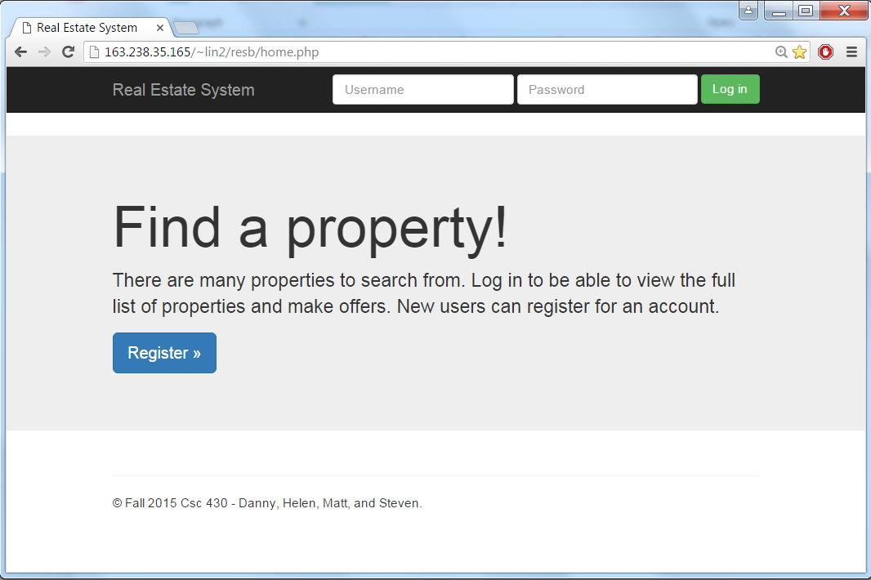

Figure 2. Login Page GUI

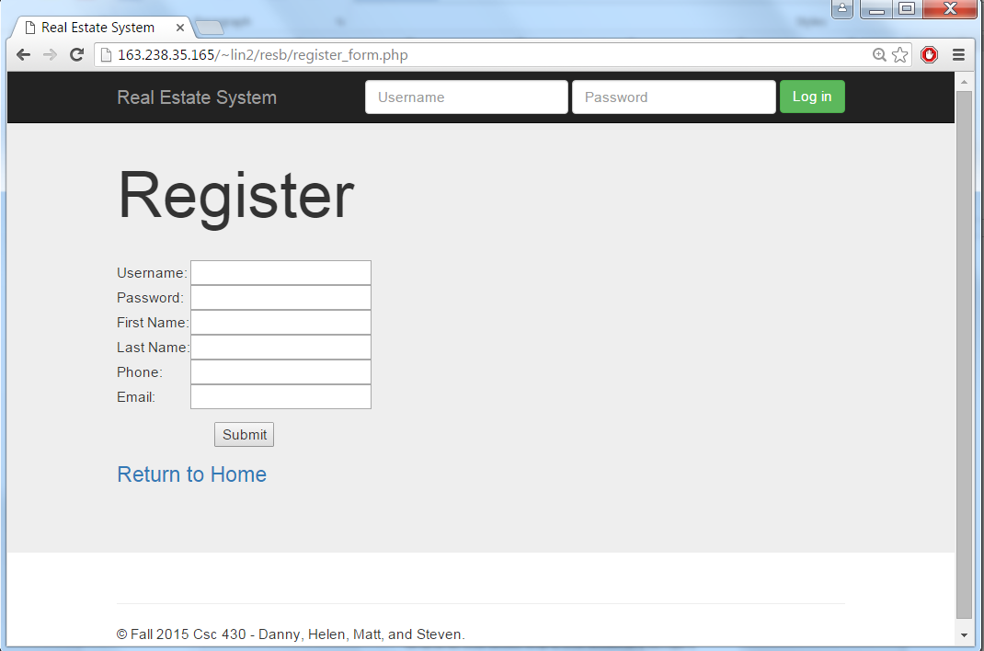

*Figure 3. Registration Form GUI*

## **Customer’s User Interface**

The Customer will be able to view all available properties for sale, submit an offer for a property, view and edit their account information through the account information screen (Figure 5), change their password associated with their user account through the change password screen (Figure 6), and also view the status of their offer and update their offer through the offer status screen (**Error! Reference source not found.**).

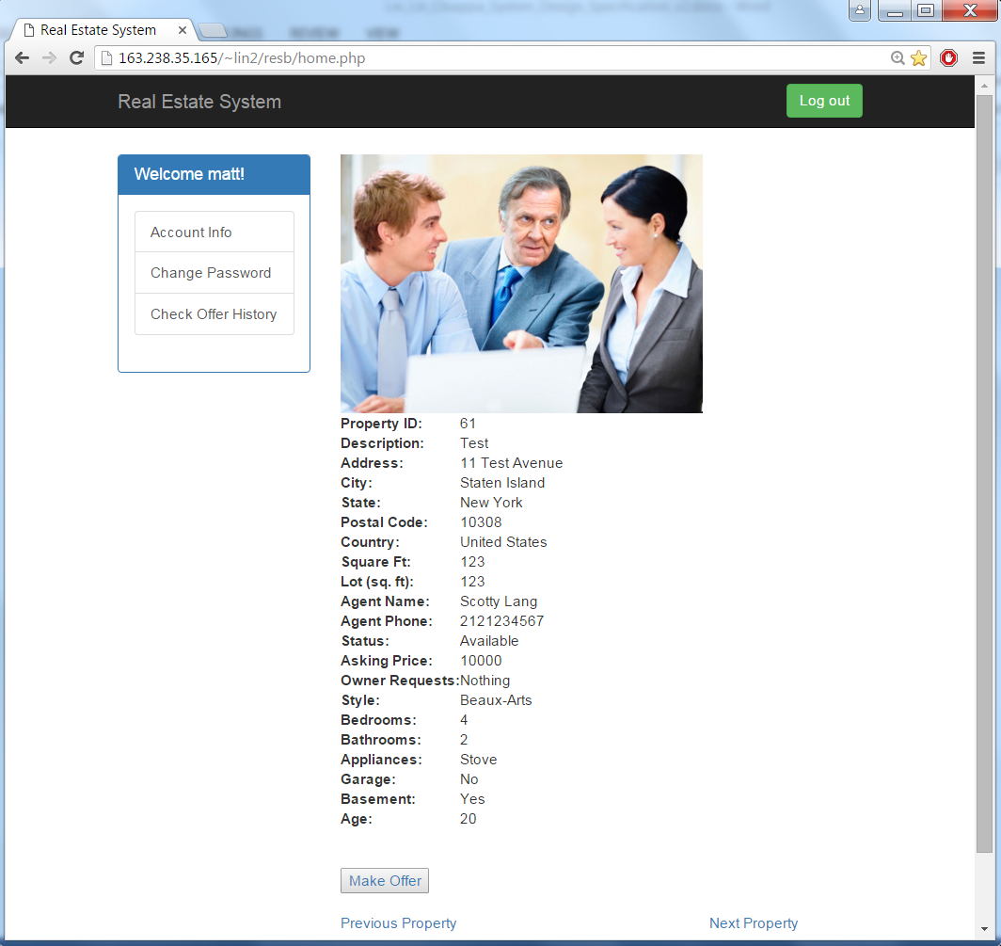

Figure 4. Customer Interface GUI

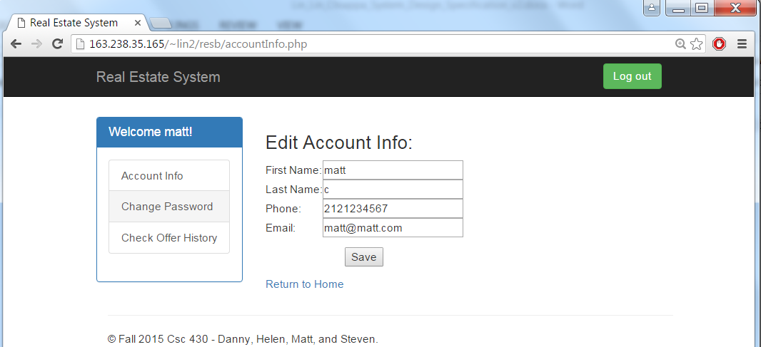

Figure 5. Edit Account Information GUI

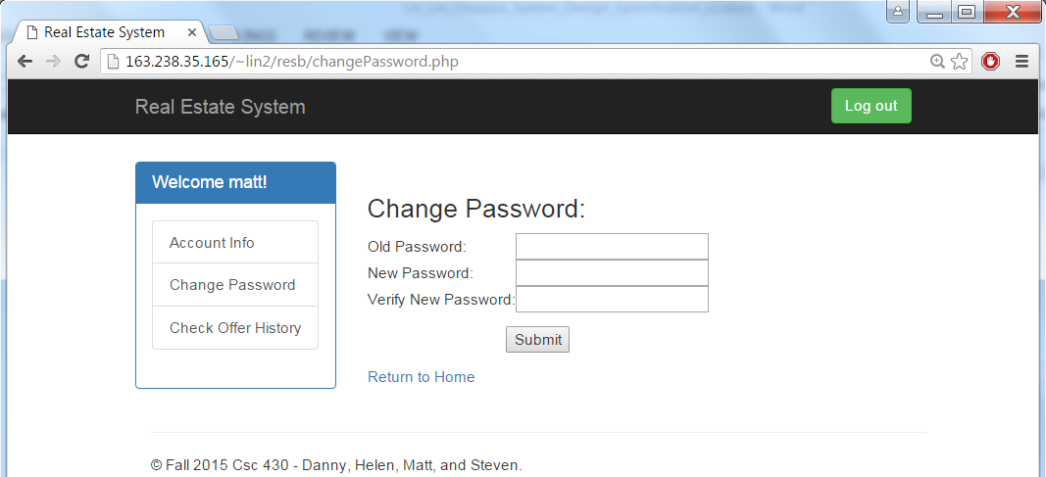

Figure 6. Change Password GUI

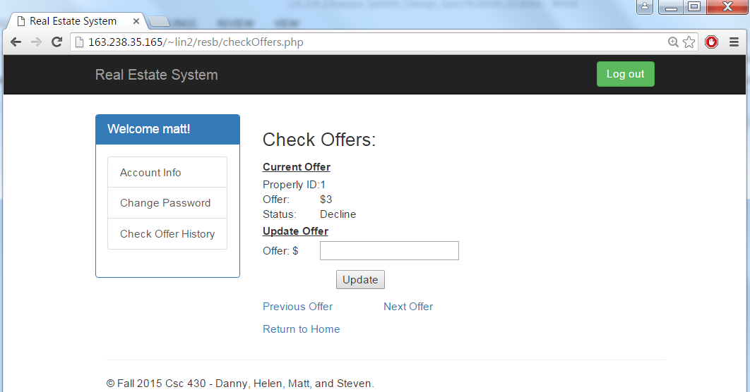

Figure 7. Check Offer GUI

## **Agent’s User Interface**

The Agent will be able to view and edit all properties within their database (this includes available and sold properties), view and edit their account information through the account information screen (Figure 5), change their password associated with their user account through the change password screen (Figure 6), view offers on all properties and make the decision to decline or accept an offer (Figure 9) – accepting an offer for a property will automatically decline all other offers on the same property and modify the property listing from the available listings the customer will see, in addition, agents will be able to add a new property through the add listing screen (Figure 10).

Compared to the Customer Interface, the Agent Interface will be more detailed showing agent comments, as well as access to owner information. Agents will have additional features that customers do not have access to such as updating property information, accepting or declining offers, and adding a new property.

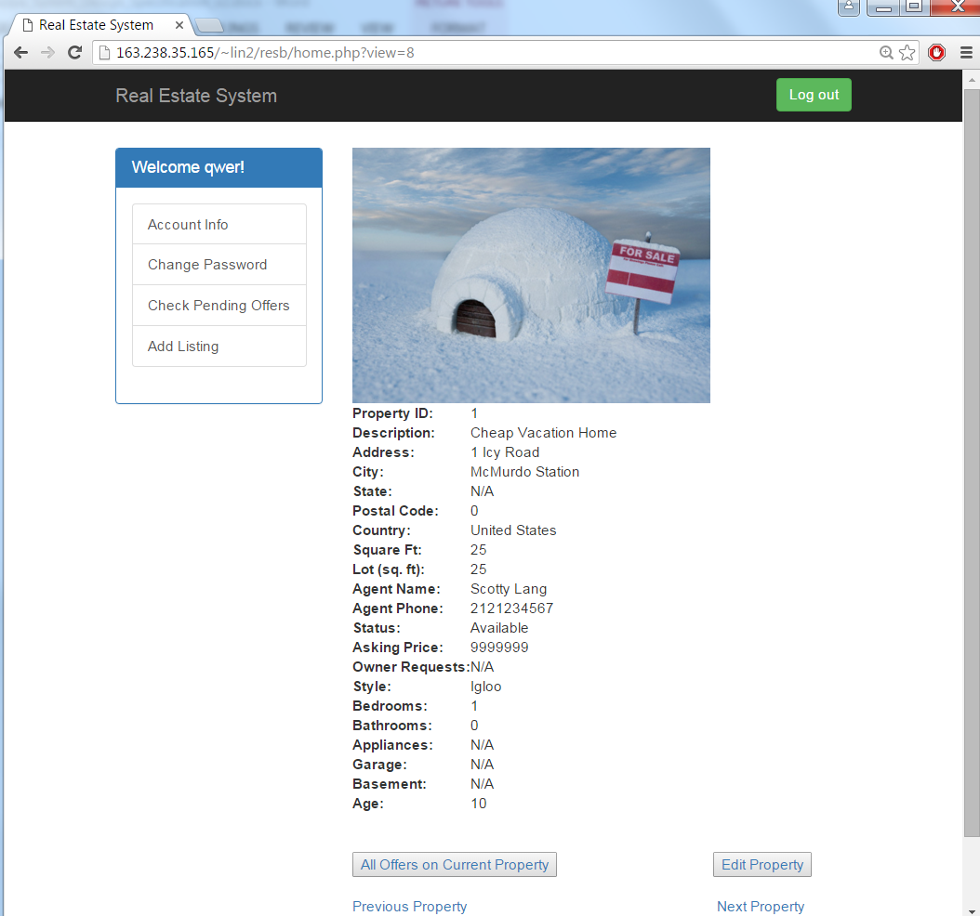

Figure 8. Agent Interface GUI

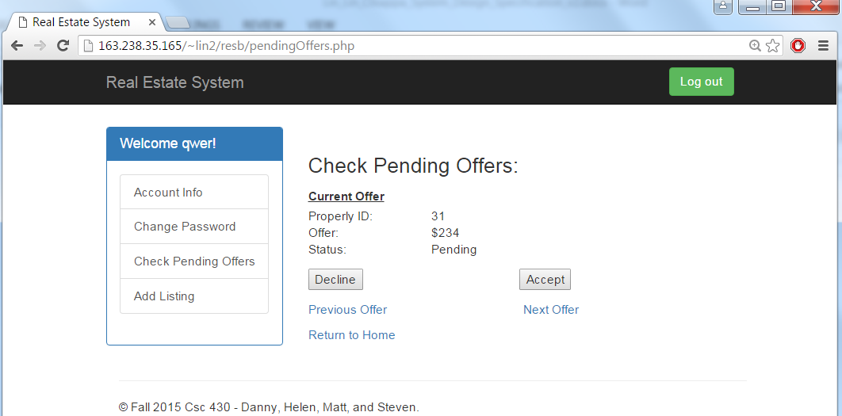

Figure 9. View offers and decide whether to decline or accept Offers GUI

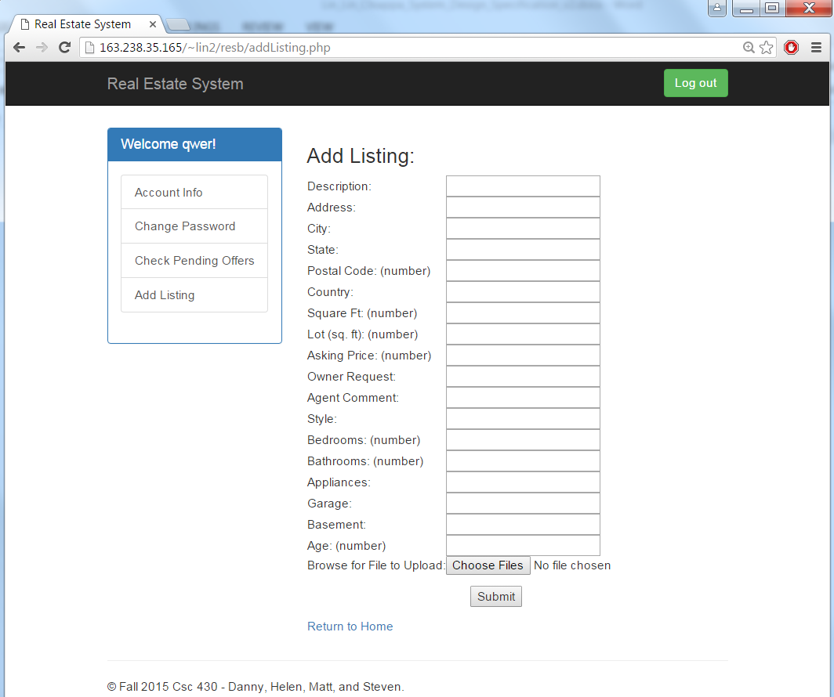

Figure 10. Add new property GUI

# **System Components**

List of system components or modules, their functions and how they interact with each other.

|  |  |  |  |  |
| --- | --- | --- | --- | --- |
| **Name** | **Function Description** | **Input Data** | **Output Data** | **Dependencies** |
| Login | Allow users to login. | username and password | confirmation: login successful or unsuccessful | database |
| Registration | Allow users to register. | user information | confirmation: registration completed or incomplete | database |
| Customer Properties Display | Display the properties information. | navigate to next or previous property in the list | properties information list | database |
| Customer Offer Submission | Create an offer to the selected property and submit it into the system. | offer information | confirmation: offer has been submitted | database |
| Customer Offer View Status | Check the status of their offers. |  | offer status | database |
| Agent Properties Display | Access to all the information of the properties. | navigate to next or previous property in the list | properties information list | database |
| Agent Properties Add | Agents can add a new property listing into the RES. | properties information | confirmation: new property added | database |
| Agent Offers Display | Display the offers list for each property. |  | offers list | database |
| Agent Offer Acceptance or Rejection | Agents can make a decision on the offers in the offers list. | acceptance or rejection | confirmation: offer decision has been made | database |

# **Database**

The database will have three main tables: users, properties, and offers. Users will be able to access the properties tables and the functionalities allowed for the user will depend on their userType (i.e agent or customer). Users will place offers into the offers table, which will be received by the corresponding properties.

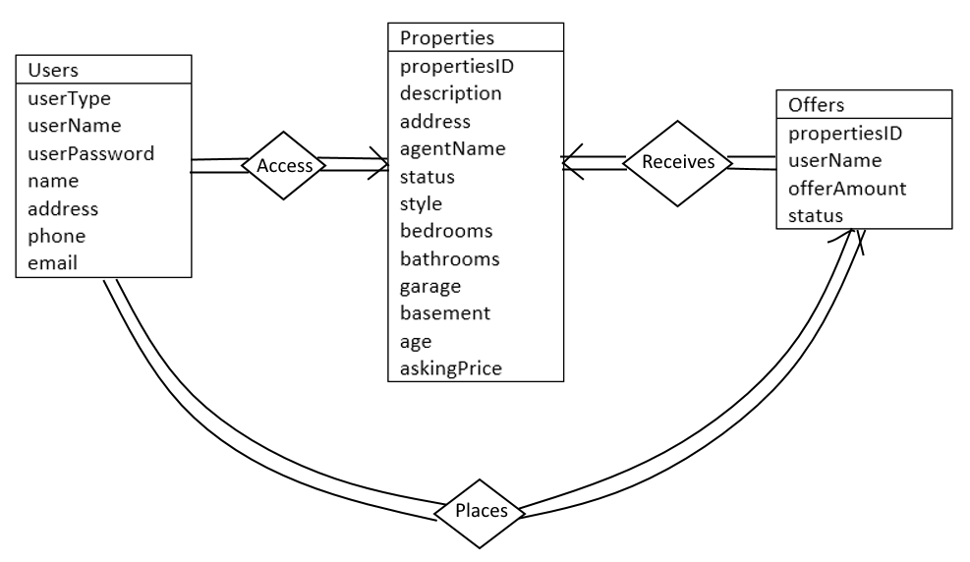

Figure 11. ER Diagram (smiley face)

# **Required Software and Hardware**

In order for the program to be installed and run properly, the client will need to have a computer that meets the minimum system requirements for the RES.