Real Estate System

Software Requirements Document

Version 1.1

Date: 12/15/15

Prepared by:
Matthew Chiappa
Danny Lin
Helen Lin
Steven O’Brien

Table of Contents

- Preface………………………………………………………………………………4
  - Modification History…………………………………………………………….4
  - Intended Audience……………………………………………………………….4
- Introduction…………………………………………………………………….…..4
  - Purpose of the requirements document………………………………………….4
  - Scope of the project……………………………………………………………...4
  - Overview of the remainder of this document……………………………………5
- Glossary…………………………………………………………………………..…5
- User Requirement Definition…………………………..……………………......5
- System Requirements Specification………………………………………........5
  - Functional Requirements………………………………………………………...6
  - Non-functional Requirements…………………………………………………...6
- System Architecture………………………………………………………………6
- System Models………………………………………………………………….…7
  - Use Case Diagram……………………………………………………………….7
  - Scenario Diagram………………………………………………………………..8
  - Class Diagram…………………………………………………………………...8
- System Evolution………………………………………...……………………......9
- Appendices………………………………………….……………………………...9
- Index…………………………………...…………………………………………….9

Table of Figures

Figure 1: Use Case Diagram………………………………………………………………7
Figure 2: Sequence Diagram 8
Figure 3: Class Diagram 8

Preface
This software requirement is intended for the client – Real Estate Company. This is version 1.1 of the Real Estate System software.

Modification History

Date | Version | Author | Summary of changes
11/22/2015 | V1.0 | Matt Chiappa, Danny Lin, Helen Lin | Started document
12/15/2015 | V1.1 | Matt Chiappa, Danny Lin, Helen Lin, Steven O’Brien | Updated the system and functional requirements

Intended Audience
This document is intended for all stakeholders of the Real Estate Company.

Introduction
This Real Estate System (RES) software will address the client’s, Real Estate Company, need for a system where their clients – prospective homebuyers, will be able to access the Real Estate Company’s properties and listings in order to place a bid on listings they are interested in. The real estate agents of the Real Estate Company will be able to access the system to add listings and accept or decline bids. The presentation layer will be a graphical user interface accessible through the web. It will connect to web services and modules in the backend that will be connected to a MySQL database for data access.

This RES software will improve user conversion (more listings sold) by allowing the client, Real Estate Company, to reach out to a larger audience through the internet.

Purpose of the requirements document
The primary purpose of the software requirements document is to introduce the Real Estate System Project to the users who will use the system and programmers who may revise the program as they need in the future.

Scope of the product
The Real Estate System is designed to store a large number of properties and all pertinent information about the properties. Most people need a place to live, the RES will cater to individuals looking to purchase a new property. One tough aspect for prospective new home buyers is finding a property they like, this is also a concern of our client, Real Estate Company. Real Estate Company is dedicated to providing easily obtainable access to the many listings they have to these home buyers. The aim of the RES is to provide prospective new residents and readily available information about the properties available for purchase on the market, as well as other comprehensive information on the properties. This will increase the visibility for our client, the Real Estate Company, and in turn increase conversions.

Overview of the remainder of this document
In the rest of the software requirements documentation, we will provide key terms and their associated meaning in the Glossary section (Section 3).

Glossary

Term | Meaning
Product Users | These are users who interact with the RES directly through the web presentation interface. For instance, this will include both prospective home buyers (customers) as well as employees of the Real Estate Company – agents, supervisors, project managers, project developers, and administrators.
Customers | These are users who interact with the RES directly through the web presentation interface. They will mainly be comprised of prospective home buyers.
Agents | These are users who interact with the RES through the web presentation interface. They will be employees of the Real Estate Company in charge of the property listings.

User Requirement Definition
The Product Users will be able to access the RES through a web presentation interface. Product Users comprise of mainly Customers and Agents.

Customers will be able to create an account and/or log in with an existing account. They will be able to browser all property listings that are available for purchase. Customers are able to filter their search through all the listings. Customers can view information about the properties. They will also be able to enter an offer for properties. Customers are informed of the status of their offers, i.e. whether they have been accepted or declined.

The Agents are able to add/modify a property for sale and input the property information. Agents are able to view the offer’s list and accept or decline any offer.

System Requirements Specification
The system requirements for the RES include:

- Allow users to login/create an account as a customer or as an agent.
- Allow customers to find a property for sale.
- Allow customers to browse through all the properties.
- Allow customers to view property information such as location of the house, size of the property, style of the house, types and number of rooms, appliances that come with the property (i.e. refrigerator), parking space, condition of the property, age of the house, and status of the house (i.e. for sale or sold).
- Allow customers to enter an offer for the desired property and receive a notice of acceptance or rejection.
- Allow agent to add/modify a property for purchase and relevant property information such as the property description, asking price, and specific requests (i.e. the allowance of pets or smokers as tenants)
- Allow agent access to the offers list to allow them to accept or decline the offer.

5.1. Functional Requirements
Some functional requirements of the RES to keep in mind are: when the Product User input their username and password, the system will verify this information against the database of user login information. If the information matches, the user is granted access to the Real Estate System. If the Product User wants to create an account, the user will be enter a username, password, and other relevant information, which will be stored into the database of user login information.

Customers will be able to browse through a list of all the properties. Customers can view a specific property information and make an offer. Customers will also receive a notice if their offer is accepted or declined.

Agents will be able to add a new property for sale along with the relevant property information, which will be stored into the database of properties. Agents are able to view a list of offers they receive and choose to accept or decline the offers. Agents are also able to modify property information and status (i.e. sold).

5.2. Non-functional Requirements
This Real Estate System must have a large enough database to store the user and property information.

System Architecture
Present the high-level overview of the anticipated system architecture. Architectural component that are reused should be highlighted.

System Models
This section will provide an use case diagram, sequence diagram, and class diagram as tools to visualize the RES in action.

Use Case Diagram
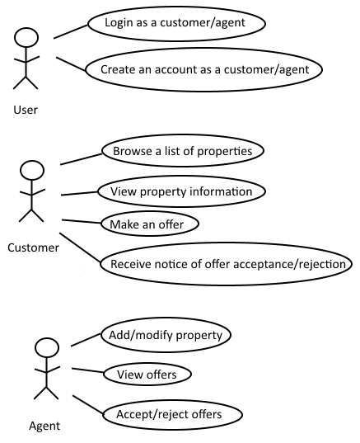
Figure 1: Use Case Diagram depicting Product Users
Use Case Name: Customer browse a list of properties.
Description: The Customer will be presented with a list of properties drawn from the database in the system. The customer make an offer on properties and view their offers status.

Sequence Diagram

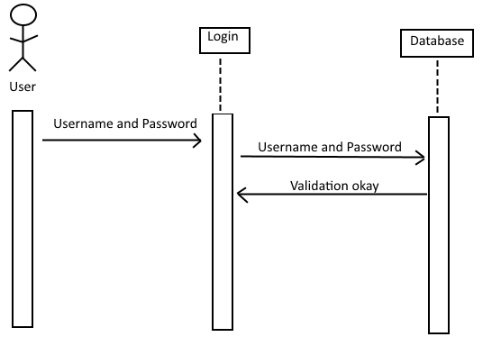
Figure 2: Sequence Diagram depicting the interaction between front and back end.

This sequence diagram depicts the interaction between the front end and the backend. The Product Users log into the RES with their username and password in the presentation layer web interface which calls upon the web service to authenticate the user by accessing the RES database.

Class Diagram
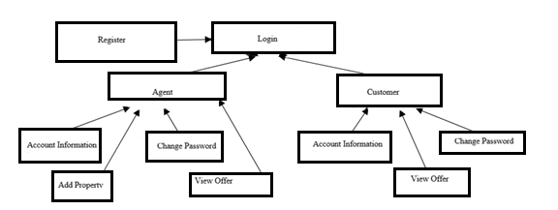
Figure 3: Class Diagram depicting the classes in the RES

The above is the class diagram for the RES. We can see that there will be classes: register, login, agent, customer, account information, change password, view offer, add property.

System Evolution
As the RES database increases, we will need to address the issue of scalability by optimizing the filter search feature. More memory may be needed to host the data.

Appendices
To be updated upon future versions.

Index
To be updated upon future versions.

