Analyzing Customers and Products

On the Welcome page, we have a home called DjTraders Home. Clicking DjTraders Home or the Home button will help you navigate the DjTraders home page with customers and products. With enhanced UI, we can see the home, customers, and products sections to navigate, respectively. Homestays are on the home page; no navigation is added here. Clicking the View Customers button will take you to the Customers page, similar to the Browse Products button.

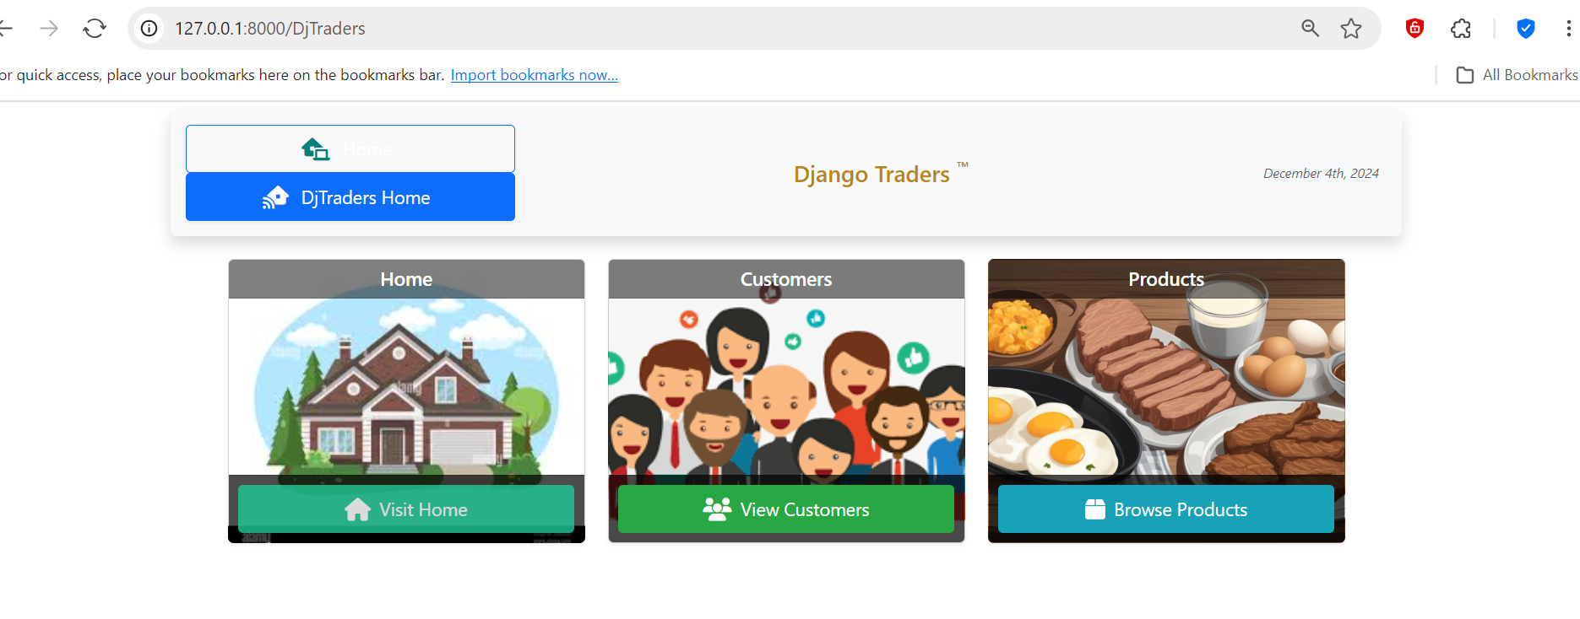

Let's first look at the functionality of customers. I am clicking on View Customers.

**Customers:**

When you click, it navigates to the Customers.html page, where you can see the customer details, which displays the list of all customers, search operations, edit, delete, and other functionalities. Performing search functionalities: We can perform search operations with customer names, contact names, City, and Country.

I added an icon and functionality to the HTML for the details view. Clicking “View User” navigates you to the customer details page, which displays information about a specific customer and all the customer requirements for this assignment. This view shows information about the customer - name, contact, address, etc. —and the orders the customer has placed. The order details display order quantity, price and total, and product name.

***Requirement 1:*Customer Sales Analysis:**Provide each customer (once they log in) with the means to view trends and patterns in their sales by developing a UI to analyze and view their sales patterns.

**1A. Customer Dashboard/Portal:** Add a dashboard to summarize the customer's sales analysis. You can decide what information is displayed on the dashboard.

I am clicking on Around the Horn Customer. Here, we have various tabs to show the customer's analysis. The Home tab displays the visualization of Orders placed and Order totals by date for the customer. I have also added the order data in tabular form.

Now, click on the Dashboard Tab. On clicking Dashboard, we can view the tabular data summary of the customer sales analysis, the number of orders placed, order IDs, placed data, and the respective product details, which include product name, quantity, price, and total.

I have added icons and a user-interactive look to make it easy to understand the tabs.

Scrolling down gives the entire list of orders.

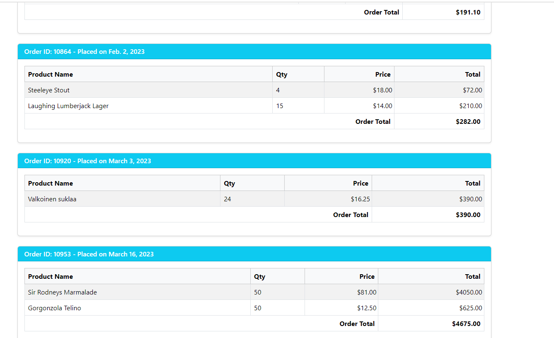

**1B. Annual Sales Analysis:**Annual sales are measured by the number of orders placed, the number of products sold, and the annual revenue generated, with the ability to drill down into monthly sales for each year.

When you click the Customer Annual Sales tab, the visualization shows the annual sales, including the number of orders placed, sold, and revenue generated. Selecting a particular year also generates the visualization monthly for that respective year.

By default, it shows All, i.e., Annual data. We can get a monthly-wise selection of a year from the year drop-down.

When the bars are hovered, labels with the data, i.e., order date, total, and IDs, should be shown.

For annual orders, it shows year and order totals. The label here displays the customer name and Year filter dropdown.

Now, I am selecting the Year 2021. It displays the monthly data for that year.

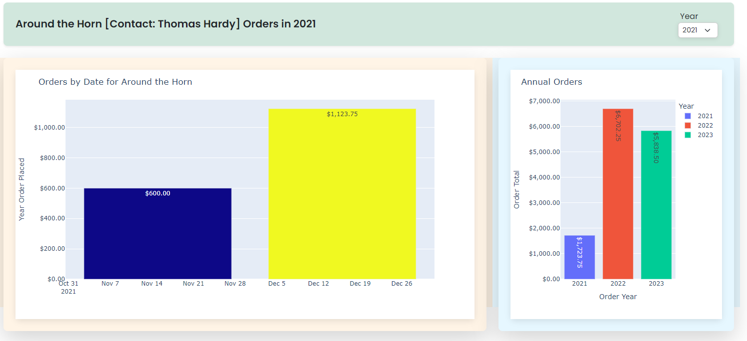

Similar for other years, 2022 and 2023.

2022:

2023:

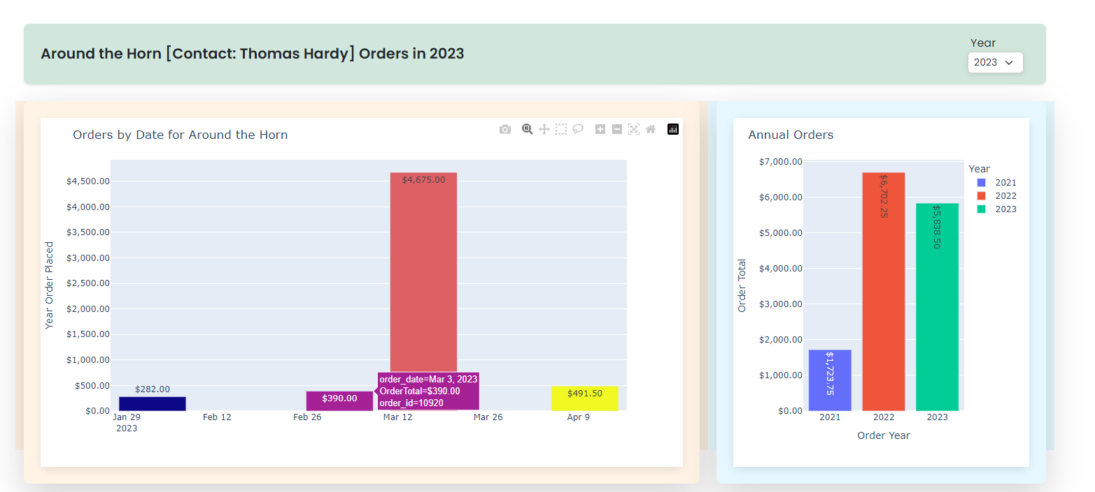

I have made the UI for screens and graphs fit and highlighted the borders while having to display data correctly.

**1C Top Products Analysis:**Most bought (Top 10) *products* for each year and across all years.

Clicking the Top Products tab allows us to visualize the products the customer has purchased. This tab gives data for product Revenue and product quantities.

Scrolling down gives the full view.

**1D. Top Categories Analysis:**Most bought (Top 10) *product categories* for each year and across all years.

Clicking the Top Products tab gives data on Category sales revenue and products bought within the category.

***Requirement 2:* Product/Sales Analysis:**For each product, provide the means for managers with views of sales and comparisons across products and categories by developing UI to analyze and view

1. **Annual and Monthly Sales Analysis:**Annual Sales are measured by the number of orders placed, the number of products sold, and revenue generated with the ability to drill down into monthly sales for each year.

When clicking DJ Traders home, we can select Products from the home page.

Clicking on Browse Products navigates to the Products page:

When you click, it navigates to the products.html page, where you can see the product details, which displays the list of all products, search operations, edit, delete, and other functionalities. Performing search functionalities: We can perform search operations with product names, categories, and product prices in respective price ranges.

**Products Details View.**

I added an icon and functionality to the HTML for the details view. Clicking “View Details” navigates you to the product details page, which displays information about a specific Product and the customers who have bought it. This page also has a customer view link to the details view of the customer who has purchased the product. Also, I added a Back button to navigate to the Customers page. All the requirements for this assignment are handled in view. I am clicking on Chang product view. It has various tabs on the global header and, by default, displays the home, which shows the product's data and the customers who bought it.

**2A. Annual and Monthly Sales Analysis:**Annual Sales are measured by the number of orders placed, the number of products sold, and revenue generated with the ability to drill down into monthly sales for each year. When the year is complete, it gives annual and monthly sales together; the respective monthly data is displayed when selecting the year.

Year 2021:

Year 2022

Year 2023:

**2B Top-Bottom Analysis:**Highest and Lowest (Top and Bottom 10) revenue-generating *products* for each year and across all years.

For Year 2021:

Year 2022:

**2C. Product Sales Analysis:**Annual Sales are measured as the number of orders placed, the number of products sold, and revenue generated with the ability to drill down into monthly sales for each year while comparing with the average. It gives monthly comparisons and Annual Sales of respective products.

Year 2021:

Year 2022:

Year 2023:

**2D Category Sales Analysis:**Annual sales are measured as the number of orders placed, the number of products sold, and the revenue generated, with the ability to drill down into sales for product categories.

*Requirement 3 UI:* Used Bootstrap CSS, Icon sets, and CSS and icon libraries to make UI more creative and designed. Enhanced the view of graphs visualization, better alignments to fit the screen, bootstrap, and CSS sets to use various icons and screen settings.