**ES_HW03_109598085**

**吳承岳**

**Part 1：Console message of your compiled Linux Kernel**

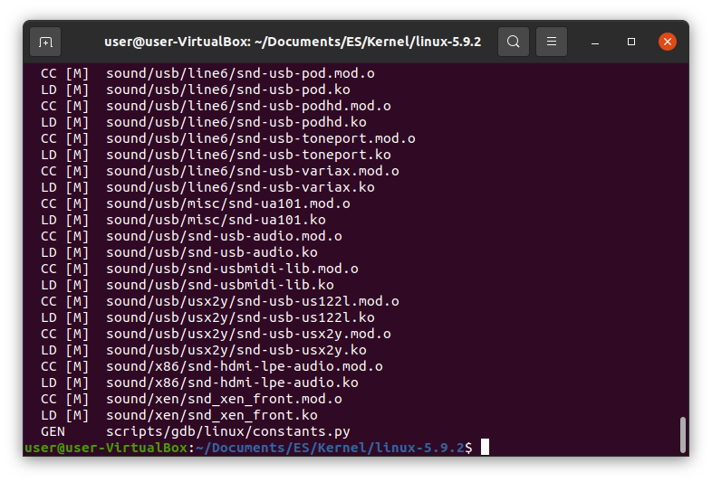

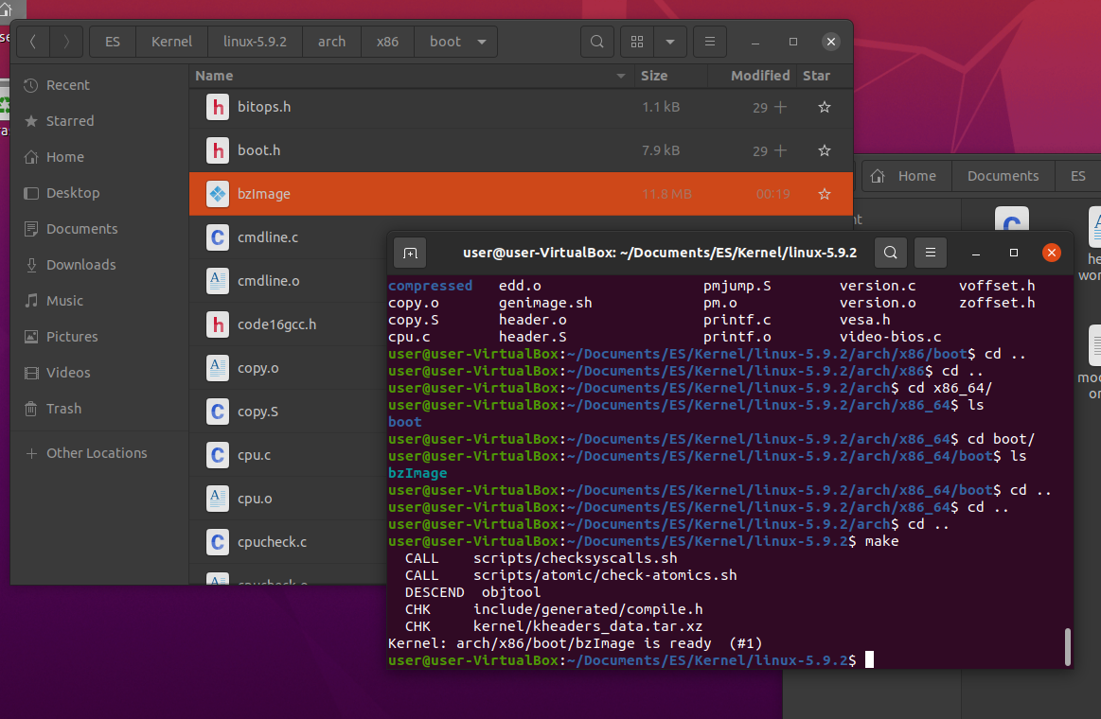

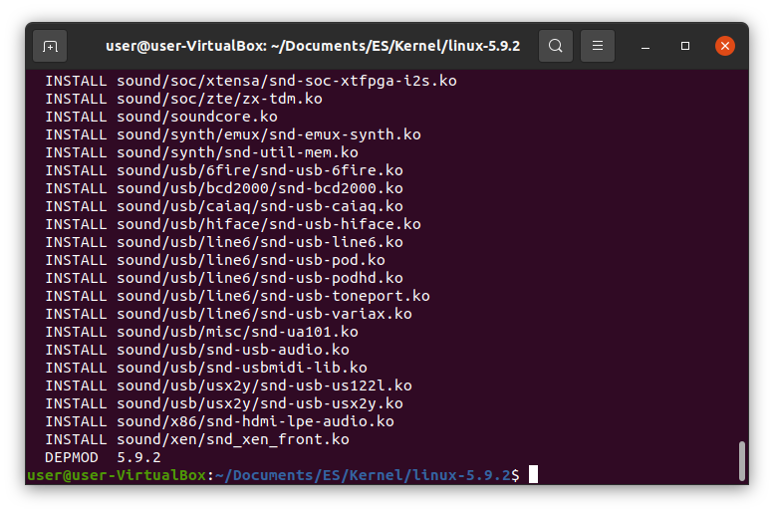

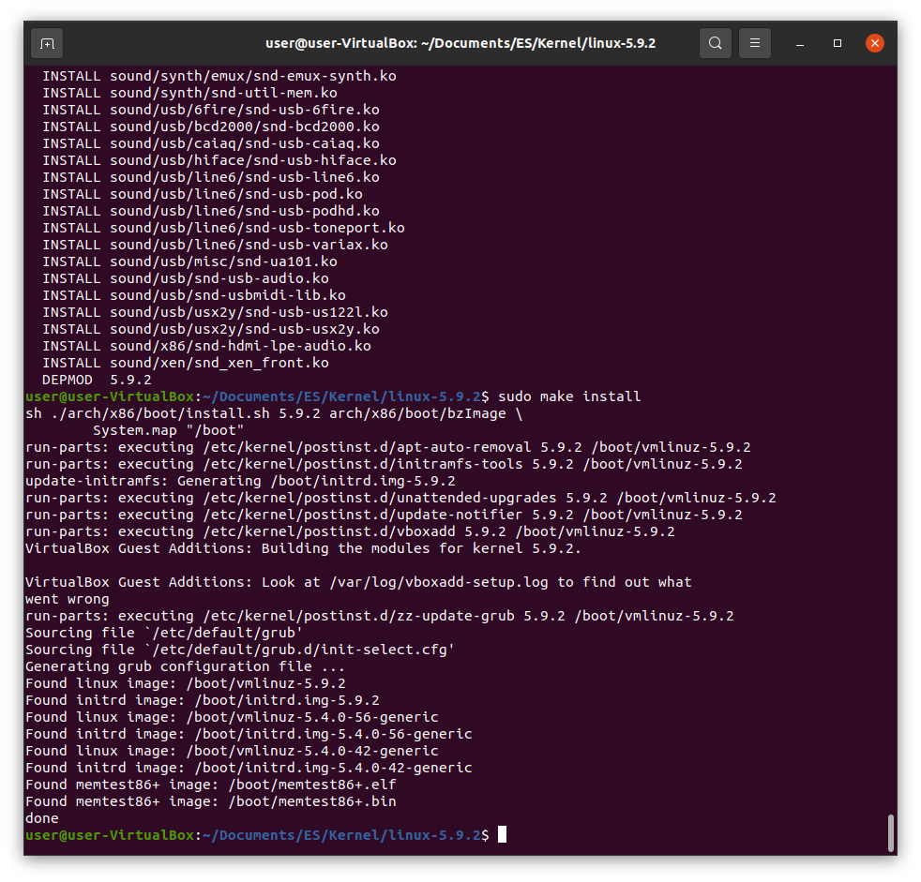

**Part 2 : Hello World message from dmsg after your new Linux Kernel is installed**

