**ES_HW04_109598085**

**吳承岳**

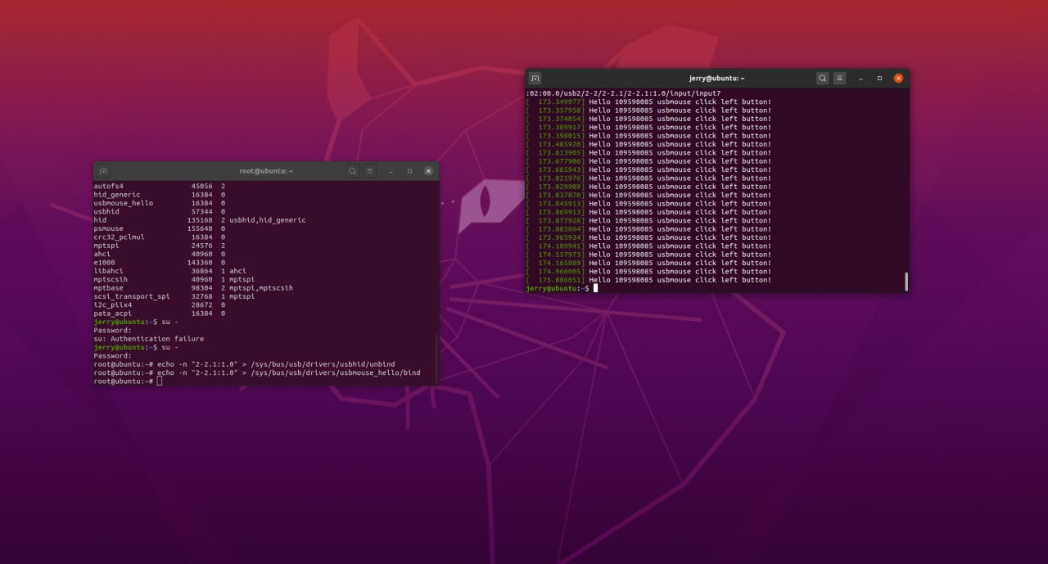**Part 1：Screenshot of your dmsg**