ES_HW00_109598061
廖昱翔
Part 1 : Installation result
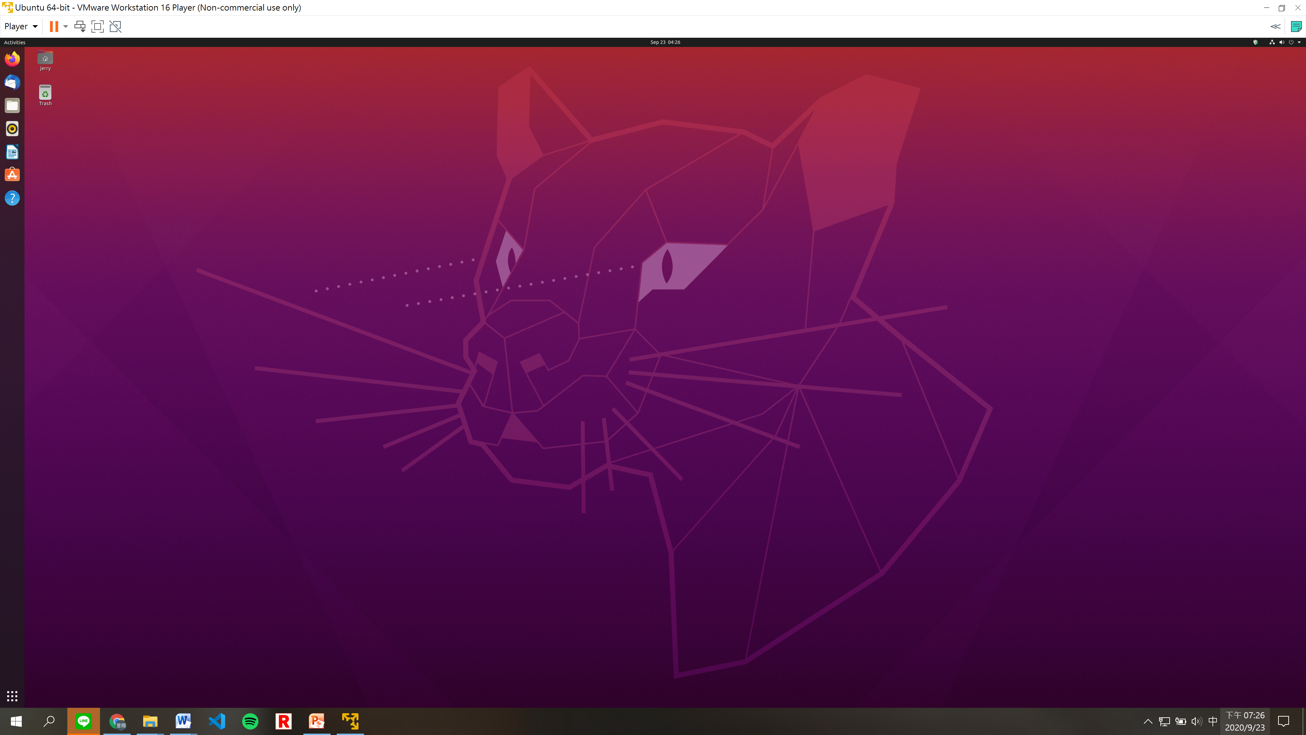

Format Guide:
- Except caption, the content should be set with row height of 20 points, align to the left.
- Caption format: 18pt and Bold font.
- Font format: Times New Roman.
- Figure: Center with single line row height
- Please upload pdf file with the file name format : ES_HW00_109000000
- Please remove the line starting with // and the format guide part.
- Grading Policy of HW00: Correct format 80% and Installation result 20%.

