# Stand up meeting

## What we have done during the past 6 weeks:

**Vy:**

* Fixed the cursor in the DeploymentController.cs
* Did a new iteration in HighScoreController.cs

**Andrew:**

* Added new Easy AI option in GameController.cs
* Added Easy AI feature to the game

**Ashen:**

* Added missing file (siren.wav)

**David:**

* Changed AI option
* Created a menu option that changes the background of the game (excluding loading screens).

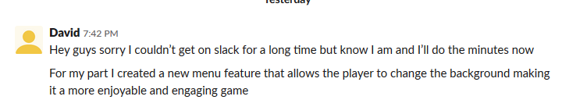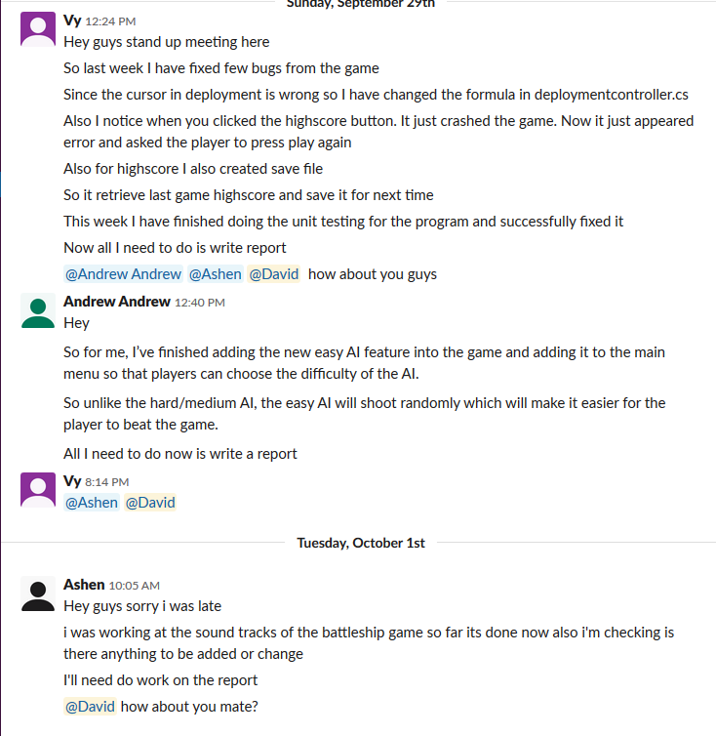

# Next Week 7 task

## What we need to improve:

* Communication
* Put more time into project
* Read the Weekly task on Canvas
* Do individual checklist
* Fix bugs related to background changes.