**Data in Action: A Model of a Dinner Party**

Such data can lead to amazing, revolutionary insights into human behavior to take you on a journey to gain the skills needed to generate those insights to grow your business and improve your products.

Analyzing customer behavior in a web or mobile product. It allows us to collect lots of data on customer behavior—more than was ever possible before—based on everything from what they clicked on to what they told their friends.

We can use this data to improve our product. Social data is powerful because it allows us to analyze thousands, often millions, of simple behaviors that were unknowable even ten years ago and to then work to change and alter that behavior.

Why is user analytics important? User analytics is the lifeblood of the modern economy. Understanding user interactions with web products often determines whether a company will succeed or fail, even when that firm sells real products. As everything moves online, from retail transactions to doctor’s visits, one must understand why users do what they do and rapidly work to improve user experience. The data explosion has allowed us to rapidly iterate and improve social and traditional product marketing, sales, and delivery.

Explores the user analytics space, identifying six core ways in which applications in user analytics differ from traditional data science and statistical applications.

* 1. **THE USER DATA DISRUPTION**
* Understanding user behavior in a variety of contexts can lead to better-targeted campaigns, increased revenue, and greater user satisfaction and engagement for any product. A myriad of professionals, from data scientists to product managers, are tasked with understanding, altering, and predicting user behavior.
* We’ll go over common problems with analyzing user data, an example of a social process (in this case, a dinner party), and common pitfalls when drawing conclusions from complex social processes.
  + 1. **Don’t Leave the Users out of the Model:**

Most modern web products have embedded social components that make them microcosms of society. Social hierarchy, friendship, culture, and a litany of interesting interactions and behaviors drive the lives of these products. The complexity of the human behavior involved makes social products incredibly difficult to analyze without the correct toolkit. Even simple purchasing websites can have gigantic stores of behavioral data and complex behavioral processes that can be analyzed, such as user clicks, sessions, purchasing behavior, and churn.

Clickstream data is the path of clicks through a website or model product ordered by time. User sessions comprise a pattern of consistent use from the first to last interaction on a site. Churn is the number of users or rate of leaving the site over a particular period. All of this data is present in almost all web products, and it can be extremely useful, when combined with the right context, for understanding what your users are doing in your product.

Why is understanding the behavioral aspect of this data useful? Having a model of human behavior will help us to organize, derive insights, and change user behavior. From a business perspective, when you understand who your users are, what they are doing with your product, and what drives them to purchase and engage with your product, then you can try to modify their engagement and revenue behavior. For instance, as an analyst, you might ask the following questions: How can I make this web product sticky—that is, increase user retention? What causes my users to buy? If we make changes to the product, will users adapt?

Let’s understand how many people initially work with data. A very easy way to look at your data is to focus on description. Most analysts stop at this level. Description simply means that you collect data about what people are doing with your product. For instance, suppose the average person visits your site three times in the first month. Users spend 30 seconds looking at listings during the average session. Only 10% of users progress past the homepage. There are a large number of potential descriptive tidbits that you can collect from a web product. Most people’s first inclination is to weave a story together from disparate descriptive facts or to create a story and then search for descriptive facts that support it.

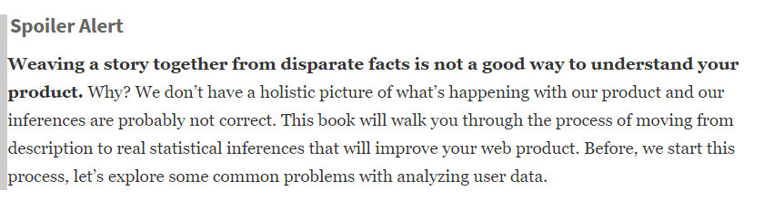

* + 1. **The Opposite of the Misguided Analyst: The Data Guru**

The analytical portion of the data scientist toolkit is primarily composed of Machine Learning/Artificial Intelligence (ML/AI). Why is ML/AI not always that useful? Although other methodologies are also part of the toolkit, ML/AI is generally focused on the problem of prediction. Prediction can be very helpful in forecasting population growth, offering product recommendations, and finding your population at risk for churn. However, prediction is not as useful as causal inference in deriving insights or changing user behavior because it does not help us find variables that cause a user to behave in a certain way, such as deciding to purchase.

* 1. **A MODEL OF A DINNER PARTY:**