Embracing the Science and Art of Metrics

Customer analytics largely involves turning customer actions and attitudes into data.

Adding up Quantitative Data

Quantitative data is information that’s broken down by concrete numbers — for example, how many products a customer places in the shopping cart (3) or how much revenue you earn from a specific customer ($2,000).

Quantitative data falls into two categories:
- Discrete (countable items)
- Continuous (measurements)

DISCRETE AND CONTINUOUS DATA
Discrete data has finite values, or buckets. You can count them.
Other examples of discrete data are
- Number of products in your catalog
- Number of employees you have
- Number of customer reviews for a specific product
Continuous data technically has an infinite number of steps, which form a continuum:
Other examples of continuous data are
- Dimensions of a specific product
- Miles to your retail store from a customer’s location
- Time for a customer to find the information he or she is looking for on your website
- Days until a product ships to a customer
LEVELS OF DATA

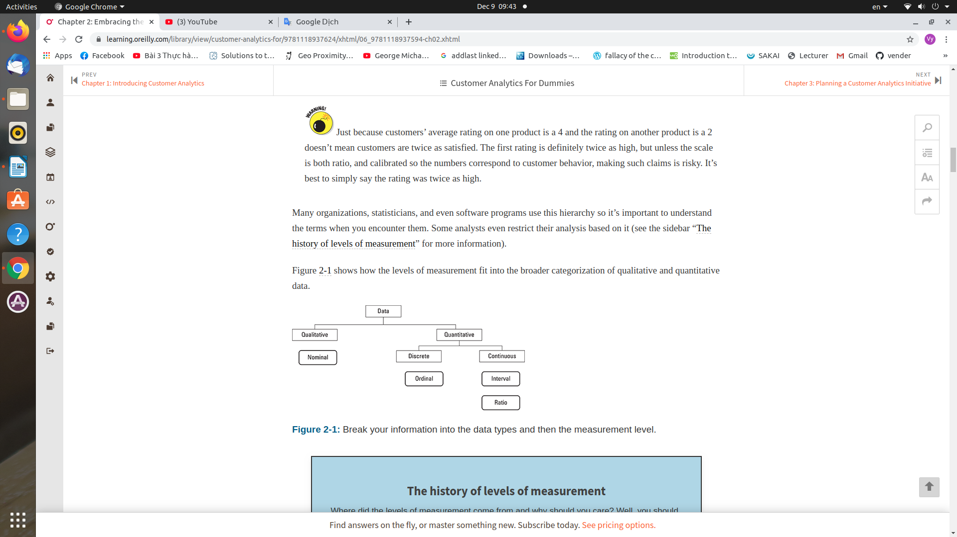

Another way customer analytics data gets divided is by the four levels of measurement.
Nominal: This includes discrete data such as the name of your company, type of car you drive, or name of a product.
Ordinal: This includes data that has a natural ordering.
Interval: This is data that has equally split intervals between each value(between 78 degrees and 79 degrees).
Ratio: This is interval data with a natural zero point.

VARIABLES
A variable is a characteristic of a product or service that varies, which can often be manipulated.
For example, price, delivery time, and color are product variables. Customer variables can include gender, income, geography, new customer versus existing customer, and type of industry, to name a few. When you look at product and customer variables, you can understand how different product attributes attract more or less sales and how different customers respond to different products and feature combinations.
There are two types of variables:

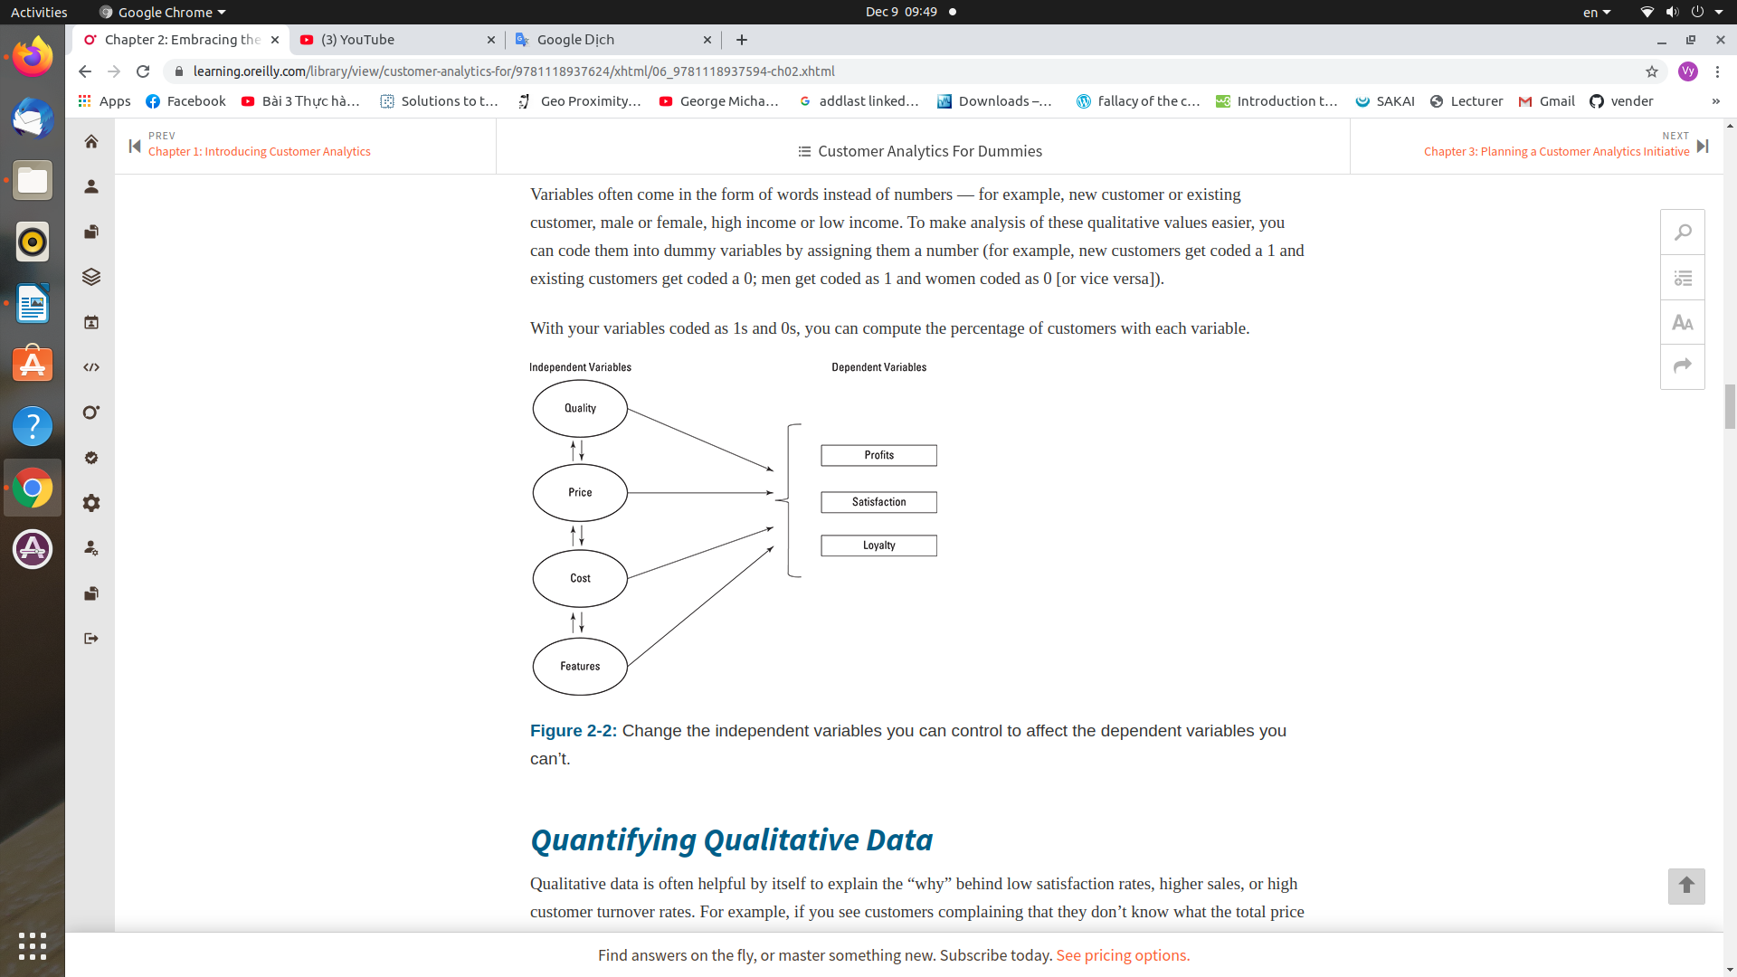

Dependent variables are usually the things you care about but can’t affect directly, such as profitability, customer satisfaction, and customer loyalty. You can influence dependent variables by changing the independent variables.
Independent variables can be directly controlled or manipulated.

Often, independent variables correlate with dependent variables, but the correlation doesn’t equal causation. Other variables that you’re not measuring can “mediate” or be responsible for the relationship. For example, higher sales (dependent variable) might be attributed to a new marketing campaign (independent variable) but the increase is actually just due to a growing economy that’s helped all businesses (mediator variable). See the appendix for more discussion on measuring correlation and causation between variables.

You can think of independent variables as the ingredients you use to cook a stew. The soup is the dependent variable (what you care about), but adjusting the ingredients and their combinations is what you can control.

Quantifying Qualitative Data
Qualitative data is often helpful by itself to explain the “why” behind low satisfaction rates, higher sales, or high customer turnover rates.
Always take the time to sort and count customer comments. Just because customer information is qualitative doesn’t mean you can’t use quantitative methods to interpret qualitative data to make better decisions. If you find that a significant portion of comments revolve around a specific issue (say 20% of the comments center around currency issues), you’ve just turned your qualitative data into quantitative data.

Quantifying iTunes experiences
My company asked 56 customers to rate their experience with iTunes. Customers answered several questions about the ease of use and quality of iTunes and whether they would recommend it to their friends. Customers who provided low scores were asked to briefly describe what motivated the rating.
For example, one customer said
I used to use iTunes much more often before they raised their prices from 99 cents to $1.29 per song. I still use the iTunes player to transfer songs to my iPod but I usually buy songs on Amazon.com now because it’s a much better deal.
And another said
I dislike iTunes. It’s unnecessary and can be annoying and difficult to use.
In total, 16 customers were rather dissatisfied with the iTunes experience. To understand the main drivers behind the dissatisfaction and the prevalence of some of these issues in the larger population, similar comments were first grouped, followed by the total number of comments in each of the groups. This table shows the results.

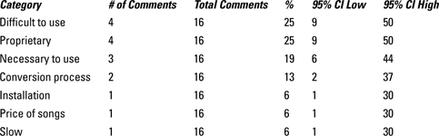Conclusions from this data indicate that one of the primary reasons users are unlikely to recommend (called detractors) iTunes is because it is difficult to use, with four users making comments about ease.
Usability is often a key driver of product loyalty, and iTunes is no exception. (See Chapter 14 for more on usability.) I was 95% confident that between 9% and 50% of all iTunes detractors feel ease of use is one of the main reasons for not recommending the product to a friend.
I generated a 95% confidence interval around each group of comments using the online calculator (www.measuringu.com/wald.htm) to get an idea about how prevalent these reasons would be in the whole iTunes user population.

Quantifying the frequency of customer comments helps you understand how prevalent a certain attitude may be in your entire customer population. Some examples of open-ended responses (often called verbatim responses) are common for things such as:
- Reasons why customers are not recommending your product
- Observations from customers using a product at their workplace
- Product complaints in customer service calls
Here are three steps you can follow to turn qualitative data into quantitative data to estimate the prevalence of responses:
Group similar comments and behaviors
Customers will use their own words to describe how they feel. Group similar phrases, behaviors, or concepts together. Some comments will be virtually identical and grouped easily. Others will differ and require additional layers of grouping.
Count the frequency.
Count the number that appear in a category and the total number. If 5 out of 50 comments are related to price, for example, then an estimate of how often price is a concern is 10% (5/50).
Estimate the frequency.
You can estimate how common an issue is with the entire customer base by using a confidence interval.

Determining the Sample Size You Need
That would be too time intensive and expensive, and you’d be swimming in data. Instead you collect data from a sample of customers. Your sample size can be small — 5 to 10 customers, or very large — 10,000+ customers. The data you collect from your sample represents all your customers.

ESTIMATING WITH A CONFIDENCE INTERVAL
Instead you need to take a sample of customers and use this sample to make inferences about all customers. You have to accept that the sample estimate has a risk of being inaccurate.
Even if your sample size is small, you can still use it to make sound decisions, especially when you use techniques like confidence intervals.
You can measure the amount of error with a confidence interval. Confidence intervals tell you how much you can expect sample estimates to fluctuate based on sample size. They provide you with the most likely range for the unknown customer population numbers you’re trying to predict. The larger the sample size, the better the estimate is. By building a 95% confidence interval around a sample, you can expect that 95% of the time your interval will contain the actual customer population average.
Confidence intervals and all data you collect will only accurately predict the customer population if your sample is representative of the actual customer population. If you sell products mostly in Europe but most of your survey data comes from the U.S., it’s unlikely your estimates will be accurate (unless U.S. customers respond similarly to European customers).

COMPUTING A 95% CONFIDENCE INTERVAL
To compute a 95% confidence interval, you need three pieces of data:
- The mean (for continuous data) or proportion (for binary data)
- The standard deviation, which describes how dispersed the data is around the average
- The sample size
Determining What Data to Collect
Descriptive: The descriptive data becomes the template for whom you measure. It includes demographic data like gender, age, geography, and income. It also includes self-described attitudes and preferences toward products, categories, and technology.. From this data, you can create meaningful segments (for example, early adopters or value-seekers) and personas
Behavioral: The behavioral data becomes the framework for testing experiences. It is the general pattern customers exhibit when using your products and services. It includes making purchases, registering, browsing, and using different devices.
For example, customers of certain product categories, like consumer electronics or home furniture, tend to browse products on their tablet at night and make purchases on their desktop during the day.

Interaction: The interaction data becomes the task scenarios that you simulate and measure during a usability test. It includes the clicks, navigation paths, and browsing activities found on websites and software.
The classic usability test typically focuses on this level of granularity by simulating real interactions. You can use real-time data from A/B testing, Google Analytics, and lab-based or unmoderated testing to collect data for this grouping.
Attitudinal: Preference data, opinions, desirability, branding, and sentiments are usually captured in surveys, focus groups, and usability tests. This is where questionnaires like the SUPR-Q (www.suprq.com), System Usability Scale quantifies how interactions and behaviors affect attitudes. These attitudes will then affect some self-described descriptive attributes quantified in the descriptive grouping.

Managing the Right Measure
If you can’t measure the customer experience, you can’t manage it. Improving the customer experience starts with measuring. But you must be sure you’re getting the right measure (or usually measures) to manage. The right measure(s) will:
- Identify problem areas
- Track improvements over time
- Be meaningful to the customer
The wrong measure(s) can:
- Identify wrong areas of focus
- Miss problems all together
- Lead to unintended consequences
- Alienate customers
Here are some different ways of thinking about measuring experiences:
Conversion rate versus number of conversions: Conversion rates are the central metric for testing better designs, ads, and campaign effectiveness. The ratio of total users who purchase, register, or click (convert) to all users who viewed the page is an effective ratio because you can compare low traffic and high traffic pages.
While this is a convenient metric, the total number of conversions likely has a bigger impact on your bottom line than the rate. Wouldn’t you rather have 100 conversions from 100,000 page views than 10 conversions from 100 page views?
Number of clicks versus time to destination: When you’re trying to make a more efficient experience, reducing the number of clicks to accomplish a goal seems like a good way to measure. Putting all functionality and content on one page would certainly reduce the number of clicks, but that probably is not what your customers have in mind.
Call time or call satisfactorily resolved: Wonder why those often scorned customer service agents you call to complain to speak so quickly? If you want to reduce call time in a customer support center, you can instruct agents to get off the phone faster, but have you really increased service or quality if customers have to call back?
Customer satisfaction as a bonus motivator: Many companies pay bonuses based on achieving and exceeding certain customer satisfaction goals. Unfortunately and not surprisingly, this can lead employees to improve their chances for getting the bonuses in ways that make measures less meaningful.

Likelihood to recommend or likelihood to repurchase: With the popularity of the Net Promoter Score (see Chapter 12), it may seem like word of mouth is the only measure you should care about. But if everyone already knows about and owns your product or visits your website, likelihood to purchase again might be a better measure of growth.
On-time arrival versus on-time departure: Have you ever been on a plane that pulled away from the Jetway only for it to sit on the tarmac waiting for mechanical issues or other delays? You then arrive at your destination late? It’s likely that the flight segment still counted as an on-time departure. You can’t argue with the measure: The plane did pull away from the Jetway on time and that does mean something. However, that action just doesn’t mean that much to the customer sitting in the idled plane.
Measuring is good. Knowing what to measure is better. Finding the right measure means taking multiple measures and seeing which one best tracks customer sentiments and revenue.

