Conditional Random Fields:
- Conditional Random Fields are a discriminative model, used for predicting sequences. They use contextual information from previous labels, thus increasing the amount of information the model has to make a good prediction.

What Discriminative classifiers are
- Machine Learning models have two common categorizations, Generative and Discriminative. Generative models, on the other hand, model how the data was generated, which after having learn, can be used to make classifications.
- Naive Bayes classifier is based on the Naive Bayes algorithm, which states the following:
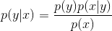

- The prediction we are trying to make with the classifier can be represented as a conditional probability, which we can use the Naive Bayes algorithm to decompose:

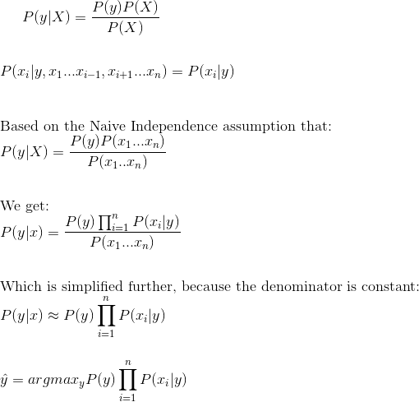

Mathematical overview of Conditional Random Fields:
- As we showed in the previous section, we model the Conditional Distribution as follows:
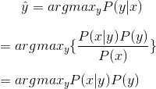

- In CRFs, our input data is sequential, and we have to take previous context into account when making predictions on a data point. To model this behavior, we will use Feature Functions, that will have multiple input values, which are going to be:
  - The set of input vectors, X
  - The position i of the data point we are predicting
  - The label of data point i-1 in X
  - The label of data point i in X
- The purpose of the feature function is to express some kind of characteristic of the sequence that the data point represents. For instance, if we are using CRFs for Parts-of-Speach tagging, than
- f (X, i, L{i - 1}, L{i} ) = 1 if L{i - 1} is a Noun, and L{i} is a Verb. 0 otherwise.
- Similarly, f (X, i, L{i - 1}, L{i} ) =1 if L{i - 1} is a Verb and L{i} is an Adverb. 0 otherwise.
- Each feature function is based on the label of the previous word and the current word, and is either a 0 or a 1. To build the conditional field, we next assign each feature function a set of weights (lambda values), which the algorithm is going to learn:
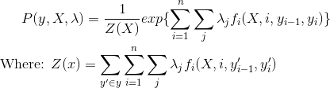

- To estimate the parameters (lambda), we will use Maximum Likelihood Estimation. To apply the technique, we will first take the Negative Log of the distribution, to make the partial derivative easier to calculate:
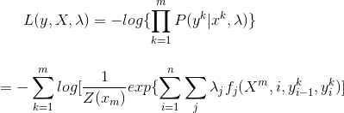

- To apply Maximum Likelihood on the Negative Log function, we will take the argmin(because minimizing the negative will yield the maximum). To find the minimum, we can take the partial derivative with respect to lambda, and get:
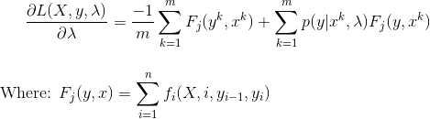
- We use the Partial Derivative as a step in Gradient Descent. Gradient Descent updates parameter values iteratively, with a small step, until the values converge. Our final Gradient Descent update equation for CRF is:\
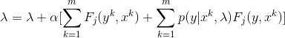
- As a summary, we use Conditional Random Fields by first defining the feature functions needed, initializing the weights to random values, and then applying Gradient Descent iteratively until the parameter values (in this case, lambda) converge. We can see that CRFs are similar to Logistic Regression, since they use the Conditional Probability distribution, but we extend the algorithm by applying Feature functions as our sequential inputs.

How CRFs differ from Hidden Markov Models:
- From the previous sections, it must be obvious how Conditional Random Fields differ from Hidden Markov Models. Although both are used to model sequential data, they are different algorithms.
- Hidden Markov Models are generative, and give output by modeling the joint probability distribution. On the other hand, Conditional Random Fields are discriminative, and model the conditional probability distribution. CRFs don’t rely on the independence assumption (that the labels are independent of each other), and avoid label bias. One way to look at it is that Hidden Markov Models are a very specific case of Conditional Random Fields, with constant transition probabilities used instead. HMMs are based on Naive Bayes, which we say can be derived from Logistic Regression, from which CRFs are derived.

