Chapter 2. Downloading Apache Spark and Getting Started

Using a Spark shell, you can prototype Spark operations with small data sets before writing a complex Spark application, but for large data sets or real work where you want to reap the benefits of distributed execution, local model is not suitable- you’ll want to use the YARN or Kubernetes deployment modes instead.

There are some extra dependencies that can be installed for SQL, ML, and MLlib, via pip install pyspark[sql,ml,mllib] (or pip install pyspark[sql] if you only want the SQL dependencies).

Understanding Spark Application Concepts
To understand what’s happening under the hood with our sample code, you’ll need to be familiar with some of the key concepts of a Spark application and how the code is transformed and executed as tasks across the Spark executors. We’ll begin by defining some important terms:
Application:
- A user program built on Spark using its APIs. It consists of a driver program and executors on the cluster.
SparkSession:
- An object that provides a point of entry to interact with underlying Spark functionality and allows programming Spark with its APIs.
  - In an interactive Spark shell, the Spark driver instantiates a SparkSession for you.
  - while in a Spark application, you create a SparkSession object yourself.
Job:
- A parallel computation consisting of multiple tasks that gets spawned in response to a Spark action (e.g., save(), collect())
Stage:
- Each job gets divided into smaller sets of tasks called stages that depend on each other.
Task:
A single unit of work or execution that will be sent to a Spark executor.

Spark Application and SparkSession

At the core of every Spark application is the Spark driver program, which creates a SparkSession object. When you’re working with a Spark shell, the driver is part of the shell and the SparkSession object is created for you, as you saw in the earlier examples when you launched the shells.
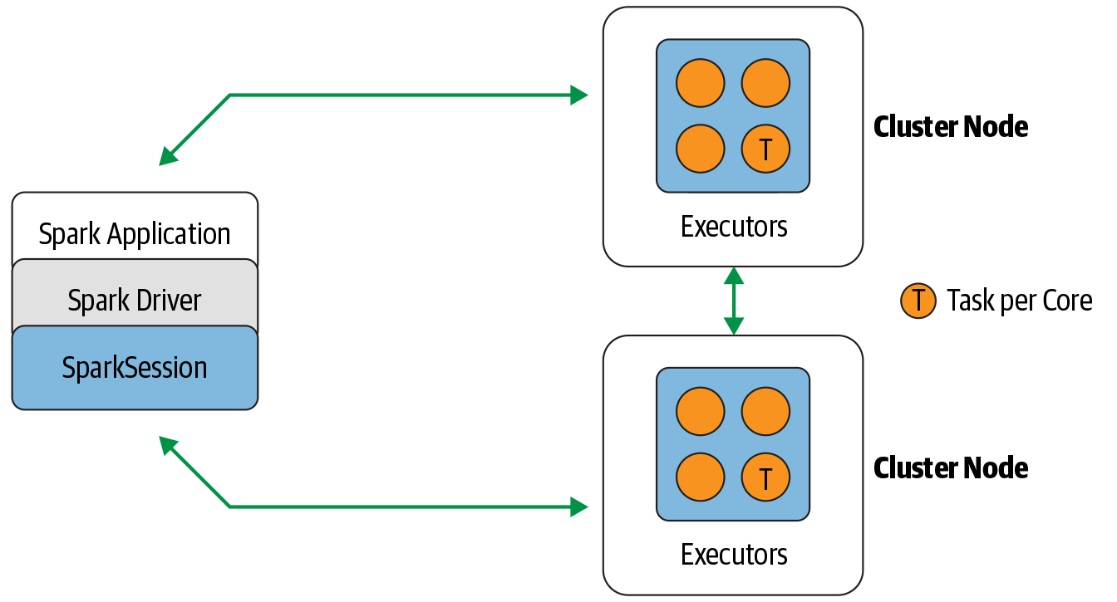

Spark Jobs
During interactive sessions with Spark shells, the driver converts your Spark application into one or more Spark jobs.

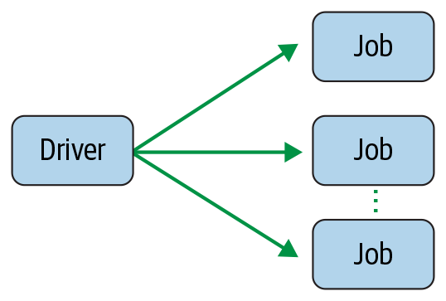

Spark Stages
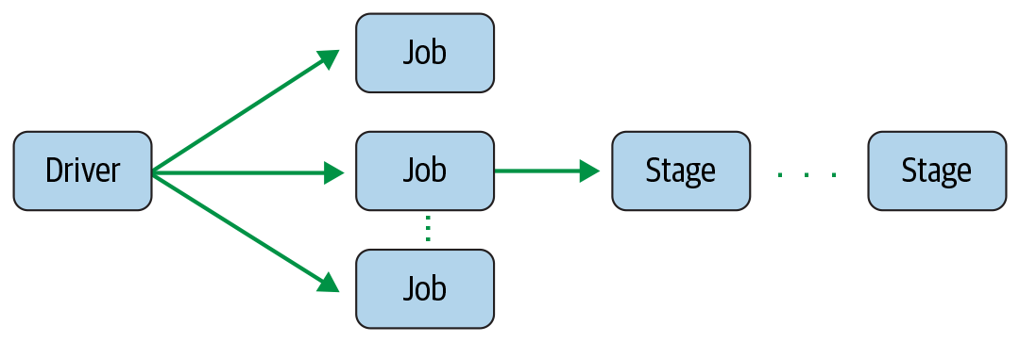
Spark Tasks

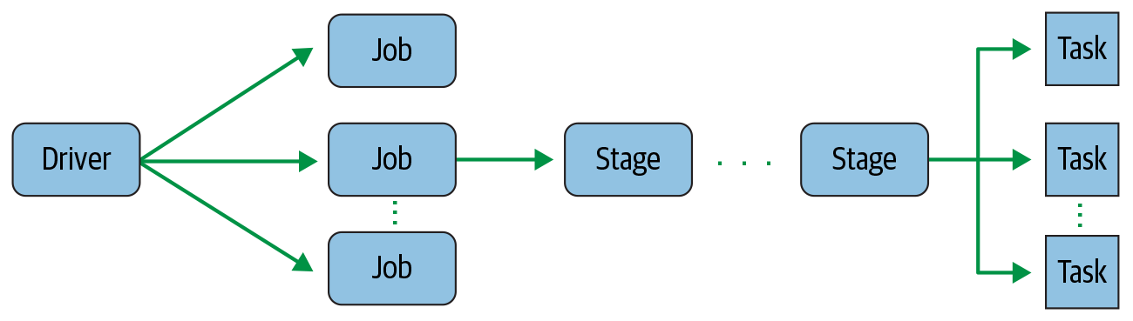
Transformations, Actions, and Lazy Evaluation
- Spark operations on distributed data can be classified into two types: transformations and actions.
- Transformations, as the name suggests, transform a Spark DataFrame into a new DataFrame without altering the original data, giving it the property of immutability.
- select() or filter() will not change the original DataFrame; instead, it will return the transformed results of the operation as a new DataFrame.
All transformations are evaluated lazily. That is, their results are not computed immediately, but they are recorded or remembered as a lineage.
A recorded lineage allows Spark, at a later time in its execution plan, to rearrange certain transformations, coalesce them, or optimize transformations into stages for more efficient execution.
=>> Transformation will be optimize computation.
Lazy evaluation is Spark’s strategy for delaying execution until an action is invoked or data is “touched” (read from or written to disk).

An action triggers the lazy evaluation of all the recorded transformations. In Figure 2-6, all transformations T are recorded until the action A is invoked. Each transformation T produces a new DataFrame:

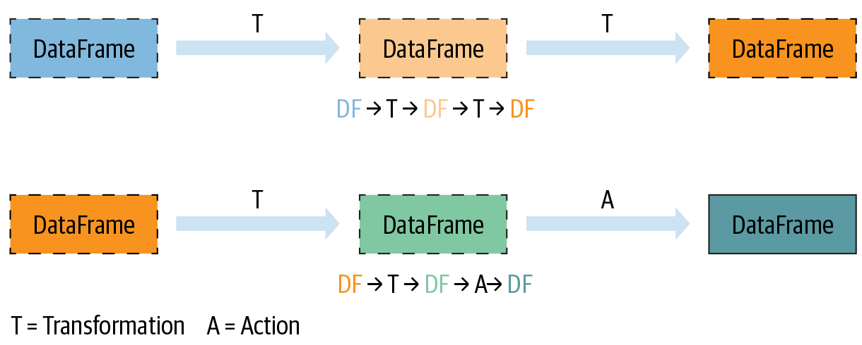
While lazy evaluation allows Spark to optimize your queries by peeking into your chained transformations, lineage and data immutability provide fault tolerance. Because Spark records each transformation in its lineage and the DataFrames are immutable between transformations, it can reproduce its original state by simply replaying the recorded lineage, giving it resiliency in the event of failures.

Transformations and actions as Spark operations:

Transformations | Actions
orderBy() | show()
groupBy() | take()
filter() | count()
select() | collect()
join() | save()
Narrow and Wide Transformations

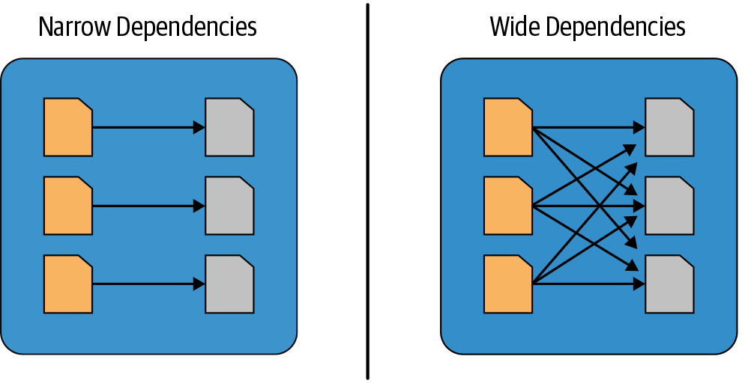
- Transformations are operations that Spark evaluates lazily.
- A huge advantage of the lazy evaluation scheme is that Spark can inspect your computation query and as certain how it can optimize it.
- Transformations can be classified as having either narrow dependencies or wide dependencies. Any transformation where a single output partition can be computed from a single input partition is a narrow transformation.
  - filter() and contains() represent narrow transformations because they can operate on a single partition and produce the resulting output partition without any exchange of data.
  - groupBy() or orderBy() instruct Spark to perform wide transformations, where data from other partitions is read in, combined, and written to disk.

The Spark UI:

Spark includes a graphical user interface that you can use to inspect or monitor Spark applications in their various stages of decomposition—that is jobs, stages, and tasks. Depending on how Spark is deployed, the driver launches a web UI, running by default on port 4040, where you can view metrics and details such as:
- A list of scheduler stages and tasks
- A summary of RDD sizes and memory usage
- Information about the environment
- Information about the running executors
- All the Spark SQL queries
DATABRICKS COMMUNITY EDITION:
Databricks is a company that offers a managed Apache Spark platform in the cloud.
Databricks provides quicker calculations and answers.

