Chapter 1. Introduction to Apache Spark: A Unified Analytics Engine

What Is Apache Spark?
Apache Spark is a unified engine designed for large-scale distributed data processing, on premises in data centers or in the cloud.

Spark provides in-memory storage for intermediate computations, making it much faster than Hadoop MapReduce. It incorporates libraries with composable APIs for machine learning (Mllib), SQL for interactive queries (Spark SQL), stream processing (Structured Streaming) for interacting with real-time data, and graph processing (GraphX).
Spark’s design philosophy centers around four key characteristics:
- Speed
  - First, its internal implementation benefits immensely from the hardware industry’s recent huge strides in improving the price and performance of CPUs and memory. Today’s commodity servers come cheap, with hundreds of gigabytes of memory, multiple cores, and the underlying Unix-based operating system taking advantage of efficient multithreading and parallel processing.
  - Second, Spark builds its query computations as a directed acyclic graph (DAG); its DAG scheduler and query optimizer construct an efficient computational graph that can usually be decomposed into tasks that are executed in parallel across workers on the cluster.
- Modularity:
  - Spark offers unified libraries with well-documented APIs that include the following modules as core components: Spark SQL, Spark Structured Streaming, Spark MLlib, and GraphX, combining all the workloads running under one engine.
- Extensibility:
  - Spark focuses on its fast, parallel computation engine rather than on storage. Unlike Apache Hadoop, which included both storage and compute.
  - Unlike Apache Hadoop, which included both storage and compute.
  - Spark’s DataFrameReaders and DataFrameWriters can also be extended to read data from other sources, such as Apache Kafka, Kinesis, Azure Storage, and Amazon S3, into its logical data abstraction, on which it can operate.

Apache Spark Components as a Unified Stack
- Spark offers four distinct components as libraries for diverse workloads: Spark SQL, Spark MLlib, Spark Structured Streaming, and GraphX

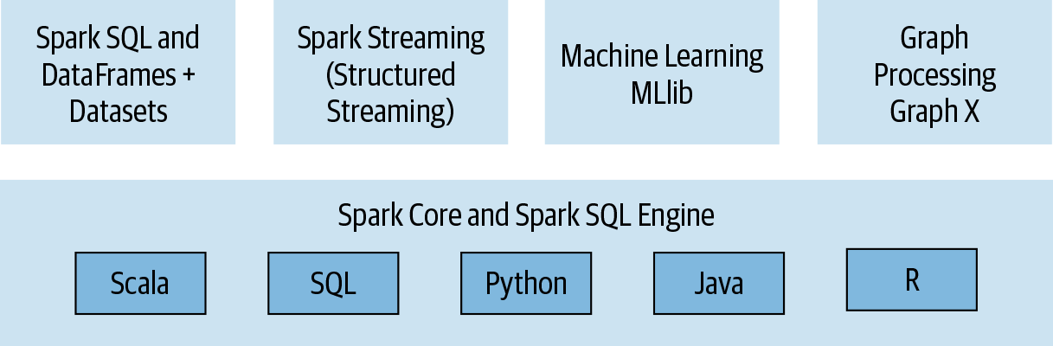
Spark SQL
- This module works well with structured data. You can read data stored in an RDBMS table or from file formats with structured data (CSV, text, JSON, Avro, ORC, Parquet, etc.) and then construct permanent or temporary tables in Spark, you can combine SQL-like queries to query the data just read into a Spark DataFrame.
- You can write similar code snippets in Python, and the generated bytecode will be identical, resulting in the same performance.

Spark MLlib
Spark comes with a library containing common machine learning (ML) algorithms called MLlib.
MLlib provides many popular machine learning algorithms built atop high-level DataFrame-based APIs to build models.
These APIs allow you to extract or transform features, build pipelines (for training and evaluating), and persist models (for saving and reloading them) during deployment.
Additional utilities include the use of common linear algebra operations and statistics.

Spark Structured Streaming
- Experimental Continuous Streaming model and Structured Streaming APIs. built atop the Spark SQL engine and DataFrame-based APIs.
- Structured Streaming was generally available, meaning that developers could use it in their production environments.

Popular Spark use cases
Whether you are a data engineer, data scientist, or machine learning engineer, you’ll find Spark useful for the following use cases:
- Processing in parallel large data sets distributed across a cluster
- Performing ad hoc or interactive queries to explore and visualize data sets
- Building, training, and evaluating machine learning models using MLlib
- Implementing end-to-end data pipelines from myriad streams of data
- Analyzing graph data sets and social networks

